**The University Of Azad Jammu & Kashmir,**

**Muzaffarabad**

**Department of Software Engineering**

**LAB TASK 02**

**Database Systems**

**Course Code**: **CS-2204**

**Submitted To:**

Engr. Tahir Jahangir

**Submitted By:**

Ahmed Ali

**Roll No:**

2023-SE-41

**Session**: 2023-2027

Contents

Task 01: Creating a Publisher Table 3

Objective 3

Task 02: Importing External Data from Excel 4

Objective 4

Task 03: Creating Relationships Between Tables: 6

Objective: 6

Instructions: 6

Task 04: Creating a Report Using the Report Wizard 7

Objective: 7

Instructions: 7s

Task 05: Creating Queries 8

Query 1: 8

Query 2: 8

Query 3: 9

Query 4: 9

Query 5 10

Query 6: 10

Query 7 11

My Learning Experience 12

Table Creation and Data Management 12

External Data Import 12

Establishing Relationships 12

Report Generation 12

Query Development 12

Conclusions 12

# **Task 01: Creating a Publisher Table**

Objective: Introduce students to creating tables with specific field properties and primary keys. Instructions:

1. Open the file *PracticeAccess*.
2. Create a new table called *Publisher* with the following structure:

**Field Name**:

▪PubID (Short Text, Field Size: 6, Primary Key, Caption: "Publisher ID")

▪ PubName (Short Text, Field Size: 40, Caption: "Publisher’s Name")

▪ URL (Hyperlink)

1. Enter Data:
2. Save the table with the name *Publisher*.

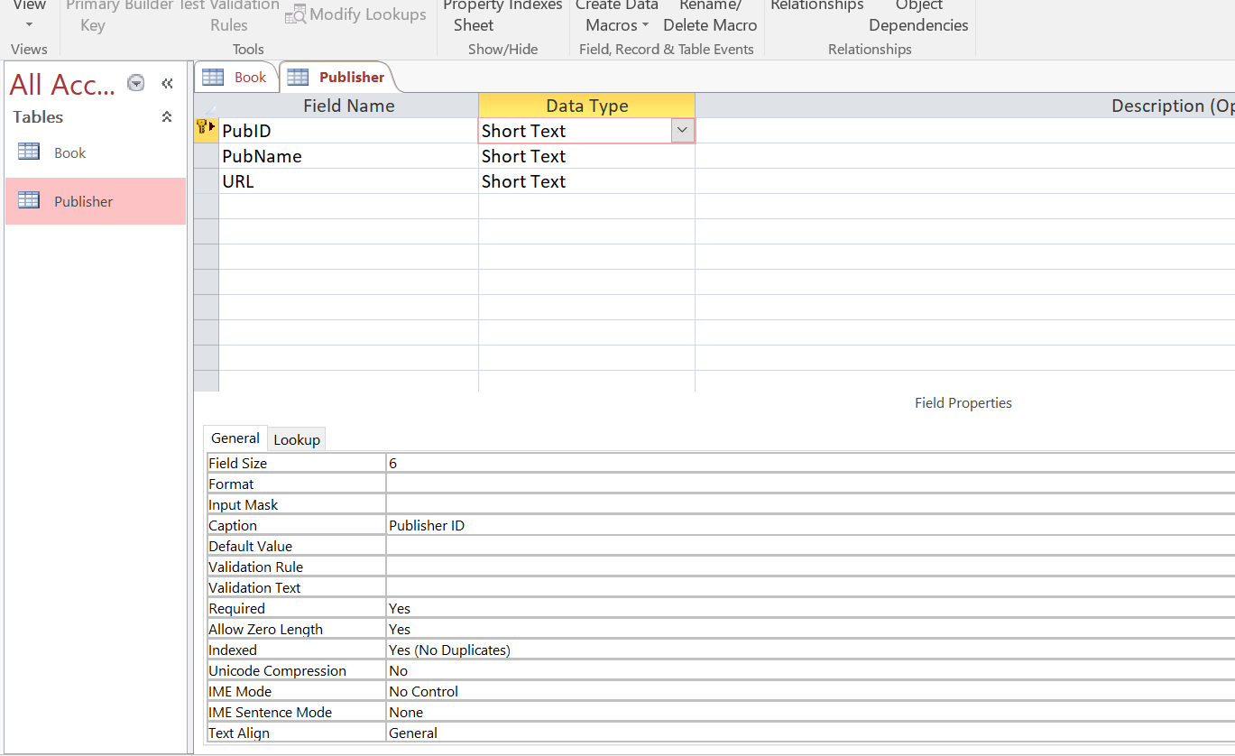

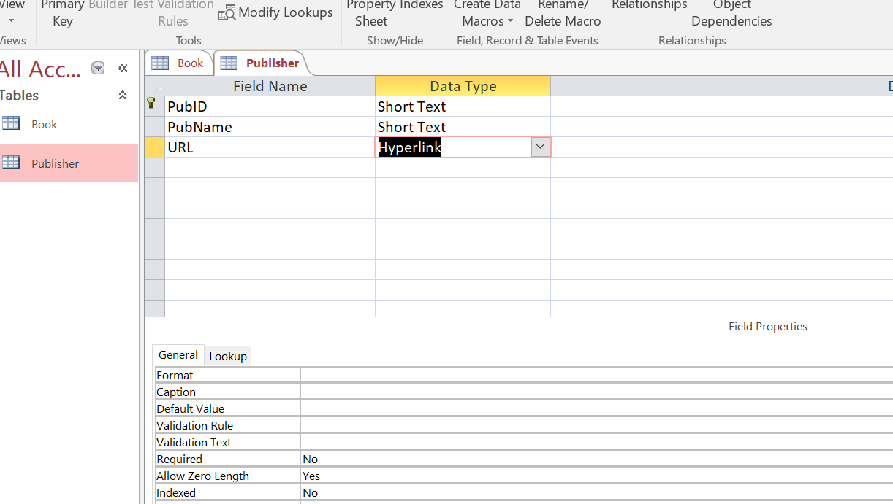

**TABLE CREATED:**

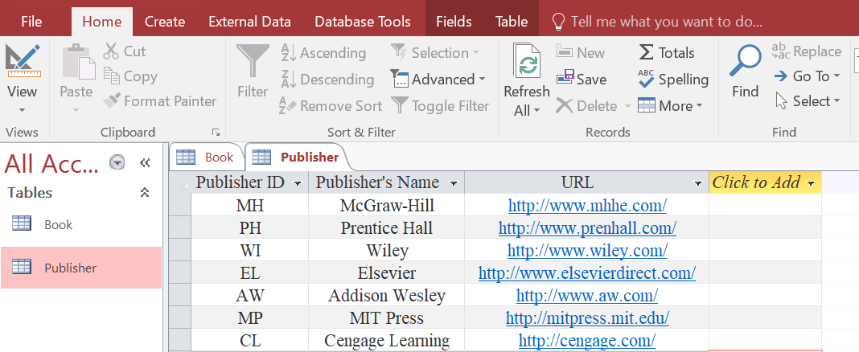

# **Task 02: Importing External Data from Excel**

Objective: Teach students how to import external data from an Excel spreadsheet into Access. Instructions:

1. Import the Excel file *Bookstore.xlsx* into the database and make sure Import the source data into a new table in the current database is selected.
2. Select the *Author* worksheet and make sure "First Row Contains Column Headings" is checked.

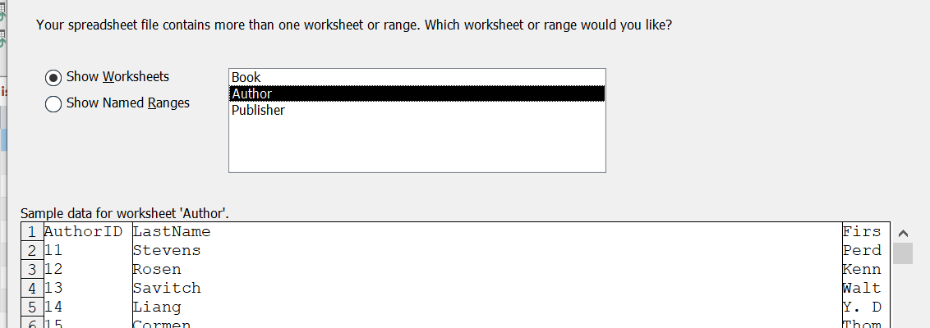

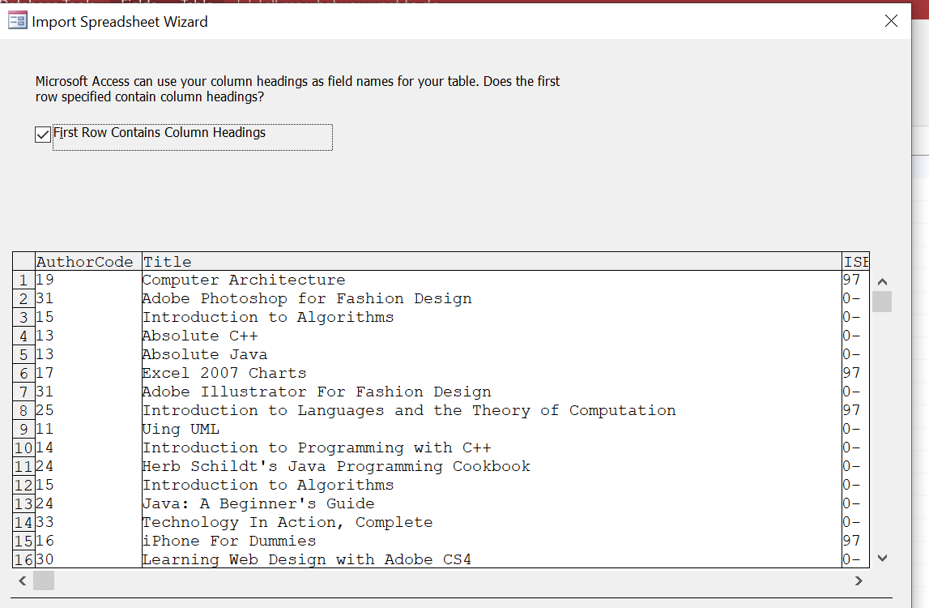

1. For the *AuthorID* field, set the Data Type to **Long Integer** and set the Indexed property to **Yes (No Duplicates)**.

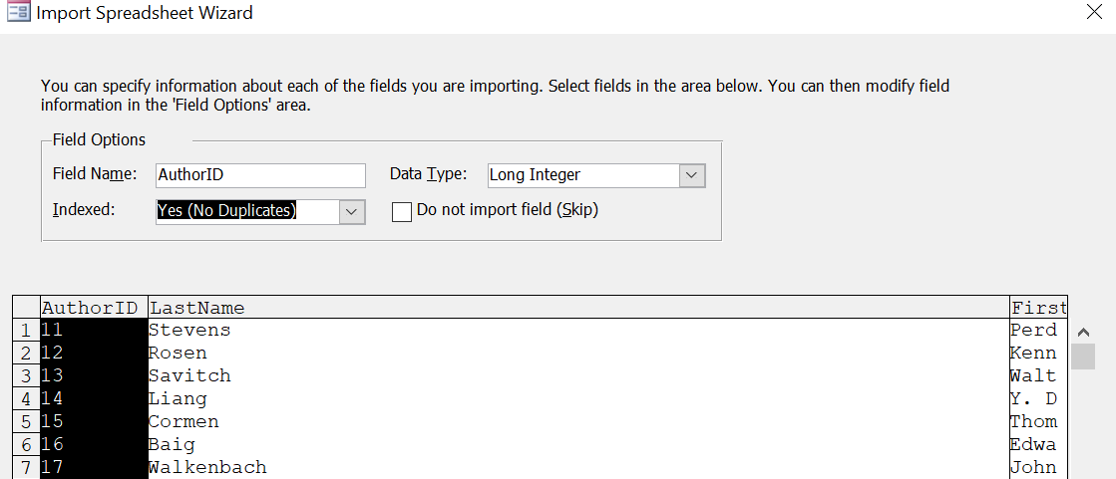

1. Set *AuthorID* as the primary key.

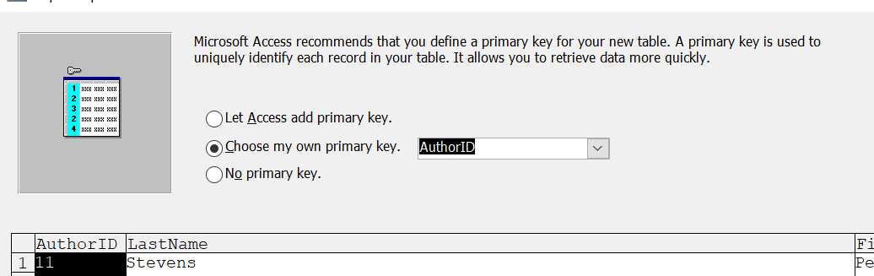

1. Save the imported table with the name *Author*.

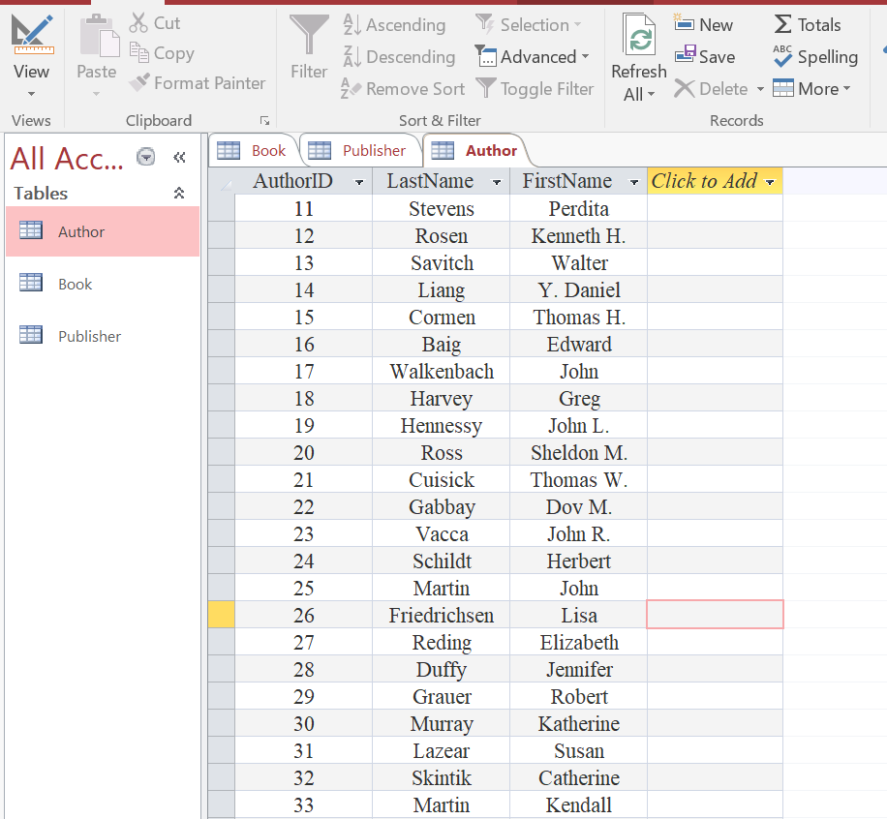

# **Task 03: Creating Relationships Between Tables:**

Objective: Show students how to create relationships between tables while enforcing referential integrity

## Instructions:

1. Open the *Relationships* window in Access.
2. Create a relationship between the *AuthorID* field in the *Author* table and the *AuthorCode* field in the *Book* table. Check the box labeled **Enforce Referential Integrity**.

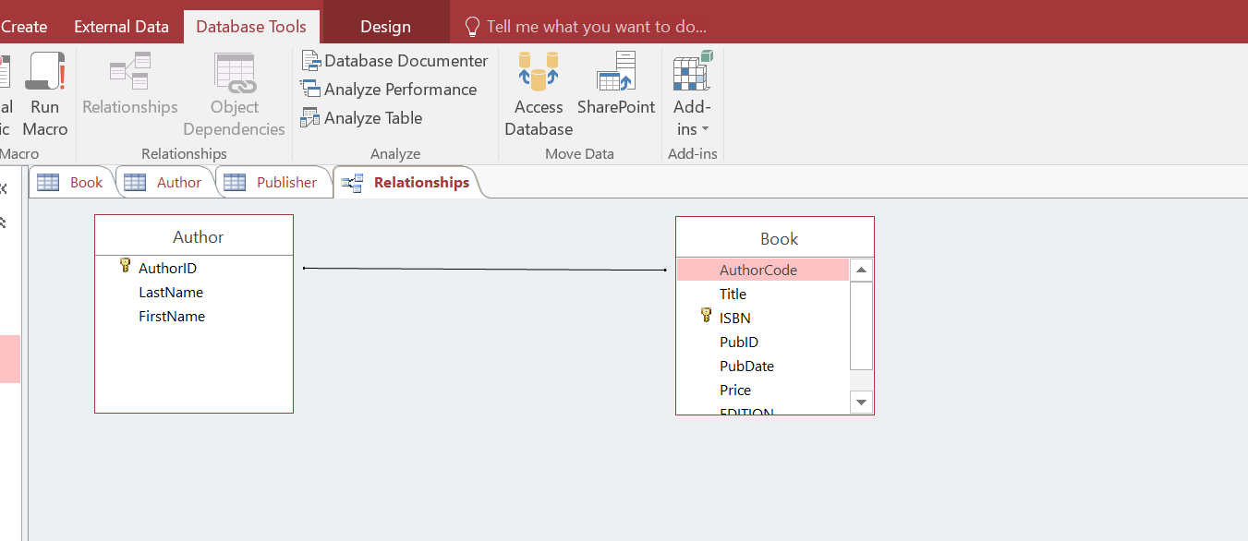

1. Create another relationship between the *PubID* field in the *Publisher* table and the *PubID* field in the *Book* table. Ensure that **Enforce Referential Integrity** is checked.

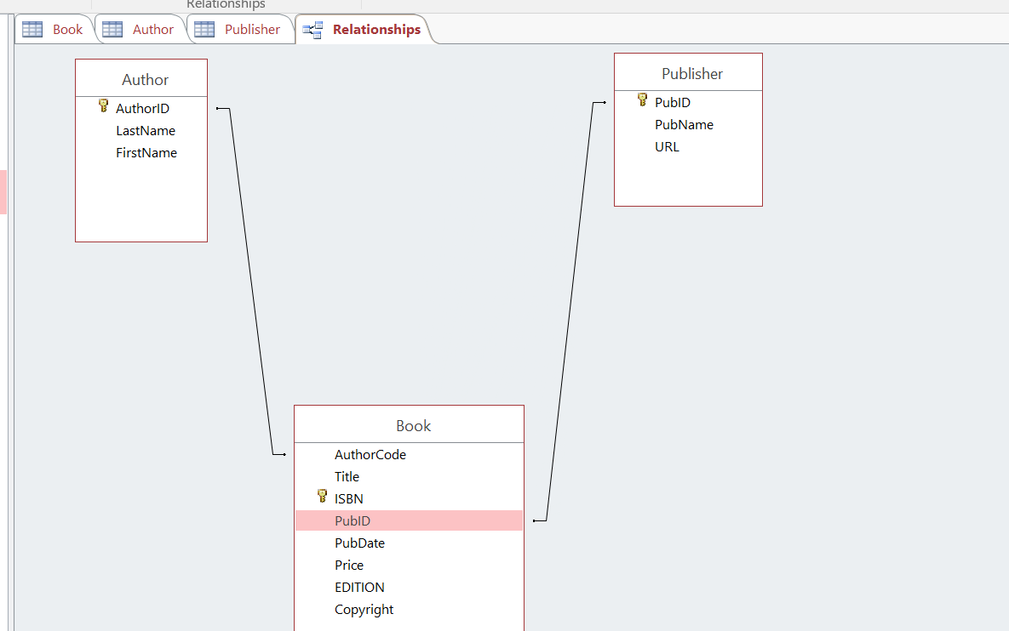

# **Task 04: Creating a Report Using the Report Wizard**

Objective: Introduce students to generating reports using the Report Wizard.

Instructions:

1. Open the *Report Wizard*.
2. Select the following fields:
   * **LastName** from the *Author* table.

o **Title** and **Price** from the *Book* table.

* + **PubName** from the *Publisher* table.

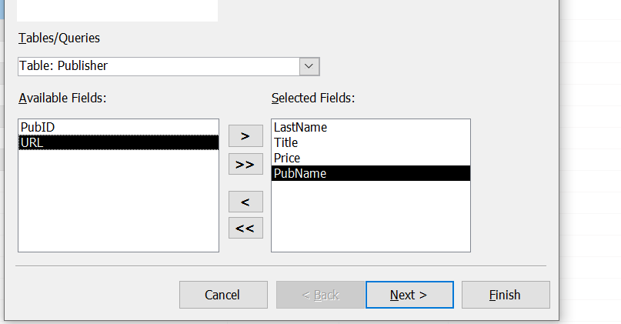

1. Group the data by **Publisher** and sort by **Title** in ascending order.

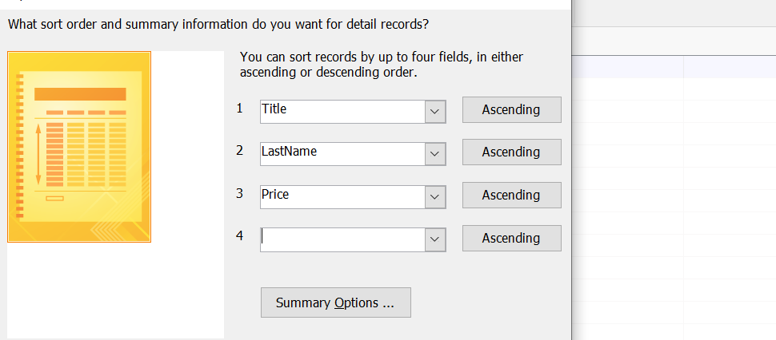

1. Choose a **Stepped Layout** and **Portrait Orientation**.
2. Set the title of the report as **Book List**.
3. Switch to **Layout View** and adjust column widths to ensure readability.

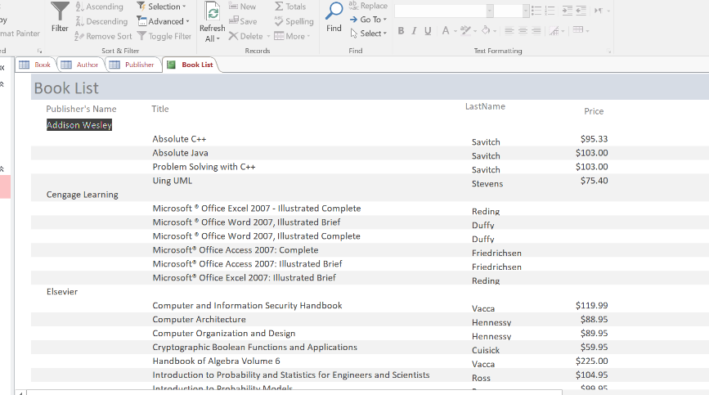

# **Task 05: Creating Queries**

**Objective**: Teach students how to create and execute queries to retrieve specific data. **Instructions**:

**Query 1**: List all books where the publish date is later than 7/31/2007.

* Include **LastName** from the *Author* table, **Title** and **PubDate** from the *Book* table, and **PubName** from the *Publisher* table.
* Sort by **PubDate** in descending order.
* Save this query as **Books not yet published**.

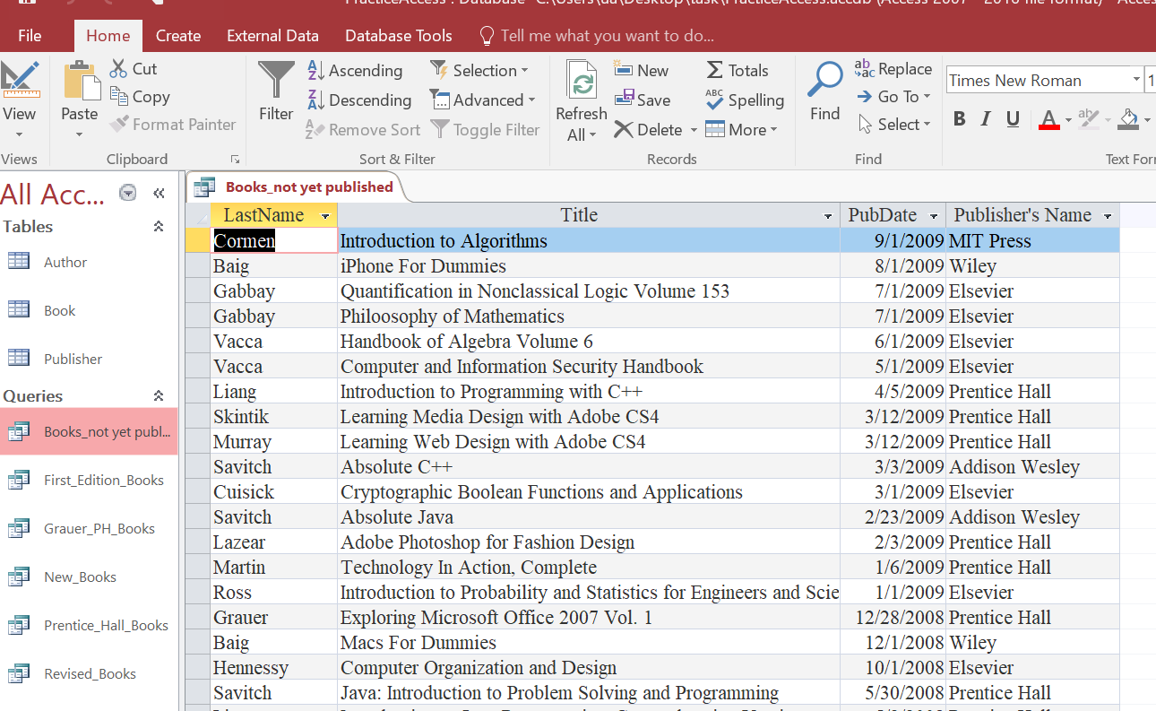

**Query 2**: List all books where the *Edition* field is empty.

* Include **LastName**, **Title**, **Edition**, and **PubName** fields.
* Sort by **PubName** in ascending order.
* Save this query as **First Edition Books**.

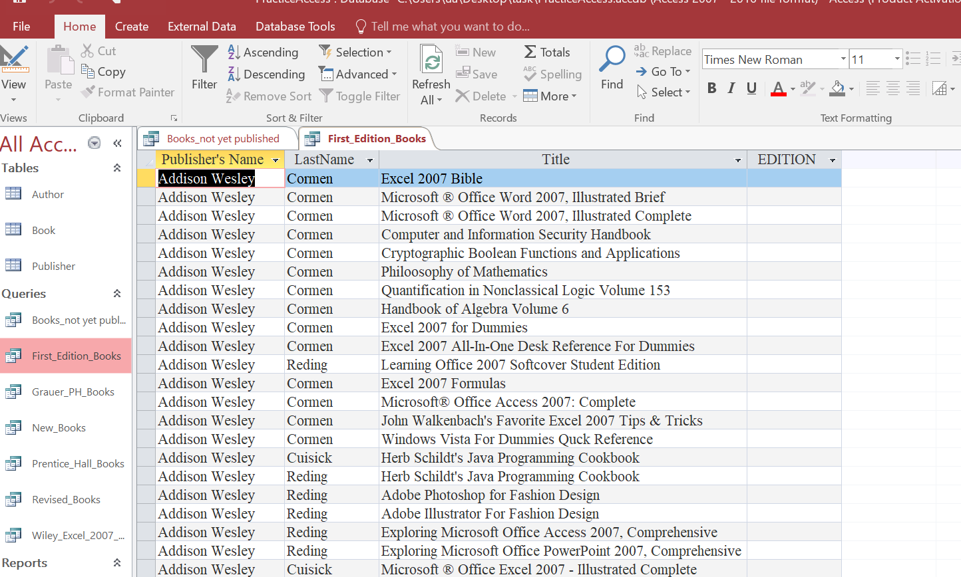

**Query 3:** List books where the price is greater than $100, published by **PH**, and written by **Grauer**.

* Sort by **Title** in descending order.
* Save this query as **Grauer PH Books**.

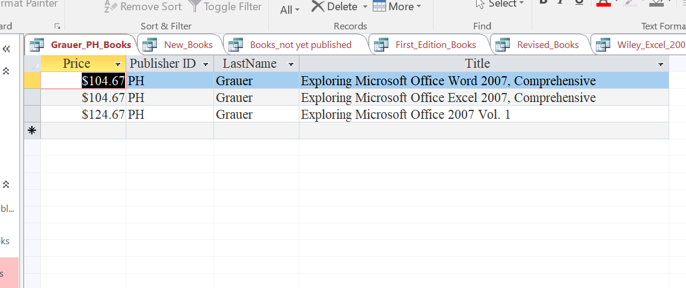

**Query 4:** List all books where the copyright year is 2010.

* Include **LastName**, **Title**, **PubDate**, and **Copyright** fields.
* Sort by **PubDate** in descending order.
* Save this query as **New Books**.

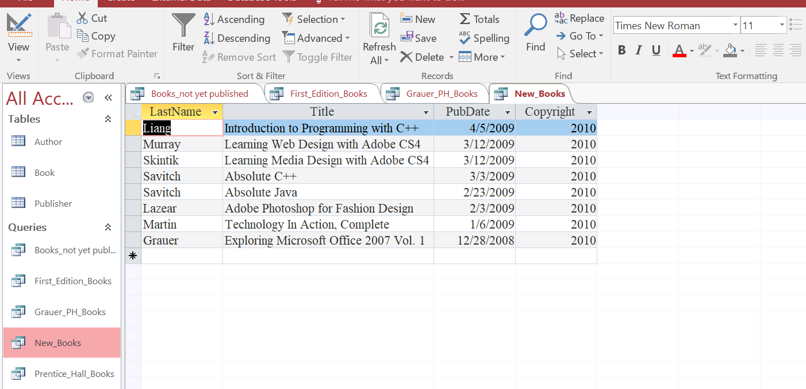

**Query 5**: List all books published by **Prentice Hall**.

* Sort by **Title** in ascending order.
* Save this query as **Prentice Hall Books**.

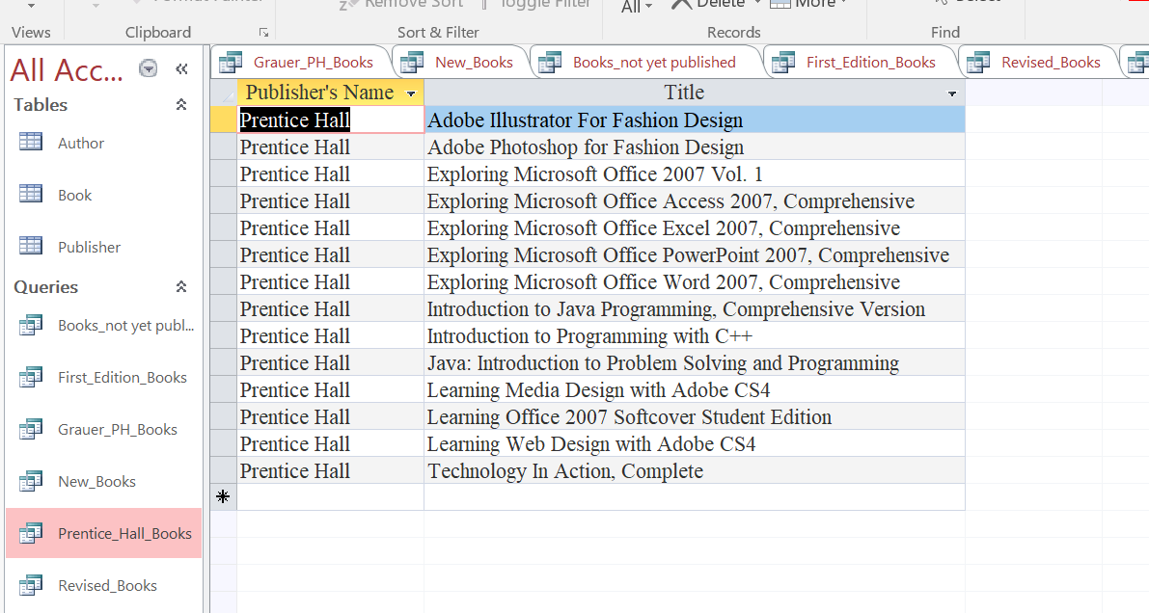

**Query 6:** List all books where the *Edition* field is not empty.

* Sort by **PubName** in ascending order.
* Save this query as **Revised Books**.

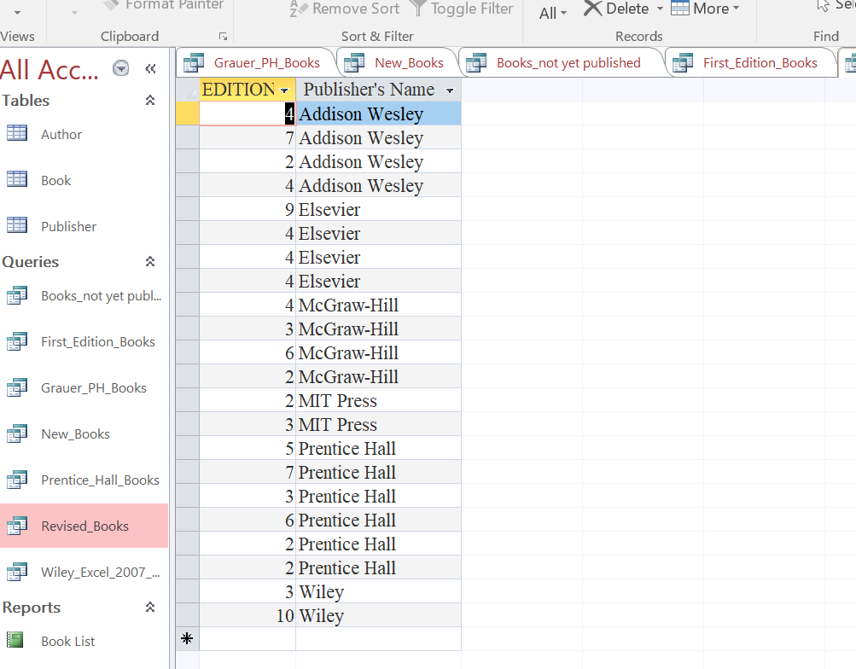

**Query 7:** List all books where the title contains "Excel 2007" and are published by **Wiley**.

* Sort by **Title** in ascending order.
* Save this query as **Wiley Excel 2007 Books**.

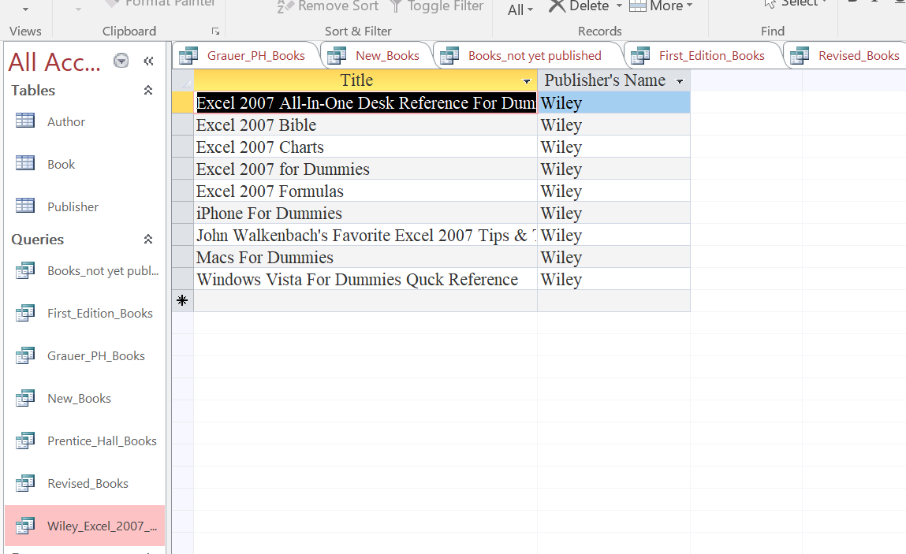

## **My Learning Experience**

This lab session on Microsoft Access provided me with valuable hands-on experience in database management. Working through tasks involving table creation, data imports, relationships, reports, and queries.

## **Table Creation and Data Management**

Creating the Publisher table taught me how to properly define fields with specific properties like field size and data type. I learned that setting appropriate field properties is crucial for data integrity and validation.

## **External Data Import**

Importing data from Excel was great. Learning to map Excel columns to appropriate Access data types showed me how important it is to properly prepare data before importing. Setting the AuthorID as primary key and configuring indexing properties taught me about performance optimization for database queries.

## **Establishing Relationships**

Creating relationships between tables helped me understand how relational databases connect information across multiple tables.

### **Report Generation**

Using the Report Wizard to create the Book List report demonstrated how raw data can be transformed into meaningful, organized information

## **Query Development**

Creating seven different queries .Each query taught me different aspects of data filtering:

* Date-based filtering in the "Books not yet published" query
* Working with null values in the "First Edition Books" query
* Combining multiple conditions in the "Grauer PH Books" query
* Text pattern matching in the "Wiley Excel 2007 Books" query

## **Conclusions**

This lab has fundamentally enhanced my understanding of database systems. I now see databases not just as storage containers but as sophisticated tools for organizing, connecting, and extracting meaningful information. The relationships between tables mirror real-world connections between entities like authors, books, and publishers.

The most valuable insight I gained was seeing how properly structured data with well-defined relationships enables powerful querying capabilities.

**....................................................................................**