**The University Of Azad Jammu & Kashmir,**

**Muzaffarabad**

**Department of Software Engineering**

**LAB TASK 04**

**Database Systems**

**Course Code**: **CS-2204**

**Submitted To:**

Engr. Tahir Jahangir

**Submitted By:**

Ahmed Ali

**Roll No:**

2023-SE-41

**Session**: 2023-2027

Contents

**Task 01: Creating a Database and Table Using SQL DDL Commands** 3

**Task 02: Modifying Table Structure Using SQL DDL Commands** 4

Add a new column Email_ID of type VARCHAR(20). 4

Change the data type of P_ID from VARCHAR to INT. 4

Change the data type of Phone from VARCHAR to INT. 4

**Task 03: Renaming and Deleting Table Using SQL DDL Commands** 5

Rename the table PUBLISHERS to PUBLISHER using an SQL command. 5

Delete the renamed table PUBLISHER using SQL. 5

**Task 04: Creating and Modifying Another Table Using SQL DDL Commands** 6

Create a table BOOKS with the following structure: 6

Modify the BOOKS table using SQL DDL Commands: 7

**Task 05: Deleting Tables and Database** 7

**REFLECTION AND LEARNING:** 8

# **Task 01: Creating a Database and Table Using SQL DDL Commands**

**Objective:** Enable students to create a database and define a table using SQL DDL commands.

**Instructions:**

1. Create a new database named as your full name in all lowercase with underscores, followed by _lab_task_04.

Example: hammad_ahmed_lab_task_04

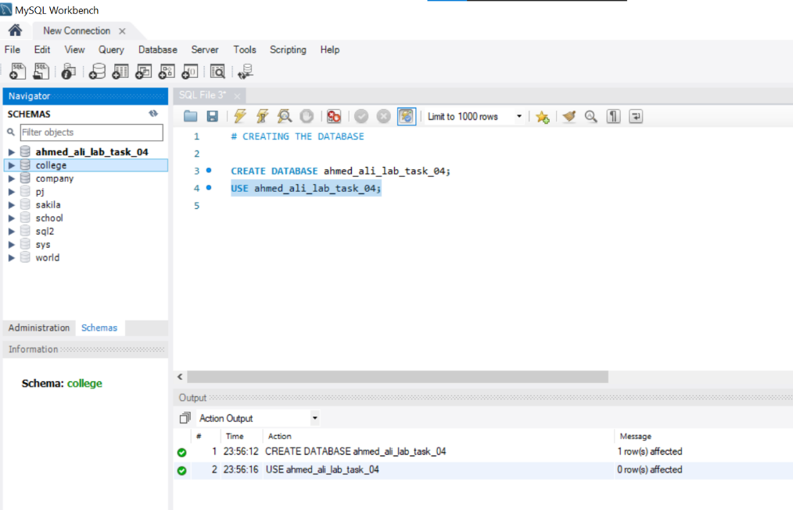

1. In this database, use SQL DDL commands to create a table named PUBLISHERS with the following attributes:

|  |  |  |
| --- | --- | --- |
| **Attribute** | **Data Type** | **Field Size** |
| **P_ID** | VARCHAR | 4 |
| **P_Name** | VARCHAR | 30 |
| **Address** | VARCHAR | 40 |
| **State** | VARCHAR | 20 |
| **Phone** | VARCHAR | 20 |

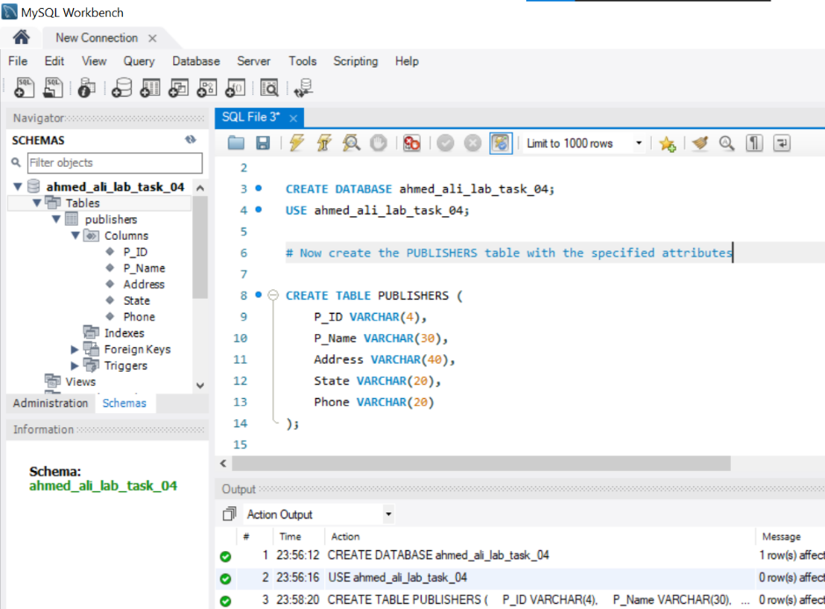

# **Task 02: Modifying Table Structure Using SQL DDL Commands**

**Objective:** Teach students to alter existing tables using SQL commands.

**Instructions:** Use SQL DDL commands to make the following changes to the PUBLISHERS table:

## Add a new column Email_ID of type VARCHAR(20).

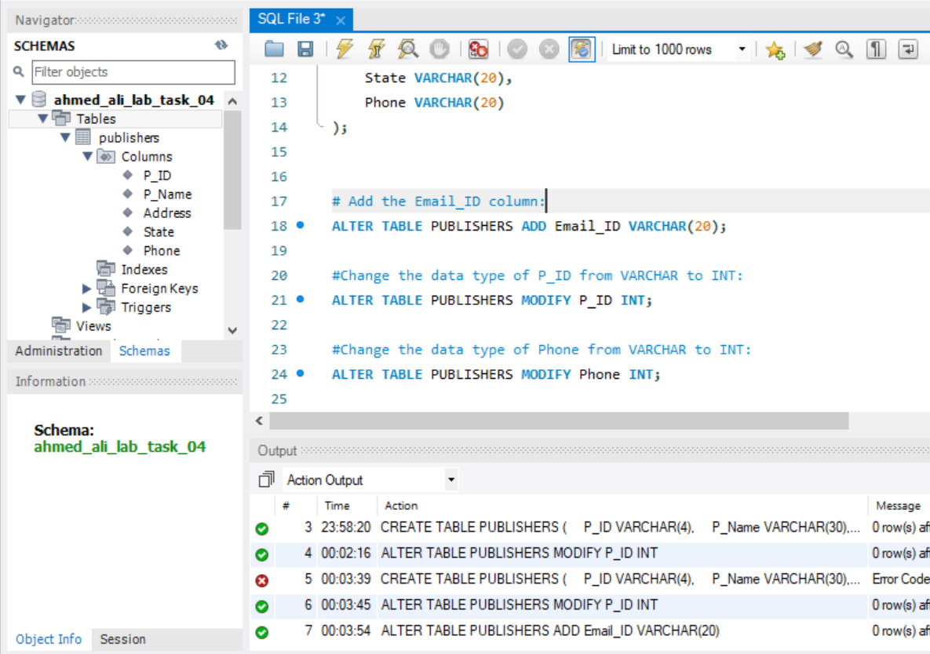

## Change the data type of P_ID from VARCHAR to INT.



## Change the data type of Phone from VARCHAR to INT.





# **Task 03: Renaming and Deleting Table Using SQL DDL Commands**

**Objective:** Enable students to rename and delete tables using SQL.

**Instructions:**

## Rename the table PUBLISHERS to PUBLISHER using an SQL command.

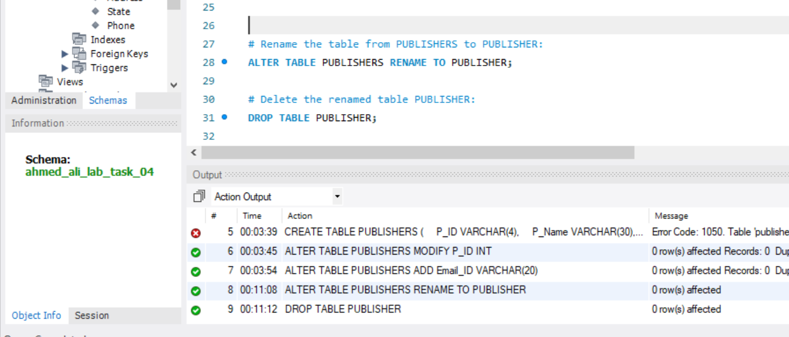

## Delete the renamed table PUBLISHER using SQL.





# **Task 04: Creating and Modifying Another Table Using SQL DDL Commands**

**Objective:** Provide experience in creating and editing additional database objects via SQL.

**Instructions:**

## Create a table BOOKS with the following structure:

|  |  |  |
| --- | --- | --- |
| **Attribute** | **Data Type** | **Field Size** |
| **ISBN** | VARCHAR | 4 |
| **Book_Title** | VARCHAR | 30 |
| **Category** | VARCHAR | 15 |
| **Price** | NUMERIC | (6,2) |
| **Copyright_Date** | NUMERIC | 4 |
| **Year** | NUMERIC | 4 |
| **P_ID** | VARCHAR | 4 |

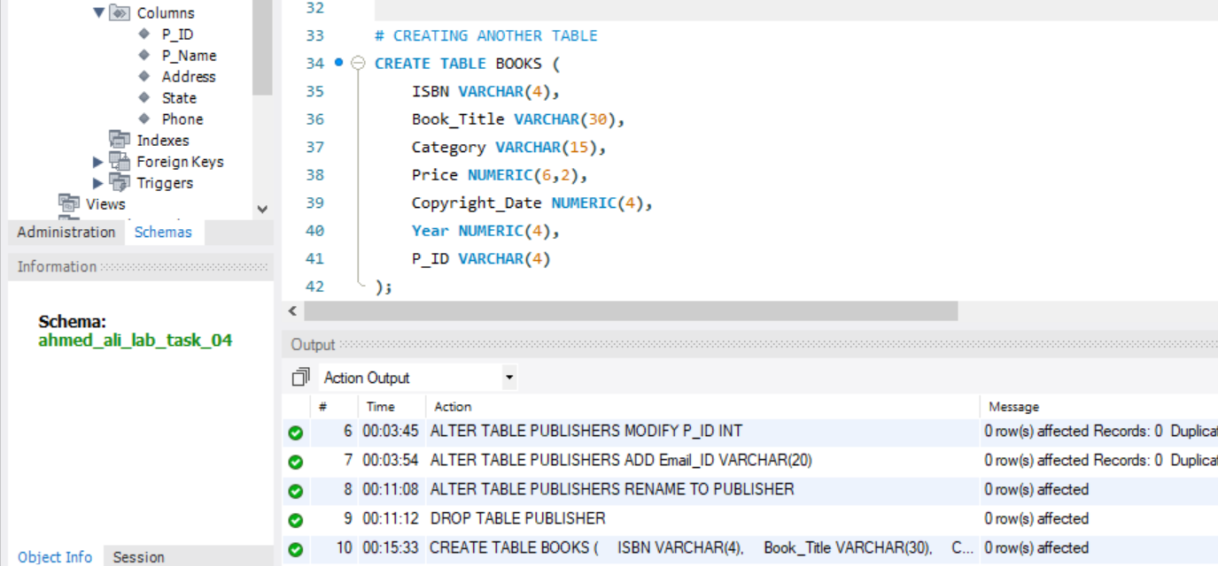

## Modify the BOOKS table using SQL DDL Commands:

* Add a new column Page_Count with type NUMERIC(4).
* Change the data type of ISBN from VARCHAR to INT.
* Change the data type of Copyright_Date from NUMERIC to VARCHAR.

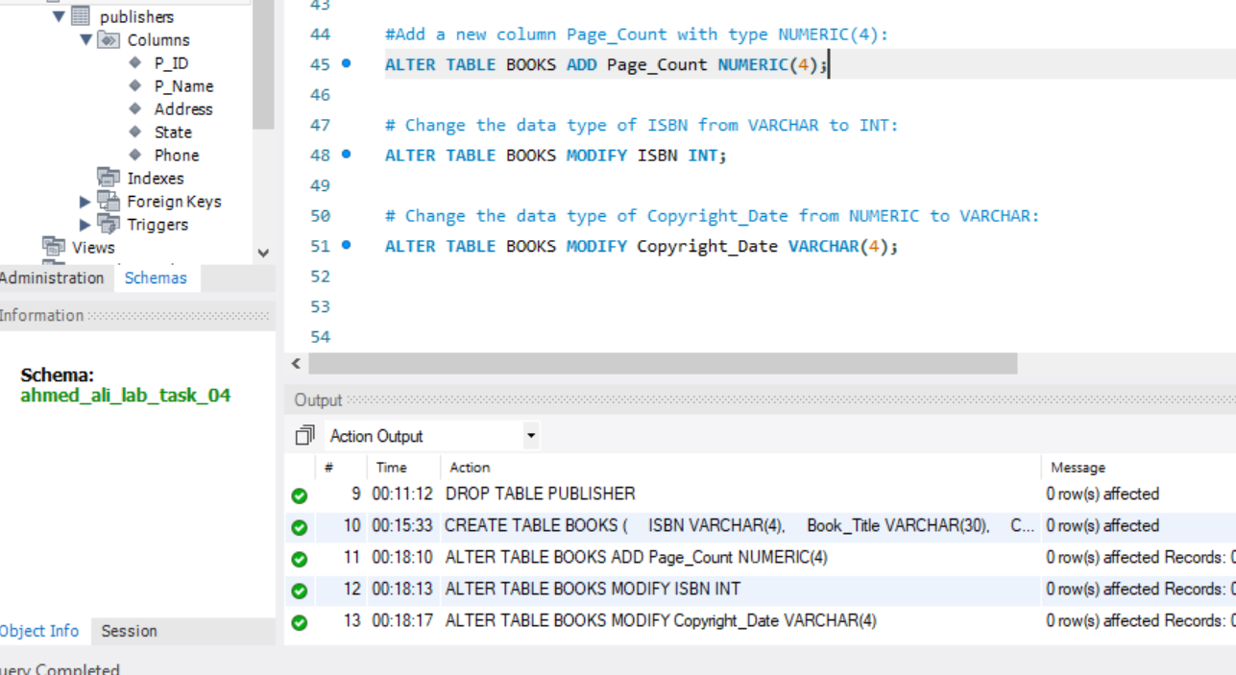

# **Task 05: Deleting Tables and Database**

**Objective:** Demonstrate database cleanup using SQL and application features.

**Instructions:**

1. Use SQL DDL Commands to delete the BOOKS table.
2. Delete the entire database from your system (this can be done manually after taking a screenshot showing its deletion).

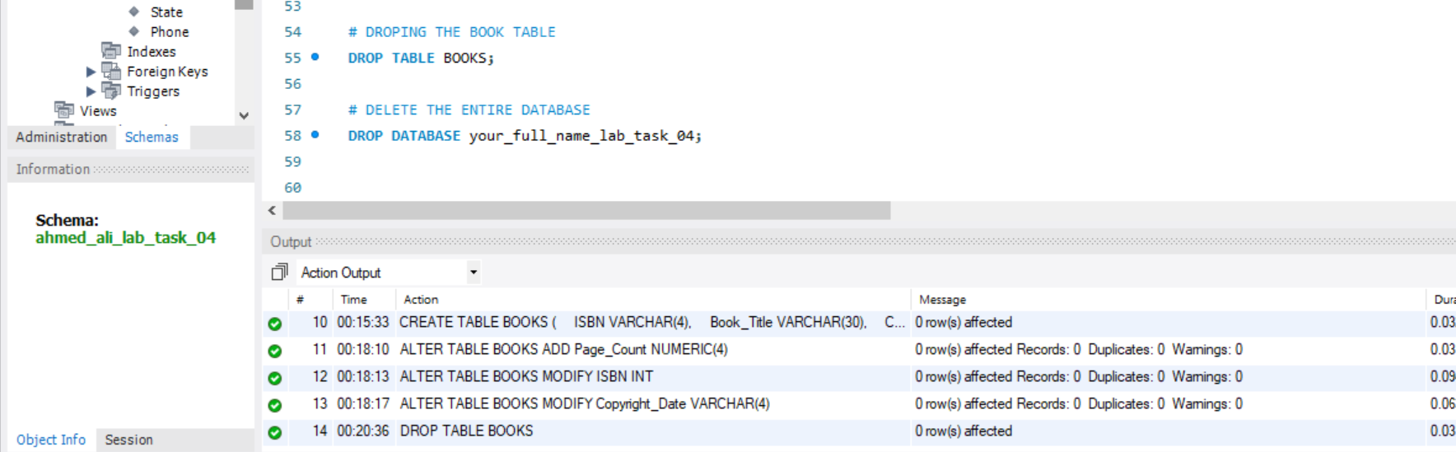

I have not deleted the database because I have the saved SQL file and I will delete it after showing my work of execution to the instructor.

# **REFLECTION AND LEARNING:**

Working with Data Definition Language commands was enlightening! I found it fascinating how a few simple commands (CREATE, ALTER, DROP) can build and modify entire database structures. Creating the PUBLISHERS and BOOKS tables taught me the importance of proper data type selection. When I had to change VARCHAR to INT for the P_ID field, I realized how critical it is to plan your schema properly from the beginning.

The most challenging part was remembering the exact syntax for some commands, especially when renaming tables. I initially tried to use RENAME TABLE which didn't work, before discovering the correct SP_RENAME procedure in SQL Server.

Overall, these labs have given me practical skills that bridge the gap between theoretical database concepts and real-world implementation. I'm looking forward to building on this foundation with more complex database operations in future labs.

**......................................................................................................................................**