**The University Of Azad Jammu & Kashmir,**

**Muzaffarabad**

**Department of Software Engineering**

**LAB TASK 06**

**Database Systems**

**Course Code**: **CS-2204**

**Submitted To:**

Engr. Tahir Jahangir

**Submitted By:**

Ahmed Ali

**Roll No:**

2023-SE-41

**Session**: 2023-2027

Contents

🔧 Lab Task – 06: SQL Server – DML Commands and Data Manipulation 1

🎯 Objective: 1

📘 Task 01: Database Creation and Table Setup 2

Instructions: 2

📝 Task 02: Data Insertion into PUBLISHERS 3

Instructions: 3

🔧 Task 03: Updating and Filtering PUBLISHERS Data 4

Instructions: 4

Update the contact number of Wesley Publications to 9256774. 4

Retrieve all publisher details where the state is Georgia. 4

Update the email of Sunshine Publishers Ltd. to s_pub@sunshine.com. 5

📗 Task 04: Creating and Populating BOOKS Table 5

Instructions: 5

Create a new table named BOOKS with the following columns: 5

Insert the following records into the BOOKS table: 6

️ Task 05: Data Manipulation and Retrieval on BOOKS Table 8

Instructions: 8

Change the Genre of the book titled C++ from *Academic* to *Language*. 8

Retrieve ISBN and Title of all books classified under *Language*. 8

Fetch complete details of books released in 2006. 8

List titles of books having less than 600 pages. 8

Display all distinct genres available in the BOOKS table. 9

Show complete records of all books in Academic category with a cost ≥ 35. 9

Delete all entries from the BOOKS table where Genre is Fiction. 10

# 🔧 Lab Task – 06: SQL Server – DML Commands and Data Manipulation

# 🎯 Objective:

In this lab, students will work with SQL Server to practice core **Data Manipulation Language (DML)** operations. Students will perform table creation, data insertion, updates, deletions, and retrievals. The lab aims to enhance practical SQL skills with focus on inserting valid data, updating specific fields, filtering records with conditions, and enforcing integrity through keys and constraints.

# 📘 Task 01: Database Creation and Table Setup

**Objective:** Help students get comfortable with creating a new SQL Server database and defining tables with appropriate constraints.

## Instructions:

1. Launch SQL Server and create a new database using **Query Wizard**.

o Name your database in the format:

**your_full_name_lab_task_06** (all lowercase, with underscores)

▪ Example: muhammad_ali_lab_task_06

1. Inside this database, create a table named **PUBLISHERS** with the following structure:

|  |  |  |  |
| --- | --- | --- | --- |
| **Column Name** | **Data Type** | **Size** | **Constraints** |
| P_ID | VARCHAR | 4 | PRIMARY KEY, NOT NULL |
| Name | VARCHAR | 50 | — |
| State | VARCHAR | 15 | — |
| Address | VARCHAR | 50 | NOT NULL |
| Email | VARCHAR | 30 | — |
| Contact | VARCHAR | 20 | UNIQUE |

💡 Use DDL (Data Definition Language) commands to create the table with these constraints.

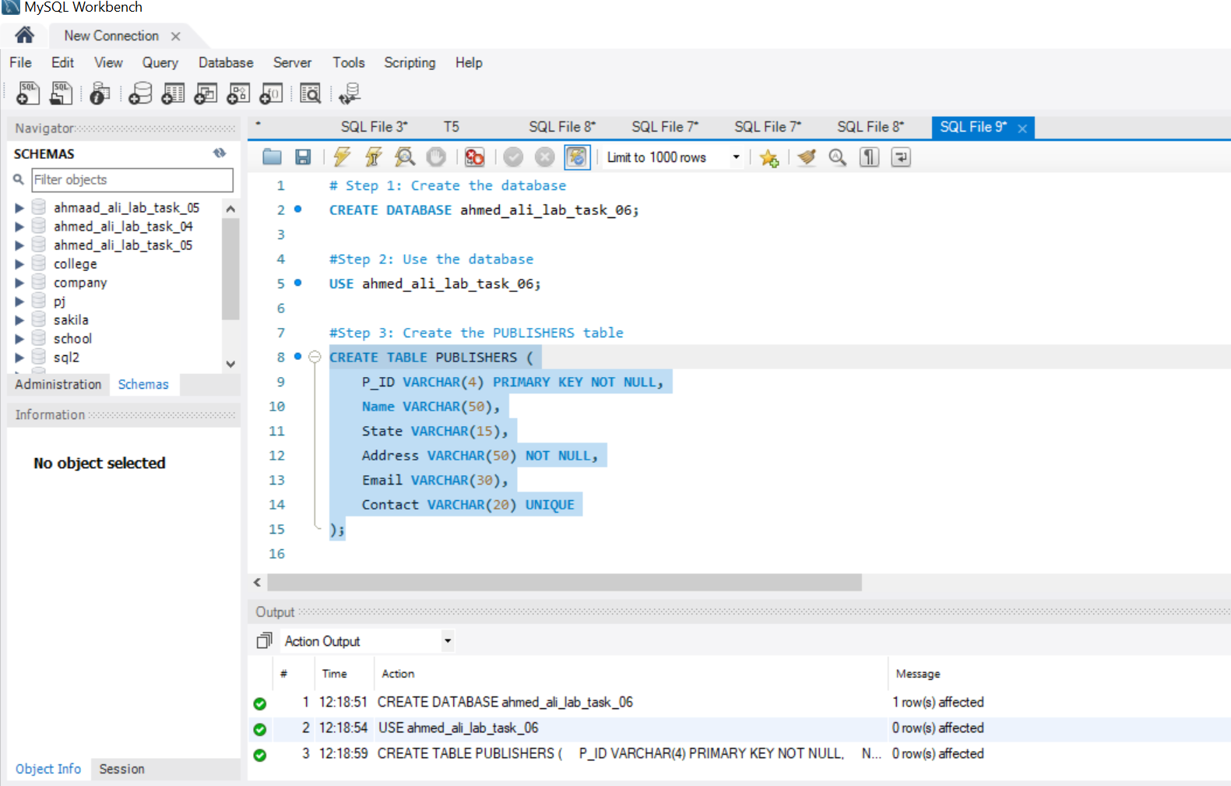

# 📝 Task 02: Data Insertion into PUBLISHERS

**Objective:** Insert valid records into the **PUBLISHERS** table using INSERT INTO.

## Instructions:

Insert the following records:

|  |  |  |  |  |  |
| --- | --- | --- | --- | --- | --- |
| **P_ID** | **Name** | **State** | **Address** | **Contact** | **Email** |
| PUB1 | Hills Publications | Georgia | 12 Park St, Atlanta | 7134019 | h_pub@hills.com |
| PUB2 | Sunshine Publishers Ltd. | New  Jersey | 45 Second St, Newark | 6548909 | NULL |
| PUB3 | Bright Publications | Hawaii | 123 Main St, Honolulu | 7678985 | bright@bp.com |
| PUB4 | Paramount Publishing House | New York | 789 Oak St, New York | 9254834 | param_house@param.com |
| PUB5 | Wesley Publications | Nevada | 456 First St, Las Vegas | 5683452 | NULL |

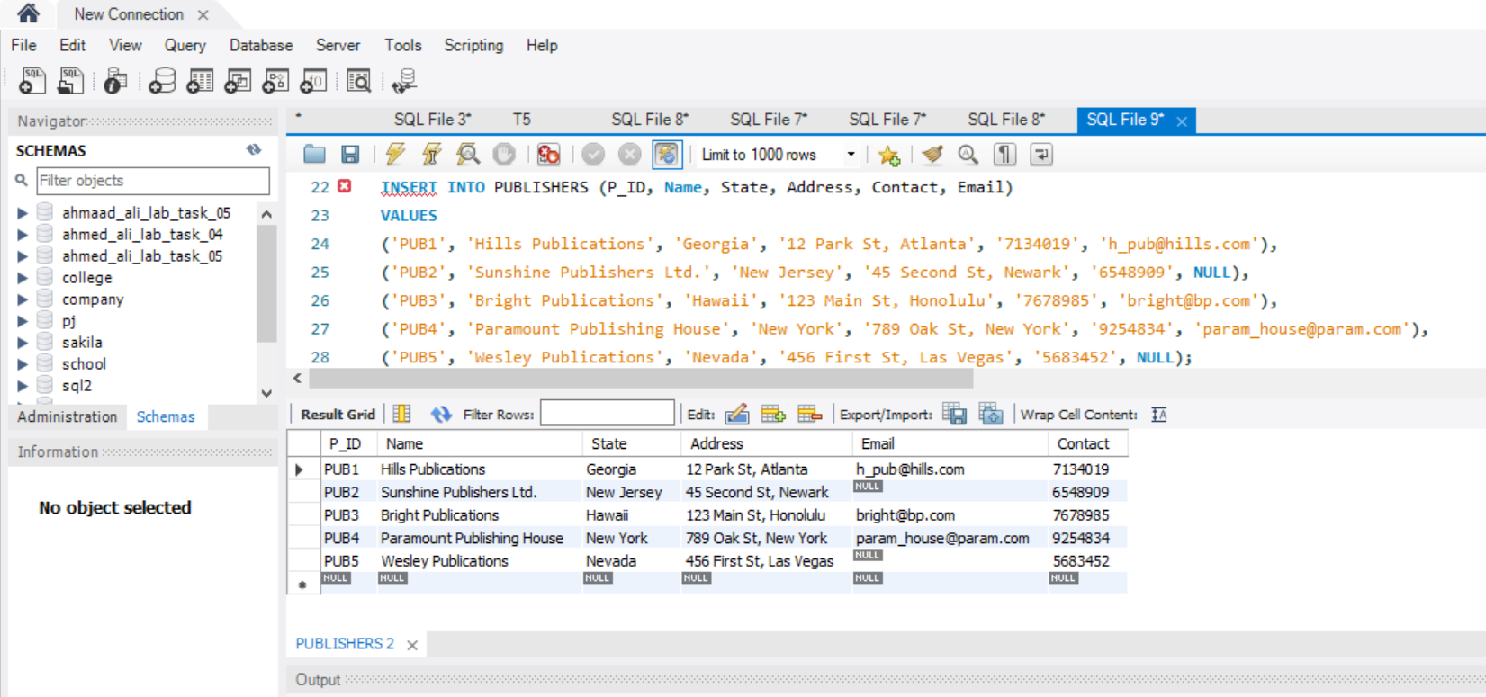

# 🔧 Task 03: Updating and Filtering PUBLISHERS Data

**Objective:** Modify existing data and retrieve specific records using UPDATE and SELECT statements.

## Instructions:

## Update the contact number of Wesley Publications to 9256774.

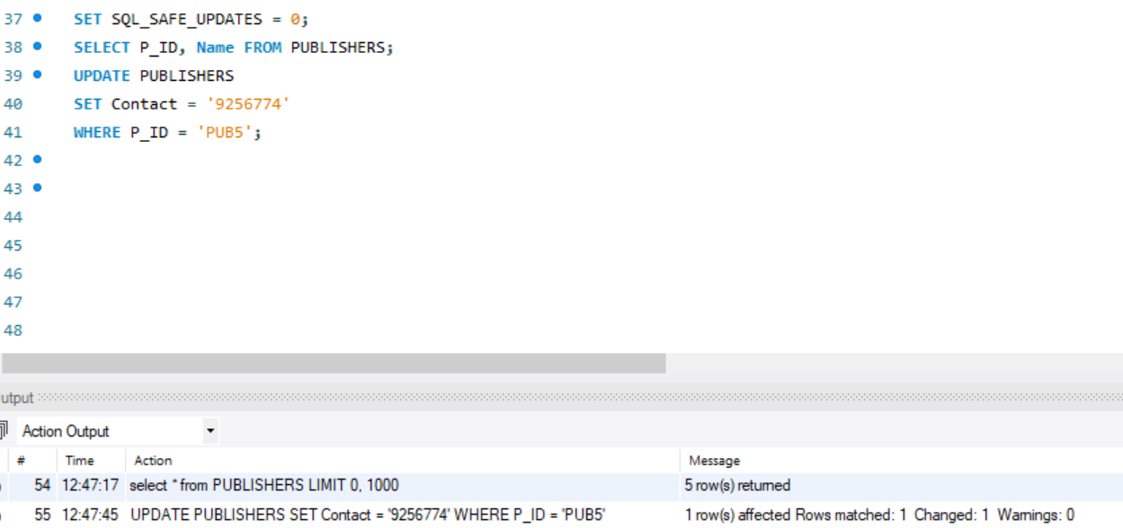

## Retrieve all publisher details where the state is Georgia.

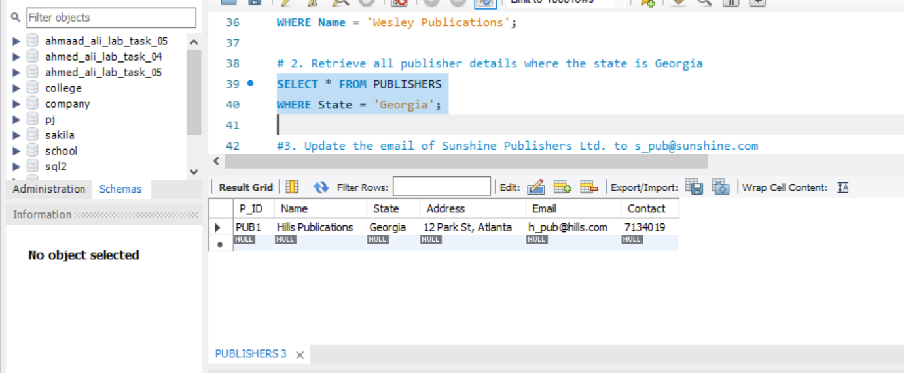

## Update the email of Sunshine Publishers Ltd. to [s_pub@sunshine.com](mailto:s_pub@sunshine.com).

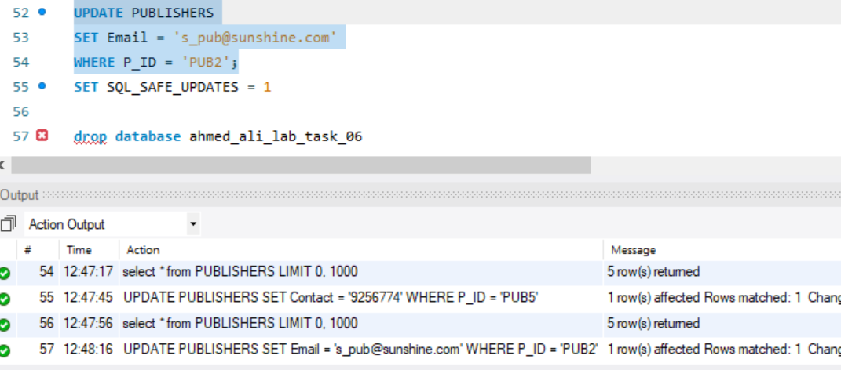

# 📗 Task 04: Creating and Populating BOOKS Table

**Objective:** Introduce a second table with a foreign key constraint and perform bulk inserts.

## Instructions:

## Create a new table named BOOKS with the following columns:

|  |  |  |  |
| --- | --- | --- | --- |
| **Column Name** | **Data Type** | **Size** | **Constraints** |
| ISBN | VARCHAR | 15 | PRIMARY KEY, UNIQUE |
| Title | VARCHAR | 50 | NOT NULL |
| Genre | VARCHAR | 20 | — |
| Pages | NUMERIC | 4 | — |
| Year_Published | NUMERIC | 4 | — |
|  |  |  |  |
| Release_Year | NUMERIC | 4 | — |
| Cost | NUMERIC | 6,2 | — |
| Publisher_ID | VARCHAR | 4 | FOREIGN KEY REFERENCES PUBLISHERS(P_ID) |

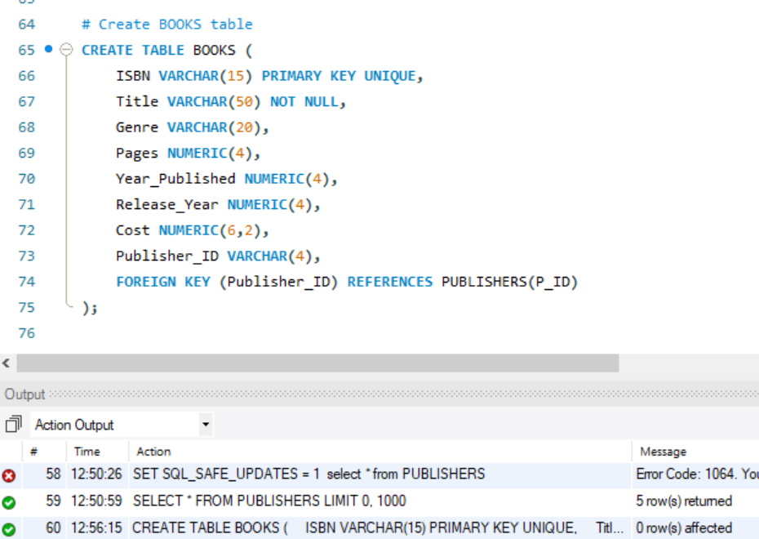

## Insert the following records into the BOOKS table:

|  |  |  |  |  |  |  |  |
| --- | --- | --- | --- | --- | --- | --- | --- |
| **ISBN** | **Title** | **Genre** | **Pages** | **Year_Published** | **Release_Year** | **Cost** | **Publisher_ID** |
| 001-354921-1 | Ransack | Fiction | 200 | 2005 | 2006 | 22 | PUB1 |
| 001-987650-5 | Differential Calculus | Academic | 450 | 2003 | 2003 | 30 | PUB1 |
| 001-987760-9 | C++ | Academic | 800 | 2004 | 2005 | 40 | PUB1 |
| 002-678880-2 | Call Away | Fiction | 200 | 2001 | 2002 | 22 | PUB2 |
| 002-678980-4 | Database Systems | Academic | 800 | 2004 | 2006 | 40 | PUB2 |
| 003-456433-6 | German Language Basics | Language | 200 | 2003 | 2004 | 22 | PUB4 |
| 003-456533-8 | French Language Guide | Language | 500 | 2005 | 2006 | 32 | PUB4 |
| 004-765359-3 | Coordinate Geometry | Academic | 650 | 2006 | 2006 | 35 | PUB3 |
| 004-765409-5 | UNIX Essentials | Academic | 550 | 2006 | 2007 | 26 | PUB3 |

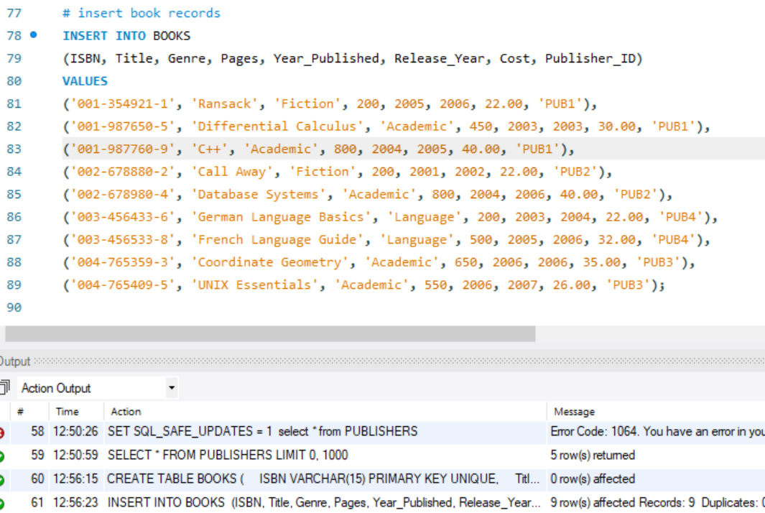

# ️ Task 05: Data Manipulation and Retrieval on BOOKS Table

**Objective:** Practice specific UPDATE, SELECT, and DELETE operations.

## Instructions:

## Change the Genre of the book titled C++ from *Academic* to *Language*.

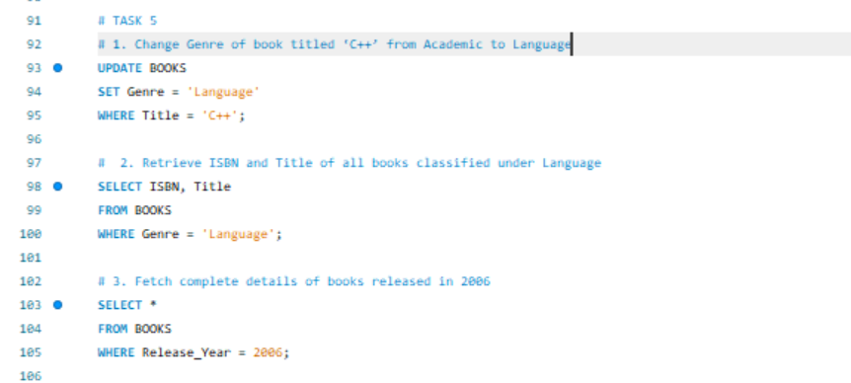

## Retrieve ISBN and Title of all books classified under *Language*.

## Fetch complete details of books released in 2006.

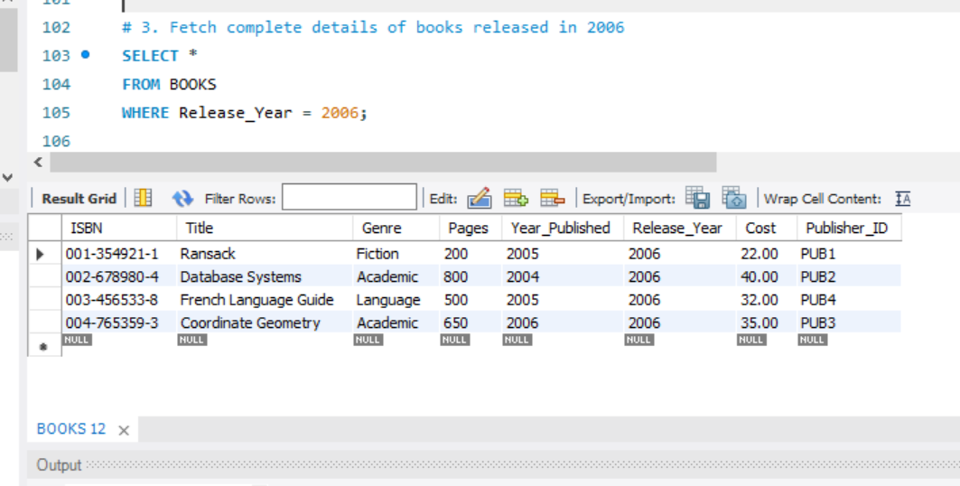

## List titles of books having less than 600 pages.

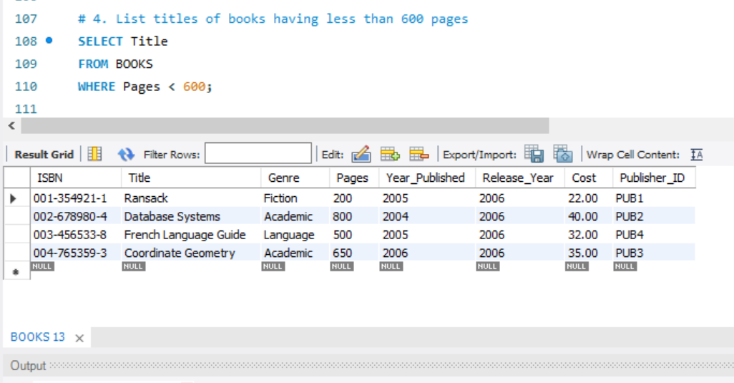

## Display all distinct genres available in the BOOKS table.

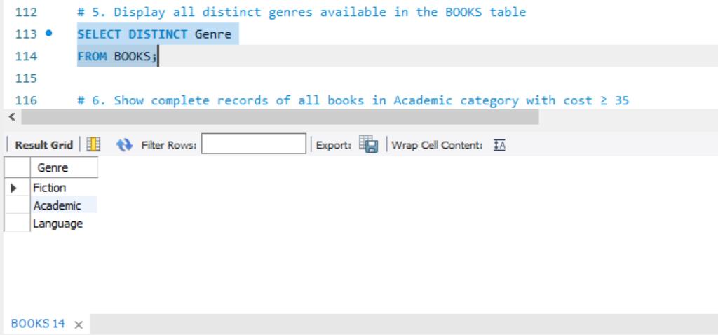

## Show complete records of all books in Academic category with a cost ≥ 35.

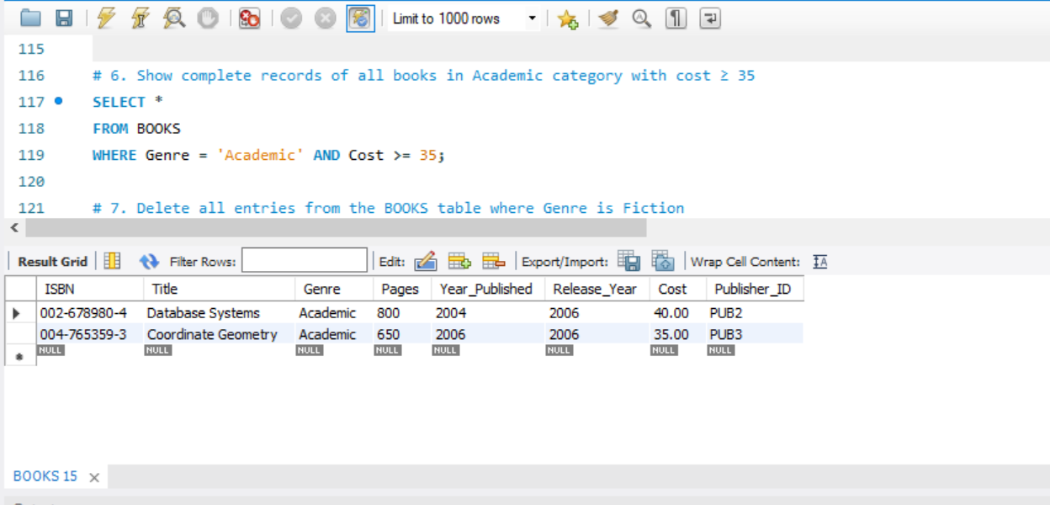

## Delete all entries from the BOOKS table where Genre is Fiction.

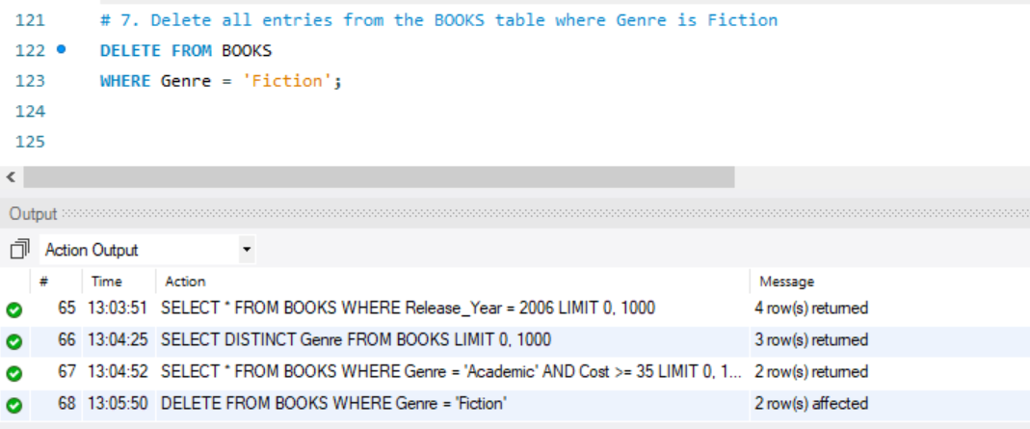

# ****Reflection and Learnings:****

During the completion of Lab Task 06, I gained practical experience with core concepts of **SQL Server database development**, including **DDL (Data Definition Language)** and **DML (Data Manipulation Language)** commands.

I started by creating a structured database using the proper naming convention and defining two related tables **PUBLISHERS** and **BOOKS**  with appropriate **constraints** like **PRIMARY KEY, NOT NULL, UNIQUE,** and **FOREIGN KEY**. This helped reinforce the importance of data integrity and relational structure in databases.

While inserting and updating data, I learned how to use the INSERT INTO, UPDATE, and SELECT statements effectively, especially with filtering conditions using WHERE. Creating relationships between tables using foreign keys also clarified how data in separate tables can be connected logically and enforced at the database level.

Moreover, I practiced advanced filtering techniques like retrieving distinct genres, applying numerical filters (**e.g., cost >= 35),** and using DELETE statements safely.

One of the challenges I faced was maintaining the correct **data types and constraints** during table creation. Another issue was ensuring the correct Publisher_ID references were used when inserting data into the BOOKS table, which required careful attention to relational integrity.

Overall, this lab enhanced my confidence in handling real-world database operations and deepened my understanding of structured database design, normalization, and relational integrity. It has prepared me well for more complex SQL queries and database projects in the future.