

**The University of Azad Jammu and Kashmir Muzaffarabad**

**Department of Software Engineering**

|  |  |
| --- | --- |
| **Name:** | **Ahmed Ali** |
| **Roll No:** | **2023-SE-41** |
| **Course Name:** | **CS – 2204 Database Systems** |
| **Instructor:** | **Engr Tahir Abbasi** |
| **Lab Task No:** | **01** |

**Lab Objective:**

The objective of this lab is to learn the working of a database. How to create and manage database using Microsoft Access Database. In this lab task I will practice.

1. Creating Database and Table with fields like Student ID, Name, Address, State etc.

2. Adding the Student record and formatting the table neatly.

3. Make a form to easily enter new data.

4. Generating a report to organize and display the student Information.

5. Creating queries to filter and find specific student details.

6. Documentation of my Lab Task.

**STEPS FOLLOWED:**

**Step 1: Creating a Database and Table Structure:**

I Created a new Microsoft Access database and defined a table with specified fields and properties.

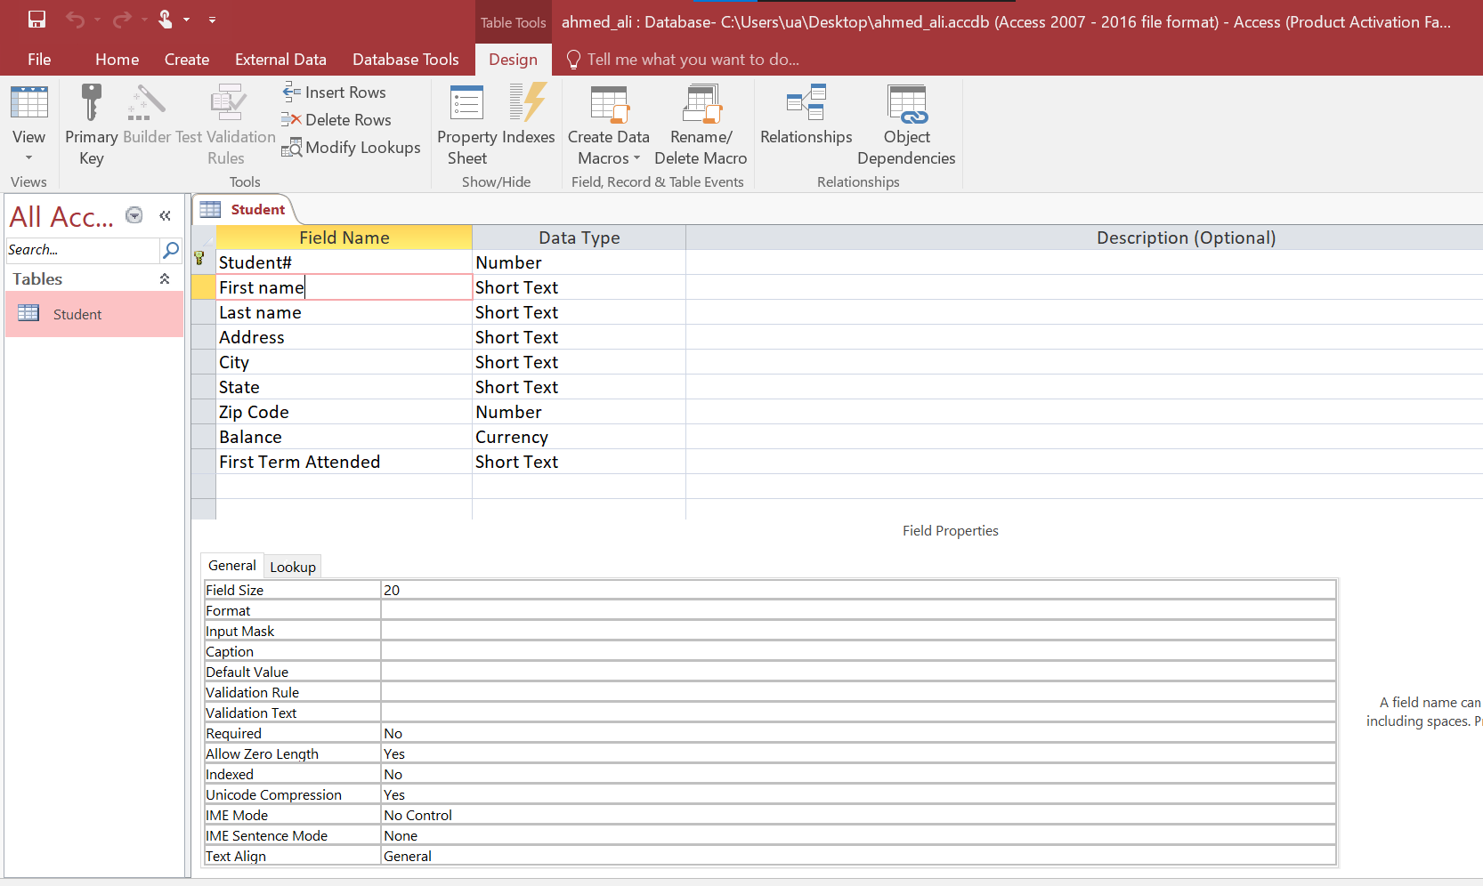

**Step 2: Entering Records in Datasheet View:**

I Entered the students records in Student Table and Viewing them.

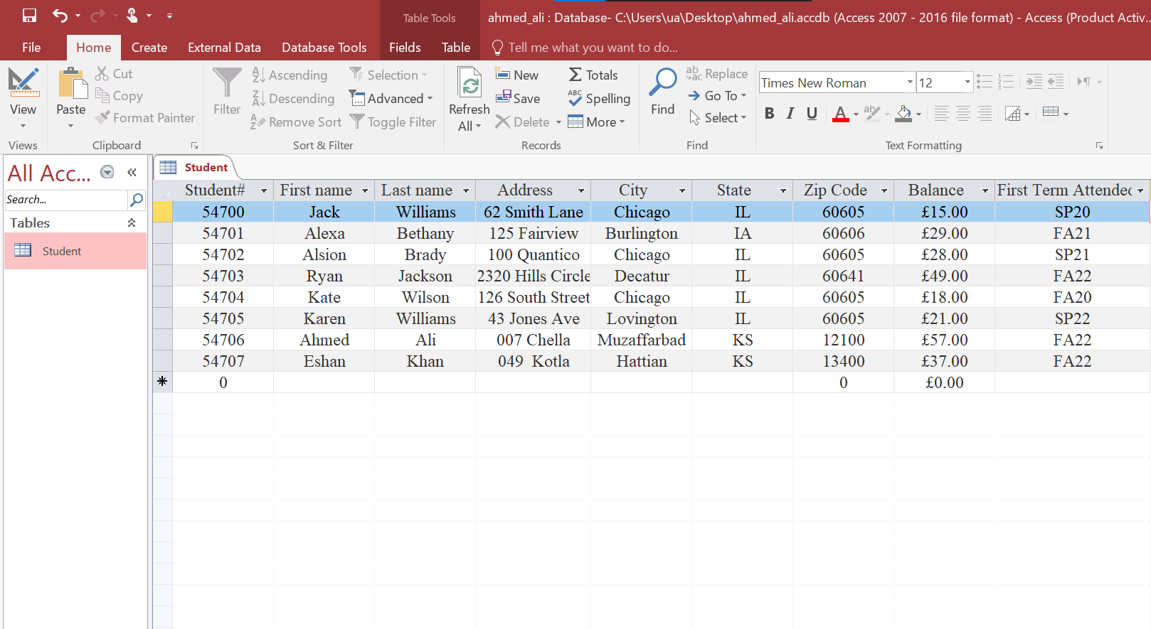

**Step 3: Creating a Form:**

I Use the Form Wizard to create a form to enter data more efficiently.

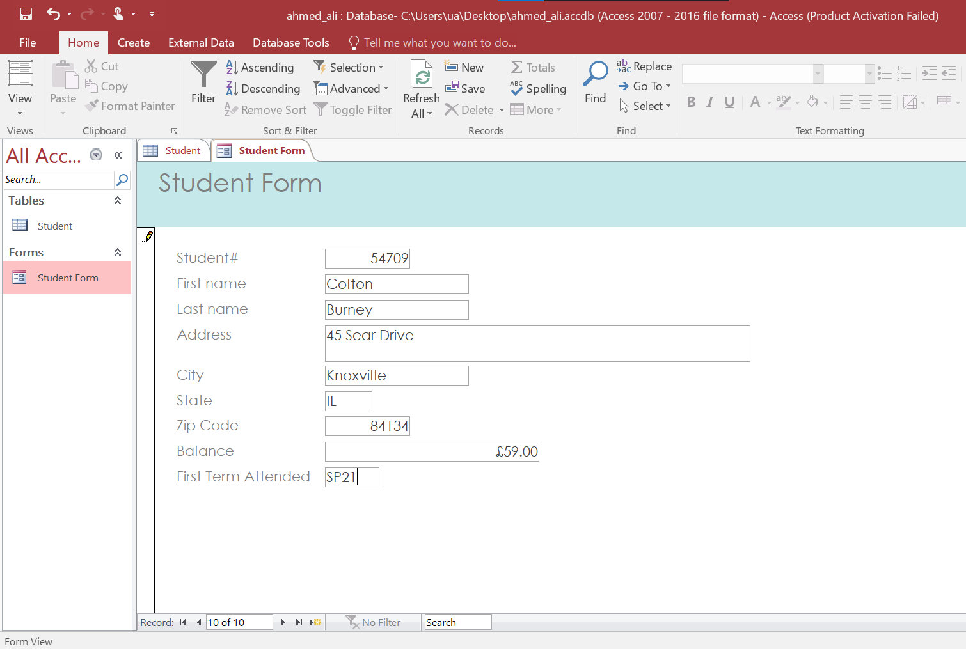

**Step 4: Creating a Report:**

I Generated a formatted report of Student Database using the Report Wizard.

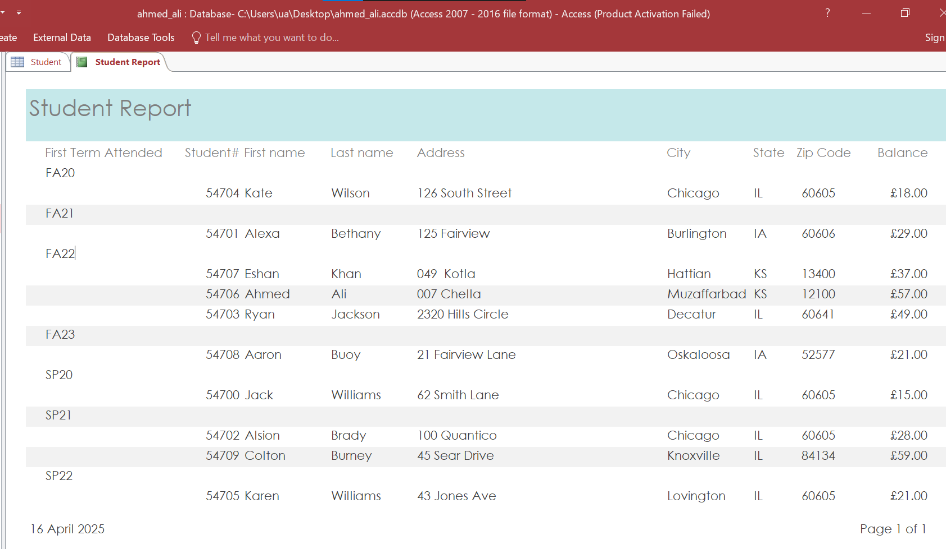

**Step 5: Creating Queries:**

I Filtered and Retrieved data using simple queries.

**Query 1** filtered students who first attended in Fall 2022 (FA22).

**Query 2** retrieved the data of students having balance greater than $30.

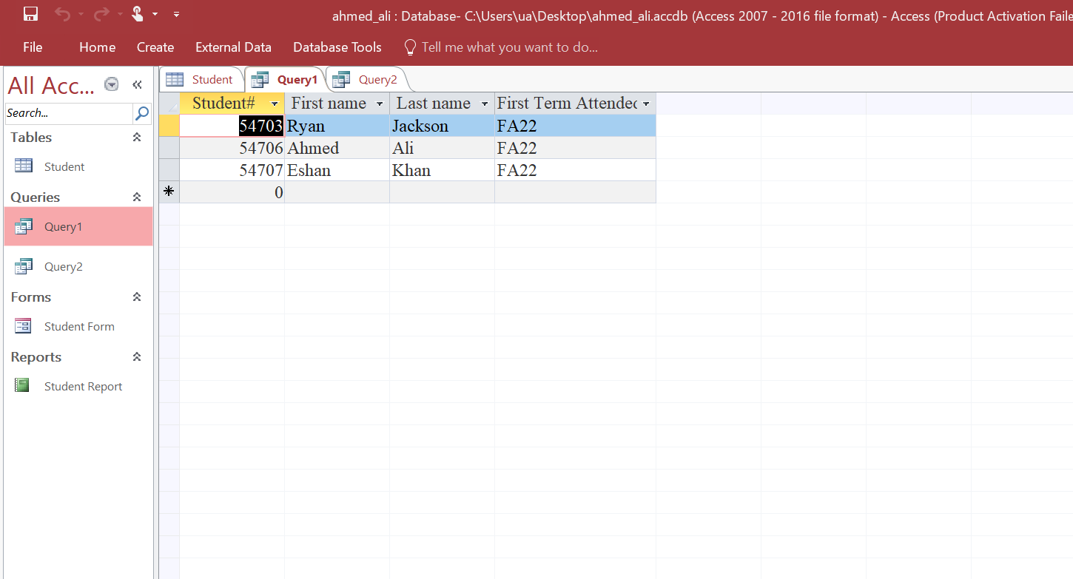

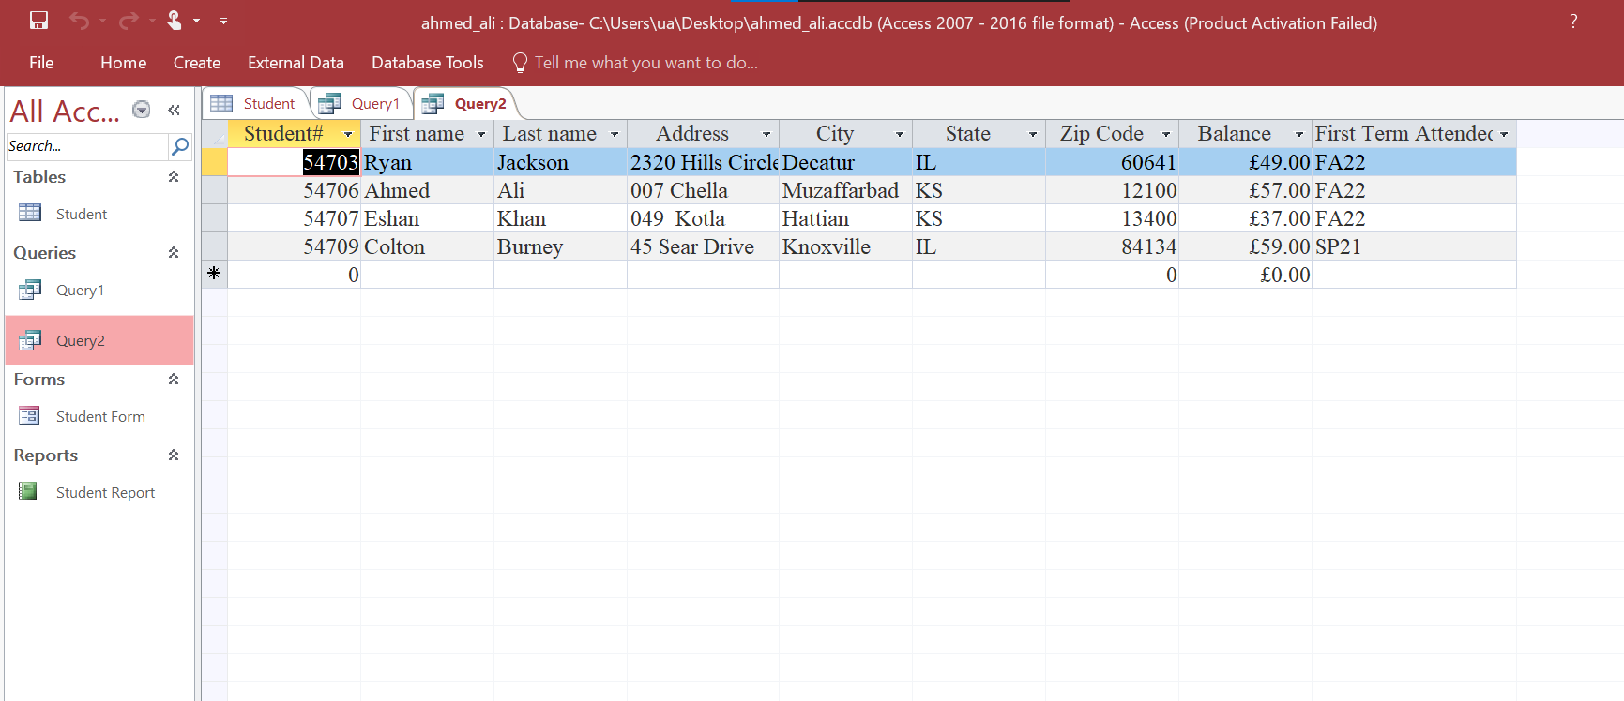

**Reflections and Learnings:**

This lab task provide a detailed introduction to Microsoft Access, covering the topics like Database Creation, Table design, Data Entry, Form and Report Creation and Query Creation. I learned:

1. **Database and Table Structure:**

I learned how to create a new database and define a Table Structure with Specific Field Properties. Setting Student# as primary Key ensured data uniqueness.

1. **Data Entry and Formatting:**

I learned regarding Entering Records in Database and formatting of data.

1. **Form and Report Creation:**

Using the Form Wizard, I created a user friendly Student Form with a columnar layout. Applying the Ion theme enhanced its appearance. The Report Wizard helped me to generate a Student Report in which the data is presented in a Decent Structure.

1. **Query Creation:**

Query 1 filtered students who first attended in Fall 2022 (FA22).

Query 2 retrieved the data of students having balance greater than $30.

**Conclusion:**

This lab strengthened my foundational MS Access skills, Data Entering in a Database and the Values of Tools like Forms Reports and Query for efficient Data management. The Hands-on Experience Boosted my confidence in Handling Real World Database Management Tasks.