**The University Of Azad Jammu & Kashmir,**

**Muzaffarabad**

**Department of Software Engineering**

**LAB TASK 05**

**Database Systems**

**Course Code**: **CS-2204**

**Submitted To:**

Engr. Tahir Jahangir

**Submitted By:**

Ahmed Ali

**Roll No:**

2023-SE-41

**Session**: 2023-2027

Contents

Lab Task – 05: SQL Server – Keys and Constraints 3

Task 01: Creating Database and Tables with Initial Constraints 3

_lab_task_05. Example: hammad_ahmed_lab_task_05 3

Task 02: Applying More Constraints Using ALTER TABLE 4

Task 03: Viewing and Describing Table Constraints 6

Task 04: Dropping Specific Constraints 7

Task 05: Managing Foreign Key Dependencies for Table Deletion 7

ERROR MESSAGE: 8

# Lab Task – 05: SQL Server – Keys and Constraints

**Objective:**

In this lab, students will work on SQL Server to understand and apply different types of keys and constraints. The focus will be on creating tables with constraints during definition and modifying tables afterward using ALTER commands. Students will also learn how to manage dependencies when deleting tables.

## Task 01: Creating Database and Tables with Initial Constraints

**Objective:** Enable students to create a database and define tables with primary key, NOT NULL, and default constraints. **Instructions:**

1. Create a new database named as your full name in all lowercase with underscores, followed by

# _lab_task_05. Example: hammad_ahmed_lab_task_05

2. Inside this database, create a table named **PUBLISHERS** with the following structure:

|  |  |  |
| --- | --- | --- |
| **Attribute** | **Data Type** | **Field Size** |
| P_ID | INT | — |
| P_Name | VARCHAR | 30 |
| Address | VARCHAR | 50 |
| State | VARCHAR | 12 |
| Phone | VARCHAR | 18 |
| Email_ID | VARCHAR | 20 |

* Set P_ID as the **Primary Key** while creating the table.
* Make sure that P_Name and Phone are **NOT NULL** while creating the table.
* Set a **DEFAULT** value of 'Unknown' for the State attribute.

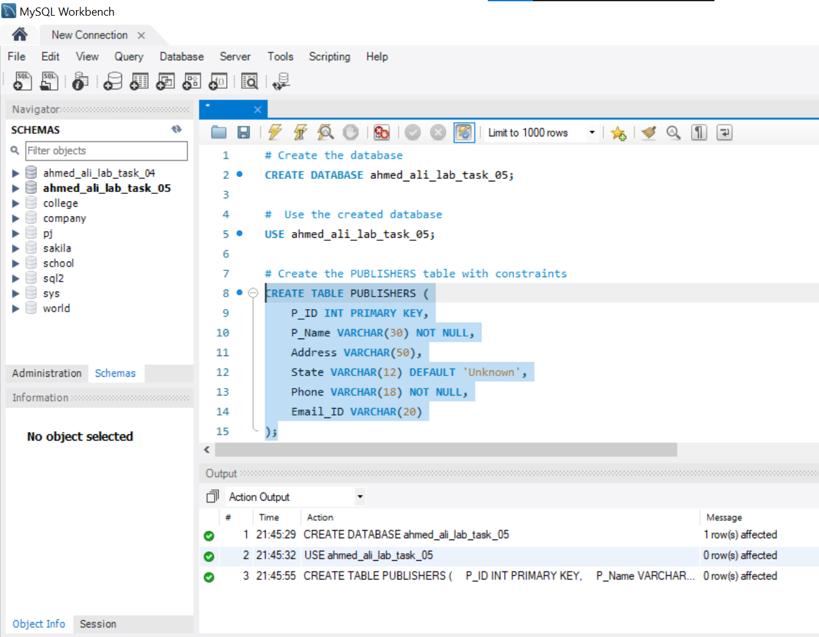

## Task 02: Applying More Constraints Using ALTER TABLE

**Objective:** Enable students to modify table structure by adding additional constraints using ALTER TABLE. **Instructions:**

1. Create a table named **BOOKS** with the following structure:

|  |  |  |
| --- | --- | --- |
| **Attribute** | **Data Type** | **Field Size** |
| ISBN | INT | — |
| Book_Title | VARCHAR | 50 |
| Category | VARCHAR | 20 |
| Price | NUMERIC | (6,2) |
| Copyright_Date | VARCHAR | 4 |
| Year | NUMERIC | 4 |
| Page_Count | NUMERIC | 4 |
| P_ID | INT | — |

* Set ISBN as the **Primary Key** while creating the table.
* Set Book_Title and P_ID as **NOT NULL** fields during creation.

2. After creating the BOOKS table:

* Add a **Foreign Key** on P_ID referencing P_ID from the PUBLISHERS table.
* Add a **CHECK Constraint** to ensure Price is greater than 20.
* Add a **UNIQUE Constraint** on Book_Title to ensure no two books have the same title.

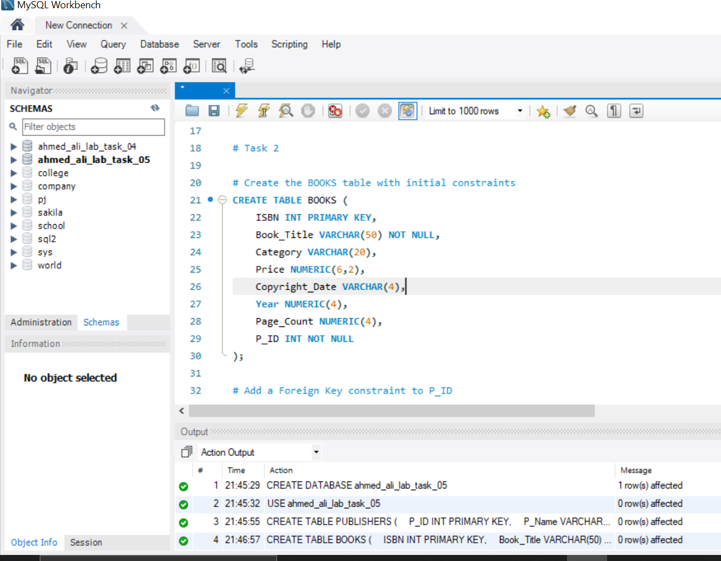

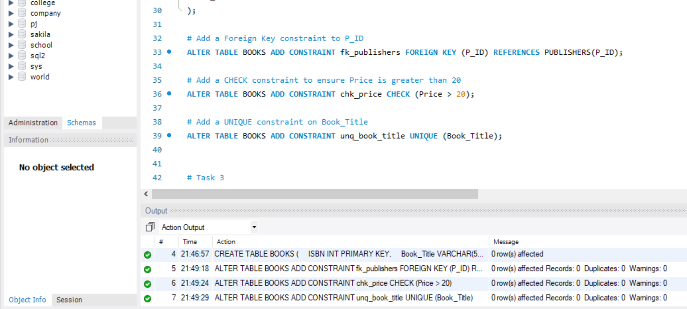

## Task 03: Viewing and Describing Table Constraints

**Objective:** Teach students how to view existing constraints and understand their structure. **Instructions:**

1. Use the SQL Server system views to list the constraints applied to both PUBLISHERS and BOOKS tables.
2. Specifically, query:
   * INFORMATION_SCHEMA.TABLE_CONSTRAINTS o INFORMATION_SCHEMA.CONSTRAINT_COLUMN_USAGE
3. Write queries that: o Display the names of all constraints on each table.
   * Display which columns are associated with which constraints.
4. Document your findings.

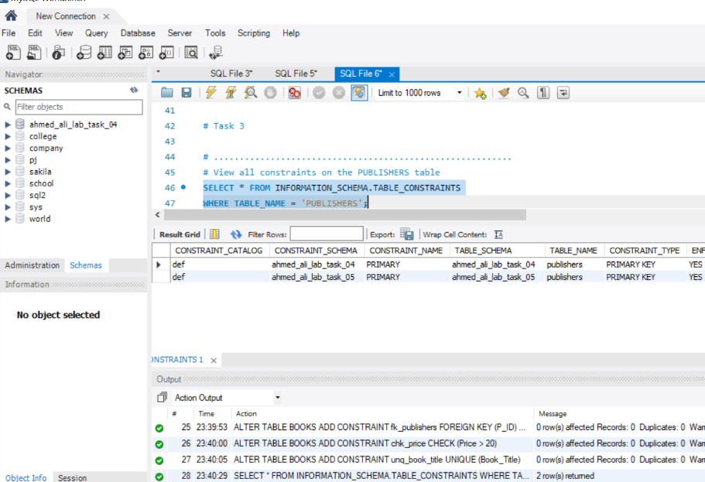

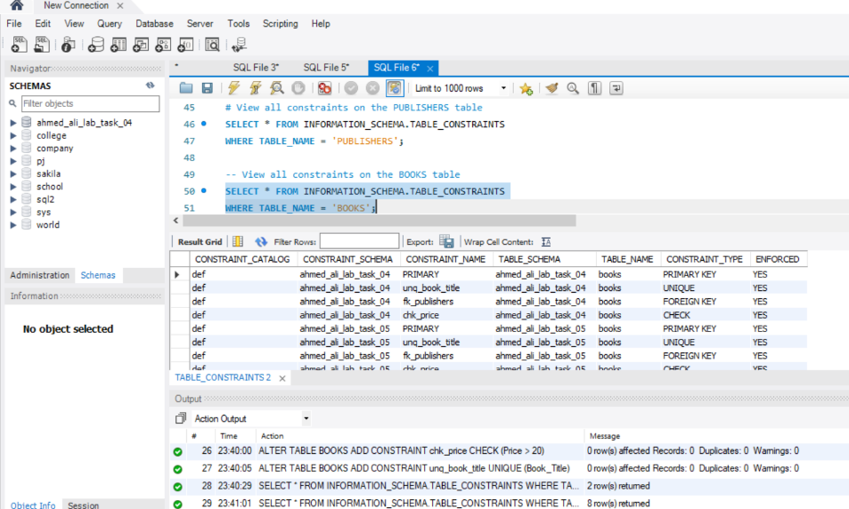

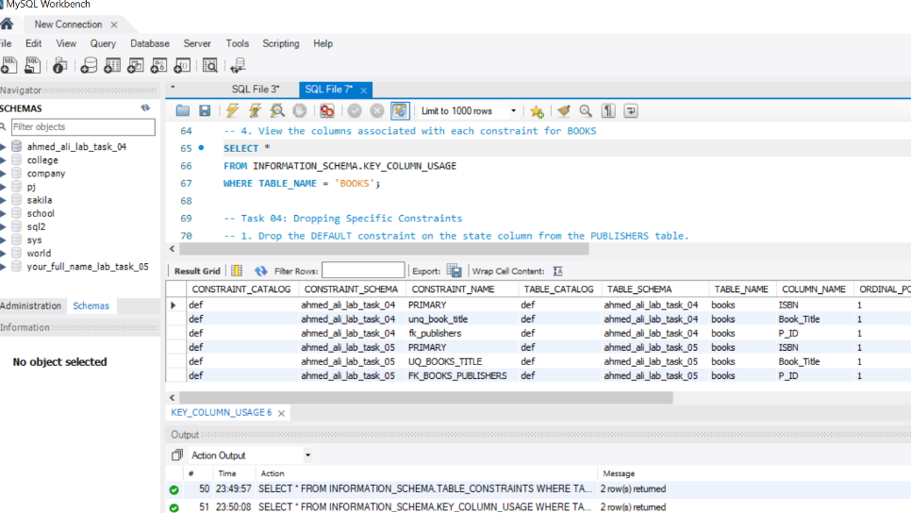

## Task 04: Dropping Specific Constraints

**Objective:** Teach students how to remove specific constraints without deleting the whole table. **Instructions:**

1. Drop the **DEFAULT constraint** on the State column from the PUBLISHERS table.
2. Drop the **CHECK constraint** applied to the Price column from the BOOKS table.
3. Make sure only the constraints are dropped, and the tables/data remain intact.

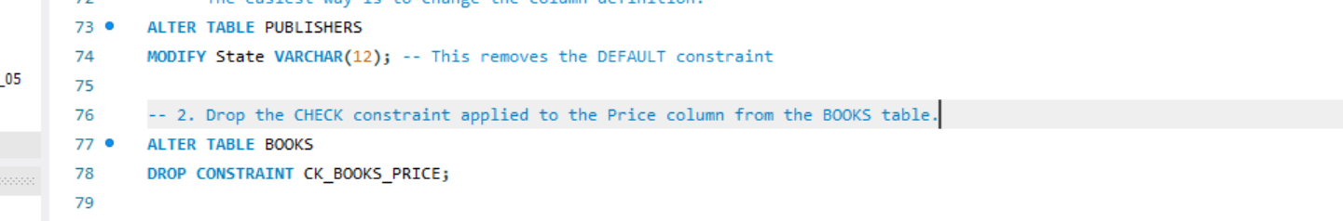

## Task 05: Managing Foreign Key Dependencies for Table Deletion

**Objective:** Teach students about foreign key dependencies and safe deletion practices. **Instructions:**

1. Attempt to delete the **PUBLISHERS** table using DROP TABLE.
2. Observe the error message related to the foreign key dependency.
3. Use ALTER TABLE to drop the **foreign key constraint** from the BOOKS table.
4. After removing the foreign key, successfully delete the PUBLISHERS table.

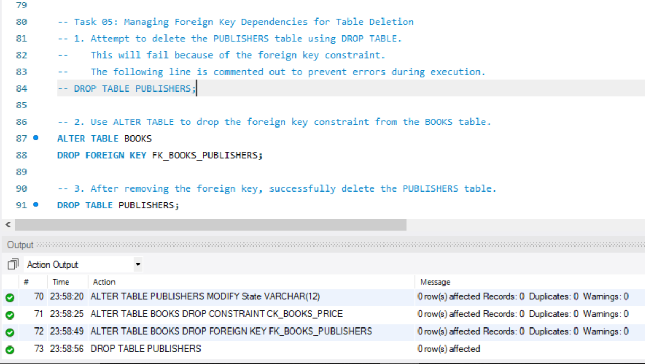

## ERROR MESSAGE:

**m**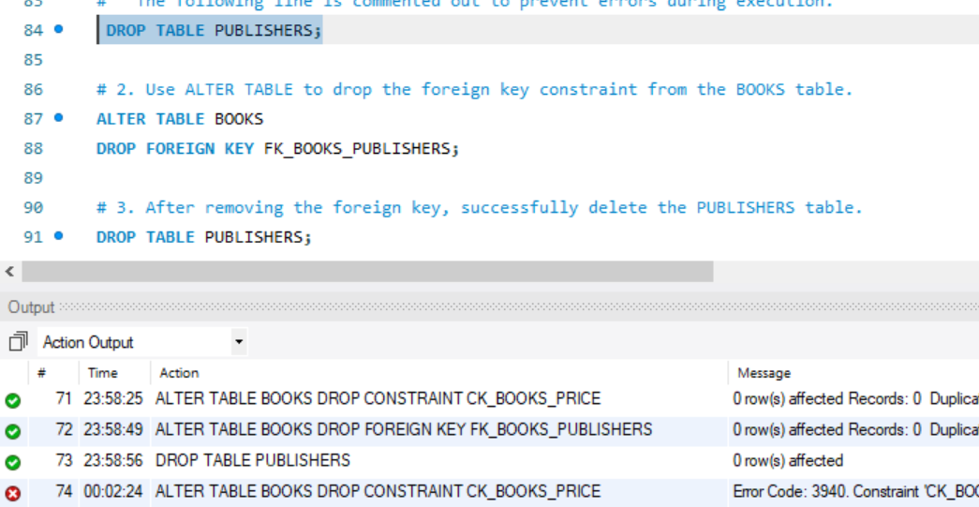

**Conclusion and Learning Outcomes:**

This lab report on SQL Server keys and constraints aimed to provide hands-on experience with database creation and modification. I learned to define tables with primary key, NOT NULL, and DEFAULT constraints during initial table creation. Subsequently, the lab focused on using ALTER TABLE commands to add foreign key, CHECK, and UNIQUE constraints. A key learning outcome was understanding how to view existing constraints using SQL Server system views, specifically INFORMATION_SCHEMA.TABLE_CONSTRAINTS and INFORMATION_SCHEMA.CONSTRAINT_COLUMN_USAGE. Furthermore, the lab taught me how to drop specific constraints without affecting table data and, importantly, how to manage foreign key dependencies to safely delete tables. Overall, I gained practical skills in defining, modifying, and managing database integrity through various SQL constraints.

**....................................................................**