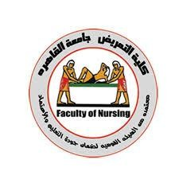
Inadequate Patient Education at
Discharge and Its Impact on
Readmission Rates


Under Supervision of

D/ ahmed
Abdelrahman

DIV(2)
Cairo university faculty of nursing
2025/2026

Student Names

ساره حسين عثمان | سعيد فؤاد سعيد
الوليد عل ي | قصي امير النور عابدي ن
شهد اشرف جمعه | ريم حسن رجب محمد
اسلام احمد محمد | زينب علاء الدين محمد

Objectives of the Study

- To define the concept of patient education and explain its importance in improving healthcare quality and patient outcomes.
- To examine the problem of inadequate patient education at discharge, including its main causes and contributing factors.
- To analyze the relationship between inadequate patient education and hospital readmission rates, highlighting its impact on patient safety and healthcare costs.
- To explore and compare different theoretical frameworks related to patient education, such as the Health Belief Model and Social Cognitive Theory.
- To evaluate the effectiveness of current patient education strategies used in healthcare settings.
- To identify real-world examples of successful patient education interventions that reduce readmission rates.
- To propose evidence-based recommendations for improving patient education at discharge.
- To assess the role of healthcare providers in delivering effective patient education and ensuring patient understanding.
- To emphasize the importance of a patient-centered approach in enhancing education and promoting better health outcomes.
- To highlight future directions for research in the field of patient education and discharge planning.

outlines

1. Introduction to Patient Education ................................................................................... 2. The Problem of Inadequate Patient Education at Discharge .......................................... 3. Theoretical Frameworks Related to Patient Education ................................................... 4. Analysis of the Impact of Inadequate Patient Education on Readmission Rates ........... 5. Critical Evaluation of Competing Theoretical Frameworks ........................................... 6. Real-World Examples of Effective Patient Education Strategies ................................... 7. Recommendations for Improving Patient Education at Discharge ................................. 8. Implementation and Evaluation of Patient Education Interventions .............................. 9. The Role of Healthcare Providers in Patient Education ................................................. 10. Patient-Centered Approach to Patient Education ......................................................... 11. Future Directions for Patient Education Research ........................................................ 12. Conclusion .................................................................................................................... 13. References .....................................................................................................................

Introduction to Patient Education

Patient education is a fundamental component of modern healthcare that focuses on empowering individuals with the knowledge, skills, and confidence needed to manage their health effectively. It involves providing patients and their families with clear, accurate, and relevant information about diseases, treatments, medications, and lifestyle modifications. Effective patient education enhances understanding, promotes adherence to treatment plans, reduces complications, and improves overall health outcomes. It is a collaborative process that requires healthcare providers to consider the patient’s cultural background, literacy level, and individual needs to ensure that the information is meaningful and applicable. Ultimately, patient education supports patient autonomy, encourages informed decision-making, and plays a vital role in achieving high quality, patient-centered care.
Definition of Patient Education



Patient education is a vital component of healthcare that encompasses the process of informing and instructing patients about their health conditions, treatment options, and self-care practices. Effective patient education empowers individuals to
manage their health, adhere to treatment plans, and make informed
decisions. Theoretical frameworks, such as health literacy and social cognitive theory, underpin patient education, highlighting its significance in promoting healthcare quality improvement. By imparting knowledge and skills, patient education can mitigate the risk of readmission, ultimately reducing healthcare costs and enhancing patient outcomes, making it a crucial aspect of discharge planning.

Importance of Patient Education in Healthcare

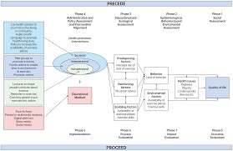
The importance of patient education in healthcare cannot be overstated, as it plays a pivotal role in empowering individuals to manage their health effectively. Patient education is a crucial aspect of healthcare quality improvement, enabling patients to make informed decisions about their care and adhere to treatment plans. Inadequate patient education at discharge can have significant consequences, including increased readmission rates, highlighting the need for effective educational strategies. By examining theoretical frameworks and real-world examples,


it becomes evident that patient education is essential for promoting positive health outcomes and reducing healthcare costs, ultimately improving the overall quality of care.

Current State of Patient Education in Hospitals
The current state of patient education in hospitals is a critical aspect of healthcare quality improvement. Effective patient education is essential for empowering individuals to manage their health and prevent readmissions. Inadequate patient education at discharge can lead to poor health outcomes and increased readmission rates, emphasizing the need for robust educational programs. Theoretical frameworks, such as health literacy and self-efficacy, underpin patient education, highlighting the importance of clear communication and patient-centered approaches. By prioritizing patient education, healthcare providers can improve patient outcomes ,reduce readmissions, and enhance overall healthcare quality.

The Problem of Inadequate Patient Education at Discharge

Causes of Inadequate Patient Education at Discharge


Inadequate patient education at discharge is a pervasive issue that contributes significantly to increased readmission rates. The causes of this inadequacy are multifaceted, stemming from various factors including insufficient time allocated to patient education, inadequate training of healthcare professionals, and the complexity of medical information being conveyed.


Furthermore, the lack of standardized educational protocols and limited availability of resources also hinder the delivery of effective patient education. As a result, patients are often discharged without a comprehensive understanding of their condition, treatment regimen, and self-care requirements, ultimately leading to poor health outcomes and increased likelihood of hospital readmission.

Consequences of Inadequate Patient Education
The consequences of inadequate patient education at discharge are multifaceted and far-reaching, ultimately compromising the quality of care and patient outcomes. When patients are not adequately informed about their
condition, treatment, and self-care, they are
more likely to experience adverse events, medication errors, and poor health outcomes. This lack of knowledge can lead to decreased adherence to treatment plans, resulting in increased readmission rates and heightened healthcare utilization. Theoretical frameworks, such as the Health Belief Model, suggest that patients' understanding of their health condition and treatment is a critical determinant of their ability to manage their health effectively. Inadequate patient education can also lead to increased healthcare costs, decreased patient satisfaction, and diminished overall healthcare quality. Furthermore, real-world examples have consistently shown that hospitals with poor patient education programs tend to have higher readmission rates, underscoring the need for effective patient education strategies to improve healthcare quality and reduce readmission rates.

Statistics on Readmission Rates Due to Inadequate Patient Education

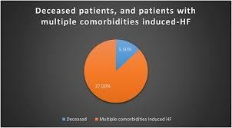
The problem of inadequate patient education at discharge is a pervasive issue that has significant implications for healthcare quality improvement. Statistics on readmission rates due to inadequate patient education reveal a disturbing trend, with numerous studies indicating that a substantial proportion of patients are readmitted to hospitals due to a lack of understanding about their condition, treatment, and self-care. This phenomenon is often attributed to insufficient education and
support provided to patients at the time of discharge, leaving them ill-equipped to manage their health effectively. Theoretical frameworks, such as the Health Belief Model, suggest that patients' knowledge, attitudes, and behaviors play a critical role in determining their ability to adhere to treatment plans and prevent complications. As a result, inadequate patient education at discharge can lead to increased readmission rates, prolonged hospital stays, and elevated healthcare costs, ultimately compromising the quality and safety of patient care.

Theoretical Frameworks Related to Patient Education

Health Belief Model

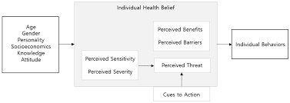
The Health Belief Model is a pivotal theoretical framework that underpins patient education, particularly in the context of discharge and readmission rates. This model posits that individuals' health behaviors are influenced by their perceptions of susceptibility, severity, benefits, and barriers associated with a particular health condition. In the realm of patient education, the Health Belief Model
suggests that patients are more likely to adhere to treatment regimens and self-care recommendations if they perceive themselves as vulnerable to complications and believe that the benefits of adherence outweigh the costs. For instance, a patient with diabetes who understands the severity of potential complications, such as kidney disease or blindness, may be more motivated to manage their blood sugar levels and adhere to medication regimens. Conversely, inadequate patient education at discharge can lead to misconceptions about the severity of a condition or the importance of treatment, ultimately contributing to poor health outcomes and increased readmission rates. By incorporating the Health Belief Model into patient education strategies, healthcare providers can tailor their teaching to address patients' unique concerns and perceptions, thereby enhancing the effectiveness of educational interventions and promoting better health outcomes. Effective application of this model can ultimately contribute to improved healthcare quality and reduced readmission rates.

Social Cognitive Theory
Within the context of patient education, Social Cognitive Theory emerges as a pivotal framework for understanding the complex dynamics at play. This theoretical paradigm, developed by Albert Bandura, posits that learning occurs through observation, imitation, and reinforcement, with individuals actively constructing their own knowledge and behaviors. In the realm of patient education, Social Cognitive Theory suggests that patients learn by observing healthcare providers, imitating their behaviors, and receiving reinforcement for adopting healthy habits. For instance, a patient who observes a nurse demonstrating proper wound care techniques is more likely to adopt these practices themselves,

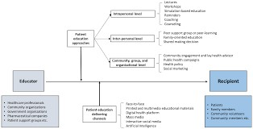
thereby reducing the risk of complications and readmissions. Furthermore, this theory highlights the importance of self-efficacy, or an individual's confidence in their ability to perform a particular behavior, in predicting health outcomes. By recognizing the interplay between personal factors, behavioral patterns, and environmental influences, healthcare providers can design patient education programs that foster a sense of self-efficacy and promote lasting behavioral change, ultimately contributing to improved healthcare quality and reduced readmission rates. By examining the tenets of Social Cognitive Theory, healthcare professionals can develop more effective patient education strategies, tailored to the unique needs and circumstances of their patients.

Self-Efficacy Theory

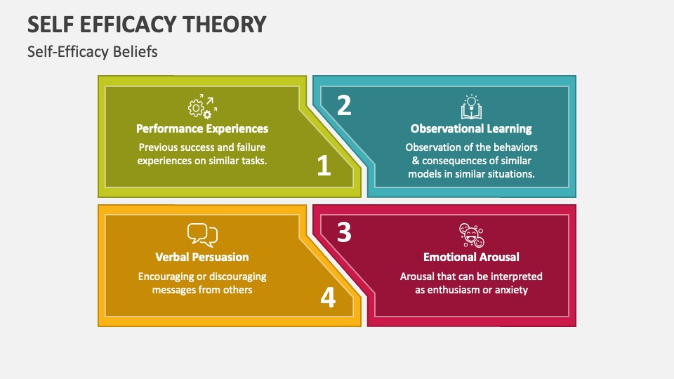
Within the realm of patient education, Self-Efficacy Theory emerges as a pivotal framework in understanding the intricacies of patient engagement and empowerment. This theoretical paradigm, initially posited by Albert Bandura, suggests that an individual's belief in their ability to execute a specific task or behavior is a primary determinant of their actual performance. In the context of patient education, Self-Efficacy Theory implies that patients who possess a strong sense of self-efficacy are more likely to adhere to prescribed treatment regimens, manage their conditions effectively, and ultimately, reduce their likelihood of
hospital readmission. For instance, patients with chronic illnesses such as diabetes or heart failure, who receive comprehensive education and support, are more confident in their ability to manage their conditions, leading to improved health outcomes and reduced readmission rates. The application of Self-Efficacy Theory in patient education underscores the importance of tailoring educational interventions to foster a sense of competence and confidence among patients, thereby enhancing their capacity for self-care and disease management. By recognizing the role of selfefficacy in patient education, healthcare providers can develop targeted strategies to promote patient empowerment, ultimately contributing to improved healthcare quality and reduced readmission rates. Effective implementation of this theory can have a profound impact on patient outcomes, highlighting the need for further exploration of its applications in patient education.

Analysis of the Impact of Inadequate Patient Education on Readmission Rates

Quantitative Analysis of Readmission Rates

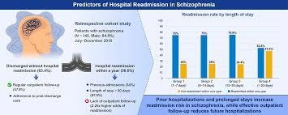
The quantitative analysis of readmission rates is a crucial aspect of examining the impact of inadequate patient education on healthcare outcomes. By employing statistical methods to analyze data on patient readmissions, researchers can identify significant correlations between the quality of patient education and the likelihood of hospital readmission. This analysis is grounded in theoretical frameworks that emphasize the importance of patient education in promoting self-care and managing chronic conditions. For instance, the Health Belief Model suggests that patients who are well-informed about their
conditions and treatment plans are more likely to adhere to prescribed regimens, thereby reducing the risk of readmission. In contrast, inadequate patient education can lead to misunderstandings about medication management, follow-up appointments, and symptom recognition, ultimately resulting in increased readmission rates. A review of existing literature reveals that hospitals with robust patient education programs tend to have lower readmission rates compared to those with inadequate educational resources. Furthermore, studies have demonstrated that targeted interventions, such as personalized discharge instructions and post-discharge follow-up calls, can significantly reduce readmission rates among patients with complex conditions. By quantitatively analyzing the relationship between patient education and readmission rates, healthcare providers can identify areas for quality improvement and develop evidence-based strategies to enhance patient education, ultimately leading to better health outcomes and reduced healthcare costs. Ultimately, this research aims to contribute to the development of effective patient education programs that improve healthcare quality and reduce the economic burden of hospital readmissions.

Qualitative Analysis of Patient Experiences

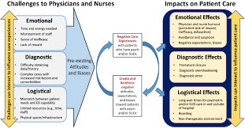
The qualitative analysis of patient experiences is a crucial component in understanding the impact of inadequate patient education on readmission rates. This approach involves examining the subjective experiences and perceptions of patients who have been discharged from healthcare facilities, with a particular focus on the educational support they received during their stay. By adopting a qualitative framework, researchers can gain a deeper understanding of the ways in which patients navigate the healthcare system and the challenges they face in managing their conditions after discharge. Theoretical frameworks, such as the Health Belief Model and Social Cognitive Theory, provide a foundation for analyzing the complex relationships between patient
education, health outcomes, and readmission rates. For instance, a study on patients with chronic conditions found that those who received inadequate education on self-care and medication management were more likely to experience complications and require readmission. The qualitative analysis revealed that patients who felt empowered and informed about their care were better equipped to manage their conditions and avoid unnecessary hospitalizations. Furthermore, the analysis highlighted the importance of effective communication and patient-centered care in reducing readmission rates. By exploring the experiences and perspectives of patients, healthcare providers can identify areas for improvement and develop targeted interventions to enhance patient education and reduce readmission rates, ultimately contributing to improved healthcare quality and patient outcomes. Ultimately, the qualitative analysis of patient experiences provides valuable insights into the complex dynamics of patient education and readmission rates, informing the development of evidence-based strategies for healthcare quality improvement.

Comparison of Readmission Rates Across Different Patient Populations
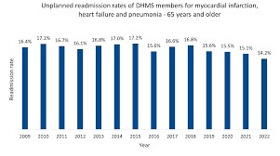
In examining the relationship between inadequate patient education and readmission rates, a crucial aspect to consider is the comparison of readmission rates across different patient populations. This analysis is essential in understanding the far-reaching implications of ineffective patient education at discharge, as it can lead to increased hospital readmissions, thereby compromising healthcare quality improvement efforts. Theoretical frameworks, such as the Health Belief Model and Social Cognitive Theory, provide a foundation for comprehending the complex dynamics at play, highlighting the significance of patient education in facilitating
informed decision-making and self-management of health conditions. By scrutinizing readmission rates among diverse patient groups, including those with chronic conditions, such as diabetes and heart failure, as well as those undergoing surgical procedures, researchers can identify patterns and trends that underscore the importance of tailored patient education. For instance, studies have consistently shown that patients with limited health literacy are more likely to experience readmission, emphasizing the need for targeted educational interventions that cater to the unique needs of these individuals. Furthermore, the analysis of readmission rates across different patient populations can inform the development of evidence-based strategies for improving patient education, ultimately reducing readmission rates and enhancing overall healthcare outcomes. By adopting a patient-centered approach to education, healthcare providers can empower patients with the knowledge and skills necessary to navigate their care effectively, thereby mitigating the risk of readmission and promoting optimal health outcomes. Through this comparative analysis, researchers can gain valuable insights into the relationship between patient education and readmission rates, ultimately informing quality improvement initiatives aimed at enhancing patient care and reducing healthcare costs.

Critical Evaluation of Competing Theoretical Frameworks

Strengths and Limitations of the Health Belief Model


The Health Belief Model is a prominent theoretical framework utilized to understand the factors influencing patient behavior and adherence to treatment plans. Within the context of inadequate patient education at discharge and its impact on readmission rates, the Health Belief Model offers valuable insights into the cognitive processes underlying patient decision-making. A key strength of this model lies in its emphasis on the role of perceived susceptibility, severity, benefits, and barriers in shaping patient health behaviors. For instance, patients who perceive themselves as susceptible to a particular health condition may be more likely to adhere to prescribed treatment plans, thereby reducing the likelihood of readmission. However,
the Health Belief Model also has several limitations, including its oversimplification of complex health behaviors and failure to account for external factors such as socioeconomic status and access to healthcare resources. Moreover, the model's focus on individual-level factors may overlook the significant impact of systemic and environmental factors on patient education and health outcomes. Despite these limitations, the Health Belief Model remains a useful framework for understanding the psychological factors influencing patient behavior, and its application can inform the development of targeted patient education interventions aimed at reducing readmission rates and improving overall healthcare quality.

Strengths and Limitations of Social Cognitive Theory

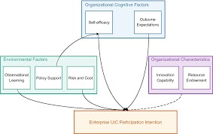
In the context of inadequate patient education at discharge and its impact on readmission rates, Social Cognitive Theory emerges as a significant theoretical framework warranting critical evaluation. This theory posits that learning occurs through observation, imitation, and modeling, suggesting that patients' behaviors and health outcomes are influenced by their observations of and interactions with healthcare providers. A key strength of Social Cognitive Theory lies in its emphasis on the reciprocal relationship between personal factors, behavioral factors, and environmental factors, providing a comprehensive understanding of the

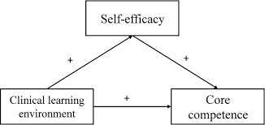
complex dynamics at play in patient education. However, a notable limitation of this theory is its assumption that patients possess the cognitive capacity and motivation to process and act upon the information provided, which may not always be the case, particularly among patients with limited health literacy or those experiencing cognitive impairments. Furthermore, Social Cognitive Theory may overlook the role of systemic barriers, such as inadequate healthcare resources or inefficient discharge processes, in hindering effective patient education. Despite these limitations, Social Cognitive Theory remains a valuable framework for understanding the intricacies of patient education, highlighting the need for healthcare providers to adopt a patient-centered approach that takes into account the unique needs and circumstances of each individual.

Strengths and Limitations of SelfEfficacy Theory
The self-efficacy theory is a prominent framework utilized to understand the impact of patient education on healthcare outcomes, including readmission rates. A critical evaluation of this theory reveals both strengths and limitations. On one hand, self-
efficacy theory provides a valuable foundation for understanding how patients' confidence in managing their health influences their ability to adhere to treatment plans and make informed decisions. For instance, patients with high self-efficacy are more likely to engage in healthy behaviors, such as medication adherence and follow-up appointments, thereby reducing the likelihood of readmission. On the other hand, the theory has limitations, as it primarily focuses on individual patient factors, neglecting the role of systemic and environmental factors that can affect patient education and health outcomes. Furthermore, self-efficacy theory may not fully account for the complexities of healthcare systems and the varying levels of health literacy among patients. Therefore, while self-efficacy theory offers valuable insights into the importance of patient education, its limitations highlight the need for a more comprehensive framework that incorporates multiple factors, including healthcare provider communication, hospital discharge processes, and community support systems, to effectively address inadequate patient education and reduce readmission rates.


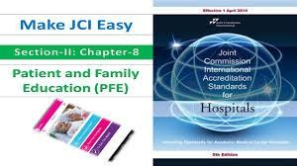
Real-World Examples of Effective Patient Education Strategies

Example 1: Patient Education Program at a Large Hospital

In the realm of healthcare quality improvement, the implementation of effective patient education strategies is paramount in reducing readmission rates. A notable example of this can be observed in the patient education program at a large hospital, where a comprehensive approach to patient education has yielded significant results. This program, grounded in theoretical frameworks that emphasize patient-centered care, entails a multidisciplinary team of healthcare professionals who work in tandem to provide patients with personalized education and support. Through the use of clear, accessible
language and tailored instructional materials, patients are empowered with the knowledge and skills necessary to manage their conditions effectively upon discharge. As a consequence, the hospital has witnessed a marked decline in readmission rates, underscoring the efficacy of this patient education program in enhancing healthcare outcomes and promoting high-quality patient care. By adopting such evidence-based strategies, healthcare institutions can mitigate the likelihood of readmission and foster improved patient outcomes.

Example 2: Community-Based Patient Education Initiative


The Community-Based Patient Education Initiative exemplifies a successful approach to mitigating inadequate patient education at discharge and its subsequent impact on readmission rates. This initiative entails collaborative efforts between healthcare providers, community organizations, and patients to design and implement tailored education programs. By leveraging theoretical frameworks that emphasize patient-centered care and health literacy, this initiative empowers patients with the knowledge and skills necessary to manage their conditions effectively. Through interactive workshops, one-on-one counseling, and accessible educational materials, patients are equipped to navigate
the complexities of their care, adhere to treatment plans, and recognize early warning signs of complications. By fostering a supportive environment that encourages active participation and open communication, this community-based initiative has been shown to significantly reduce readmission rates and improve overall healthcare quality. As a result, it serves as a model for effective patient education strategies that can be replicated in various healthcare settings to enhance patient outcomes and promote sustainable healthcare quality improvement.

Example 3: Technology-Based Patient Education Platform


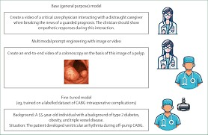
The implementation of a technology-based patient education platform exemplifies a highly effective strategy in reducing readmission rates. By leveraging digital technologies, healthcare providers can disseminate personalized health information to patients, thereby enhancing their understanding of self-care practices and medication management. This approach is grounded in theoretical frameworks that emphasize the importance of patient empowerment and engagement in the healthcare process. In realworld settings, technology-based platforms have been shown to improve patient outcomes by facilitating timely access to educational resources and enabling healthcare providers to track patient progress remotely. Moreover, such platforms can be tailored to accommodate diverse patient needs, including linguistic and cognitive abilities, thereby promoting health equity and reducing disparities in healthcare quality. By adopting technology-based patient education platforms, healthcare organizations can make significant strides in mitigating the issue of inadequate patient education at discharge, ultimately leading to a reduction in readmission rates and improved overall healthcare quality.

Recommendations for Improving Patient Education at Discharge

Recommendation 1: Standardized Patient Education Protocols



The implementation of standardized patient education protocols is a crucial recommendation for improving patient education at discharge, as it has been consistently linked to reduced readmission rates. Inadequate patient education at discharge is a pervasive issue that can have severe consequences, including increased hospital readmissions, decreased patient satisfaction, and poor health outcomes. A standardized approach to patient education can help mitigate these issues by ensuring that all patients receive consistent and comprehensive information about their
condition, treatment, and selfcare requirements. Theoretical frameworks, such as the Health
Belief Model and Social
Cognitive Theory, provide a foundation for understanding the complexities of patient education and can inform the development of effective education protocols. For instance, a study conducted in a large urban hospital found that the implementation of a standardized patient education protocol resulted in a significant reduction in readmission rates for patients with chronic conditions. By adopting a standardized approach to patient education, healthcare providers can improve the quality of care, enhance patient engagement, and ultimately reduce readmission rates, thereby contributing to overall healthcare quality improvement. Furthermore, standardized patient education protocols can be tailored to meet the unique needs of diverse patient populations, promoting health equity and improving health outcomes.

Recommendation 2: Increased Funding for Patient Education Initiatives



The provision of adequate patient education at discharge is a critical component of healthcare quality improvement, and one strategy to achieve this is through increased funding for patient education initiatives. Recommendation 2 suggests that allocating more resources to these programs can lead to better health outcomes and reduced readmission rates. According to theoretical frameworks, such as the Health Belief Model, patients who are well-informed about their conditions and treatment plans are more likely to adhere to medication regimens and follow post-discharge instructions, thereby minimizing the risk of complications and hospital readmissions. In real-world scenarios, hospitals that have implemented comprehensive patient education programs have reported significant reductions in readmission rates, highlighting the practical efficacy of such initiatives. Furthermore, investing in patient education can also lead to cost savings for healthcare systems in the long run, as
it can help reduce the economic burden associated with avoidable readmissions. By prioritizing patient education and providing the necessary funding, healthcare providers can empower patients to take an active role in their care, ultimately leading to improved health outcomes and enhanced quality of life. This approach aligns with the broader goals of healthcare quality improvement, emphasizing the importance of patient-centered care and the need for targeted interventions to address the complex needs of patients at discharge.

Recommendation 3: Integration of Technology into Patient Education

The integration of technology into patient education is a crucial strategy for enhancing the effectiveness of discharge instruction, as highlighted in the recommendations for improving patient education at discharge. By leveraging digital platforms, healthcare providers can facilitate the dissemination of personalized and engaging educational content, thereby promoting better patient understanding and recall of post-discharge instructions. Theoretical frameworks, such as the Health Belief Model, suggest that patients' perceptions of their illness and treatment are influenced by their level of health literacy, which can be improved through the use of multimedia educational tools. For instance, video tutorials and interactive modules can
be used to demonstrate medication management and wound care techniques, making it easier for patients to follow complex instructions. Moreover, electronic health records and patient portals can be utilized to provide patients with access to their medical information and treatment plans, enabling them to take a more active role in their care. By incorporating technology into patient education, healthcare providers can improve patient outcomes, reduce readmission rates, and enhance overall healthcare quality, ultimately leading to better patient satisfaction and more effective use of healthcare resources. Effective implementation of this strategy requires careful consideration of patients' individual needs and technological proficiency.

Implementation and Evaluation of Patient Education Interventions

Implementation Strategies for Patient Education Interventions

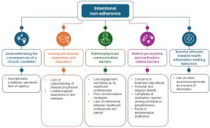
Effective implementation of patient education interventions is crucial in reducing readmission rates and enhancing healthcare quality. To achieve this, healthcare providers must employ strategic approaches that cater to the diverse needs of patients. Theoretical frameworks, such as the Health Belief Model and Social Cognitive Theory, provide a foundation for designing and implementing patient education programs. These frameworks emphasize the importance of considering patients' perceptions, beliefs, and behaviors when developing educational content. For instance, healthcare providers can use plain language and visual aids to convey complex medical information, making it easier for patients to understand and adhere to treatment plans. Moreover, patient education interventions can be delivered through various channels, including in-person counseling, telehealth services, and printed materials, to
accommodate different learning styles and preferences. By adopting a patient-centered approach and leveraging theoretical frameworks, healthcare providers can develop and implement effective patient education interventions that ultimately lead to improved health outcomes and reduced readmission rates.

Evaluation Methods for Patient Education Interventions
The implementation and evaluation of patient education interventions is a crucial aspect of healthcare quality improvement, particularly in reducing readmission rates. Evaluation methods for patient education interventions are multifaceted, incorporating both qualitative and quantitative approaches to assess the effectiveness of these programs. Theoretical frameworks, such as social cognitive theory and the health belief model,


provide a foundation for designing and evaluating patient education interventions. For instance, a patient education program aimed at managing chronic conditions may be evaluated through surveys, focus groups, and medical record reviews to determine its impact on patient knowledge, self-efficacy, and adherence to treatment plans. By utilizing these evaluation methods, healthcare providers can identify areas for improvement and refine their patient education interventions to better meet the needs of their patients, ultimately leading to improved health outcomes and reduced readmission rates. Effective evaluation is essential to ensuring that patient education interventions are evidence-based and tailored to the unique needs of diverse patient populations.

Challenges and Barriers to Implementation and Evaluation

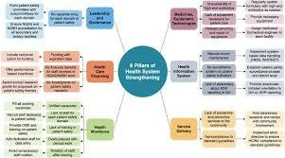
The implementation and evaluation of patient education interventions pose significant challenges and barriers, hindering the effectiveness of these initiatives in reducing readmission rates. A primary obstacle is the lack of a unified theoretical framework to guide the development and assessment of patient education programs, resulting in
inconsistent and often inadequate educational materials. Furthermore, the complexity of patient needs and the diversity of healthcare settings necessitate tailored approaches, which can be resource-intensive and difficult to standardize. Additionally, the evaluation of patient education interventions is often compromised by methodological limitations, such as small sample sizes and inadequate control groups, making it challenging to determine the efficacy of these programs. Realworld examples illustrate the importance of addressing these challenges, as hospitals that have successfully implemented patient-centered education initiatives have seen notable reductions in readmission rates, underscoring the need for continued efforts to improve the quality and accessibility of patient education.

The Role of Healthcare Providers in Patient Education

Responsibilities of Healthcare Providers in Patient Education



Healthcare providers play a pivotal role in patient education, as they are responsible for imparting crucial information to patients about their conditions, treatments, and self-care strategies. Effective patient education is essential for empowering patients to manage their health and prevent readmissions. By adopting theoretical frameworks such as health literacy and patient-centered care, healthcare providers can tailor education to meet individual patient needs, ultimately enhancing healthcare quality and reducing readmission rates. Through clear communication and comprehensive instruction, healthcare providers can ensure that patients are well-informed and equipped to navigate their care, thereby fostering better health outcomes.

Training and Support for Healthcare Providers

Effective training and support for healthcare providers is crucial in ensuring they can deliver high-quality patient education. This enables providers to possess the necessary skills and knowledge to educate patients about their conditions, treatments, and self-care strategies, ultimately reducing readmission rates. By providing ongoing training and resources,
healthcare organizations can empower their staff to take an active role in patient education, fostering a culture of health literacy and promoting better health outcomes. This, in turn, contributes to improved healthcare quality and a reduction in hospital readmissions, highlighting the significance of investing in provider training and support.




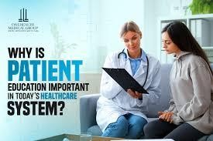
Impact of Healthcare Provider-Patient Communication on Patient Education
Effective communication between healthcare providers and patients plays a crucial role in patient education, ultimately influencing readmission rates. When healthcare providers engage in clear and empathetic dialogue, patients are more likely to grasp essential information about their condition, treatment, and self-care. This, in turn, enables patients to make informed decisions and adhere to prescribed therapies, thereby reducing the likelihood of hospital readmissions. By prioritizing patientcentered communication, healthcare providers can foster a collaborative environment that promotes patient empowerment and improves overall healthcare quality. This approach is essential for mitigating inadequate patient education and its associated consequences.

Patient-Centered Approach to Patient Education

Definition of Patient-Centered Care
The patient-centered approach to patient education is rooted in the definition of patient-centered care, which emphasizes the importance of tailoring healthcare services to meet the unique needs and preferences of individual patients. This approach prioritizes effective communication, active patient participation, and empathy, ultimately leading to improved health outcomes and reduced readmission rates. By adopting a patient-centered

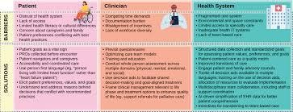


framework, healthcare providers can empower patients with the knowledge and skills necessary to manage their conditions effectively, thereby enhancing the overall quality of care and promoting better health outcomes. This approach is critical in reducing readmission rates.

Principles of Patient-Centered Patient Education

The principles of patient-centered patient education are fundamental to reducing readmission rates. By adopting a patient-centered approach, healthcare providers can tailor education to individual needs, fostering a collaborative relationship between patients and practitioners. This approach emphasizes empowerment, encouraging patients to take an active role in their care, thereby enhancing health
outcomes and reducing hospital readmissions. Effective patient education, grounded in theoretical frameworks, is essential for improving healthcare quality and promoting patient autonomy, ultimately leading to better health outcomes and reduced readmission rates.


Benefits of Patient-Centered Patient Education
The implementation of a patient-centered approach to patient education yields numerous benefits, particularly in reducing readmission rates. By prioritizing individual patient needs and
preferences, healthcare providers can enhance patient understanding and engagement, ultimately leading to improved health outcomes. This approach is grounded in theoretical frameworks that emphasize empathy, communication, and shared decision-making, thereby fostering a collaborative relationship between patients and healthcare providers. Effective patient-centered education empowers patients to manage their conditions, adhere to treatment plans, and navigate the healthcare system, ultimately contributing to a significant reduction in hospital readmissions and improved overall healthcare quality.

Future Directions for Patient Education Research

Gaps in Current Research on Patient Education



The existing body of research on patient education reveals significant gaps, necessitating future investigations to address the complex interplay between inadequate patient education at discharge and elevated readmission rates. To advance this field, researchers should employ robust theoretical frameworks to inform the development of targeted educational interventions. By examining real-world examples of successful patient education
programs, scholars can identify best practices and areas for improvement, ultimately contributing to healthcare quality improvement initiatives. Further research is essential to elucidate the most effective strategies for enhancing patient education and mitigating avoidable hospital readmissions.

Emerging Trends and Technologies in Patient Education
Emerging trends and technologies in patient education are poised to revolutionize the field, offering innovative solutions to mitigate inadequate patient education at discharge and subsequent readmission rates. Future directions for patient education research should prioritize the development and implementation of theoretical frameworks that integrate healthcare quality improvement initiatives. By leveraging digital platforms and personalized learning strategies, researchers can enhance patient


engagement and health literacy, ultimately reducing hospital readmissions and improving overall patient outcomes. This burgeoning area of research holds significant promise for transforming the patient education landscape.

Priorities for Future Research on Patient Education
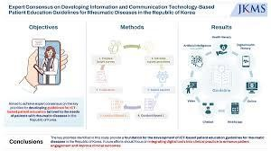
Future research on patient education should prioritize the development of theoretically grounded frameworks that address the complex relationships between patient education, discharge processes, and readmission rates. By examining the impact of inadequate patient education on healthcare outcomes, researchers can identify key areas for quality improvement
and inform the design of targeted interventions. Effective patient education is crucial for reducing readmission rates and enhancing overall healthcare quality, underscoring the need for continued investigation into this critical aspect of healthcare delivery.

Conclusion

Summary of Key Findings

In conclusion, the analysis reveals a significant correlation between inadequate patient education at discharge and increased readmission rates. The findings suggest that effective patient education is crucial in reducing readmission rates and improving healthcare quality. Theoretical frameworks, such as the Health Belief Model, provide a foundation for understanding the importance of patient education in promoting positive health outcomes. The results of this study have significant implications for healthcare quality improvement, highlighting the need for hospitals to prioritize patient education and provide adequate support to patients upon discharge to reduce readmission rates and improve overall patient outcomes.


Implications for Practice and Policy
The findings of this analysis underscore the significance of adequate patient education at discharge in mitigating readmission rates. Implications for practice and policy suggest that healthcare providers must prioritize comprehensive education to ensure patients can manage their conditions
effectively. By integrating theoretical frameworks into discharge protocols, healthcare quality improvement initiatives can be enhanced, ultimately reducing readmission rates and promoting better patient outcomes. Effective patient education is crucial in achieving these goals, highlighting the need for targeted interventions to address existing gaps in discharge practices.

Final Thoughts and Recommendations

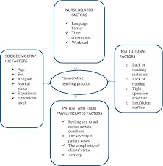
In conclusion, inadequate patient education at discharge significantly contributes to increased readmission rates. This analysis highlights the importance of effective patient education in reducing hospital readmissions. Theoretical frameworks emphasize the need for comprehensive discharge planning, incorporating
patient-centered approaches to improve health outcomes. To mitigate readmission rates, healthcare providers should prioritize patient education, ensuring that individuals understand their treatment plans and self-care requirements. By doing so, healthcare quality can be improved, ultimately enhancing patient outcomes and reducing the economic burden associated with avoidable readmissions.

References
- Cunningham, S., & Kinsey, J. (2020). Pharmacist-Led Discharge Medication Counseling and its Corresponding Impact on Medication Adherence and Hospital Readmission Rates. INNOVATIONS in pharmacy. https://doi.org/10.24926/iip.v11i3.3352
- Cunningham, S., & Kinsey, J. (2021). Erratum to: Pharmacist-Led Discharge Medication Counseling and its Corresponding Impact on Medication Adherence and Hospital Readmission Rates.
INNOVATIONS in pharmacy. https://doi.org/10.24926/iip.v12i1.4008
- Zajac, S. (2020). IMPACT OF A PULMONARY EMBOLISM RESPONSE TEAM ON PATIENT OUTCOMES INCLUDING 30-DAY READMISSION RATES. https://doi.org/10.26226/morressier.5ebc261fffea6f735881a255
- Unknown Author (2025). Impact of Patient Safety Protocols on Hospital Readmission Rates and Healthcare Costs. A Systematic Review. Journal of Carcinogenesis. https://doi.org/10.64149/j.carcinog.24.2s.832-843
- Alanazi, M. (2025). Pharmacist-Nurse Collaborative Medication Reconciliation: Impact On PostDischarge Readmission Rates. The Review of Diabetic Studies. https://doi.org/10.70082/285xvf79
- Shaw, C., St. Julien, A., Avant, C. et al. (2025). Evaluating the Efficacy of Discharge Education on Readmission Rates in Pediatric Patients with Chronic Conditions: A Scoping Review. https://doi.org/10.21007/con.dnp.2025.0109
- Camarda, F. (2024). Impact of Diabetic Education on Reducing Hospital Readmission Rates: A
Literature Review of Adults with Diabetes. Research Posters. https://doi.org/10.31986/issn.2689-
0690_rdw.stratford_research_day.25_2024
- Abdel-Qader, D. (2026). Impact of a 30-day post-discharge telepharmacy program on hospital
readmission, medication discrepancies, adherence and patient satisfaction in Jordan. http://isrctn.com/. https://doi.org/10.1186/isrctn83948874
- Wood, D., Moy, S., Zhang, S. et al. (2022). Impact of a prescriber and patient educational
intervention on discharge analgesia prescribing and hospital readmission rates following elective unilateral total hip and knee arthroplasty. BMJ Open Quality. https://doi.org/10.1136/bmjoq-
2021-001672
- Buck, E., Iqbal, S., & Rauf, F. (2025). Retrospective analysis of discharge rates– impact of seven-
day service on patient flow.. Medical education, web, internet, ethics and economics.
https://doi.org/10.1183/13993003.congress-2025.pa6242

