AN ANALYSIS AND VISUALIZATION OF WeRateDogs

Siddartha Thentu

Introduction:

WeRateDogs is a hilarious Twitter account that rates people’s dogs with a humorous comment about the dog. Their style of ratings is very peculiar and popular. For example, although for most of the ratings, the denominator is 10, the numerator is however almost always greater than 10 (11/10, 14/10, 15/10). Although some people might argue that ratings are supposed to up to 10/10, WeRateDogs disagree. They believe that all dogs deserve 10 and more than a 10.

WeRateDogs received international media coverage when it’s founder Matt
Nelson spawned the catchphrase "They're good dogs, Brent", while shutting down a person having an issue with its rating system. This became one of the biggest memes of 2016 and as of now, the account has garnered around 8 million followers.

Analysis:

After wrangling, assessing and cleaning the WeRateDogs twitter archive, let’s work on some cool analysis. Let’s think about some questions

1. Which dog breeds have most number of posts?
2. Which breed consistently receives the greatest number of retweets and thus more popular?
3. What sized dogs are more popular? Pupper or floofer or ?
4. What breeds of dogs are not so popular?

After data cleaning, we had around 1600 tweets at our disposal. Let’s analyze them to answer our questions.
Visualization:

Which dog breeds have the greatest number of posts?

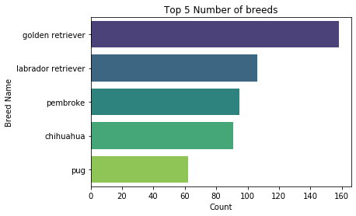

We can see that most of the tweets are about Golden retriever followed by Labrador retriever and it’s a no brainer that a simple google search corroborates this plot that retrievers are the most popular dog breeds in America.

Which dog breeds have the greatest number of retweets?

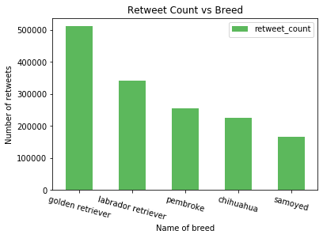
Again, Golden retrievers are the most popular with more than 500000 retweets.

What sized dogs are more popular? Pupper or floofer or ?

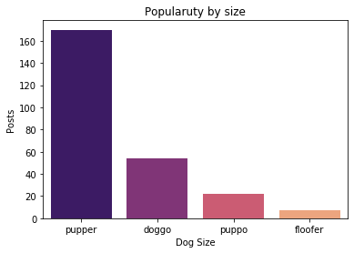

Looks like most of the posts are about puppers. No wonder why.



Cute Pupper 14/10
What breeds of dogs are not so popular?

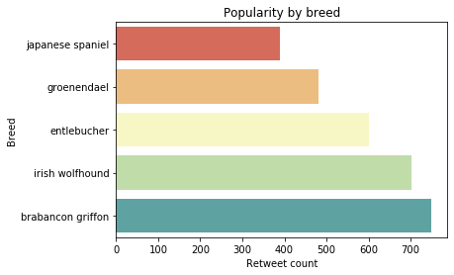

Japanese spaniel isn’t much retweeted.



Fair enough.

