**CLO1**

**Question 1: Define the purpose of data analysis for the chosen dataset.**

**Answer:**

**Purpose: Find which factors (film, price, time, cinema) drive ticket sales and seat occupancy, so you can optimize scheduling and pricing.**

**Question 2: Identify and Justify the type of programming used for data analysis.**

**Answer:**

**Programming: Python—using pandas/NumPy for data wrangling, Matplotlib/Seaborn for charts, and scikit-learn for modeling.**

**Question 3: Identify the type and purpose of the machine learning algorithm to be implemented for the chosen dataset.**

**Answer:**

**ML Algorithm: Regression (e.g. linear or random forest) to predict total sales or occupancy rate from your features.**

**Question 4: Identify and Justify the independent and dependent variables for the chosen dataset.**

**Answer:**

**Variables:**

**Features (independent): ticket_price, show_time, capacity, film_code, cinema_code**

**Target (dependent): total_sales (or occupancy_rate)**

**Question 5: Justify why you want to perform the descriptive analysis for the chosen dataset.**

**Answer:**

**Why Descriptive Analysis: Quickly summarize distributions, catch errors/outliers, and inform feature choices before building models.CLO2**

**Loading the selected data.**

To answer this question, we will start reading data and doing some processing of that data. Now I will share some of the screenshots of the data loading and processing. 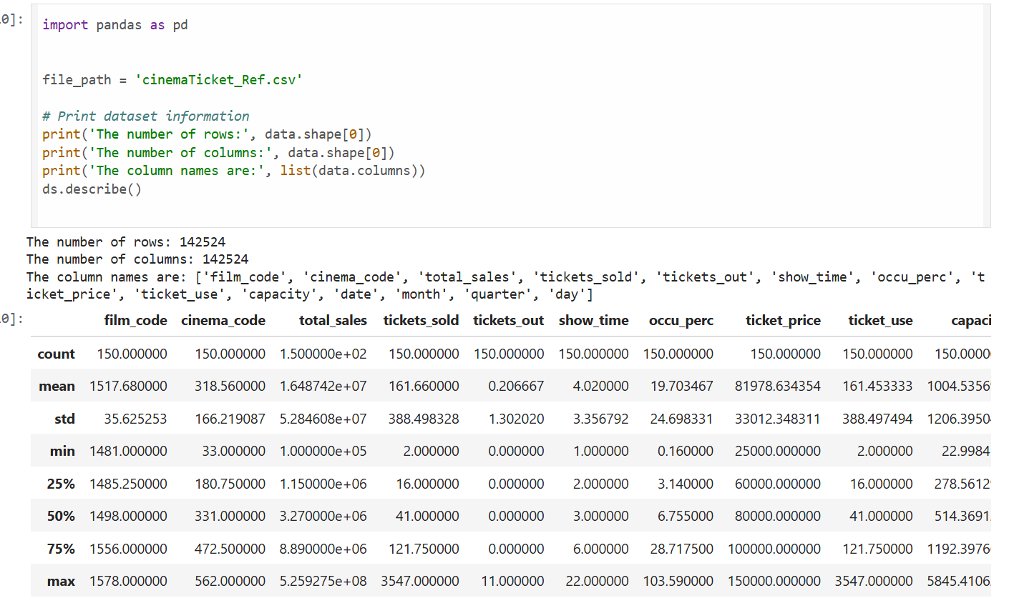

Now we are done with the initial analysis of the data after loading it, this data loading will help us for later analysis.

**Question 6: Create a script to develop a Python function for** **descriptive statistics. The input for the function should be the sample and the field to perform the descriptive statistics.**

**Answer:**

Now we will write the script for the descriptive statistics.

**Question 7: Create a program to random sampling of size 150 and find the descriptive statistics for the dependent variable from the sample [Apply the descriptive function which you created.**

**Answer:**

**This is the results of the script that we write.**

**Question 8: Create a script for systematic sampling by giving certain conditions and finding the desc stat for the dependent variable from the sample [Apply the descriptive function which you created].**

**Answer:**

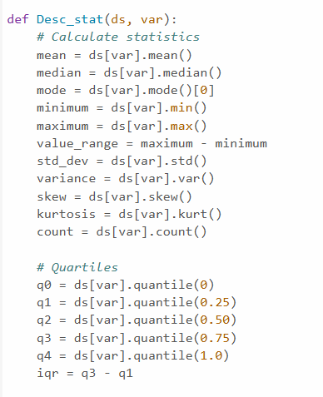

**Question 9: Create a detailed descriptive statistics report about the dependent variable of the chosen dataset.**

**Answer:**

**Question 10: Visualize the dependent variable by the Graph/Chart of the following using Python Program:**

* Scatter plot
* Box Plot
* Histogram
* Heat Map

Hint: Use Matplot or Ski-learn library

**Answer:**

1. Script for the scatter plot

1. Script for the Box Plot

1. Script for the Histogram.

1. Script for of Heat Map.

**Question 11: Perform the hypothesis test to find the correlation (Pearson and Spearman for numerical variable and chi-square test for categorical variable) between the independent variable and the dependent variable.**

**Note:** If you have more than one independent variable, then chose any one of the independent variables.

**Answer:**

We will:

* Use Pearson and Spearman correlation for numerical variables
* Use Chi-Square test for categorical variables

Let’s say:

* Dependent Variable: total_sales
* Independent Variable: tickets_sold (numeric)
* Optional Categorical: You could use something like cinema_code or month if you want to run a chi-square test.

**Use Pearson and Spearman correlation for numerical variables**

The output of this script show below:

**Use Chi-Square test for categorical variables**

**Question 12: Assess the performance of the dependent variable to know whether the sample is representative of the normal population by a one-sample t-test.**

**Answer:**

.

**CLO3**

**Question 13: Build, Train, Develop and Evaluate using Simple Regression for chosen dataset.**

**Answer:** We’ll choose one independent variable (e.g., ticket_price) to predict the dependent variable (e.g., tickets_sold).

**Question 14: Develop a script to forecast the value of the dependent variable from all the relevant independent variables using Multiple Linear Regression.**

**Answer:**

**Question 15: Predict the value of the dependent variable from the different classifier such as Logistic Regression, KNN, Naïve-Bayes and Decision Tree.**

**Answer:**

**Question 16: Evaluate the performance of each model using confusion matrix and accuracy and identify the best fit classifier for the chosen dataset.**

**Answer:**

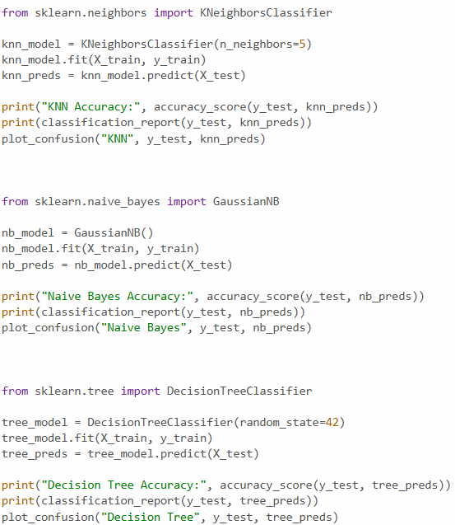

**Question 17: Predict the dependent variable by using best-fit classifier.**

**Answer:**

**Question 18: Perform the cluster analysis such as K-means and Horizontal for any field from the chosen dataset  
Answer:**

**Question 19: Explain the strategy for improving the system after viewing the cluster diagram.  
Answer:**

**Improvement Strategies Based on Clustering:**

* **Segment Target Groups:** Tailor promotions for low-performing clusters and loyalty programs for high performers.
* **Optimize Resources:** Allocate staff and advertising based on cluster performance and potential.
* **Personalize Marketing:** Customize pricing and services to fit each cluster’s preferences.
* **Analyze Outliers:** Investigate anomalies for errors, fraud, or special cases.
* **Refine Features:** Adjust or create features to better distinguish between groups.
* **Track Continuously:** Regularly update clustering as new data comes in to keep strategies relevant.