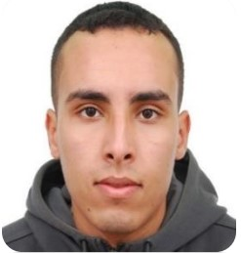

**CONTACT**

Duis augue magna, bibendum en lorem ipsum dolor sit amet, consectetur adipiscing elit. Aliquam nec varius mauris. Duis augue magna, bibendum at nunc id, gravida ultrices tellus. Pellentesqu, ehicula ante id, dictum arcu hicula ante gravida ultrices. Lorem ipsum dolor sit amet, consectetur. Duis augue magna, bibendum at nunc id, gravida ultrices tellus.

**SKILLS**

**LANGUAGES**

(+213)659841097

Ghardaïa, Algeria

**Ahmed BAALI**

**STRENGHTS**

**Computer Science Engineer**

baali.ahmed7@gmail.comemail



Arabic

English

French

https://github.com/Ahmedbaali

https://www.linkedin.com/in/ahmed-baali-32762788/

The projects realized :

* A Real-time web based suspicious behavior detection system

March 2021 - September 2021

* Quality of Service over SDN (Software Defined Network)

March 2019 - July 2019

* Personnel Management Application

March 2018 - June 2018

* Quiz Maker

March 2017 - May 2017

Engineering in Computer Science.

September 2015 - October 2021

Sidi Bel Abbes, Algeria

**The Higher School of Computer Science Sidi Bel Abbes (ESI-SBA)**

**EXPERIENCE**

**EDUCATION**

September 2018 - October 2018

Ouargla, Algeria

**Groupement Sonatrach-Agip Hassi Messaoud| Intern**

* Realize the graduation project which is “**A Real-time web based suspicious behavior detection system**”

March 2021 - September 2021

Sidi Bel Abbes, Algeria

**LABRI(ESI-SBA) | Intern**

* Work as a functional to train system users
* Participate in the data Migration in the new system.
* Create some python scripts to do repetitive taske.

February 2022 – Present

Algiers, Algeria

**Techno Modern Stationery| IT Engineer**

©AZURIUS – Modeles-de-cv,com