LAB Logbook

Lab 1

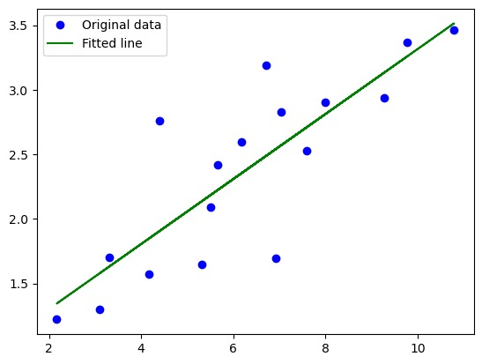

Lab 2

Lab 3



Lab 4

Lab 5

Based on this analysis the optimal number **of** epochs for training should be around 4 to 6 epochs.

Lab 6

Optimal Number of Epochs is 6 for this analysis

Lab 7

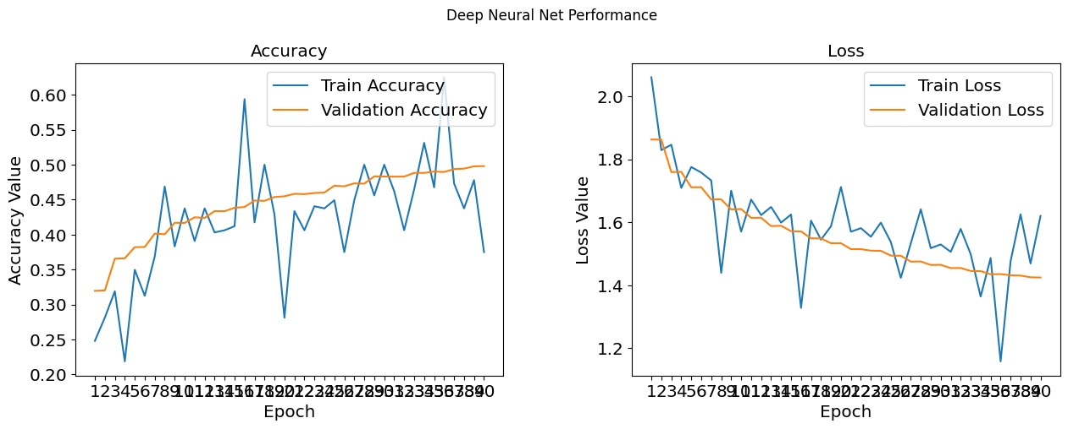

**The optimal number of epochs for training VVG16 model would be 25**

Lab 8

Lab 9

Lab 10

Lab 11

Lab 12