Assignment (3) report
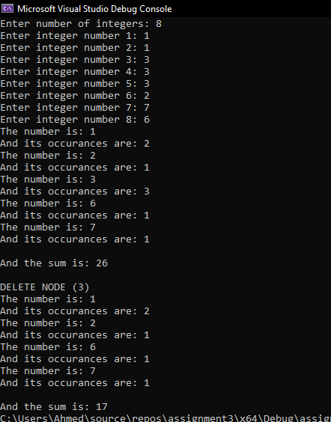
Here I create a vector of size 8 then make the linked list, display each number and it number of occurrences then displaying the sum by calculating the total of each number * its number of occurrences. Then I delete the node that contain the number 3 and I redisplay the all the nodes and recalculate the sum.
One thing I did was that I sorted the vector before counting the number of occurrences to make it easier for me to count the number of occurrences.
I also met a problem where whenever I added a new node the linked list would delete the previous one and so I was not able to create a linked list. I fixed this by make the new node a pointer as follows: Node *newnode = new node;

