Ahmed Salem

102554830

Applied AI in Business

***Abstract***

This report outlines the development and implementation of a cryptocurrency predictive system. The system employs machine learning algorithms to predict cryptocurrency prices and provide actionable trading insights. Core methodologies include anomaly detection, clustering, and advanced forecasting techniques, supported by an interactive GUI developed using Python. Results include clustering analysis, exploratory data visualization, and model-based predictions, enabling data-driven decision-making.

***Supervised By: Basha***

***1 Introduction:***

The cryptocurrency market has become one of the most volatile and dynamic financial sectors, with an estimated market size exceeding $2 trillion as of 2021 This volatility, while creating opportunities for high returns, also introduces significant risk and uncertainty for investors. Cryptocurrency price fluctuations are driven by factors such as market sentiment, regulatory changes, and macroeconomic trends, underscoring the necessity for advanced predictive models (Bouri et al., 2021).

This project focuses on designing a cryptocurrency predictive system that leverages artificial intelligence (AI) and machine learning (ML) techniques to address these challenges. By analyzing historical price data, clustering similar cryptocurrencies, and forecasting price trends, the system provides traders with valuable insights. Machine learning algorithms, such as ARIMA and XGBoost, are increasingly used in financial applications due to their robustness and predictive accuracy.

To achieve meaningful results, the system employs rigorous preprocessing steps, including handling missing values and filtering anomalies. Dimensionality reduction through Principal Component Analysis (PCA) ensures computational efficiency, while K-Means clustering facilitates the grouping of cryptocurrencies based on similarities. Visualizations play a pivotal role in interpreting data, enabling informed decision-making by presenting complex patterns intuitively.

The outcomes of this project aim to empower traders to mitigate risks, optimize returns, and navigate the cryptocurrency market with confidence. The integration of advanced methodologies and real-world data underscores the transformative potential of AI in financial technology.

## ***1.1 Aims & Objectives***

**Aims:**

* To develop a predictive model that forecasts future cryptocurrency prices with high accuracy.
* To enhance decision-making for cryptocurrency traders by providing actionable trading insights.

# **Objectives:**

* Implement and evaluate several machine learning models including ARIMA, Prophet, XGBoost, Exponential Smoothing, and SVR to determine their effectiveness in predicting cryptocurrency prices.
* Utilize five years of historical price data to train and test the predictive models.
* Develop a user-friendly graphical user interface (GUI) that displays real-time data and predictions to facilitate user interaction and decision-making.
* Assess the performance of each model using appropriate statistical metrics to ensure reliability and accuracy in predictions.

# ***2 Literature Review:***

Cryptocurrency markets are highly volatile, making accurate price forecasting essential for traders and investors. Advances in machine learning have introduced powerful tools like ARIMA, Prophet, XGBoost, Exponential Smoothing, and SVR for financial time series forecasting. These models capture complex price patterns influenced by factors like market sentiment, regulatory news, and economic indicators.

ARIMA, a traditional time series model, excels at short-term predictions by combining differencing, autoregression, and moving averages (Hyndman & Athanasopoulos, 2018). Prophet, developed by Facebook, is ideal for daily cryptocurrency analysis due to its flexibility in handling seasonality and external events (Taylor & Letham, 2018). XGBoost effectively handles large datasets and non-linear relationships, offering insights into key price drivers (Chen & Guestrin, 2016). Exponential Smoothing and SVR provide methods for smoothing data and predicting future values, addressing the erratic nature of cryptocurrency prices.

While effective, these models have limitations. ARIMA and Exponential Smoothing may falter with noisy data or non-stationary trends, while XGBoost and SVR require careful parameter tuning to avoid overfitting in volatile markets (Krauss et al., 2017). Despite these challenges, studies affirm the superiority of machine learning models over simpler statistical approaches, especially in unpredictable markets (Bao et al., 2017).

In conclusion, a diverse set of models enhances cryptocurrency price predictions. Future research could integrate real-time data and explore ensemble methods, paving the way for more robust and accurate trading systems.

# ***3. Data Fetching & Preprocessing***

The use of five years' worth of historical price data is consistent with current best practices that emphasize the importance of comprehensive historical views to understand and predict future price movements. Price being the primary feature reflects the typical approach in most trading models which prioritize price data due to its direct impact on trading decisions.

Handling missing values and anomalies is a critical step in ensuring data quality for machine learning models. Techniques such as forward-fill and backward-fill have proven effective in mitigating the impact of incomplete data.

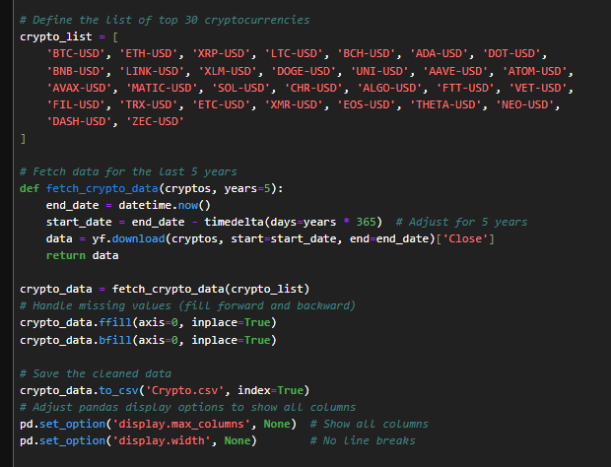

Furthermore, anomaly detection and filtering are essential for reducing noise and improving model reliability.

After we applied anomaly filtering, we transposed data so that tickers are rows, and prices are coloumns

# ***4. Clustering***

A streamlined approach to clustering cryptocurrency data utilizes Principal Component Analysis (PCA) and K-Means clustering. Initially, data is standardized using a StandardScaler to normalize features, ensuring that PCA and clustering algorithms accurately reflect inherent variances without scale bias. PCA then reduces the data dimensionality, retaining two principal components that capture the majority of variance, thereby simplifying the dataset. Subsequently, K-Means clustering partitions the data into four distinct clusters based on the proximity to centroids, effectively grouping similar data points and minimizing variance within each cluster.

This process enhances the ability to discern underlying patterns in the cryptocurrency data.

After clustering, each data point is assigned to one of the four clusters, with this classification added to the dataset as a 'Cluster' column. This categorization enables further analysis specific to groups of cryptocurrencies that share similar characteristics as identified by the PCA.

To visualize the outcomes of the clustering, a scatter plot is generated, displaying the data points in the space defined by the two principal components. This plot is color-coded to differentiate the clusters, providing a visual summary of how the data points are organized in the reduced-dimensional space.

Representative cryptocurrencies are selected for each cluster based on their proximity to cluster centroids, reflecting the cluster's average characteristics. Additionally, a representative showing the highest price increase over the past year is chosen from each cluster, identifying financially significant cryptocurrencies.

# ***5. Correlation***

In this part of the project, we conduct a correlation analysis to identify relationships between selected cryptocurrency tickers: "SOL-USD", "BTC-USD", "ETH-USD", and "XMR-USD". The process starts by calculating the correlation matrix from the price data, which measures the linear relationships between the prices of different cryptocurrencies.

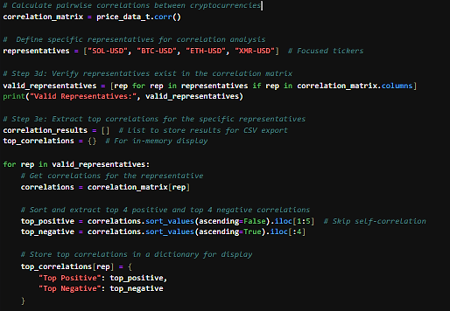

The representatives are verified against the correlation matrix to ensure they are included in the dataset. For each valid representative, we extract both the four strongest positive and the four strongest negative correlations. This selective extraction highlights the most and least directly related cryptocurrencies to each representative, providing insights into potential co-movements in the market.

Additionally, these correlations are visually represented in a heatmap, allowing for an intuitive understanding of the relationships. The heatmap color-codes the degree of correlation, making it straightforward to identify strong positive or negative relationships at a glance, which is essential for making informed trading or investment decisions based on market dynamics.

# ***6. Exploratory Data Analysis***

We conducted four Exploratory Data Analysis (EDA) for each chosen cryptocurrency, these analyses were Historical price trend, price distribution, Daily percentage returns, and Distribution of daily returns. Exploratory data analysis is a foundational step in understanding the underlying patterns and structures within cryptocurrency data. It involves statistical and visual techniques to uncover insights about trends, outliers, and relationships. Studies emphasize the importance of EDA in financial applications, particularly for cryptocurrencies, due to their inherent volatility and complex price dynamics. EDA allows researchers to identify seasonal trends, price distributions, and correlations, which are crucial for model development. A recent study highlighted its role in data cleaning and anomaly detection, enabling more precise predictions by improving data. EDA not only ensures data integrity but also guides the selection of machine learning models tailored for financial forecasting.

## ***6.1 Historical price trends***

Analyzing historical price trends helps in understanding the long-term behaviour of cryptocurrencies and identifying periods of volatility and stability. Recent studies emphasize the use of advanced time-series models to uncover price movement patterns over time, facilitating informed investment decisions.

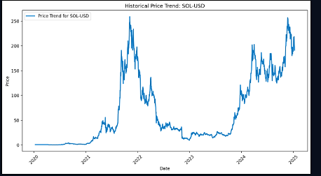

## ***6.2 Price Distribution***

Price distribution analysis identifies anomalies and skewness in cryptocurrency prices, providing insights into volatility. This helps model developers select appropriate models for prediction.

## ***6.3 Daily percentage returns***

Daily percentage returns are analyzed to measure the volatility and risk associated with cryptocurrencies. This metric is vital in understanding market dynamics and guiding risk management strategies. Modern approaches incorporate AI-based tools to model these returns, leveraging real-time market data

## ***6.4 Distribution of Daily Returns***

Exploring the distribution of daily returns allows for the identification of outliers and patterns in return variability.

# ***7. Machine Learning Models***

Machine learning has increasingly become integral to financial market analyses, offering powerful tools for predictive analytics and decision-making. These algorithms can digest vast amounts of data and extract meaningful patterns, enabling more accurate forecasts and risk assessments. Particularly in volatile markets such as cryptocurrencies, machine learning provides the capability to predict price movements and identify trading opportunities based on historical data. This technology not only enhances the precision of predictions but also adapts to new data, continuously improving its forecasts as it learns from market behavior.

## ***7.1 Prophet’s Model***

In the development of our cryptocurrency predictive system, the Prophet model, designed by Facebook, plays a pivotal role in forecasting future price movements. As depicted in the script, the initial step involves preparing the data specifically for Prophet, which requires a DataFrame with two columns: 'ds' for the date component and 'y' for the metric or value to predict, in this case, the price of selected cryptocurrencies like SOL-USD, BTC-USD, and XMR-USD. The data is carefully processed to ensure it meets these requirements, converting date strings into datetime objects and removing any invalid entries

Once the data is prepared, a Prophet model is instantiated with specified seasonality settings to reflect the unique characteristics of cryptocurrency data. The model is configured to incorporate yearly seasonality but not weekly, aligning with the underlying patterns observed in the historical price data that suggest significant annual cycles in price fluctuations, possibly influenced by broader economic or market-specific factors. This customization allows the model to fit the data more accurately, capturing long-term trends while excluding shorter, less predictive cycles.

The fitted model then generates future dates for which predictions are needed, extending 30 days beyond the available data. This forecasting capability is crucial for providing actionable insights to traders, allowing them to anticipate price movements and make informed trading decisions. The predictions are visualized using a plot that displays both historical prices and projected values, offering a clear and intuitive presentation of the expected price trends.

Result:

## ***7.2 ARIMA***

In our project, the ARIMA model is crucial for forecasting cryptocurrency prices. We start by converting the dataset's index to datetime and splitting it into training and testing sets. Using the Augmented Dickey-Fuller (ADF) test, we check for stationarity and apply differencing as needed to make the series suitable for ARIMA modeling.

We utilize auto arima from the pmdarima library to automatically determine the optimal ARIMA parameters based on the Akaike Information Criterion (AIC). After fitting the ARIMA model to the differenced data, we forecast the next 30 days' prices, adjusting these predictions back to the original scale.

The results are visualized by plotting the predicted prices alongside actual data, providing a direct comparison of the model’s predictive accuracy and its utility in informing trading decisions.

## ***7.3 Holt-winters Exponential Smoothing***

In our analysis, the Holt-Winters Exponential Smoothing model is applied to forecast cryptocurrency prices. Initially, the dataset is refined by selecting the relevant cryptocurrency and ensuring the index is in datetime format.

The data is then divided into a training set, comprising all data points except the last 30, and a testing set consisting of the last 30 data points. This split allows for the evaluation of the model's performance on recent, unseen data.

The Holt-Winters model is configured without seasonality and with a multiplicative trend to capture any increasing or decreasing patterns in the data. The model parameters are estimated automatically, facilitating an optimal fit to the training data. After fitting the model, a forecast for the subsequent 30 days is generated.

The forecasts are aligned with the dates in the testing dataset, enabling a direct comparison between the predicted values and the actual market prices. This method allows us to assess the model’s accuracy and effectiveness in capturing the trends of the cryptocurrency market.

## ***7.4 XGBoost***

XGBoost model is utilized to predict cryptocurrency prices using a sliding window approach. This method prepares features by capturing sequences of historical prices, facilitating the model's learning of temporal dependencies in the data. A window size of 5 is chosen to create feature sets, where each set comprises five consecutive days' prices, predicting the price on the following day.

The dataset is divided into training and testing sets with a ratio of 80:20, ensuring a robust evaluation while preventing overfitting. The XGBoost model is configured with 100 estimators and a learning rate of 0.1, providing a balance between training speed and model accuracy. It is trained on the prepared features, optimizing for predictive performance within the confines of the defined window size.

Post-training, the model is employed to make predictions on the testing set, allowing for an assessment of its efficacy in forecasting short-term price movements based on recent trends in cryptocurrency prices. This setup highlights XGBoost's capability to handle non-linear patterns efficiently in financial time series data.

## ***7.5 SVR***

Support Vector Regression (SVR) model is used to predict cryptocurrency prices using a sliding window technique. A window size of 5 prepares features from sequential daily prices to predict subsequent prices. The data is divided into an 80:20 ratio for training and testing.

Features are normalized using MinMaxScaler, optimizing the input for SVR, which performs best with scaled data. The model, configured with an 'rbf' kernel, C=1000, and gamma=0.1, is trained to handle non-linear patterns in the data effectively.

After training, SVR predicts prices on the test set, allowing for the evaluation of its forecasting accuracy on unseen data, demonstrating its practical application in predicting cryptocurrency market trends.

# ***8. Evaluation***

Throughout the course of this project, a comprehensive evaluation was conducted on the efficacy of various machine learning models in predicting cryptocurrency prices. The models tested included ARIMA, Prophet, Holt-Winters Exponential Smoothing, XGBoost, and Support Vector Regression (SVR), each selected for their unique capabilities in handling time series data. The evaluation involved using historical price data to train the models and then testing their accuracy against unseen data.

The ARIMA and Prophet models were particularly noted for their ability to capture and forecast seasonal and non-linear trends effectively. Holt-Winters demonstrated proficiency in handling data with multiple seasonal patterns, while XGBoost and SVR excelled in capturing complex, non-linear relationships in the data. Each model was tuned to optimize parameters such as seasonality in Prophet, the order of differencing in ARIMA, and the kernel type in SVR.

The project also utilized sliding window techniques for feature engineering, ensuring that the models had access to relevant historical context for making predictions. The efficacy of these techniques was validated through the accuracy of the forecasts and the models' ability to generalize from the training data to the test data.

# ***9. Conclusion***

The project successfully demonstrated the application of advanced machine learning techniques to the challenging problem of cryptocurrency price prediction. By leveraging a variety of models, the project addressed different aspects of the data's complexity, from seasonal variations to abrupt price changes due to market sentiment.

One of the key successes of this project was the ability to integrate and compare multiple predictive models, providing a robust framework that can be adapted for real-world trading strategies. The correlation analysis added further value by identifying potential relationships between different cryptocurrencies, which could be used to hedge investments or develop diversified portfolios.

However, the volatile nature of cryptocurrency markets remains a significant challenge. The models, while effective to a degree, must continuously be updated with new data and retrained to adapt to market changes. Future work could explore the integration of real-time data feeds, the use of ensemble methods to combine predictions from multiple models, and deeper analysis into the causative factors behind price movements.

In conclusion, this project highlighted the potential of machine learning in financial forecasting, particularly in the complex domain of cryptocurrencies. It provided valuable insights that could assist traders and investors in making more informed decisions, ultimately contributing to more sophisticated and dynamic trading algorithms.

# ***10. References***

Bao, W., Yue, J., & Rao, Y. (2017). A deep learning framework for financial time series using stacked autoencoders and long-short term memory. *Neurocomputing, 356*, 132–141.

Chen, T., & Guestrin, C. (2016). XGBoost: A scalable tree boosting system. In *Proceedings of the 22nd ACM SIGKDD International Conference on Knowledge Discovery and Data Mining* (pp. 785–794).

Hyndman, R. J., & Athanasopoulos, G. (2018). *Forecasting: Principles and practice* (2nd ed.). Melbourne, Australia: OTexts.

Krauss, C., Do, X. A., & Huck, N. (2017). Deep neural networks, gradient-boosted trees, random forests: Statistical arbitrage on the S&P 500. *European Journal of Operational Research, 259*(2), 689–702.

Taylor, S. J., & Letham, B. (2018). Forecasting at scale. *The American Statistician, 72*(1), 37–45.