FWD Design Project

Name: Ahmed Sherif Mohamed

Contents

System Schematic 3

ECU 1 API 4

ECU 2 API 8

ECU 1 Typedefs used 12

ECU 2 Typedefs 13

ECU 1 Layered Architecture 14

ECU 2 Layered Architecture 15

ECU 1 Folder Structure 16

ECU 2 Folder Structure 17

ECU 1 State Machine 18

ECU 2 State Machine 19

ECU 1 Sequence Diagram 20

ECU 2 Sequence Diagram 21

CPU Load 22

Bus Load Calculation 23

Static Design

# System Schematic

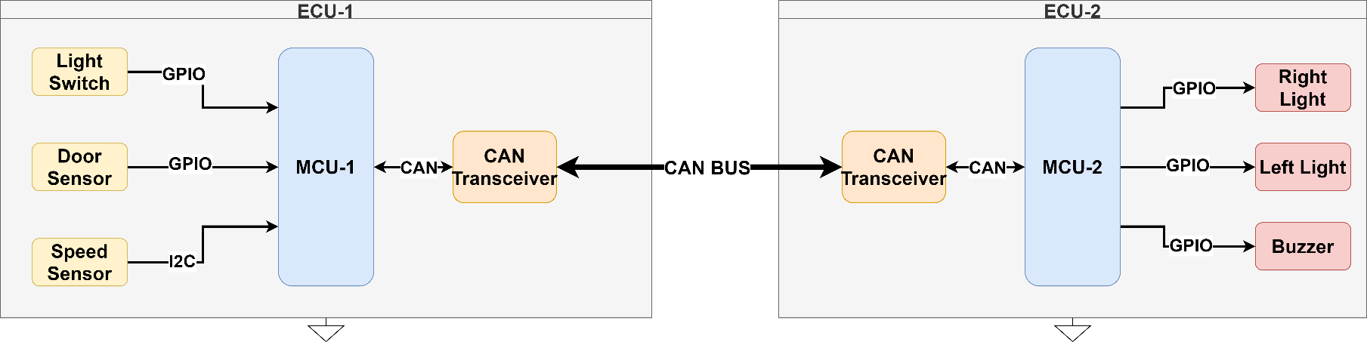

# ECU 1 API

|  |  |
| --- | --- |
| **ECU Name** | ECU 1 |
| **Module name** | DIO |
| **API Name** | DIO_Init |
| **API Description** | Intializes the DIO Module |
| **Sync/Async** | Synchrounous |
| **Reentrancy** | None |
| **Parameters(in)** | Configuration : Struct |
| **Parameters (out)** | None |
| **Parameters(in/out)** | None |
| **Return Type** | errorr_t |
|  |  |
| **ECU Name** | ECU 1 |
| **Module name** | DIO |
| **API Name** | DIO_Read |
| **API Description** | Gets Pin Value |
| **Sync/Async** | Synchrounous |
| **Reentrancy** | Reentrent |
| **Parameters(in)** | PortNum : uint8, pinNumber : uint8 |
| **Parameters (out)** | pinValue : bool |
| **Parameters(in/out)** | None |
| **Return Type** | errorr_t |
|  |  |
| **ECU Name** | ECU 1 |
| **Module name** | DIO |
| **API Name** | DIO_Write |
| **API Description** | Writes Pin Value |
| **Sync/Async** | Synchrounous |
| **Reentrancy** | Reentrent |
| **Parameters(in)** | PortNum : uint8, pinNumber : uint8, value : bool |
| **Parameters (out)** | None |
| **Parameters(in/out)** | None |
| **Return Type** | errorr_t |

|  |  |
| --- | --- |
|  |  |
| **ECU Name** | ECU 1 |
| **Module name** | RCC |
| **API Name** | RCC_Init |
| **API Description** | Intializes the RCC Module |
| **Sync/Async** | Synchrounous |
| **Reentrancy** | None |
| **Parameters(in)** | Configuration : Struct |
| **Parameters (out)** | None |
| **Parameters(in/out)** | None |
| **Return Type** | errorr_t |
|  |  |
| **ECU Name** | ECU 1 |
| **Module name** | RCC |
| **API Name** | RCC_Enable |
| **API Description** | Enables the RCC On a periphral |
| **Sync/Async** | Synchrounous |
| **Reentrancy** | None |
| **Parameters(in)** | Periphral : enum |
| **Parameters (out)** | None |
| **Parameters(in/out)** | None |
| **Return Type** | errorr_t |
|  |  |
| **ECU Name** | ECU 1 |
| **Module name** | Door |
| **API Name** | DoorSensor_SendState |
| **API Description** | Send door data to ecu2 |
| **Sync/Async** | Asynchrounous |
| **Reentrancy** | None |
| **Parameters(in)** | None |
| **Parameters (out)** | None |
| **Parameters(in/out)** | None |
| **Return Type** | errorr_t |
|  |  |
| **ECU Name** | ECU 1 |
| **Module name** | Speed |
| **API Name** | SpeedSensor_SendState |
| **API Description** | send speed data to ecu2 |
| **Sync/Async** | Asynchrounous |
| **Reentrancy** | None |
| **Parameters(in)** | None |
| **Parameters (out)** | None |
| **Parameters(in/out)** | None |
| **Return Type** | errorr_t |
|  |  |
| **ECU Name** | ECU 1 |
| **Module name** | Light |
| **API Name** | LightSwitch_SendState |
| **API Description** | send switch data to ecu2 |
| **Sync/Async** | Asynchrounous |
| **Reentrancy** | None |
| **Parameters(in)** | None |
| **Parameters (out)** | None |
| **Parameters(in/out)** | None |
| **Return Type** | errorr_t |
|  |  |
| **ECU Name** | ECU 1 |
| **Module name** | BCM |
| **API Name** | BCM_Init |
| **API Description** | intialize bcm module |
| **Sync/Async** | Synchrounous |
| **Reentrancy** | None |
| **Parameters(in)** | Configuration : Struct |
| **Parameters (out)** | None |
| **Parameters(in/out)** | None |
| **Return Type** | errorr_t |
|  |  |
| **ECU Name** | ECU 1 |
| **Module name** | BCM |
| **API Name** | BCM_SendMessage |
| **API Description** | send messege through bcm |
| **Sync/Async** | Asynchrounous |
| **Reentrancy** | Reentrent |
| **Parameters(in)** | MessageId : uint8, Message : uint 32 |
| **Parameters (out)** | None |
| **Parameters(in/out)** | None |
| **Return Type** | errorr_t |
|  |  |
| **ECU Name** | ECU 1 |
| **Module name** | Canif |
| **API Name** | CanIf_Init |
| **API Description** | intitialize the canif |
| **Sync/Async** | Synchrounous |
| **Reentrancy** | None |
| **Parameters(in)** | Configuration : Struct |
| **Parameters (out)** | None |
| **Parameters(in/out)** | None |
| **Return Type** | errorr_t |

|  |  |
| --- | --- |
|  |  |
| **ECU Name** | ECU 1 |
| **Module name** | Canif |
| **API Name** | CanIf_Transmit |
| **API Description** | transmit throught the canif |
| **Sync/Async** | Asynchrounous |
| **Reentrancy** | None |
| **Parameters(in)** | ID : uint16, data : uint32 |
| **Parameters (out)** | None |
| **Parameters(in/out)** | None |
| **Return Type** | errorr_t |
|  |  |
| **ECU Name** | ECU 1 |
| **Module name** | Canif |
| **API Name** | CanIf_SetTrcvMode |
| **API Description** | sets the treanceivers mode |
| **Sync/Async** | Synchrounous |
| **Reentrancy** | None |
| **Parameters(in)** | Mode : uint8 |
| **Parameters (out)** | None |
| **Parameters(in/out)** | None |
| **Return Type** | errorr_t |
|  |  |
| **ECU Name** | ECU 1 |
| **Module name** | Can |
| **API Name** | Can_Init |
| **API Description** | intialize can module |
| **Sync/Async** | Synchrounous |
| **Reentrancy** | None |
| **Parameters(in)** | Configuration : Struct |
| **Parameters (out)** | None |
| **Parameters(in/out)** | None |
| **Return Type** | errorr_t |
|  |  |
| **ECU Name** | ECU 1 |
| **Module name** | Can |
| **API Name** | Can_Write |
| **API Description** | write throught the can |
| **Sync/Async** | Asynchrounous |
| **Reentrancy** | Reentrent |
| **Parameters(in)** | ID : uint16, data : uint32 |
| **Parameters (out)** | None |
| **Parameters(in/out)** | None |
| **Return Type** | errorr_t |
|  |  |
| ECU 2 API **ECU Name** | ECU 2 |
| **Module name** | Switch |
| **API Name** | LightSwitch_ReciveState |
| **API Description** | recive switch data to ecu2 |
| **Sync/Async** | Synchrounous |
| **Reentrancy** | None |
| **Parameters(in)** | None |
| **Parameters (out)** | None |
| **Parameters(in/out)** | None |
| **Return Type** | errorr_t |
|  |  |
| **ECU Name** | ECU 2 |
| **Module name** | Buzzer |
| **API Name** | Buzzer_Control |
| **API Description** | sends buzzer data to ecu2 |
| **Sync/Async** | Synchrounous |
| **Reentrancy** | None |
| **Parameters(in)** | None |
| **Parameters (out)** | None |
| **Parameters(in/out)** | None |
| **Return Type** | errorr_t |
|  |  |
| **ECU Name** | ECU 2 |
| **Module name** | Light |
| **API Name** | Light_Control |
| **API Description** | sends light data to ecu2 |
| **Sync/Async** | Synchrounous |
| **Reentrancy** | None |
| **Parameters(in)** | None |
| **Parameters (out)** | None |
| **Parameters(in/out)** | None |
| **Return Type** | errorr_t |

|  |  |
| --- | --- |
|  |  |
| **ECU Name** | ECU 2 |
| **Module name** | DIO |
| **API Name** | DIO_Init |
| **API Description** | Intializes the DIO Module |
| **Sync/Async** | Synchrounous |
| **Reentrancy** | None |
| **Parameters(in)** | Configuration : Struct |
| **Parameters (out)** | None |
| **Parameters(in/out)** | None |
| **Return Type** | errorr_t |
| **ECU Name** | ECU 2 |
| **Module name** | DIO |
| **API Name** | DIO_Read |
| **API Description** | Gets Pin Value |
| **Sync/Async** | Synchrounous |
| **Reentrancy** | Reentrent |
| **Parameters(in)** | PortNum : uint8, pinNumber : uint8 |
| **Parameters (out)** | pinValue : bool |
| **Parameters(in/out)** | None |
| **Return Type** | errorr_t |
|  |  |
| **ECU Name** | ECU 2 |
| **Module name** | DIO |
| **API Name** | DIO_Write |
| **API Description** | Writes Pin Value |
| **Sync/Async** | Synchrounous |
| **Reentrancy** | Reentrent |
| **Parameters(in)** | PortNum : uint8, pinNumber : uint8, value : bool |
| **Parameters (out)** | None |
| **Parameters(in/out)** | None |
| **Return Type** | errorr_t |
|  |  |
| **ECU Name** | ECU 2 |
| **Module name** | RCC |
| **API Name** | RCC_Init |
| **API Description** | Intializes the RCC Module |
| **Sync/Async** | Synchrounous |
| **Reentrancy** | None |
| **Parameters(in)** | Configuration : Struct |
| **Parameters (out)** | None |
| **Parameters(in/out)** | None |
| **Return Type** | errorr_t |
|  |  |
| **ECU Name** | ECU 2 |
| **Module name** | RCC |
| **API Name** | RCC_Enable |
| **API Description** | Enables the RCC On a periphral |
| **Sync/Async** | Synchrounous |
| **Reentrancy** | None |
| **Parameters(in)** | Periphral : enum |
| **Parameters (out)** | None |
| **Parameters(in/out)** | None |
| **Return Type** | errorr_t |
|  |  |
| **ECU Name** | ECU 2 |
| **Module name** | BCM |
| **API Name** | BCM_Init |
| **API Description** | intialize bcm module |
| **Sync/Async** | Synchrounous |
| **Reentrancy** | None |
| **Parameters(in)** | Configuration : Struct |
| **Parameters (out)** | None |
| **Parameters(in/out)** | None |
| **Return Type** | errorr_t |
|  |  |
| **ECU Name** | ECU 2 |
| **Module name** | BCM |
| **API Name** | BCM_SendMessage |
| **API Description** | send messege through bcm |
| **Sync/Async** | Asynchrounous |
| **Reentrancy** | Reentrent |
| **Parameters(in)** | MessageId : uint8, Message : uint 32 |
| **Parameters (out)** | None |
| **Parameters(in/out)** | None |
| **Return Type** | errorr_t |
|  |  |
| **ECU Name** | ECU 2 |
| **Module name** | Canif |
| **API Name** | CanIf_Init |
| **API Description** | intitialize the canif |
| **Sync/Async** | Synchrounous |
| **Reentrancy** | None |
| **Parameters(in)** | Configuration : Struct |
| **Parameters (out)** | None |
| **Parameters(in/out)** | None |
| **Return Type** | errorr_t |

|  |  |
| --- | --- |
|  |  |
| **ECU Name** | ECU 2 |
| **Module name** | Canif |
| **API Name** | CanIf_Transmit |
| **API Description** | transmit throught the canif |
| **Sync/Async** | Asynchrounous |
| **Reentrancy** | None |
| **Parameters(in)** | ID : uint16, data : uint32 |
| **Parameters (out)** | None |
| **Parameters(in/out)** | None |
| **Return Type** | errorr_t |
| **ECU Name** | ECU 2 |
| **Module name** | Canif |
| **API Name** | CanIf_SetTrcvMode |
| **API Description** | sets the treanceivers mode |
| **Sync/Async** | Synchrounous |
| **Reentrancy** | None |
| **Parameters(in)** | Mode : uint8 |
| **Parameters (out)** | None |
| **Parameters(in/out)** | None |
| **Return Type** | errorr_t |
|  |  |
| **ECU Name** | ECU 2 |
| **Module name** | Can |
| **API Name** | Can_Init |
| **API Description** | intialize can module |
| **Sync/Async** | Synchrounous |
| **Reentrancy** | None |
| **Parameters(in)** | Configuration : Struct |
| **Parameters (out)** | None |
| **Parameters(in/out)** | None |
| **Return Type** | errorr_t |
|  |  |
| **ECU Name** | ECU 2 |
| **Module name** | Can |
| **API Name** | Can_Write |
| **API Description** | write throught the can |
| **Sync/Async** | Asynchrounous |
| **Reentrancy** | Reentrent |
| **Parameters(in)** | ID : uint16, data : uint32 |
| **Parameters (out)** | None |
| **Parameters(in/out)** | None |
| **Return Type** | errorr_t |

# ECU 1 Typedefs used

|  |  |  |
| --- | --- | --- |
| **typedef** | DoorStatus | uint8 |
| **typedef** | SpeedValue | uint16 |
| **typedef** | DioChannelType | uint11 |
| **typedef** | DioChannelType | uint8 |

# ECU 2 Typedefs

|  |  |  |
| --- | --- | --- |
| **typedef** | DioChannelType | uint8 |
| **typedef** | LightLevelType | uint9 |
| **typedef** | BuzzerLevelType | uint10 |
| **typedef** | DioChannelType | uint11 |

# ECU 1 Layered Architecture

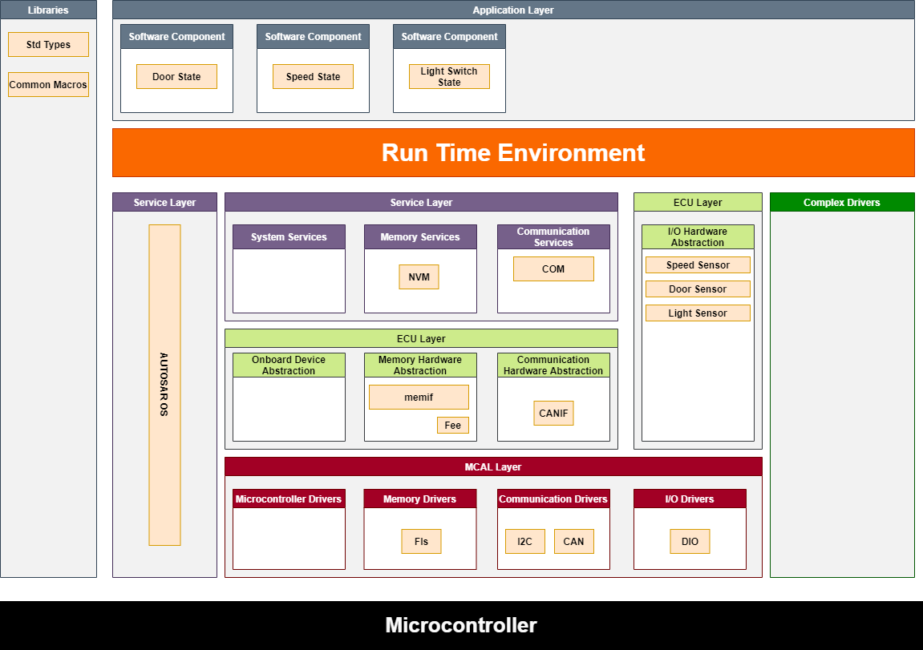

# ECU 2 Layered Architecture

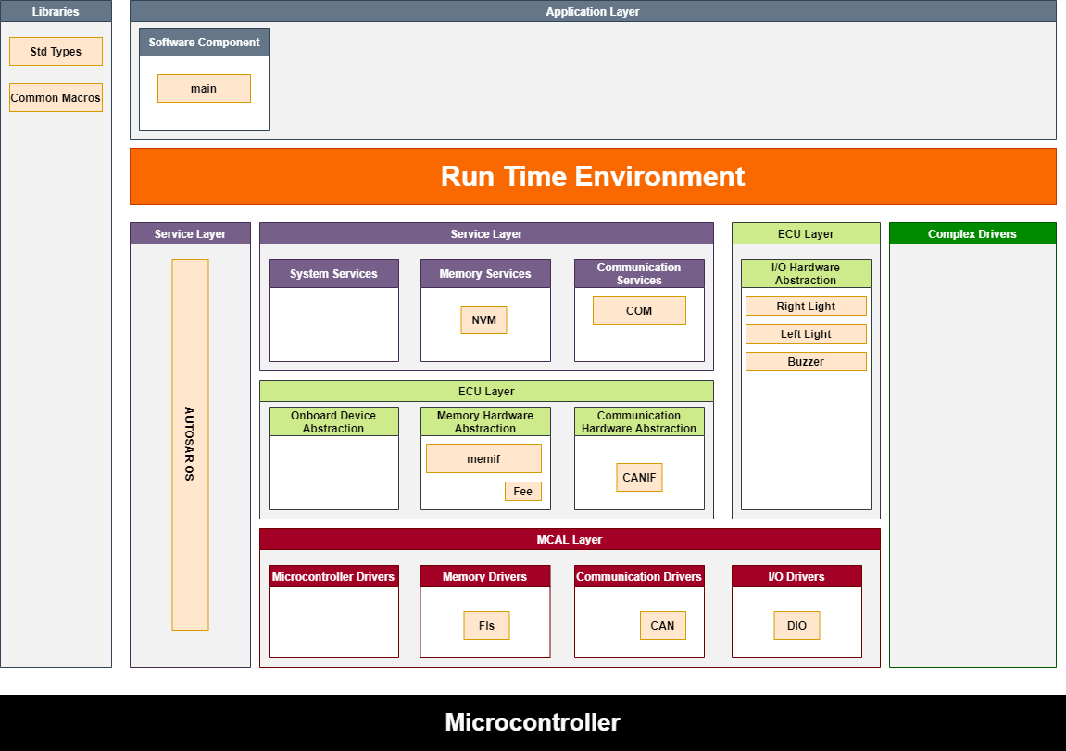

# ECU 1 Folder Structure

# ECU 2 Folder Structure

Dynamic Design

# ECU 1 State Machine

# ECU 2 State Machine

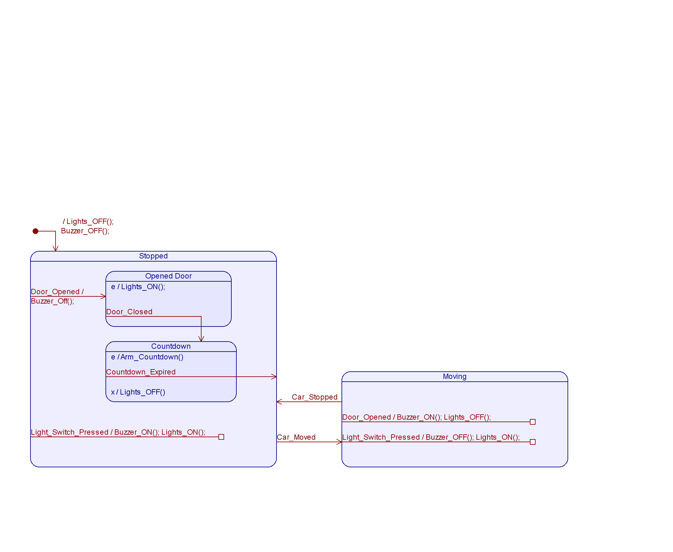

# ECU 1 Sequence Diagram

# ECU 2 Sequence Diagram

# CPU Load

# Bus Load Calculation

**Bus Load** = Total bits / 12500 = 32 / 125000 = 0.000256 = 0.0256%