*How The Web Works?

_ Computers connected to the web are called **clients** and **servers.**.

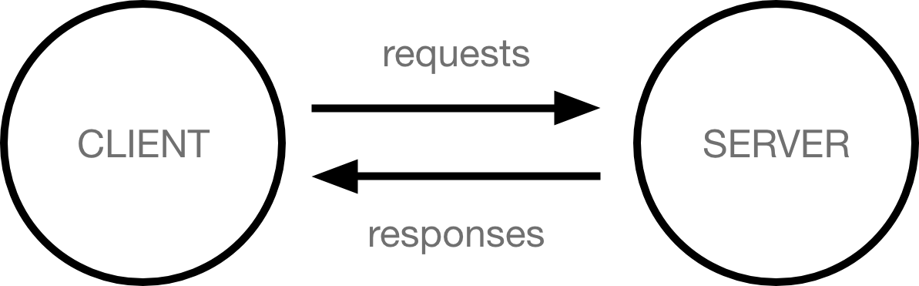

When a client device wants to access a webpage, a copy of the webpage is downloaded from the server onto the client machine to be displayed in the user's web browser.

So when we type a web address into our browser the browser goes to the DNS server, and finds the real address of the server that the website lives on then the browser sends an HTTP request message to the server, asking it to send a copy of the website to the client, Finally If the server approves the client's request, the server sends the client a "200 OK" message.

*The structure of a HTTP message.

HTTP requests and responses are text-based, and both have a similar four-part structure:

* A single line used to denote whether the message is a request or a response
* A variable number of header fields terminated
* A blank line
* The message body (if applicable)