MedVault
Design Document
An AI-powered secure patient data access auditor
Author: Ahmed Furkhan
Course: CS 5610 Web Development, MS CS, Northeastern University
Instructor: Prof. John Alexis Guerra Gomez

1. Project Description
MedVault is a full-stack, privacy-first web application that makes medical-record access transparent to the patient. Most patient portals let you view your own records but never show who else looked at them, when, or why - so unusual access goes unnoticed and raw logs, when they exist at all, are unreadable to a non-technical patient.
MedVault treats access transparency as a first-class feature. Every time a record is viewed, the event is logged (timestamp, simulated device/IP, access type). A MongoDB aggregation pipeline evaluates those logs against rule-based anomaly checks - off-hours access, unrecognized device, and rapid view bursts - and surfaces the results on a personal risk dashboard, similar to a credit-monitoring alert system but for health data.
The single AI touchpoint is deliberately narrow and grounded: after the rules engine raises a flag, the Groq API (llama-3.3-70b-versatile) translates the flagged fields into a short, plain-English explanation with a severity label and a recommended action - without ever deciding what counts as suspicious. A separate grounded, multi-turn assistant answers who-accessed-what questions using only the patient's real audit data.
The application is built on React (Hooks, client-side rendering) with a Node.js + Express backend and a MongoDB database accessed through the native Node.js driver - no Mongoose, no CORS, and no prohibited libraries. Authentication uses Passport (local strategy).

2. User Personas

Persona 1: Maria, 34 - the non-technical patient (primary)
Maria manages Type 2 diabetes and sees an endocrinologist, a primary-care physician, and periodically a cardiologist. Her records are touched by several offices, and after each visit she wonders who accessed what. She is not technical and does not want to read raw logs - she wants a clear view of her records and a plain-language heads-up when something looks off.
- Goals: keep her history in one place, know who accessed it and when, be alerted in language she understands.
- Frustrations: portals that show data but hide the access footprint; tools that dump numbers instead of explanations.

Persona 2: James, 28 - the breach-wary monitor (secondary)
James had personal medical data exposed in a provider breach two years ago and is now hypervigilant about where his information lives and who touches it. He actively checks access logs and wants to spot unusual activity fast.
- Goals: verify no unexpected access is happening; catch anomalies quickly.
- Frustrations: no visibility into access history on most portals; alerts without context.

3. User Stories
The three stories below are the scope approved in the #project proposal. Each is implemented full-stack (frontend, backend, and database) and is independently functional.
Story 1 - Manage my health records (with authentication)
As Maria, I can register, log in, and manage my own health records (conditions, visit notes, dates) so that my medical history is centralized and private to my account.
- Backend: POST /api/auth/register, POST /api/auth/login; POST /api/records, GET /api/records, PUT /api/records/:id, DELETE /api/records/:id (Passport local strategy, bcrypt).
- Frontend: auth forms, a searchable/paginated record list, and an add/edit record form.
- CRUD: full Create / Read / Update / Delete on the records collection.
Story 2 - Automatic access-log audit trail
As Maria, every time a record is viewed it is automatically logged (timestamp, simulated device/IP, access type) so that I can see a chronological audit trail of who accessed my data and when, filterable by date range.
- Backend: middleware on GET /api/records/:id writes to the accessLogs collection; GET /api/access-logs?recordId=... returns the per-record timeline.
- Frontend: a per-record audit-trail timeline, filterable by date range, with normal vs. flagged entries visually distinguished.
Story 3 - Risk dashboard with plain-English explanations
As Maria, I want a risk dashboard that flags unusual access patterns and explains them in plain English, so that I understand why something is flagged without reading raw stats myself.
- Backend: GET /api/risk-dashboard runs a MongoDB aggregation over accessLogs to compute anomaly flags (odd hours, new device, view burst) and a rolling risk score; each flagged event's fields are sent to an LLM which returns { explanation, severityLabel } stored on the log.
- Frontend: a flagged-event list showing the AI-generated explanation and severity, plus a risk-score trend chart.
Enhancements beyond the approved scope
In addition to the three approved stories, MedVault adds a grounded, multi-turn AI access assistant (POST /api/assistant) that answers who-accessed-what questions using only the patient's real audit data, plus a light/dark theme and a secure password-reset flow.

4. AI Integration
Anomaly detection stays rule-based (time-window and frequency checks via a MongoDB aggregation pipeline) - the AI is never used to decide what is suspicious. The LLM is called only after a rule-based flag already exists, to translate the flagged fields (access time, device, frequency delta) into a short plain-English explanation and severity label for the patient. This mirrors a categorization pattern: structured input in, structured JSON out ({ explanation, severityLabel }), stored on the accessLogs document.

5. Design Mockups
The wireframes below show the core client-side-rendered React views, annotated with their API endpoints. The records portal pairs a searchable record list with a per-record access timeline; the risk dashboard combines a live risk score, anomaly tiles, a trend chart, and AI-explained alerts; and the assistant answers grounded, multi-turn questions.
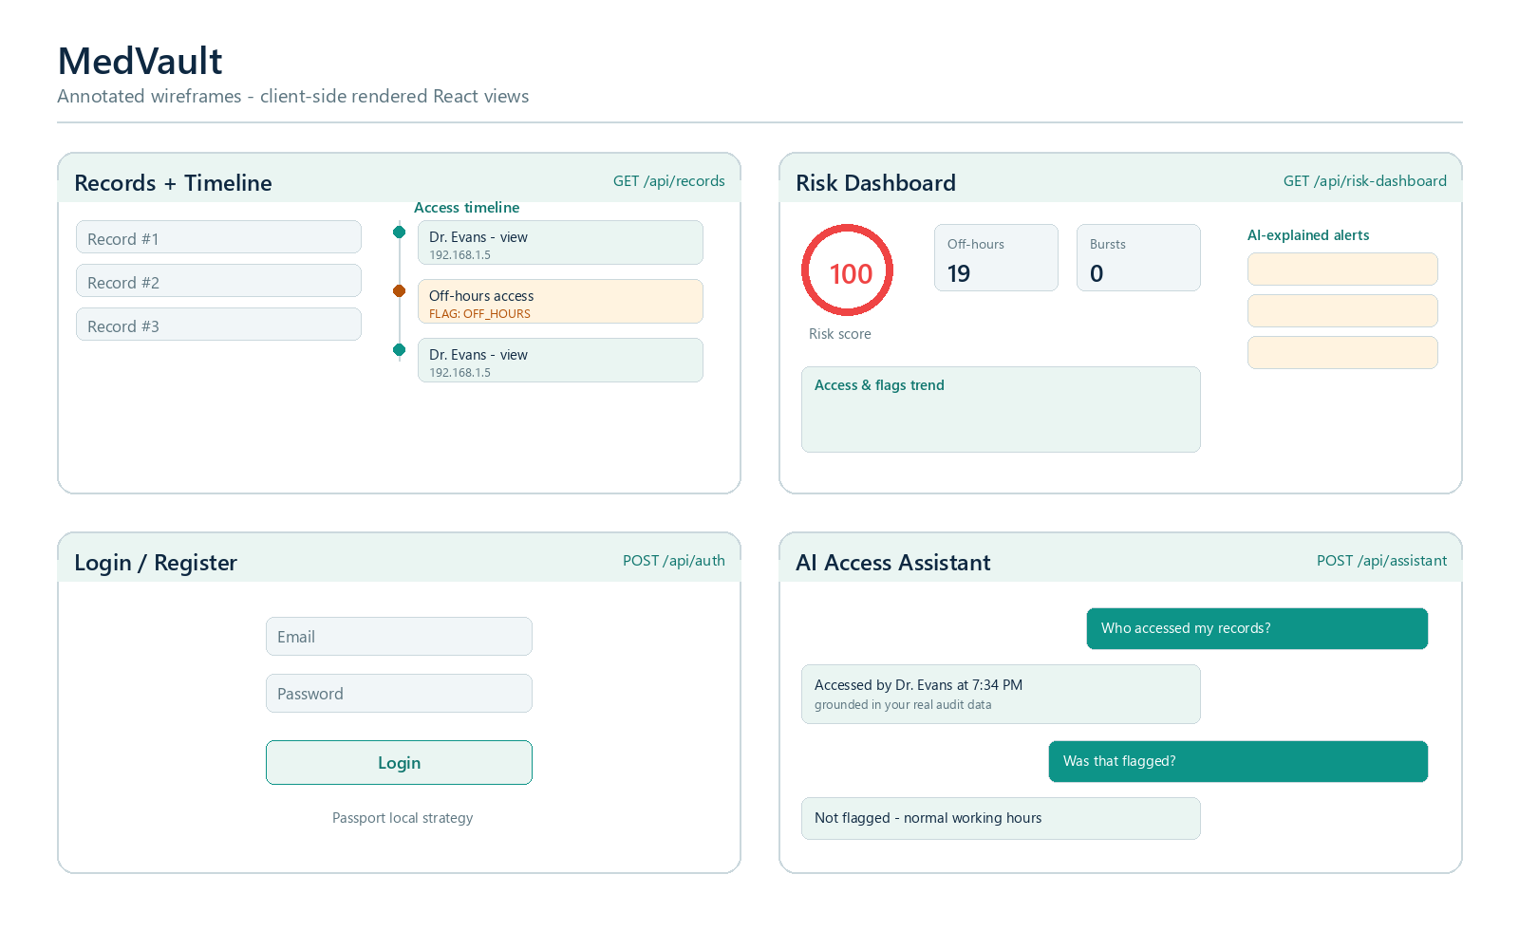
Figure 1. Annotated wireframes - Records + Timeline, Risk Dashboard, Login/Register, and AI Assistant.
- Login / Register: email and password with Passport local strategy; POST /api/auth.
- Records + Timeline: searchable, paginated records with a per-record audit timeline filterable by date range; GET /api/records and /api/access-logs.
- Risk Dashboard: risk score, off-hours and view-burst tiles, trend chart, and AI-explained alerts; GET /api/risk-dashboard.
- AI Assistant: grounded, multi-turn Q&A over the user's real access history; POST /api/assistant.

Appendix: Data Model & Technology
Collections:
users (account info and auth credentials), records (userId, condition/title, visit notes, date), and accessLogs (userId, recordId, timestamp, simulated device/IP, access type, anomalyFlag, aiExplanation, aiSeverityLabel). Three collections, exceeding the two-collection requirement, with full CRUD on records.
Stack:
React (Hooks, client-side rendering) with Recharts for the audit-trail and risk-score visualizations (library use approved in the proposal); Node.js + Express (ES modules); MongoDB via the native Node.js driver (no Mongoose); Passport local strategy with bcrypt and express-session; the Fetch API for all data requests; and an LLM API (Groq, Llama 3.3) for anomaly explanations. Same-origin design - no CORS, axios, or Mongoose. ESLint and Prettier for code quality; MIT license.

