Usability Study Report
MedVault — AI-assisted patient record access auditor
Author: Ahmed Furkhan
Course: CS 5610 Web Development — Northeastern University
Participants: 3 (Tabassum Tailor, Mohammed Taher, Rabiya Basri).
Study date: August 2026

Application scope

Application description

MedVault is a privacy-first, AI-assisted access auditor for personal medical records. It answers the question patients rarely get to ask: "Who looked at my health data, when, and why?" It turns raw access logs into a plain-English audit experience: a dynamic risk score, flagged anomalies (off-hours access, view bursts, new devices), a per-record access timeline written in plain language, and a grounded AI assistant that answers questions using only the user’s own history. Patients can attach a report file (PDF/JPG/PNG) to a record. A separate Doctor (provider) role can browse patients and open their records — and every doctor view is written to that patient’s audit trail, closing the transparency loop the app is built around. Full stack: React (Vite), Node + Express, MongoDB (users, records, accessLogs), seeded with 1,000+ realistic synthetic records.
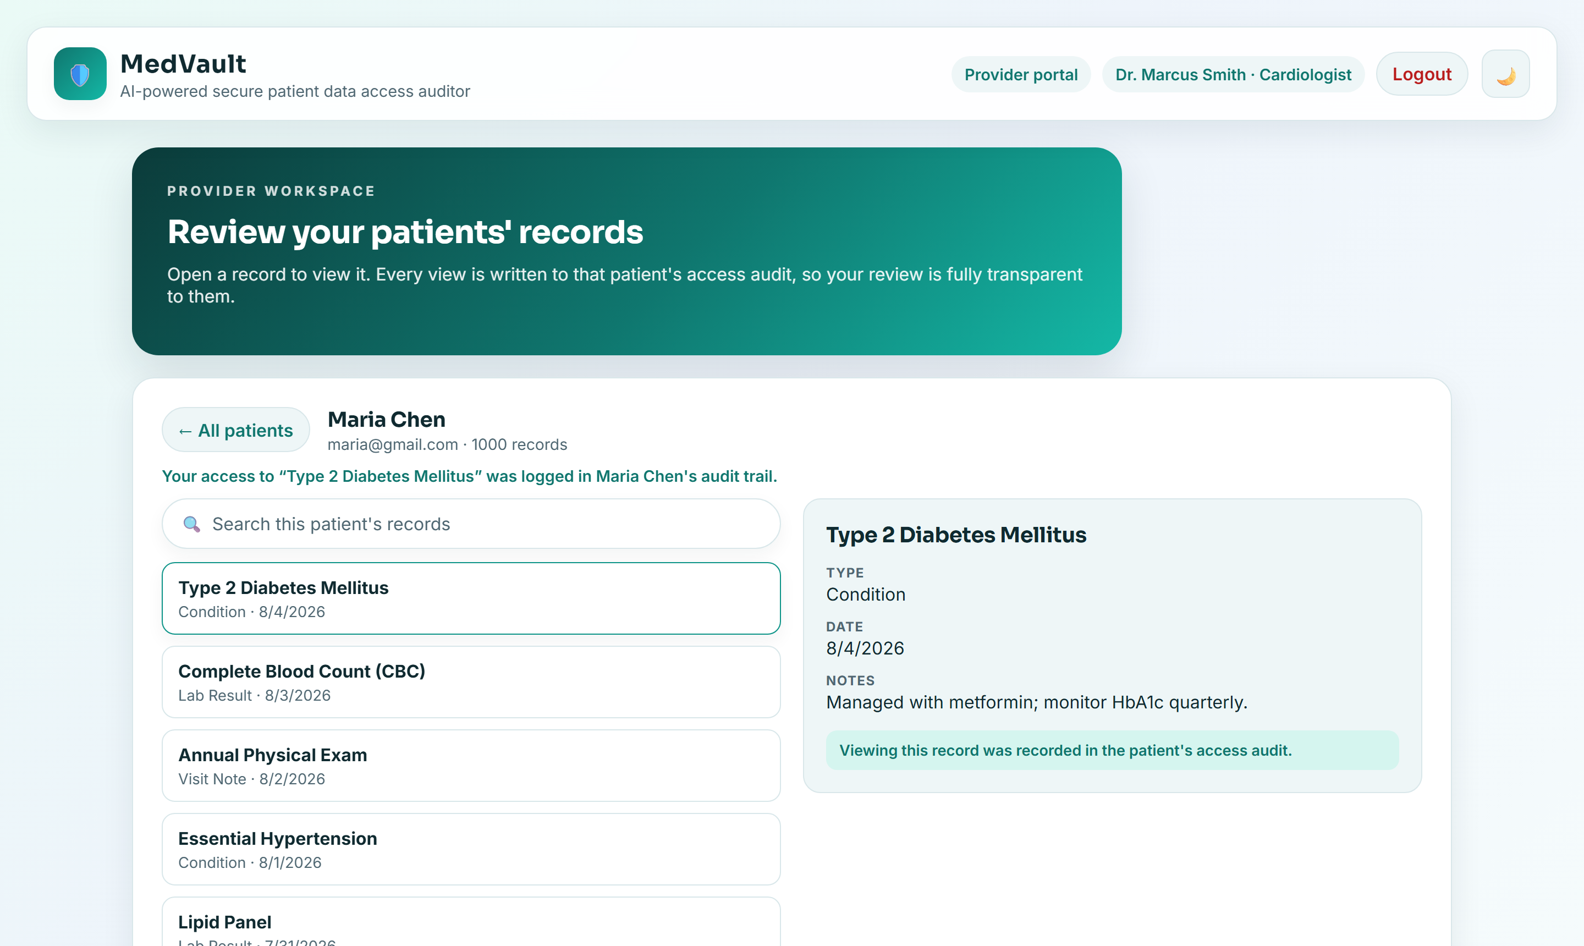
Figure 1. Doctor / provider portal — opening a patient record logs the access to that patient’s audit trail (task T4).
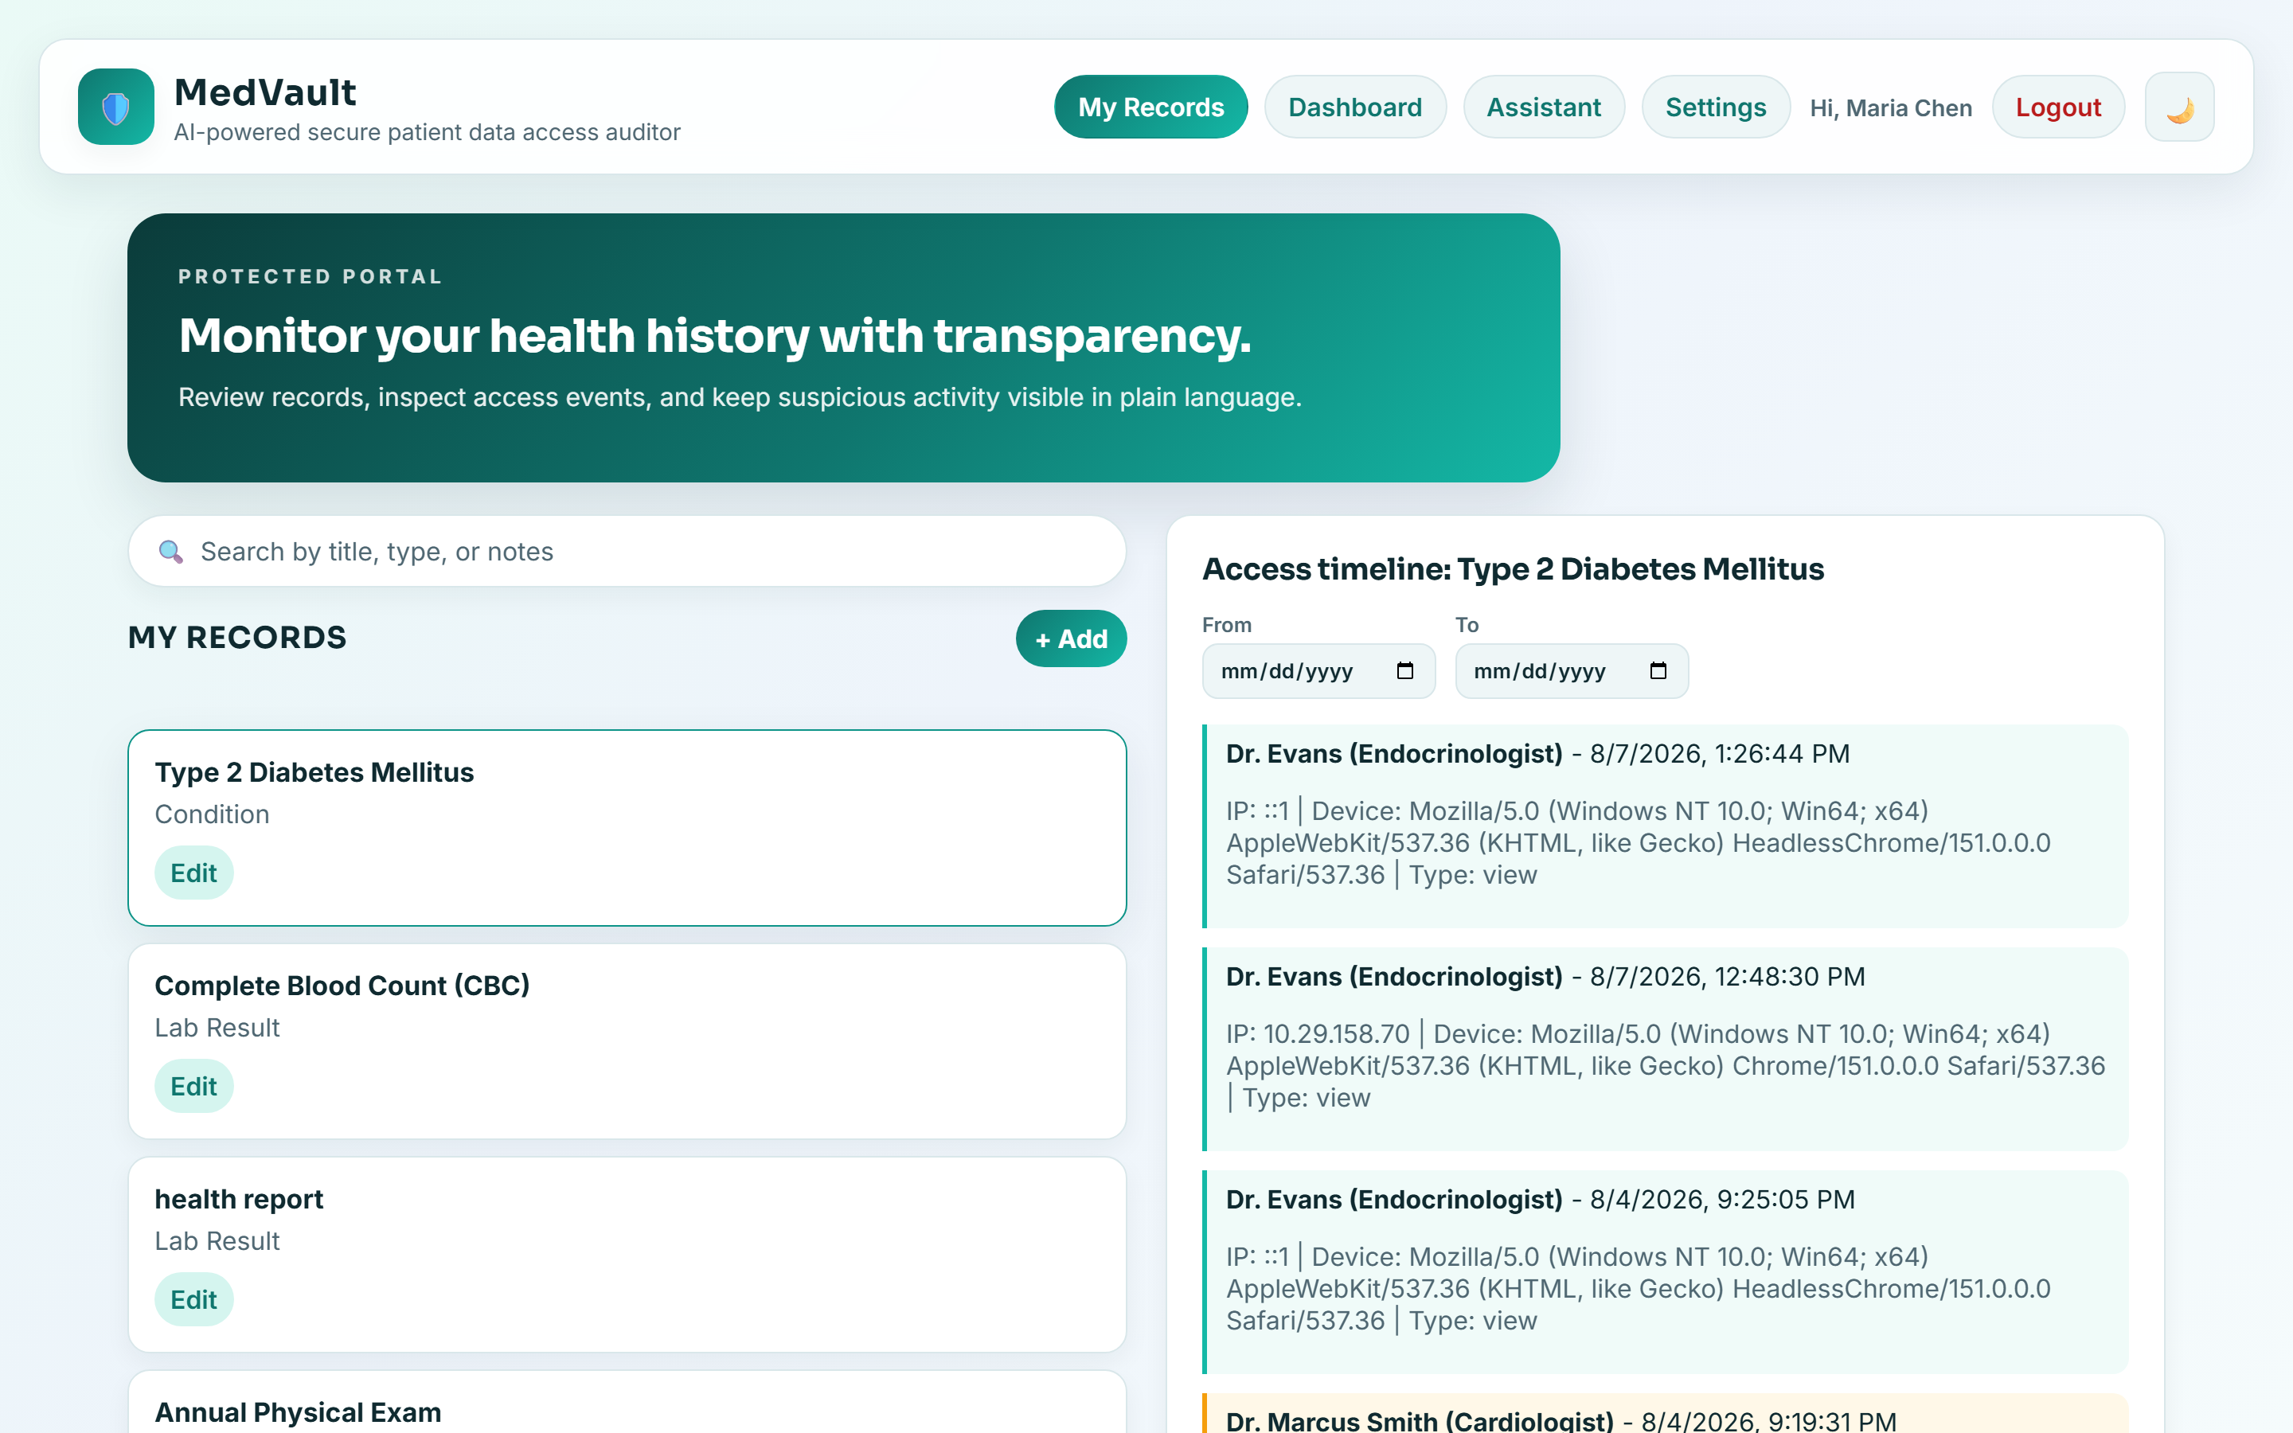
Figure 2. The same access appears in the patient’s own audit timeline (flagged), closing the loop.

Users — target audience (personas)
- Persona A — privacy-conscious patient with a chronic condition. Non-technical, checks records on a laptop, worried staff or third parties view her data without a clear reason.
- Persona B — family caregiver (laptop). Coordinates care for a parent from a laptop between appointments; needs to spot anything unusual fast and know the next step.
- Persona C — assistive-technology user. Use keyboard-only / a screen reader, or relies on zoom; every task must be completable without a mouse.

Data description (what is stored and displayed)
- Users: name, email, bcrypt-hashed password, role (patient/doctor), off-hours-window preference.
- Medical records: title, type (Condition / Lab Result / Visit Note), date, notes, optional report attachment.
- Access logs: accessor name and clinical role, timestamp, device, access type, isFlagged, plain-English AI explanation for flagged events.
- Derived / displayed: risk score (0–100) with severity band, anomaly counts, an access-trend series, and AI-explained alerts with a recommended action.

Main tasks — use cases (from the facilitator script)
T1 — Inspect an access timeline: Find the record "Type 2 Diabetes Mellitus" and report who most recently accessed it and when.
T2 — Understand the risk dashboard + ask the assistant: Read the risk score, find the highest-severity alert and its recommended action, then ask the assistant whether any records were accessed outside normal hours.
T3 — Add a record and attach a report: Add a new "flu shot" record dated today, attach the sample report file, and save it.
T4 — Doctor view and the audit loop: As a doctor, find a patient, open one of their records (which logs the access), then, as the patient, find that doctor’s access in the record’s timeline.
Success metrics: completed unaided (yes/no), time on task, and number of wrong turns / help requests.

Experiment

Preparation

Introduction & protocol (read to every participant)
- Welcome the participant and thank them for their time.
- Explain the app in one sentence and the format (four short tasks, ~40–45 min).
- Ask for explicit consent to record audio, video, and screen; start recording only after "yes".
- Ask them to think out loud.
- Remind them: we are testing the app, not them; there are no wrong answers; they may stop anytime.
- Ask them to act like the target audience — for T4, to switch hats and act as the doctor.

Demographics questions (any may be skipped)
- Age range.
- Comfort with web apps (1–5).
- Assistive technology used, if any.
- Primary device for a task like this.
- Prior experience reading an access/activity log.

Task scripts (read aloud)
Intuitiveness: "Take a minute to look around the signed-in app and tell me what you think it does and what you could do here — don’t click anything destructive yet."
T1: "Find the record ‘Type 2 Diabetes Mellitus’ and tell me who most recently accessed it and when."
T2: "Go to the Dashboard. What is your risk score and what does it mean? Find the most serious alert and tell me what happened and what the app recommends. Then open the Assistant and ask whether any of your records were accessed outside normal hours."
T3: "Add a new record for a flu shot today, attach the sample report file, and save it."
T4: "Now switch hats — you’re the doctor. Find the patient ‘Maria Chen’, open her ‘Lipid Panel’ record, and tell me what you notice. Then, back as the patient, look at that record’s timeline — is there anything there from the doctor you just were?"

Post-test questionnaire — Likert (1 = very poor / very hard, 5 = excellent / very easy)
- How effective was the application for T1?
- How intuitive / easy to use was the application for T1?
- How effective was the application for T2?
- How intuitive / easy to use was the application for T2?
- How effective was the application for T3?
- How intuitive / easy to use was the application for T3?
- How effective was the application for T4?
- How intuitive / easy to use was the application for T4?
- How effective was the application overall?
- How intuitive / easy to use was the application overall?
- Any final comments or suggestions for improvement?

Experiment Notes

Tabassum Tailor
Assigned persona: Persona A — privacy-conscious patient (laptop)
Demographics answers:
- Age range: 34.
- Web-app comfort: 3/5.
- Assistive tech: none but enlarges browser text.
- Prior access-log experience: no.
- Primary device: laptop.
Detailed notes:
- Notes for initial approach: Understood the purpose from the dashboard and plain-English alerts ("so it tells me if someone looked at my records"). Found it reassuring.
- Notes for T1: Completed. Paused on sign-in because fields showed only grey placeholder text; once typing, briefly unsure which box she was in. Found the record and its timeline without help and said the plain-language line ("Viewed your record on … using Chrome on Windows") was easy to read.
- Notes for T2: Completed. Read the risk score and the high-severity alert correctly and used the text badge to judge severity rather than the color; the assistant answered her off-hours question clearly.
- Notes for T3: Added the record and attached a report photo easily ("like adding a photo to a message"). Wanted clearer confirmation that the save/attachment worked.
- Notes for T4: As the doctor found Maria and opened the record; noticed the "logged in the patient’s audit" message. Back as the patient, spotted the doctor’s entry in the timeline and liked the transparency.
Post-test questionnaire results (Likert 1–5):
Task | Effectiveness | Intuitiveness / Easy
T1 — Access timeline | 4 | 4
T2 — Dashboard + assistant | 3.5 | 3.5
T3 — Add record + attachment | 5 | 5
T4 — Doctor view + audit loop | 5 | 5
Overall app | 4 | 5

Optional SUS-style quick questions (1 = strongly disagree, 5 = strongly agree):
- I would use an app like this to monitor my records. 5/5
- I found the app unnecessarily complex. 1/5
- I felt confident using the app. 5/5
- I would need help from a technical person to use it. 1/5
Final comments: "Put the field names above the boxes so I don’t forget what I’m filling in, make it obvious when my changes are saved, add a Delete button right on the record next to Edit, and a simpler chart (like a donut) so I can understand the alerts at a glance."

Mohammed Taher
Assigned persona: Persona C — assistive-technology / keyboard user (laptop)
Demographics answers:
- Age range: 21.
- Web-app comfort: 5/5.
- Assistive tech: keyboard-only; occasional screen reader.
- Prior access-log experience: yes.
- Primary device: laptop.
Detailed notes:
- Notes for initial approach: Immediately tabbed through the app; used the skip link and the visible focus ring to track his position and noted the active nav item was clearly marked.
- Notes for T1: Completed entirely by keyboard; the plain-language timeline and clear focus made it quick.
- Notes for T2: Completed. Appreciated that the risk gauge was announced as a labelled value and the trend chart had a spoken summary; the assistant reply was concise.
- Notes for T3: Added the record; found the full-width chat easy “this feels like a real chatbot now." The two-step delete on a test record reassured him ("good, it asked first").
- Notes for T4: Navigated the provider portal by keyboard without issue; confirmed the access appeared in the patient timeline. Suggested a doctor could benefit from a keyboard shortcut to jump to search.
Post-test questionnaire results (Likert 1–5):
Task | Effectiveness | Intuitiveness
T1 — Access timeline | 5 | 4.5
T2 — Dashboard + assistant | 4 | 4.5
T3 — Add record + tachment | 4 | 5
T4 — Doctor view + audit loop | 4 | 4
Overall app | 5 | 5

Optional SUS-style quick questions (1 = strongly disagree, 5 = strongly agree):
- I would use an app like this to monitor my records. 5/5
- I found the app unnecessarily complex. 1/5
- I felt confident using the app. 5/5
- I would need help from a technical person to use it. 1/5
Final comments: "Keyboard support and dialog behavior are solid. In Settings I’d like to add a profile photo, a phone number, and a way to change my password. A voice-input button on the assistant would be a nice extra too."

Rabiya Basri
Assigned persona: Persona B — family caregiver
Demographics answers:
- Age range: 31.
- Web-app comfort: 4/5.
- Assistive tech: none.
- Prior access-log experience: no.
- Primary device: Laptop.
Detailed notes:
- Notes for initial approach: Fast, confident navigation on the laptop; explored the nav quickly and liked the AI assistant idea.
- Notes for T1: Completed quickly. The access timeline appeared right beside the record, so she saw it immediately; said the flagged event "stands out now" thanks to the warning icon and label.
- Notes for T2: Completed. Understood the alert and recommended action; the risk gauge stating its severity helped at a glance.
- Notes for T3: Added the record and attached a report scan; the form was clear and the save confirmation was noticed.
- Notes for T4: Did the doctor task; the provider portal was easy to navigate. Found the doctor’s access in the patient timeline and said the loop "made the whole point of the app click."
Post-test questionnaire results (Likert 1–5):
Task | Effectiveness | Intuitiveness
T1 — Access timeline | 5 | 4
T2 — Dashboard + assistant | 5 | 5
T3 — Add record + attachment | 5 | 4
T4 — Doctor view + audit loop | 5 | 5
Overall | 5 | 4

Optional SUS-style quick questions (1 = strongly disagree, 5 = strongly agree):
- I would use an app like this to monitor my records. 5/5
- I found the app unnecessarily complex. 1/5
- I felt confident using the app. 5/5
- I would need help from a technical person to use it. 1/5

Final comments: "Works great on my laptop. Attaching a report photo and seeing exactly who viewed my record were the features I liked most."

Aggregate Likert results (mean of 3 participants)
Measure | Effectiveness (mean) | Intuitiveness (mean)
T1 — Access timeline | 4.6 | 4.5
T2 — Dashboard + assistant | 3.8 | 4.0
T3 — Add record + attachment | 4.5 | 4.8
T4 — Doctor view + audit loop | 4.3 | 4.3
Overall | 4.6 | 5

Takeaway: all three participants completed all four tasks. Intuitiveness dipped mainly on T1/T3 around form labels and saved feedback; T4 (the doctor patient audit loop) scored highest and was the moment the app’s value became clearest. These findings showed the changes below.

Prioritized list of issues and corresponding changes
Priority uses MoSCoW (Must / Should / Could / Would). Each change is verifiable in the codebase.
1.
Issue: The Delete action was hidden inside the Edit dialog; Tabassum expected to delete a record directly from the list (T3).
Change: Add a Delete button next to Edit on each record card, with a safe inline "Keep / Delete" confirmation.
Priority: Should
Was it implemented? How? Implemented in RecordList: each card shows Edit + Delete; Delete asks to confirm inline before removing, then announces "Record deleted." via a live region.

2.
Issue: Tabassum found the single trend chart hard to read for the mix of anomaly types and asked for a clearer visual (T2).
Change: Add a donut chart breaking down flagged access by type (off-hours / view-burst / new-device) beside the trend graph.
Priority: Could
Was it implemented? How? Implemented on the Dashboard: an "Anomaly breakdown" donut with a center total and a labelled legend; verified axe-clean (the pie is made non-focusable inside the decorative chart).

3.
Issue: Mohammed Taher wanted to manage his profile more fully — a profile photo, a phone number, and a way to change his password.
Change: Extend Profile & Settings with an avatar upload, a phone field, and a change-password form.
Priority: Should
Was it implemented? How? Implemented in a new ProfileSettings component + backend endpoints: avatar upload (PNG/JPG/WEBP ≤ 1 MB, also shown in the header), a phone number field, and a change-password flow that verifies the current password. Verified axe-clean.

4.
Issue: Form fields used placeholder text only, with no visible keyboard focus indicator — hard for lower-vision (Tabassum) and keyboard users (Mohammed).
Change: Add real labels + autocomplete to every field and one consistent, high contrast focus ring.
Priority: Must
Was it implemented? How? Implemented across login/register/forgot/reset, the record modal, assistant, and settings; a global: focus-visible ring replaced removed outlines.

5.
Issue: Deleting a record happened instantly with no confirmation — irreversible and one wrong click away.
Change: Add a two-step delete with a safe default; only an explicit second click deletes.
Priority: Must
Was it implemented? How? Implemented: a role="alert dialog" confirmation, focus on "Keep record", and a live-region "Record deleted." message (Mohammed called this out positively).

6.
Issue: The access timeline showed raw technical detail (full user-agent string, IP like "::1") that confused patients.
Change: Show a plain-language line: who, a friendly date, and a friendly device name; drop the raw IP and user-agent.
Priority: Must
Was it implemented? How? Implemented: entries now read "Dr. Evans · Endocrinologist — Viewed your record on Aug 7, 2026 at 1:31 PM — Using Chrome on Windows."

7.
Issue: On phones, tapping a record meant scrolling far past a long list to reach the access timeline (T1 on mobile).
Change: Auto-scroll the timeline into view when a record is opened on mobile.
Priority: Should
Was it implemented? How? Implemented; on mobile the page scrolls to the timeline on tap (Rabiya no longer had to hunt for it).

8.
Issue: Keyboard users had no way to bypass the header, no active-page indicator, and the add/edit dialog was not a true dialog.
Change: Add a skip link, aria-current on the active nav, and a focus-trapped dialog (Escape, focus restored).
Priority: Must
Was it implemented? How? Implemented; verified 0 axe-core violations across views in light and dark and via keyboard walkthrough.

9.
Issue: Status was conveyed by color alone (flagged events; risk band), and the trend chart was invisible to screen readers (T2).
Change: Add non-color cues (icon + "Flagged"), a labelled risk meter, and a chart text alternative.
Priority: Should
Was it implemented? How? Implemented; the gauge exposes aria-valuetext and the chart has an sr-only summary.

10.
Issue: The Assistant was a small card floating in whitespace with a verbose header (T2) and was not tuned for small screens.
Change: Redesign as a minimal, full-width, full-height chatbot; auto-focus the composer; auto-scroll to newest; responsive down to 375px.
Priority: Should
Was it implemented? How? Implemented; verified responsive from 375px (iPhone SE) to desktop with no horizontal overflow.

11.
Issue: Patients wanted to keep the actual report (scan/photo), not just notes (T3).
Change: Let patients attach a PDF/JPG/PNG report to a record and view/remove it later.
Priority: Could
Was it implemented? How? Implemented: validated upload (type + 5 MB limit), stored in MongoDB, served via a dedicated endpoint; a 📎 indicator marks records with a report.

12.
Issue: The app modeled "a doctor accessed your record" but there was no way for a doctor to actually do so — the audit loop was simulated (T4).
Change: Add a doctor role and provider portal: browse patients, open a record, and write a real access entry to that patient’s audit.
Priority: Should
Was it implemented? How? Implemented (Figures 1–2): a doctor’s view of a record appears in the patient’s timeline; doctor endpoints are role-gated (patients get 403). T4 was the highest-rated task.

13.
Issue: AI alert explanations intermittently failed and, in an early build, surfaced a raw error.
Change: Make the AI service robust: plain-text explanation (no fragile JSON), flag-based severity, retry, graceful fallback.
Priority: Should
Was it implemented? How? Implemented; the dashboard shows real explanations for all alerts with no errors.

14.
Issue: A voice-input mode for the assistant would help one-handed mobile use (Mohammed suggestion).
Change: Add speech-to-text to the assistant composer.
Priority: Would
Was it implemented? How? Not implemented this iteration — logged as a future enhancement.

Recordings & evidence
Session recordings (audio + video + screen) access shared with jguerra@northeastern.edu, puri.pu@northeastern.edu, garcia.lui@northeastern.edu .
Tabassum Tailor recording link https://drive.google.com/file/d/1YezxtCPFjBjEyo0yzc0mVV4plhBIhEqh/view?usp=drive_link
Mohammed Taher recording link https://drive.google.com/file/d/1mef3e5aLvKG6QiDq4UCCrPulyA065Fco/view?usp=drive_link
Rabiya Basri recording link https://drive.google.com/file/d/1WGipOMfoWQClBdY8vHbvquLpaknhTrKn/view?usp=drive_link
Each recording begins with the spoken consent to record and follows the four-task script.

MedVault Usability Study Report CS 5610, Northeastern University.

