|  |  |  |  |  |  |  |
| --- | --- | --- | --- | --- | --- | --- |
|  | | | | | | |
|  | | CAR RENTAL MANAGEMENT SYSTEM | | |  | |
|  |  | | | | |  |
|  | | |  |  | | |
|  | | | BY-Ahmed Rehmani & Mohammad Ahmed ***INSTRUCTOR=MS. RIMSHA JAVED*** |  | | |

*Table of Contents*

*INTRODUCTION .......................................................*

*Problem Statement ......................................*

*SOLUTION ......................................................*

*Features ...........................................................*

*SOURCE CODE ...........................................................*

*ALGORITHM ..............................................................*

*RESULTS .....................................................................*

*Conclusions ...............................................*

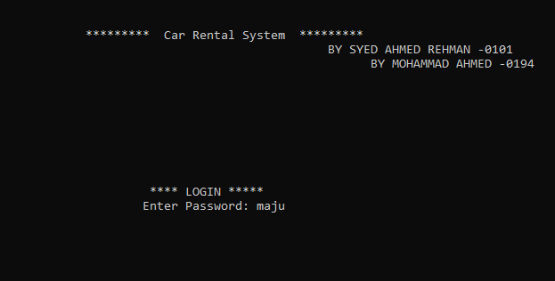

***INTRODUCTION***

The Car Rental System Project is designed in a Human-friendly Interface which helps customers of a car rental shop to go through their available cars and it’s specification and book the car whichever they like. This project is designed to aid the car rental company to enable renting of cars through an online system. It helps the users to search for available cars view profile and book the cars for the time period. It has a user-friendly interface which helps the user to check for cars and rent them for the period specified. The rental cars shall be categorized into average, luxury etc. Based on the type of car required by the customer, the user shall be able to make bookings. This Car Rental System makes the bookings easy. It saves time and labor. The tool shall ask the user for information such as the date and time of journey, type of car etc. Also, it will need an identification number. Using these details, the tool shall help the customer to book a car for the journey.

***PROBLEM STATEMENT***

* Will a customer have its own account info and privacy?
* After renting a car customer wouldn’t know total amount and rent charged per hour
* Customer might need to know more details about the car He’s renting.
* Customer cannot rent a car for his other relatives or friends once at a time.

***SOLUTION***

* Customers has to enter their password for it’s personal account and settings which provides privacy
* Before Confirming booking system will show total payment so user can check it’s balance
* The customer will be shown more detailed specification of a car ones he choses a car.
* They can book multiple cars at the same time.

***FEATURES***

* This Program shows login page so user can have privacy of their account.
* This Program helps user choose car which suits their budget, choice and personality by showing detailed statistics of every car.
* Program automatically calculates total rent of car user just need to choose its favorite car and total days he will use
* Program automatically generates receipt of the complete transaction and info

***SOURCE CODE***

#include <iostream>

#include <stdlib.h>

using namespace std;

// SYSTEM(PAUSE) = USES TO PAUSE THE PROGRAM

// SYSTEM(CLS) = CLEARS THE SCREEN

struct Cars {

string name [8] = {"Suzuki","Audi","Lamborghini","Toyota","Hyundai","Honda","BMW"};

string color [8]={"White","Purple","Blue","Gun Metallic","Red","Maroon","Silver" };

string m_speed [8]={"180 Km/h ","230 Km/h","300 Km/h","210 Km/h","130 Km/h","220 Km/h","270 Km/h"};

int model [8]= { 2010 , 2017 , 2019 , 2014 , 2013 , 2015 , 2018 };

int price [8] ={8000,19000,25000,9000,8000,11000,23000 } ;

string category [8] = {"Moderate","LUXURY","SUPREME","HIGH","MODERATE","S-CLASS","LUXURY"};

};

struct Info {

string Name [10];

string Natio_ID [10] ;

int payment_acc [ 10] ;

};

Cars car ;

Info info ;

int login(){

string pw ;

string ch;

cout <<"\n\n\n\n\t\t\t\t\t********* Car Rental System *********";

cout <<" \n\t\t\t\t\t\t BY SYED AHMED REHMAN -0101 ";

cout <<" \n\t\t\t\t\t\t BY MOHAMMAD AHMED -0194 ";

cout<<" \n\n\n\n\n\n\n\n\n\t\t\t\t\t\t **** LOGIN ***** ";

cout << "\n\t\t\t\t\t\tEnter Password: ";

cin>>ch ;

pw = ch ;

if(pw == "maju"){

cout << "\n\n\n\n\t\t\t\t\t Access Granted! Welcome To Our System \n\n";

system("PAUSE");

system("CLS");

}

else{

cout << "\n\n\n\n\t\t\t\t\tAccess Aborted...Please Try Again!!\n";

system("PAUSE");

system("CLS");

login();

}

}

void list ()

{

int num=1;

for(int i=0 ;i<7;++i)

{

cout<<"\t\t\t";

cout<<"Enter " <<num<<"\t- To Select "<<car.name[i]<<endl;

num++ ;

}

}

void Details (int theChoice)

{

system("CLS");

cout<<"\n\n\n\t\t\t-----------------------------\n";

cout<<"\t\t\tYou Have Selected - "<<car.name[theChoice-1]<<endl;

cout<<"\t\t\t-----------------------------\n\n\n";

cout<<"\t\t\tColor : "<<car.color[theChoice-1]<<endl;

cout<<"\t\t\tModel : "<<car.model[theChoice-1]<<endl;

cout<<"\t\t\tCategory : "<<car.category[theChoice-1]<<endl;

cout<<"\t\t\tPrice = "<<"PKR"<<car.price[theChoice-1]<<" **PER DAY**"<<endl;

}

void check (int j )

{

if(info.payment_acc[j] >= car.price[j])

cout<<"\n\n\n\t\t\tProcess has been done successfully!! " <<endl;

else

cout<<"\n\n\n\t\t\tNot Available " <<endl;

}

void user_input (int theChoice, int tot)

{

system("CLS");

int j=theChoice-1 ;

cout<<"\t\t\t----------------------------------------\n";

cout<<"\t\t\tPlease Provide Your Personal Details : \n";

cout<<"\t\t\t----------------------------------------\n\n";

cout<<"\n\tNOTE: PROVIDE FIRST NAME ONLY, DONOT ENTER SPACE WHILE PROVIDING NAME,\n\tPAYMENT WON'T PROCEED IF THE GIVEN AMOUNT IS LESS THEN THE RATE OF CAR\n\n\n\n";

cout<<"\n\t\tYOUR TOTAL AMOUNT IS = "<< tot<<"PKR";

cout<<"\n\n\t\t\tEnter Your Name : ";

cin>>info.Name[j];

cout<<"\t\t\tEnter Your National ID : ";

cin>>info.Natio_ID[j] ;

cout<<"\t\t\tPayment Amount: " ;

cin>>info.payment_acc[j] ;

check( j ) ;

}

int rent(int x,int num){

int tot ;

tot = car.price[num-1]*x ;

return tot ;

}

void showrent(int theChoice,int days,int rent )

{

system("CLS");

cout << "\n\t\t Car Rental - Customer Invoice "<<endl;

cout << "\t\t ///////////////////////////////////////////////////////////"<<endl;

cout << "\t\t | Invoice No. :"<<"------------------|" <<"#FA22BSCS"<<" |"<<endl;

cout << "\t\t | Customer Name:"<<"-----------------|" <<info.Name[theChoice-1]<<" |"<<endl;

cout << "\t\t | Car Name :"<<"--------------------|" <<car.name[theChoice-1]<<" |"<<endl;

cout << "\t\t | Number of days :"<<"---------------|" <<days<<" |"<<endl;

cout << "\t\t | Your Rental Amount is :"<<"--------|" <<rent<<" |"<<endl;

cout << "\t\t ________________________________________________________"<<endl;

cout <<"\n";

cout << "\t\t | Total Rental Amount is :"<<"-------|" <<rent<<" |"<<endl;

cout << "\t\t ________________________________________________________"<<endl;

cout << "\t\t # This is a computer generated invoce and it does not"<<endl;

cout << "\t\t require an authorised signture #"<<endl;

cout <<" "<<endl;

cout << "\t\t ///////////////////////////////////////////////////////////"<<endl;

cout << "\t\t You are advised to pay up the amount before due date."<<endl;

cout << "\t\t Otherwise penelty fee will be applied"<<endl;

cout << "\t\t ///////////////////////////////////////////////////////////"<<endl;

int f;

system("PAUSE");

system ("CLS");

}

int main()

{

int ren;

int login();

login();

string decide ="yes" ;

cout<<"\t\t\t----------------------------------------------\n";

cout<<"\t\t\t\tSIMPLE CAR RENTAL SYSTEM \n";

cout<<"\t\t\tWelcome to Our Company ,Choose from the menu : "<<endl;

cout<<"\t\t\t----------------------------------------------\n";

while(decide!="exit")

{

list();

cout<<"\n\n\n\t\t\tEnter Only the Number to select the Car : ";

int theChoice,tot ;

cin>>theChoice ;

Details(theChoice);

cout<<"\n\n\n\t\t\tEnter the Number of Days you want to Rent this Car for = ";

cin>>ren;

cout<<" \n\n\n\t\t\tTOTAL PRICE IS = "<<rent(ren,theChoice)<<"PKR" ;

tot = rent(ren,theChoice) ;

cout<<"\n\n\n\t\t\tAre You Sure, you want to rent this Car? (yes /no /exit ) : ";

cin>>decide ;

if(decide=="yes") {

user_input(theChoice,tot);

showrent(theChoice,ren,tot) ;

cout<<"\n\n\t\t\tDo you want to continue ?(yes/no) ";

cin>>decide;

if (decide=="no") break ;

system("CLS");

}

else {

if(decide=="no")

{

system("CLS");

continue ;

}

else if (decide=="exit")

{

system("CLS");

break ;

}

}

}

return 0;

}

***ALGORITHM***

* The program starts with a home screen that contains a login screen.
* If you try log in by Admin it requires a password that only admins know. If the password matches, it allows you to login. Once the password is matched, the program will take you to a new screen where you can perform different tasks.
* The screen will display a list of cars with the given number and user can choose the following car after entering the number of the given car.
* After choosing a specific car the program will output the detailed specification of the following car for e.g it’s price, color and it’s rent charged per day. The user will be asked to input the number of days he want to rent this car for.
* After the user enters the number of rent day program will output a confirmation message for the order.
* After the confirmation the program will output total amount and will take user information for security purposes. If user doesn’t confirm the purchase the program will end.
* After the program take user info and collect the user total amount it will print a final invoice which will show the total amount of user rent and its info.

***RESULTS***

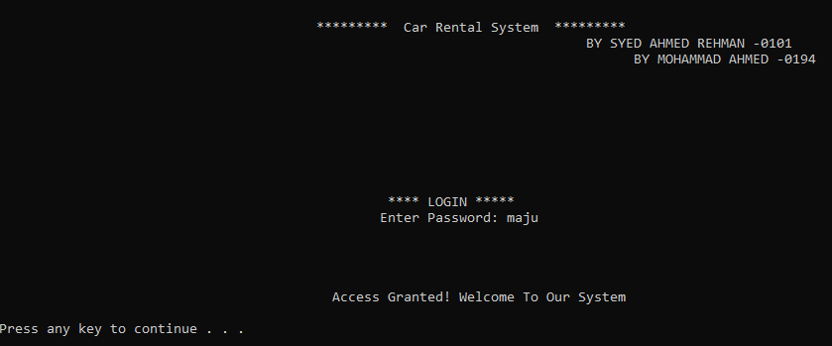

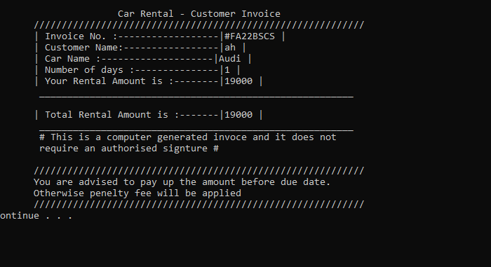

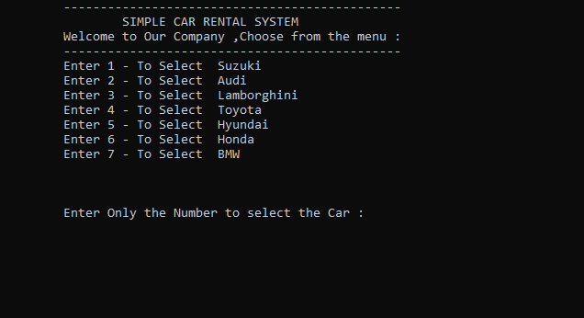

***CONCLUSIONS***

**1) the group's experience with the project (which steps were the most**

**difficult? Which were the easiest? what did you learn that you did not**

**imagine you would have? if you had to do it all over again, what would you**

**have do****ne differently?)**

**ANS-** The Project helped us in aspects which were not just related to the education but it also involved understanding the capability of each member and knowing what each of our members our good in. It helped us increase our group synergy and chemistry which could help us in other aspects of our lives as well. There were some functions like system() which earlier didn’t knew about and it helped us in organizing our program according to our plan we learned how working outside the comfort zone is actually like,there were some parts where every member would help each other in helping other understood some programming concepts which helped thorough learning of every concept we learned this semester.

* The Most difficult step was planning the project and since it was the first time we all were confused like where to start, as well there was lack of believe in each of us that we couldn’t complete this project.
* The Easiest part was the whole project itself after we started believing that this project could be completed by using the concepts we know about programming and believing each other.
* The thing we learned and couldn’t have imagined that we would ever learn was that we will ever make a programming system based on the real world problem
* If we had to do all over again we will plan better functions and use better programming techniques so that program could be more efficient and more effective .

**b) any final comments and conclusions**

**ANS-** Learned a lot and it made our programming concepts strong learned some new functions as well and experienced how to work in group and team.