Using sed utility

1. Display the lines that contain the word “lp” in /etc/passwd file.

{sed -n '/lp/p' /etc/passwd)

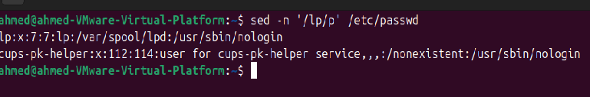

1. Display /etc/passwd file except the third line.

{sed ‘3d’ /etc/passwd}

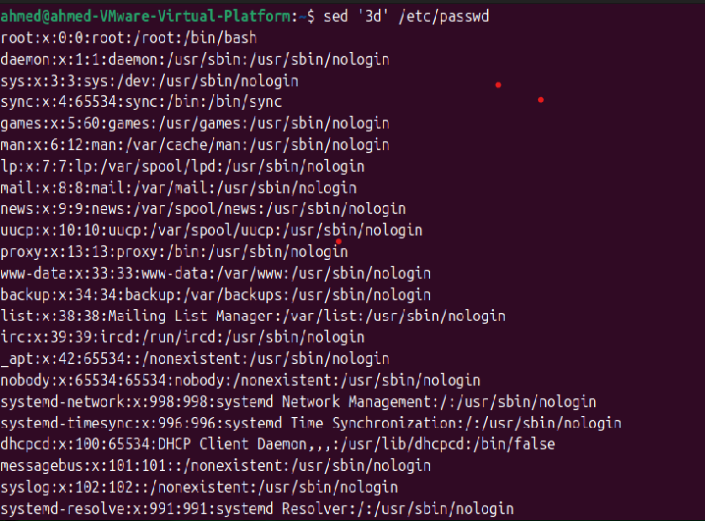

1. Display /etc/passwd file except the last line.

sed '$d' /etc/passwd

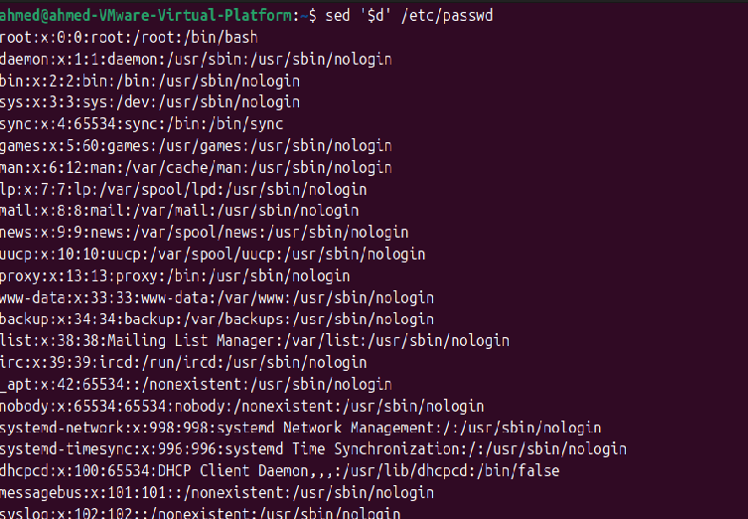

1. Display /etc/passwd file except the lines that contain the word “lp”.

sed '/lp/d' /etc/passwd

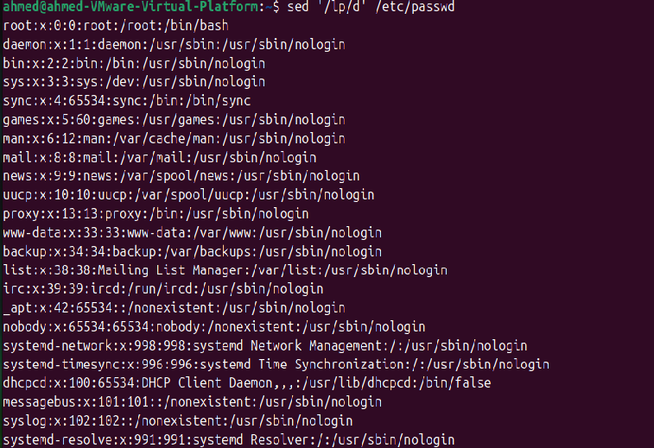

1. Substitute all the words that contain “lp” with “mylp” in /etc/passwd file.

Sed ‘s/lp/mylp/g’ /etc/passwd

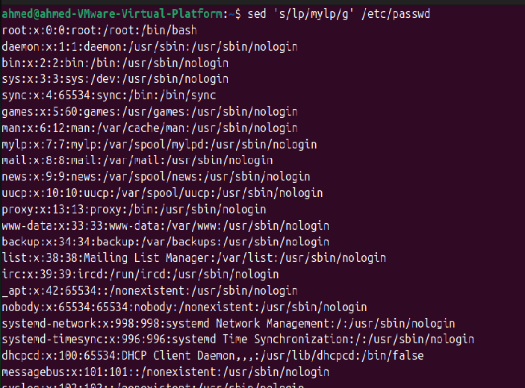

Using awk utility

1. Print full name (comment) of all users in the system.

awk -F: ‘{print $5}’ /etc/passwd

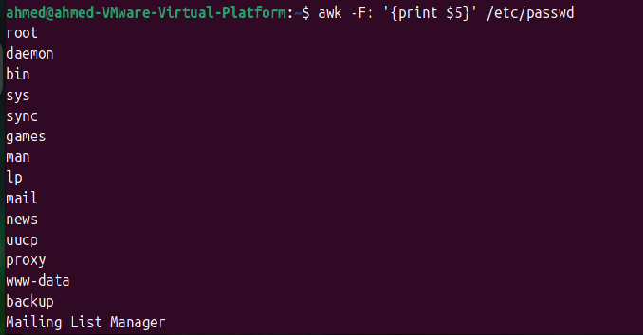

2- Print login, full name (comment) and home directory of all users.( Print each line preceded

by a line number)

awk -F: ‘{print NR, $1, $5, $6}’ /etc/passwd

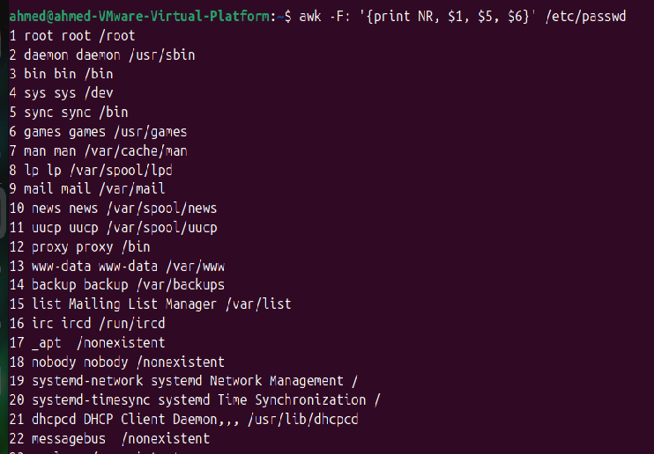

3-Print login, uid and full name (comment) of those uid is greater than 500

awk -F: ‘$3 > 500 {print $1, $3, $5}’ /etc/passwd

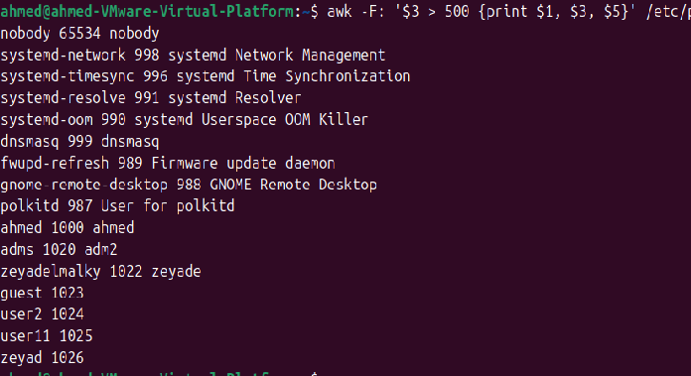

4- Print login, uid and full name (comment) of those uid is exactly 500

awk -F: '$3 == 500 {print $1, $3, $5}' /etc/passwd



5- Print line from 5 to 15 from /etc/passwd

awk 'NR>=5 && NR<=15' /etc/passwd

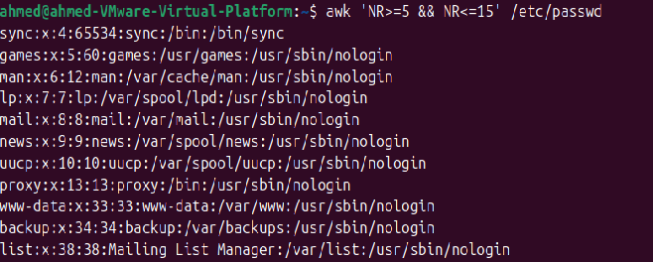

6- Change lp to mylp

awk ‘{gsub(/lp/, “mylp”); print}’ /etc/passwd

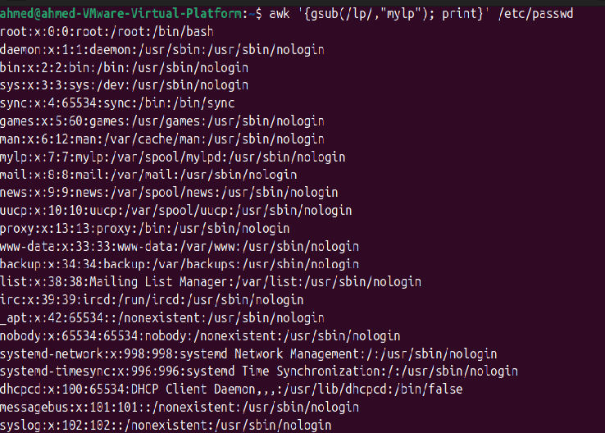

7- Print all information about greatest uid.

Awk -F: ‘max<$3 {max=$3; user=$0} END {print user}’ /etc/passwd

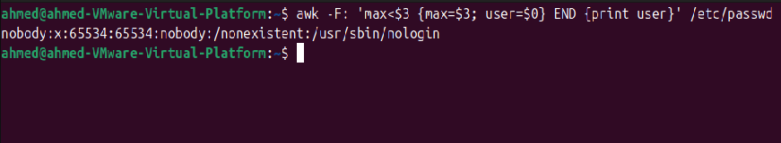

8- Get the sum of all accounts id’s.

awk -F: '{sum += $3} END {print sum}' /etc/passwd 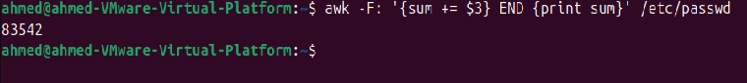

Bonus

1. Get the sum of accounts id’s that has the same group.

awk -F: '{sum[$4] += $3} END

{for (g in sum) print "Group ID:", g,

"Sum of UIDs:", sum[g]}' /etc/passwd

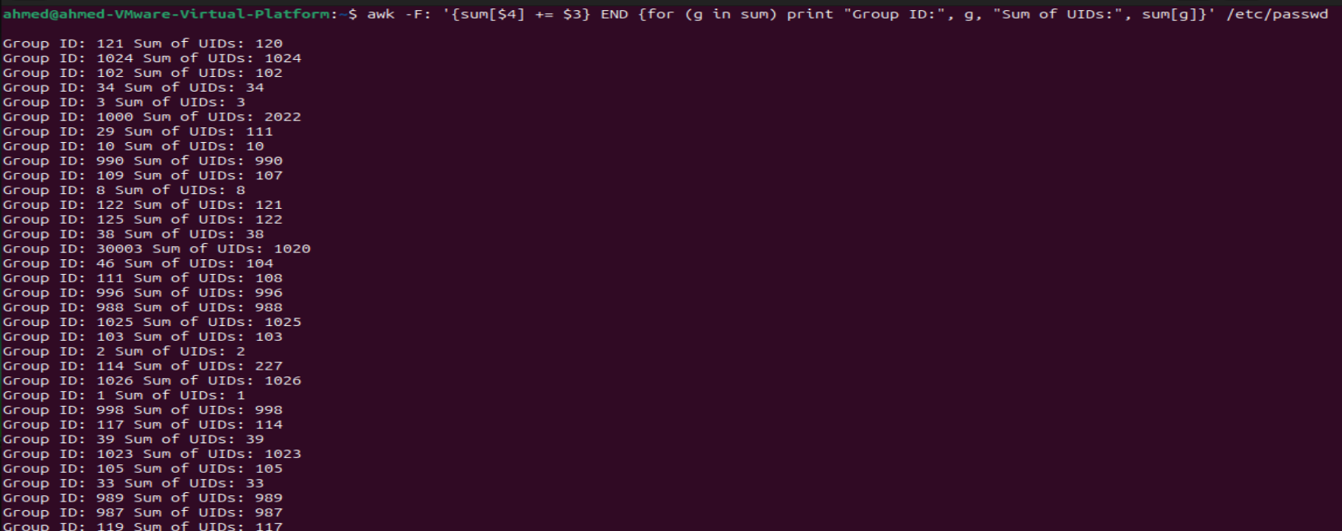

2. Make the following report:

User-Group Report

--------------------------

Group1 Name:

User1

User2

Group2 Name:

User3

User4

awk -F: '{users[$4] = users[$4] "\n " $1}

END {for (group in users) {print "Group ID:", group print users[group] "\n"}}' /etc/passwd

