Sales & Customer Dashboard Documentation
1. Overview
This section documents the Sales & Customer Dashboard created in Power BI, presenting key business metrics, pricing analysis, customer RFM segmentation, revenue trends over time, and customer geographic distribution.
2. KPI Cards
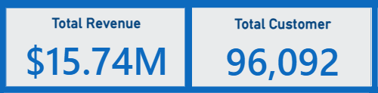
- Total Revenue | $15.74M
  - Cumulative payment value across all orders.
- Total Customer | 96,092
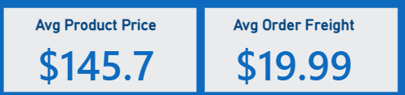
  - Total count of distinct customers.
- Avg Product Price | $145.7
  - Average price of products.
- Avg Order Freight | $19.99
  - Average freight value per order.

3. Dashboard Visuals
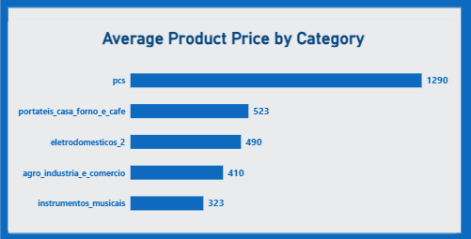
A. Average Product Price by Category (Bar Chart)
Displays the top categories ranked by average product price:
- pcs: $1290
- portateis_casa_forno_e_cafe: $523
- eletrodomesticos_2: $450
- agro_industria_e_comercio: $410
- instrumentos_musicais: $323
B. Customers by RFM Segment (Donut Chart)
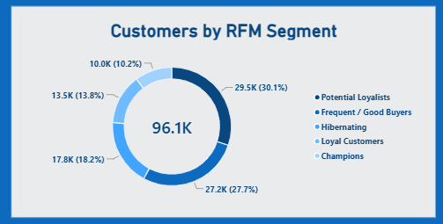
Segments the total customer base of 96.1K customers into RFM categories:
- Potential Loyalists: 29.0K (30.1%)
- Champions: 26.6K (27.7%)
- Frequent / Good Buyers: 17.5K (18.2%)
- Loyal Customers: 11.7K (12.2%)
- Low Value / Regular: 11.3K (11.8%)
C. Sales Trend over Time (Area Chart)
Tracks revenue values across quarters:
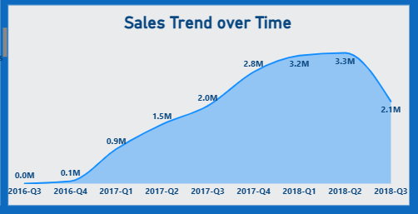
- 2016-Q3: 0.0M
- 2016-Q4: 0.1M
- 2017-Q1: 0.9M
- 2017-Q2: 1.5M
- 2017-Q3: 2.0M
- 2017-Q4: 2.8M
- 2018-Q1: 3.2M
- 2018-Q2: 3.3M
- 2018-Q3: 2.1M
- 📌 Data Note on 2018-Q3 Trend Drop
The drop observed in 2018-Q3 ($2.1M) does not indicate a decline in business sales performance. Instead, it is due to data truncation (partial data collection), as the dataset records conclude mid-quarter in August 2018 and do not represent a full 3-month reporting period.

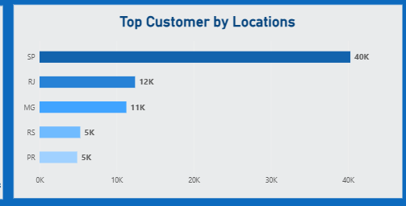
D. Top Customer by Locations (Bar Chart)
Shows customer count across top states:
- SP: 42K
- RJ: 13K
- MG: 11K
- RS: 5.5K
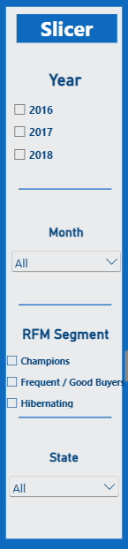
- PR: 5K
4. Dashboard Slicers
- Year Slicer: Filters data by year (2016, 2017, 2018).
- Month Slicer: Dropdown filter for months (All).
- RFM Segment Slicer: Checkbox filter for RFM segments (Champions, Frequent / Good Buyers, Low Value / Regular).
- State Slicer: Dropdown filter for states (All).

5. Dashboard
