Cairo University  
Faculty of Computers and Information



**CS251**

**Software Engineering I**

Phase 2

Contents

Instructions [To be removed] 3

Team 3

Document Purpose and Audience 3

System Models 3

I. Class diagrams 3

Important Algorithm 5

II. Sequence diagrams 5

Class - Sequence Usage Table 7

Ownership Report 8

Policy Regarding Plagiarism: 8

References 8

Authors 8

***Team***

|  |  |  |  |
| --- | --- | --- | --- |
| ***ID*** | ***Name*** | ***Email*** | ***Mobile*** |
| 20140001 | Abraam Emad Reda | abraamaj27@gmail.com | 01278055444 |
| 20140004 | Ahmed Ibrahim Mokhtar | ahmed0123031@gmail.com | 01225068308 |
| 20140177 | Ali Mohamed EL-Amin | Ali.amin823@gmail.com | 01112794151 |

# 

# Document Purpose and Audience

This document includes design of the educational website that’s make to help students to understand basic educational concepts

* **Class Diagram** : this diagram represent the system as classes and relations between this classes, attributes and functions of every class.
* **Sequence diagram** : this diagram represent sequence function that actor ( teacher-student) do within objects

**The Audience :** project manager – developer- customer

# System Models

## I. Class diagrams

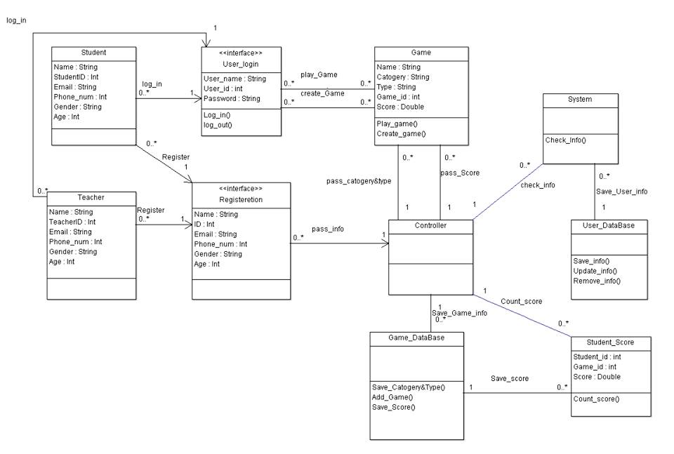

| **Class ID** | **Class Name** | **Description & Responsibility** |
| --- | --- | --- |
| 1 | Student | * Have attributes (name,studentID-Email-PhoneNumber-Gender-Age) * This class used to collect Student information |
| 2 | Teacher | * Have attributes (name-teacherID-Email-PhoneNumber-Gender-Age ) * This class used to collect Teacher information |
| 3 | Game | * Have attributes ( name-category-type-gameID-score) * Has a method (play game – create game) |
| 4 | Controller | * This class used to manage the system |
| 5 | System | * Have methods (check_information) * This class used to check information of the student or teacher before saving in user database |
| 6 | User Login | * Have attributes (username-userID-Password) * Have methods (login-logout) * This class used as interface between actor and system to login or logout from the website |
| 7 | Registeration | * Have attributes (name,ID-Email-PhoneNumber-Gender-Age ) * This class used as interface between actor and system to register |
| 8 | Student_Score | * Have attributes (gameID-StudentID-Score) * Has a method count_score * This class used to count the score of the student that’s achieve in a game before saving it in game database |
| 9 | User DataBase | * Have methods(save_information-update_information – remove_information) * This class used to call a functions that’s save information of the user in the database |
| 10 | Game DataBase | * Have functions save_category and types – save score – addGame * Thos class used to call a functions that’s save category and types ,save_score and addGame |

## 

## II. Sequence diagrams

**1 ) Registeration**

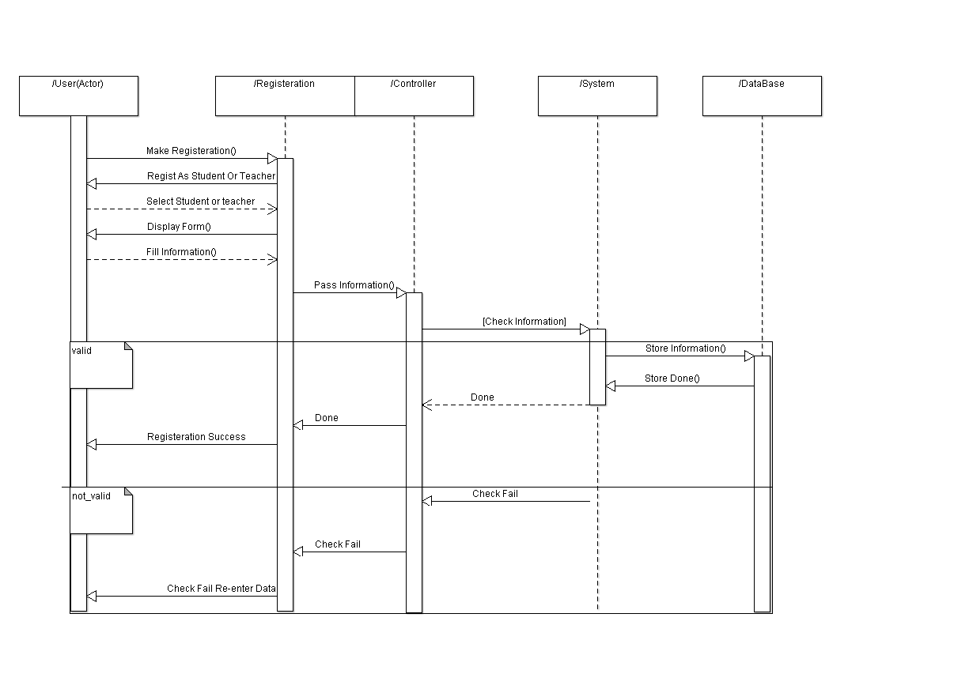

***2) play game***

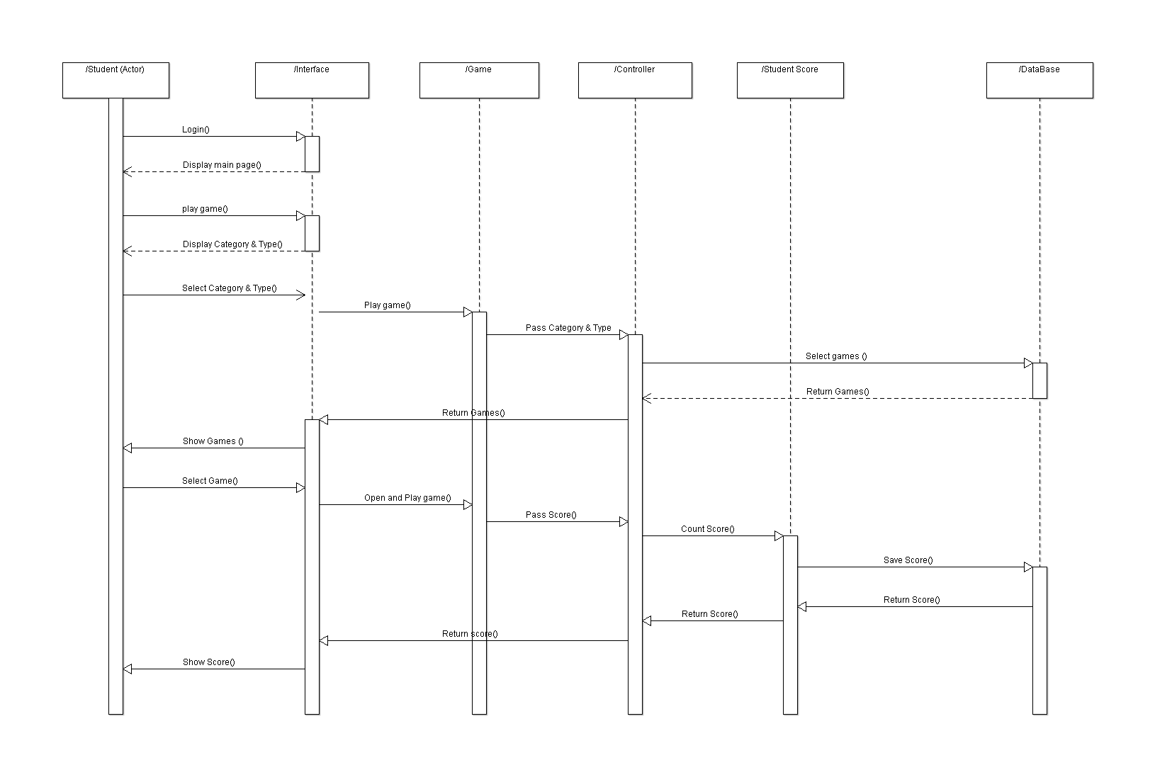

***3) create game***

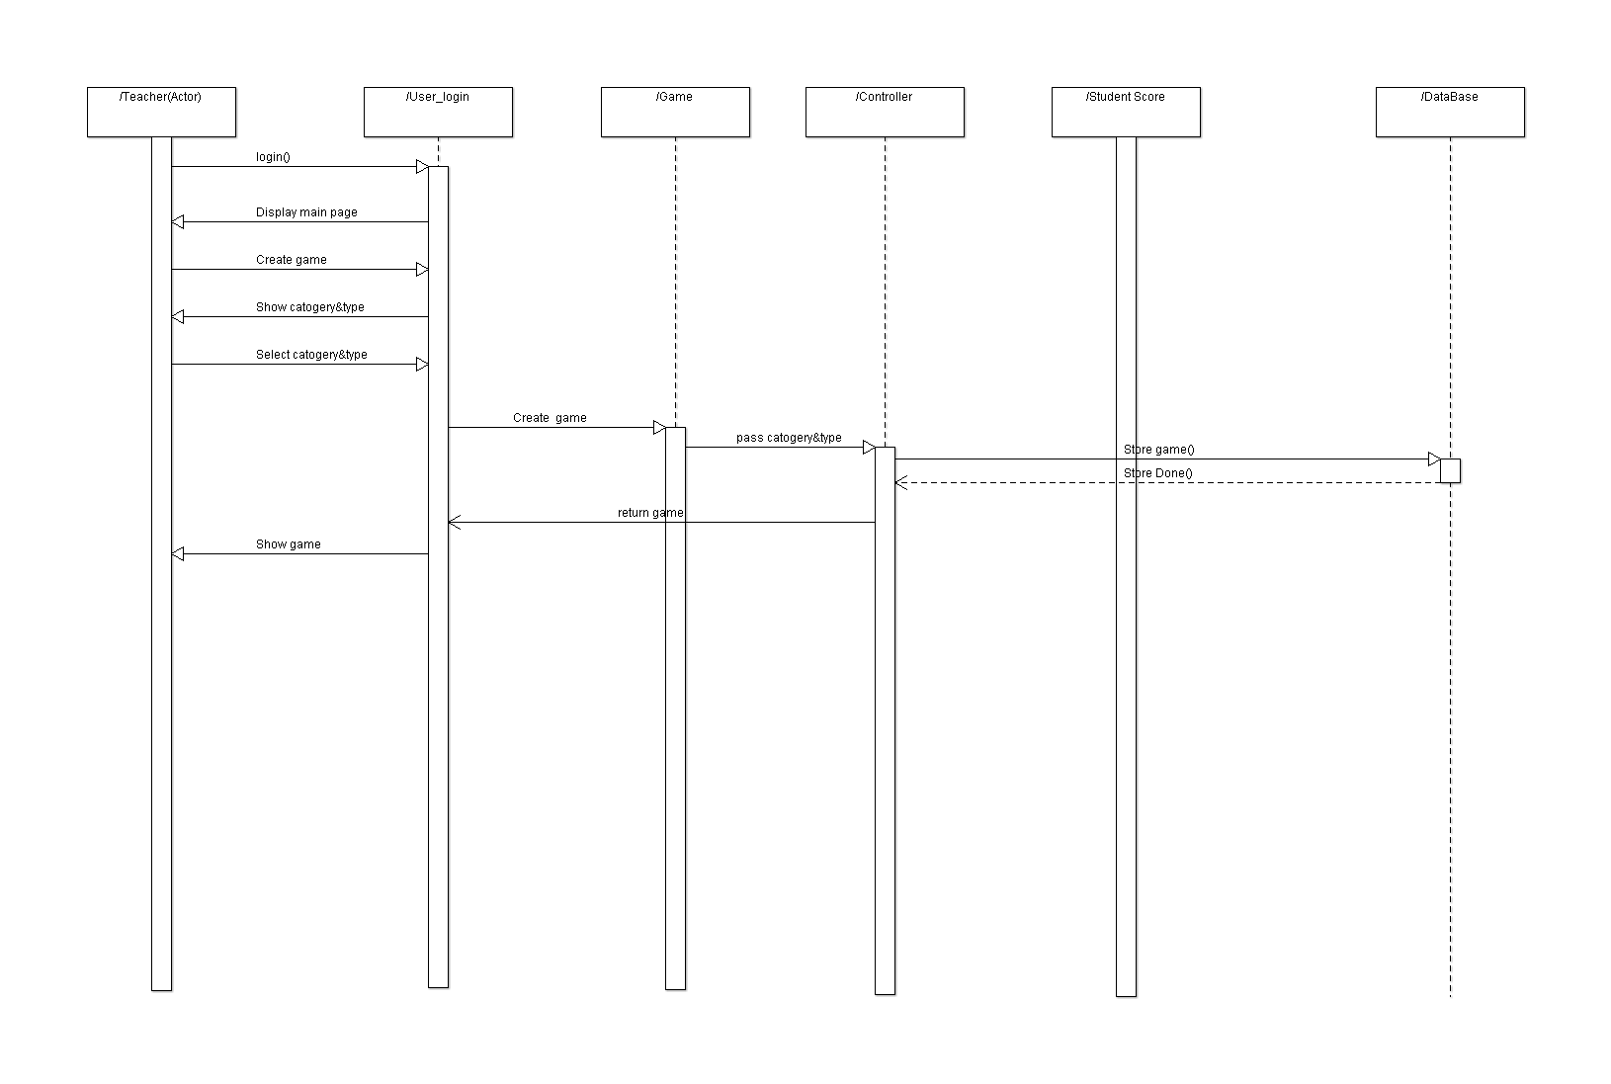

### Class - Sequence Usage Table

* **In this table, we will list EVERY class in class diagram and which sequences used this class diagram. This helps in avoiding either unused classes or extra classes appears in sequence diagrams. In "Overall used methods" section, put all functions appeared in all sequences. If this table was built in ignorance of actual class / sequence diagrams = REJECTED for whole document.**

| **Class Name** | **Sequence Diagrams** | **Overall used methods** |
| --- | --- | --- |
| Student | 1,2 | Log in – make registeration |
| Teacher | 1,3 | Log in – make registeration |
| Game | 2,3 | PlayGame – CreateGame |
| Controller | 1,2,3 |  |
| System | 1 | Check user information |
| User Login | 2,3 | Login |
| Registeration | 1 |  |
| Student_Score | 2 | Calculate studentScore |
| User DataBase | 1 | Save,update and remove user information |
| Game DataBase | 2,3 | Save GameInformation |

# Ownership Report

|  |  |
| --- | --- |
| **Item** | **Owners** |
| Class Diagram – sequence Diagram 1 | *Abraam Emad* |
| Class Diagram –Sequence Diagram 2 | *Ahmed ibrahim mokhtar* |
| Class Diagram –Sequence Diagram 3 | *Ali Mohamed EL-Amin* |