UC AIwan+ Student Support System

Complete System Documentation for Turnover
Document Version: 1.0
Last Updated: December 5, 2025
System Version: 2.0.0

TABLE OF CONTENTS
- System Overview
- System Architecture
- Technical Documentation
- Database Documentation
- Administrative & Security
- Known Issues & Recommendations

1. SYSTEM OVERVIEW

1.1 Executive Summary
UC AIwan+ is a comprehensive multi-service student support platform designed for the University of the Cordillera. The system integrates mental health awareness, wellbeing support, career development, and digital literacy services into a unified platform.

Purpose
- Provide holistic student support services through a single digital platform
- Enable anonymous reporting and feedback mechanisms
- Gamify career development and mental wellness activities
- Track student engagement and progress across all services

Target Users
- Primary: 15,000+ high school and college students
- Secondary: University administrators and support staff

Key Capabilities
- Anonymous student reporting system with AI-powered emotion detection
- Gamified career development trail (Career Clues) with 6 core missions + monthly challenges
- Mental health toolkit (eMindCare) with interactive activities
- Points and voucher reward system
- Multi-department admin dashboard with intelligent report routing

1.2 System Features

Student-Facing Features
Feature | Description | Status
Submit Report | Anonymous concern submission with AI analysis | Active
Track Report | View report status using tracking ID | Active
Career Clues | Gamified career development trail (6 missions + monthly). Desktop: 3D view, Mobile: 2D map view | Active
eMindCare | Mental health toolkit with 8+ interactive activities | Active
Awareness Desk | Digital awareness and help desk resources | Active
Voucher Redemption | Redeem points for vouchers | Active
Chatbot | FAQ assistant | Active

Admin-Facing Features
Feature | Description | Access
Admin Dashboard | Overview of reports and analytics | All Admins
Manage Reports | View, respond, forward reports | All Admins
CACC Dashboard | Career Clues management, certificates, leaderboard | CACC Admin
Manage Vouchers | Create and manage vouchers | CACC, GSWC, SAS
Manage Activities | Create and manage activities | All Admins
Manage FAQs | Create and manage chatbot FAQs | SAS Admin
Manage Admins | Create and manage admin accounts | SAS Admin
View Thoughts | Review student feedback | SAS, SDWC

1.3 User Roles & Access Matrix

Admin Roles
Role | Code | Responsibilities
SAS Manager | sas_manager | System oversight, all access, admin management
CACC Admin | cacc | Career services, vouchers, career clues management
GSWC Admin | gswc | Student welfare, vouchers, wellbeing reports
SDWC Admin | sdwc | Digital awareness, help desk, student thoughts
Note: Admins can see student Tracking IDs in the admin reports page for reference and follow-up purposes.

Access Control Matrix
Feature | SAS | CACC | GSWC | SDWC
View All Reports | Yes | No | No | No
Manage Vouchers | Yes | Yes | Yes | No
Manage FAQs | Yes | No | No | No
Manage Admins | Yes | No | No | No
Career Clues Admin | No | Yes | No | No
View Student Thoughts | Yes | No | No | Yes
Forward Reports | Yes | Yes | Yes | Yes

1.4 Report Routing System
Reports are automatically routed to departments based on AI analysis:

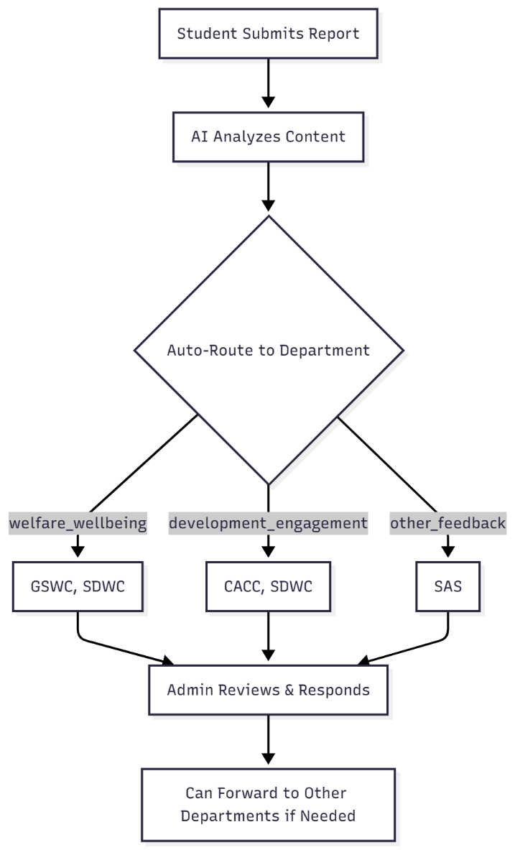

2. SYSTEM ARCHITECTURE

2.1 Architecture Diagram
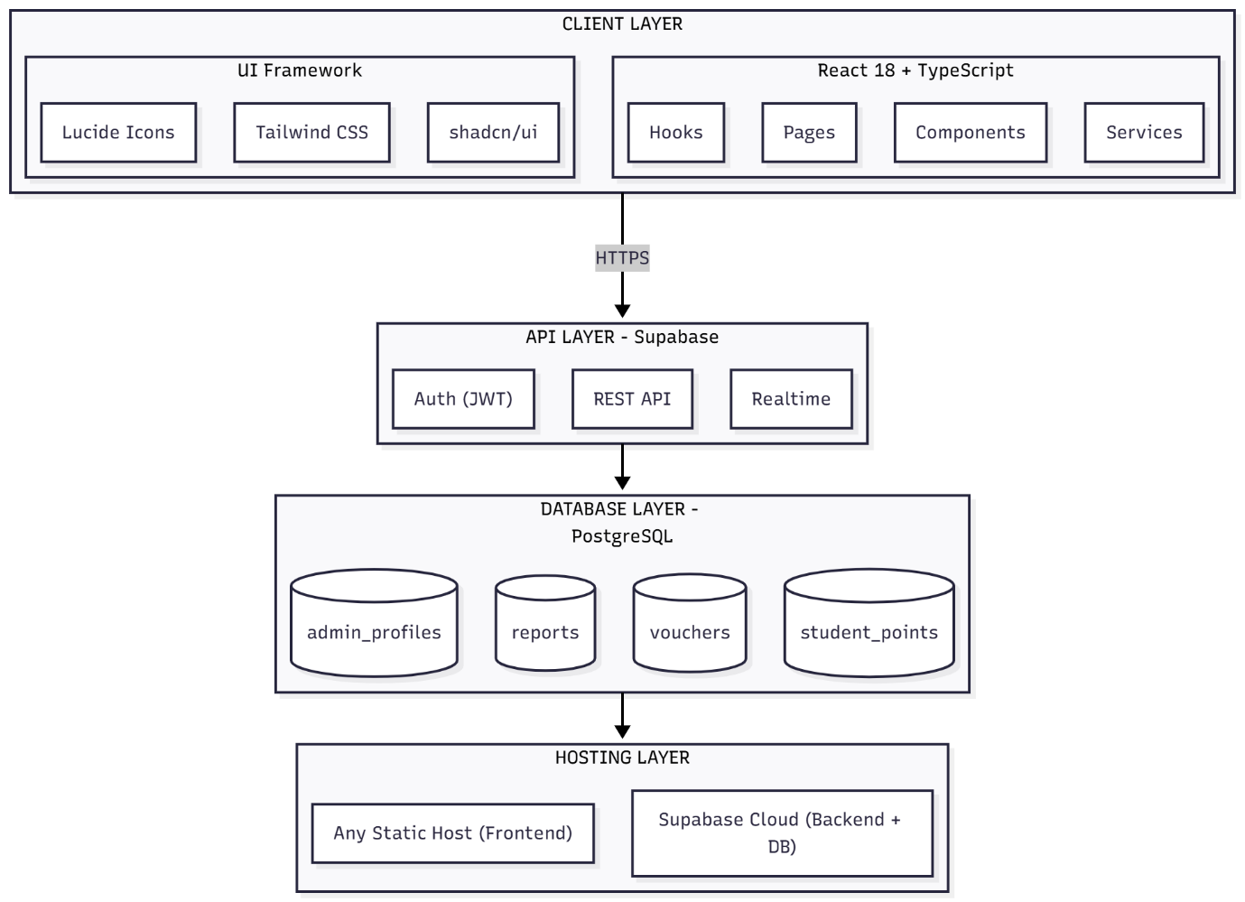

2.2 Data Flow Diagram

Student Report Submission Flow
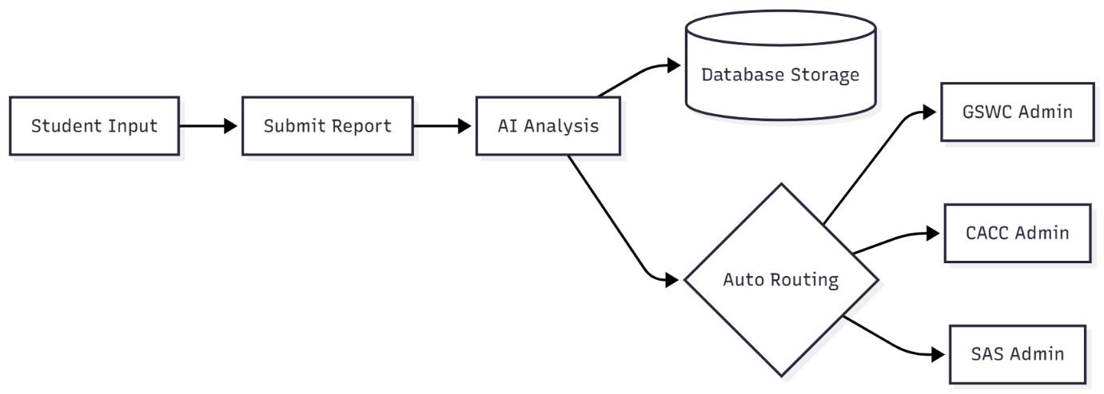

Career Clues Progress Flow

3. TECHNICAL DOCUMENTATION

3.1 Technology Stack

Frontend
Technology | Version | Purpose
React | 18.3.1 | UI Framework
TypeScript | 5.8.3 | Type Safety
Vite | 5.4.19 | Build Tool
Tailwind CSS | 3.4.17 | Styling
shadcn/ui | Latest | UI Components
Lucide React | 0.462.0 | Icons
Three.js | 0.158.0 | 3D Graphics (Career Clues - Desktop only)
React Three Fiber | 8.15.6 | React Three.js Integration (Desktop only)
Note: Career Clues uses 3D view on desktop browsers and 2D map view on mobile devices for performance optimization.

Backend
Technology | Version | Purpose
Supabase | 2.74.0 | Backend-as-a-Service
PostgreSQL | 15+ | Database
Supabase Auth | Built-in | Authentication (JWT)

Additional Libraries
Library | Purpose
html2canvas | Image export
jspdf | PDF generation
perfect-freehand | Drawing tools
recharts | Charts and analytics
date-fns | Date utilities

3.2 Project Structure
src/
├── components/ # Reusable UI components
│ ├── ui/ # shadcn/ui components
│ ├── Header.tsx # Main navigation header
│ ├── ChatbotWidget.tsx # FAQ chatbot
│ ├── CareerCluesComponents.tsx # Career Clues UI
│ ├── EmotionTracker.tsx # Mood tracking
│ ├── MandalaStudioFresh.tsx # Mandala coloring
│ ├── MindsetMakeover.tsx # Thought analysis
│ ├── GratitudeJournal.tsx # Journaling
│ ├── MoodChart.tsx # Mood visualization
│ ├── SelfCareChallenge.tsx # 30-day challenge
│ └── RainbowWalkGrounding.tsx # Grounding exercise
│
├── pages/ # Route pages
│ ├── Index.tsx # Homepage
│ ├── SubmitReport.tsx # Report submission
│ ├── TrackReport.tsx # Report tracking
│ ├── CareerClues.tsx # Career Clues main page
│ ├── EMindCare.tsx # Mental health toolkit
│ ├── AwarenessDesk.tsx # Digital awareness
│ ├── AdminDashboard.tsx # Admin overview
│ ├── AdminReports.tsx # Report management
│ ├── CACCAdminDashboard.tsx # Career Clues admin
│ ├── ManageVouchers.tsx # Voucher management
│ ├── ManageActivities.tsx # Activity management
│ ├── ManageFAQs.tsx # FAQ management
│ ├── ManageAdmins.tsx # Admin management
│ └── ViewThoughts.tsx # Student thoughts
│
├── services/ # AI & Business logic
│ ├── aiAnalytics.ts # Main AI orchestrator (entry point)
│ ├── advancedEmotionEngine.ts # Contextual pattern matching
│ ├── emotionDetectionEngine.ts # Basic keyword detection
│ ├── llmEmotionClassifier.ts # Hugging Face API integration
│ └── thoughtSuggestions.ts # CBT suggestions for MindsetMakeover
│
├── integrations/ # External integrations
│ └── supabase/
│ ├── client.ts # Supabase client
│ └── types.ts # Database types
│
├── providers/ # React context providers
│ └── AuthProvider.tsx # Authentication context
│
├── routes/ # Route protection
│ └── ProtectedRoute.tsx # Admin route guard
│
├── hooks/ # Custom React hooks
│ └── use-toast.ts # Toast notifications
│
└── lib/ # Utilities
└── utils.ts # Helper functions

3.2.1 UI Component Library (src/components/ui)
The src/components/ui directory contains the shared design-system primitives used across the entire application. These components are built on shadcn/ui and Tailwind CSS and provide consistent styling and behavior for common interface elements, including: - Buttons, inputs, textareas, selects, checkboxes, switches - Cards, dialogs, drawers, sheets, tooltips, toasts - Tables, tabs, navigation menus, pagination, and layout primitives
All pages and feature-specific components should import reusable elements from this folder instead of re-implementing basic UI. Typical imports look like: - import { Button } from "@/components/ui/button"; - import { Card } from "@/components/ui/card"; - import { Input } from "@/components/ui/input";
Updating components in src/components/ui allows future maintainers to adjust the global look-and-feel of UC AIwan+ (colors, spacing, interaction states) in one place without modifying every page individually.

3.2.2 AI Services Architecture (src/services/)
The system uses a layered approach for emotion/sentiment analysis, combining multiple methods for accuracy and reliability:
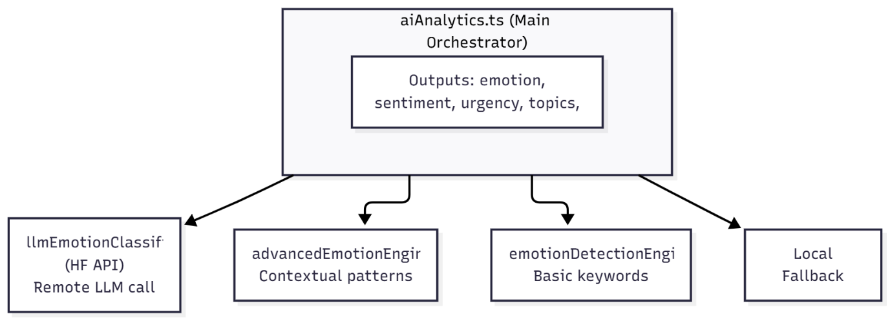

Why Multiple AI Services Instead of Just Hugging Face?
Reason | Explanation
Fallback | If Hugging Face API is down, rate-limited, or slow, local engines still provide analysis
Cost | HF API has usage limits; local analysis is free and unlimited
Speed | Local pattern matching is instant (~1ms); API calls add 200-500ms latency
Accuracy | Multiple methods combined give better results than any single method alone
Offline | System works without internet using local engines

Service Details
Service File | Method | Purpose
llmEmotionClassifier.ts | Hugging Face Inference API | Primary emotion detection - highest accuracy, requires VITE_HF_TOKEN
advancedEmotionEngine.ts | Contextual pattern matching | Catches nuanced phrases like “I can’t take this anymore”
emotionDetectionEngine.ts | Basic keyword detection | Fast baseline detection for common emotion words
aiAnalytics.ts | Orchestrator | Entry point - combines all above + adds urgency, topics, risk flags
thoughtSuggestions.ts | CBT-based suggestions | Used by MindsetMakeover for thought reframing

How Analysis Works
- Student submits report → SubmitReport.tsx calls analyzeReportText() from aiAnalytics.ts
- aiAnalytics.ts runs all detection methods in parallel
- Results are combined using weighted scoring (LLM results weighted higher if available)
- Final analysis includes: detected_emotion, sentiment, urgency_level, key_topics, risk_flags, tone
- Auto-routing uses analysis to assign report to appropriate department(s)

Hugging Face Token Setup
- Create account at huggingface.co
- Go to Settings → Access Tokens → Create new token (Read-only is sufficient)
- Add to .env: VITE_HF_TOKEN=hf_your_token_here
Note: The system works without the HF token - it will use local analysis only, which is still effective for most cases.

3.3 Environment Variables
Create a .env file in the project root:
# Supabase Configuration (Required)
VITE_SUPABASE_URL=https://your-project.supabase.co
VITE_SUPABASE_ANON_KEY=your-anon-key
# HuggingFace Token for AI (Optional - for enhanced emotion detection)
VITE_HF_TOKEN=your-huggingface-token
Security Notes: - Never commit .env to version control - Set environment variables in your hosting platform’s dashboard (not in code) - Rotate keys if compromised

3.4 Build & Deployment

Understanding the Build Process
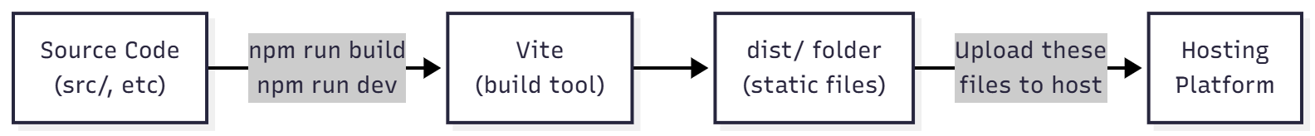

- Vite is the BUILD TOOL - it compiles your React/TypeScript code into static HTML/CSS/JS files
- Hosting platforms (Netlify, Vercel, GitHub Pages, etc.) SERVE those files to users
- You cannot “deploy to Vite” - Vite only builds, it doesn’t host

Local Development (using Vite dev server)
# Install dependencies
npm install
# Start Vite development server (hot reload, fast refresh)
npm run dev
# Access at http://localhost:8080

Production Build (using Vite)
# Build for production (creates dist/ folder)
npm run build
# Preview production build locally
npm run preview
After running npm run build, Vite creates a dist/ folder containing: - index.html - Main HTML file - assets/ - Bundled JS, CSS, images

Deployment Options (Hosting the dist/ folder)
The dist/ folder can be deployed to ANY static hosting service:
Option 1: Netlify (Free tier available)
npm install -g netlify-cli
netlify login
netlify deploy --prod --dir=dist
Option 2: Vercel (Free tier available)
npm install -g vercel
vercel --prod
Option 3: GitHub Pages (Free) - Push dist/ contents to a gh-pages branch - Or use GitHub Actions to automate
Option 4: Any Web Server - Upload dist/ folder contents to Apache, Nginx, or any static file server - Configure server to serve index.html for all routes (SPA routing)
Option 5: Cloud Providers - AWS S3 + CloudFront - Google Cloud Storage - Azure Static Web Apps - Cloudflare Pages

Setting Environment Variables in Production
Since .env is not committed to git, you must set environment variables in your hosting platform:
Platform | Where to Set
Netlify | Site Settings → Environment Variables
Vercel | Project Settings → Environment Variables
GitHub Pages | Use GitHub Secrets + build action
Others | Check platform documentation
Note: The system is NOT currently deployed to Netlify. You can choose any hosting platform. Supabase handles the backend and database.

4. DATABASE DOCUMENTATION

4.1 Entity Relationship Diagram

(To understand the relationship more please read 4.2 Table Definitions as a reference)
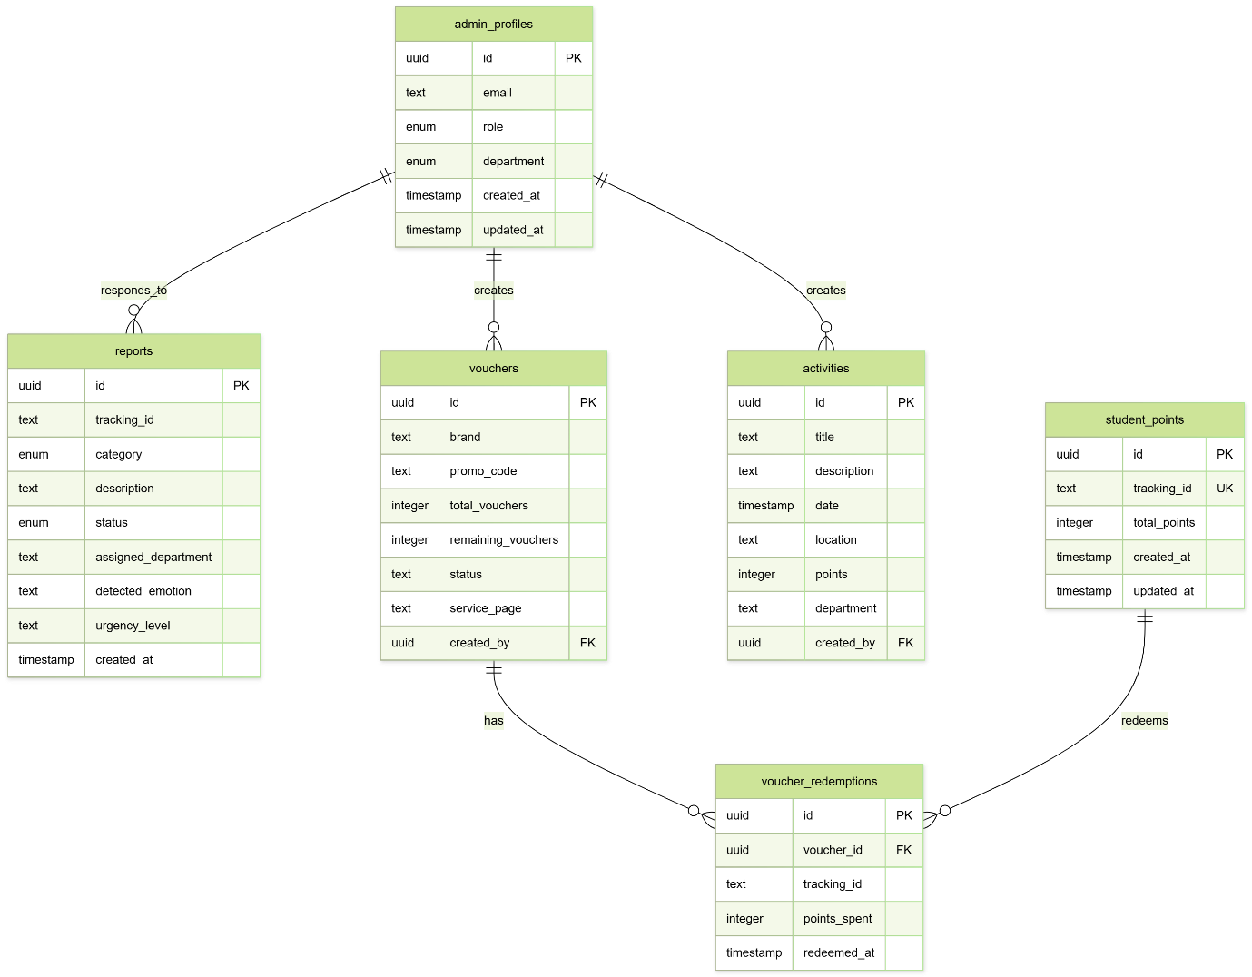

4.2 Table Definitions

reports
Primary table for student concern submissions.
Column | Type | Description
id | UUID | Primary key
tracking_id | TEXT | Student identifier
category | ENUM | Report category
description | TEXT | Report content
status | ENUM | submitted/in_progress/resolved
assigned_department | TEXT | Comma-separated dept codes
detected_emotion | TEXT | AI-detected emotion
sentiment | TEXT | positive/negative/neutral
urgency_level | TEXT | critical/high/medium/low
risk_flags | TEXT[] | Array of risk indicators
admin_response | TEXT | Admin reply
created_at | TIMESTAMP | Submission time

admin_profiles
Admin user accounts and roles.
Column | Type | Description
id | UUID | Primary key (links to auth.users)
email | TEXT | Admin email
role | ENUM | sas_manager/dept_admin
department | ENUM | cacc/gswc/sdwc/sas
created_at | TIMESTAMP | Account creation

student_points
Student points tracking.
Column | Type | Description
id | UUID | Primary key
tracking_id | TEXT | Student identifier (unique)
total_points | INTEGER | Current point balance
created_at | TIMESTAMP | First activity
updated_at | TIMESTAMP | Last activity

vouchers
Redeemable vouchers.
Column | Type | Description
id | UUID | Primary key
brand | TEXT | Voucher brand/title
promo_code | TEXT | Redemption code
total_vouchers | INTEGER | Initial quantity
remaining_vouchers | INTEGER | Available quantity
status | TEXT | active/inactive
service_page | TEXT | emindcare/career_trail
created_by | UUID | Admin who created

career_clues_progress
Student progress in Career Clues.
Column | Type | Description
id | UUID | Primary key
tracking_id | TEXT | Student identifier
mission_id | TEXT | Mission identifier
mission_data | JSONB | Mission responses
xp_earned | INTEGER | XP from mission
completed_at | TIMESTAMP | Completion time

monthly_challenges
Monthly challenge questions.
Column | Type | Description
id | UUID | Primary key
month_key | TEXT | Format: YYYY-MM
title | TEXT | Challenge title
question | TEXT | Challenge question
options | JSONB | Answer options
correct_answer | INTEGER | Correct option index
reward_points | INTEGER | XP reward
is_active | BOOLEAN | Currently active

4.3 Backup Information

Current Hosting
- Database: Supabase Cloud (PostgreSQL)
- Backup Schedule: Automatic daily backups by Supabase
- Retention: 7 days (Free tier) / 30 days (Pro tier)
  - What "Retention" means:
    - This refers to **LOG retention** (history of database queries, API calls, errors)
    - - It does NOT affect your actual data (reports, users, vouchers, etc.)

What | Free Tier (7 days) | Pro Tier (30 days)
Logs (query history, errors) | Deleted after 7 days | Deleted after 30 days
Your Data (tables, records) | Kept forever | Kept forever
Auth Users | Kept forever | Kept forever
Database Backups | 7 days of backups | 30 days of backups

In simple terms:
- Student reports, admin accounts, vouchers, and all other data are permanently stored and will NOT be deleted
- Only the debugging logs (what queries ran, who logged in when) are cleaned up after 7/30 days
- For most use cases, the Free tier is sufficient

Supabase Free Tier Limits
Resource | Free Tier Limit
Database Size | 500 MB
File Storage | 1 GB
Monthly Active Users | 50,000
API Requests  Realtime Connections | Unlimited  200 concurrent
If exceed these limits, consider upgrading to Pro ($25/month) or optimize your data.

Manual Backup
# Export database using Supabase CLI
supabase db dump -f backup.sql
# Or use pg_dump directly
pg_dump -h db.your-project.supabase.co -U postgres -d postgres > backup.sql

Restore
# Restore from backup
psql -h db.your-project.supabase.co -U postgres -d postgres < backup.sql

5. ADMINISTRATIVE & SECURITY

5.1 Access Credentials Inventory

Admin Accounts
Admin accounts are managed through the SAS Manager interface at /sas/manage-admins.
Role | Access Level | Created By
SAS Manager | Full system access | Initial setup
CACC Admin | Career services | SAS Manager
GSWC Admin | Student welfare | SAS Manager
SDWC Admin | Digital awareness | SAS Manager
Password Policy: - Minimum 8 characters - Managed through Supabase Auth - Password reset via email

5.1.1 Initial SAS Manager Setup (Supabase)
The SAS Manager (super admin) is the only account that needs to be created manually in Supabase. After this initial setup, the SAS Manager can create and manage all other admin accounts from the website interface at /sas/manage-admins.
Step 1 – Create SAS Manager user in Supabase Auth - Sign in to the Supabase Dashboard for the active UC AIwan+ project. - Navigate to Authentication → Users. - Click “Add user” → “Create new user”. - Enter the SAS Manager email (e.g., sas.example@example.comDon’t put the same email it’s an example). - Set a strong password that will be shared securely with the SAS Manager. - Click Create user.
This creates an auth.users record but does not yet grant SAS permissions inside the website.
- Don’t forget before leaving the Authentication page to copy the UID to paste it in the database
Step 2 – Link user to admin_profiles (database)
The application uses the public.admin_profiles table to assign roles and departments to admin users. The relevant columns are: - id (UUID) – primary key, must match auth.users.id. - email (TEXT) – admin email. - role (ENUM) – sas_manager or dept_admin. - department (ENUM) – sas, cacc, gswc, sdwc (may be NULL for SAS).
To promote the new Auth user to SAS Manager:
- In Supabase, go to Authentication → Users, open the SAS user you created, and copy the User ID (UUID).
- Go to SQL Editor and run the following, replacing placeholders:
INSERT INTO admin_profiles (id, email, role, department)
VALUES (
'PASTE_USER_ID_HERE', -- from auth.users.id(which is the UID)
'sas.manager@uc.edu', -- SAS Manager email
'sas_manager', -- full system role
NULL -- department NULL = oversees all
);
After this insert: - The SAS Manager can log in via /admin-login using the email and password from Step 1. - The application will detect role = 'sas_manager' and grant access to the Manage Admins page and all admin features.
Step 3 – Verifying SAS Manager access - Start the frontend (npm run dev) and open the app. - Navigate to /admin-login. - Log in with the SAS Manager email and password. - Confirm that the SAS Manager can access: - /admin/dashboard (Admin overview) - /admin/reports (Report management) - /sas/manage-admins (Admin management interface)
If login fails, verify: - The user exists in Authentication → Users. - The UUID in admin_profiles.id matches auth.users.id. - The role value is exactly sas_manager. - The project is using the correct VITE_SUPABASE_URL and VITE_SUPABASE_PUBLISHABLE_KEY in .env.

Service Accounts
Service | Purpose | Location
Supabase | Database & Auth & Hosting | Supabase Dashboard
HuggingFace | AI emotion detection | Optional
Note: Frontend hosting is flexible - deploy to any static hosting service (Netlify, Vercel, GitHub Pages, etc.)

5.2 Security Protocols

Authentication
- Method: JWT (JSON Web Tokens) via Supabase Auth
- Session: Secure, HTTP-only cookies
- Expiry: 1 hour (auto-refresh)

Data Protection
- Encryption: TLS 1.3 for all connections
- Database: Encrypted at rest (Supabase)
- Privacy: No email storage for students (tracking ID only)

Row Level Security (RLS)
Database tables have RLS policies: - Students can only access their own data - Admins can access data based on department - SAS Manager has full access

SSL/HTTPS
- Frontend: Automatic via hosting provider
- API: Automatic via Supabase
- Certificate: Auto-renewed

5.3 Data Privacy Compliance

Privacy Features
- Anonymous reporting (no email required)
- Tracking ID system for student identification
- No personal data stored beyond necessary
- Data deletion available on request

Data Inventory
Data Type | Storage | Retention | Access
Reports | Database | Until resolved + archive | Admins
Student Points | Database | Indefinite | Student + Admins
Thoughts | Database | Until reviewed | SAS, SDWC
Activity Data | Database | Indefinite | Admins

Consent
- Students consent by using the platform
- Anonymous mode available
- No third-party data sharing

6. KNOWN ISSUES & RECOMMENDATIONS

6.1 Known Issues
Issue | Severity | Workaround
3D model loading slow on mobile | Low | Optimized textures in use
Monthly challenge requires manual activation | Low | Admin must set is_active = true
Email notifications not implemented | Medium | Manual tracking ID communication

6.2 Recommendations for Future Updates

High Priority
- Email Notification System - Send tracking IDs via email
- Push Notifications - Alert admins of critical reports
- Mobile App - Native iOS/Android application

Medium Priority
- Offline Mode - Allow offline access to some features
- Multi-language Support - Add Filipino language option
- Advanced Analytics - More detailed admin dashboards

Low Priority
- Social Sharing - Share achievements on social media
- Community Gallery - Share mandala artwork
- Peer Mentoring - Student-to-student support

6.3 Changelog

Version 2.0.0 (December 2025)
- Added Career Clues gamified career trail
- Added Monthly Challenge system (M7)
- Implemented AI emotion detection
- Added voucher system
- Added 30-day self-care challenge
- Optimized database (61% size reduction)

Version 1.0.0 (October 2025)
- Initial release
- Basic reporting system
- Admin dashboard
- eMindCare toolkit

APPENDIX

A. Glossary
Term | Definition
Tracking ID | Unique identifier for students (format: UC-XXXXX)
XP | Experience Points earned in Career Clues
Mission | A stage in the Career Clues trail (M1-M7)
RLS | Row Level Security (database access control)

B. Quick File Reference
Feature | Primary File | Description
Homepage | src/pages/Index.tsx | Main landing page
Submit Report | src/pages/SubmitReport.tsx | Report submission form
Track Report | src/pages/TrackReport.tsx | Report status tracking
Career Clues (Desktop 3D) | src/pages/CareerClues.tsx | 3D career trail
Career Clues (Mobile 2D) | src/components/CareerCluesComponents.tsx | 2D mobile map
eMindCare | src/pages/EMindCare.tsx | Mental health toolkit
Awareness Desk | src/pages/AwarenessDesk.tsx | Digital awareness page
Admin Dashboard | src/pages/AdminDashboard.tsx | Admin overview
Manage Reports | src/pages/AdminReports.tsx | Report management
CACC Dashboard | src/pages/CACCAdminDashboard.tsx | Career Clues admin
Manage Vouchers | src/pages/ManageVouchers.tsx | Voucher CRUD
Manage Activities | src/pages/ManageActivities.tsx | Activity CRUD
Manage FAQs | src/pages/ManageFAQs.tsx | FAQ management
Manage Admins | src/pages/ManageAdmins.tsx | Admin account management
Chatbot | src/components/ChatbotWidget.tsx | FAQ chatbot widget
Emotion Detection | src/services/aiAnalytics.ts | AI emotion analysis
30-Day Challenge | src/components/SelfCareChallenge.tsx | Self-care challenge

C. Database Tables Reference
Table | Purpose | Key Columns
reports | Student reports | tracking_id, description, status, assigned_department
admin_profiles | Admin accounts | email, role, department
student_points | Points tracking | tracking_id, total_points
vouchers | Redeemable vouchers | brand, promo_code, remaining_vouchers
activities | Campus activities | title, date, points, department
faqs | Chatbot FAQs | question, answer, category
thoughts | Student feedback | content, status
career_clues_progress | Mission progress | tracking_id, mission_id, xp_earned
monthly_challenges | Monthly quizzes | month_key, question, is_active
monthly_challenge_completions | Challenge completions | tracking_id, challenge_id

D. Contact Information
For Technical Issues: - Check Supabase Dashboard for database issues - Check your hosting provider dashboard for frontend issues - Review browser console for frontend errors
For System Access: - Contact SAS Manager for admin account creation

E. Quick Start Guide for New Developers

First-Time Setup (New Supabase Project)
- Create Supabase Project at supabase.com
- Run the Complete Schema
  - Go to Supabase Dashboard → SQL Editor
  - Copy contents of supabase/migrations/COMPLETE_SCHEMA.sql
  - Run the SQL (this creates all tables, ENUMs, indexes, and RLS policies)
- Create SAS Manager Admin
  - Go to Authentication → Users → Add user
  - Create user with email/password
  - Copy the user’s UUID
  - Run in SQL Editor:
- INSERT INTO admin_profiles (id, email, role, department)
VALUES ('paste-uuid-here', 'admin@email.com', 'sas_manager', NULL);
- Configure Environment Variables
  - Copy .env.example to .env (or create new .env)
  - Add your Supabase URL and anon key
  - Optionally add Hugging Face token for enhanced AI
- Install and Run
- npm install
npm run dev

Important Files to Know
File | What It Does
supabase/migrations/COMPLETE_SCHEMA.sql | Complete database schema - run this first
.env | Environment variables (never commit to git)
src/integrations/supabase/client.ts | Supabase client initialization
src/services/aiAnalytics.ts | Main AI analysis entry point
src/pages/SubmitReport.tsx | Report submission with auto-routing
src/providers/AuthProvider.tsx | Authentication context

Common Issues & Solutions
Issue | Solution
“supabaseKey is required” | Check .env has VITE_SUPABASE_URL and VITE_SUPABASE_ANON_KEY (no spaces around =)
“invalid input value for enum” | Run COMPLETE_SCHEMA.sql to create all ENUM types
Login fails | Ensure Auth user exists AND has matching admin_profiles record
AI analysis not working | Check VITE_HF_TOKEN in .env (optional - local analysis still works)
3D Career Clues not loading | Normal on mobile - it uses 2D view instead

Database ENUM Values Reference
These are the valid values for ENUM columns (must match exactly):
-- admin_profiles.role
'sas_manager' | 'dept_admin'
-- admin_profiles.department / activities.department
'sas' | 'gswc' | 'cacc' | 'sdwc'
-- reports.category
'welfare_wellbeing' | 'development_engagement' | 'other_feedback'
-- reports.status
'submitted' | 'in_progress' | 'resolved' | 'forwarded' | 'archived'

Security Reminders
- Never expose VITE_SUPABASE_SERVICE_ROLE_KEY in frontend code
- Never commit .env to version control
- Rotate keys if they are ever exposed
- Use Row Level Security for sensitive tables

Document Prepared By: JAMIL ALAMIN OMER AHMEDIN
Last Updated: December 04, 2025
Classification: Internal Use Only for UC Support Team

