Egyptian E-Learning University
Faculty of Computers & Information Technology

Project title: AI-Powered Virtual Try-On Platform for Eyewear E-Commerce
Name : Ahmed Mohamed Abd El Rahem | ID: 2202105
Name: Verona Safwat Eid | ID: 2202016
Name: Marya Medhat Fayez | ID: 2201995
Name: Mariam Hanna Farhat | ID: 2202007
Name: Nader Abd Elhameed | ID: 2200135
Name: Alaa Adel Ibrahim | ID: 2202130
Name: Bilal Ashraf Kamal | ID: 2202062
Name: Hager Adel Abuzaid | ID: 2201979
Name: Mariam Hany Zarif | ID: 2200679

Supervised by:
Dr.Manal Shaaban
Assistant:
Eng.Ziad Mohamed

[Fayoum]-2026
Abstract
The increasing demand for online eyewear shopping has highlighted the need for intelligent tools that enhance user experience and decision-making. This project presents Optivio, an AI-powered virtual try-on platform for eyewear e-commerce that integrates computer vision, augmented reality, and machine learning technologies into a unified system. The main objective is to allow users to virtually try on glasses, receive personalized recommendations based on face shape classification, and perform a basic online vision test within a single platform.
The proposed system utilizes facial landmark detection and face tracking techniques using libraries such as MediaPipe and OpenCV to accurately align virtual eyewear on the user’s face in real time. A machine learning model is developed to classify face shapes using geometric facial features, enabling personalized eyewear recommendations. Additionally, the platform integrates a modern e-commerce environment with search, filtering, and product management functionalities. The frontend is implemented using Angular with Three.js for 3D visualization, while the backend relies on .NET for API services and system integration.
The expected outcome is an intelligent, user-friendly platform that improves online eyewear shopping by reducing uncertainty, enhancing personalization, and providing a realistic virtual try-on experience. This solution addresses gaps in existing platforms by combining AR visualization, AI-driven recommendations, and vision screening into a single comprehensive system.

Acknowledgments
We would like to express our sincere gratitude to our academic supervisor for their continuous guidance, valuable feedback, and support throughout the development of this project. Their expertise and encouragement played a significant role in shaping the direction and quality of our work.
We also extend our appreciation to our instructors and faculty members for providing us with the knowledge and technical foundation necessary to complete this project successfully. Special thanks go to our teammates for their collaboration, dedication, and collective effort in overcoming challenges and achieving the project goals.
Additionally, we acknowledge the open-source community and the developers of tools and libraries such as MediaPipe, OpenCV, Three.js, Angular, and .NET, whose resources greatly supported the implementation of this system.
Finally, we would like to thank our families and friends for their patience, motivation, and moral support throughout this journey.

Chapter 1
Introduction
1.1 Introduction
The rapid growth of digital transformation has significantly changed how customers interact with online retail services, especially in the eyewear industry. Traditional in-store optical shopping allows customers to try different frames, receive expert guidance, and evaluate how each design fits their face. However, the shift toward e-commerce has created challenges for users who can no longer physically try on products before purchasing. This limitation often results in uncertainty, low customer confidence, and increased return rates.
Advancements in artificial intelligence, computer vision, and augmented reality now offer innovative solutions to bridge this gap. AI-driven technologies are capable of analyzing facial features, detecting face shapes, generating personalized recommendations, and allowing customers to virtually try on eyewear in real time. These tools bring accuracy, convenience, and personalization to the online shopping experience, transforming how consumers select optical products.
This project aims to develop an AI-powered virtual try-on platform for eyewear e-commerce, combining face shape classification, augmented reality try-on, and intelligent product recommendation. The platform provides users with an immersive, interactive, and highly personalized experience, enabling them to make informed decisions while shopping for glasses online. By integrating 2D/3D try-on technology, machine learning, and an integrated eyewear marketplace, the system enhances customer satisfaction and reduces the uncertainty associated with online optical purchases.
1.2 Background and motivation for the project.
In recent years, the global eyewear market has experienced substantial growth, driven by increased digital adoption, evolving fashion trends, and rising demand for prescription lenses. Despite this expansion, online eyewear retail continues to face major challenges related to user confidence and product visualization. Unlike physical optical stores—where customers can try on multiple frames, assess comfort, and receive expert guidance—online platforms lack the ability to simulate a realistic and personalized try-on experience. As a result, many users hesitate to purchase eyewear online, leading to abandoned carts, poor customer satisfaction, and high return rates.
At the same time, advancements in artificial intelligence, computer vision, and deep learning have enabled machines to understand facial geometry, predict face shapes, track facial landmarks, and overlay digital objects with high accuracy. These technologies are now widely adopted in applications such as AR filters, 3D scanning, and virtual fitting rooms. Several leading global retailers, such as Warby Parker and Lenskart, have demonstrated that AI-powered AR try-on systems can significantly increase user engagement, improve decision-making, and build customer trust.
The motivation behind this project emerges from the need to bridge the gap between traditional in-store eyewear shopping and modern e-commerce platforms. Customers require a reliable way to visualize how glasses will look on their face, identify which frames suit their facial structure, and receive personalized recommendations—without physically visiting an optical store. By leveraging machine learning for face shape classification, AR-based virtual try-on, and intelligent recommendation algorithms, the project aims to revolutionize the eyewear purchasing experience.
Additionally, the integration of an online vision test (optional) enhances accessibility for users who cannot visit an optician while also providing an added layer of functionality. The combined system not only supports the commercial needs of optical retailers but also empowers consumers with a convenient, accurate, and interactive platform that enhances confidence in online purchases.
The motivation for this project is therefore grounded in three key drivers:
- Improving user trust and decision-making in online eyewear shopping.
- Leveraging AI technologies to replicate the personalized service of physical optical stores.
- Enhancing accessibility and convenience by enabling virtual try-on, face shape analysis, and online vision support from any device.
1.3 Importance of the problem being addressed.
The problem addressed in this project is of significant importance due to its direct impact on user experience, commercial performance, and accessibility within the eyewear industry. As e-commerce continues to expand, consumers increasingly rely on online platforms to purchase essential products, including prescription glasses and fashion eyewear. However, the inability to physically try on frames or accurately assess how they fit creates a major barrier to successful online purchasing. This challenge not only affects customer satisfaction but also leads to increased product returns, logistical inefficiencies, and financial losses for retailers.
Providing an accurate and interactive virtual try-on solution is essential to enhancing user confidence, especially since eyewear selection depends heavily on face geometry, personal style, and precise fitting. A poor choice of frame can affect both comfort and visual appearance, making the purchase decision highly sensitive. Without effective visualization tools, users struggle to evaluate key factors such as frame size, shape compatibility, color suitability, and overall aesthetics.
The importance of addressing this problem extends beyond improving user convenience. By incorporating AI-based face shape classification and intelligent recommendation systems, online platforms can offer a level of personalization similar to that of in-store optical experts. This personalized guidance reduces uncertainty, helps users discover frames that best match their facial features, and strengthens the decision-making process.
Furthermore, offering a virtual try-on solution contributes to broader accessibility. Individuals who lack access to physical optical stores—whether due to geographical, medical, or situational constraints—can benefit greatly from remote evaluation tools. Additionally, integrating an optional online vision test supports users in maintaining eye health while simplifying the prescription renewal process.
From a commercial perspective, solving this problem enables retailers to differentiate themselves in a highly competitive market. Enhanced virtual try-on capabilities increase conversion rates, reduce return rates, and improve the overall customer journey. At the industry level, this contributes to a more seamless digital transformation of the eyewear sector.
In summary, the problem is critically important because it affects user satisfaction, accessibility, and commercial performance. By addressing it through AI-powered virtual try-on, face shape classification, and personalized recommendations, this project offers an innovative solution that enhances both the user experience and the operational efficiency of online eyewear shopping.
1.4 Problem Statement
Despite the rapid growth of e-commerce in the eyewear sector, customers still face major limitations when purchasing glasses online due to the inability to physically try frames, assess fit, or determine compatibility with their facial features. Traditional online product images fail to provide a realistic representation of how eyewear will appear on an individual’s face, leading to uncertainty, low confidence during purchase decisions, and higher product return rates. Additionally, users lack personalized guidance regarding which frame shapes best suit their unique facial structure, a service commonly offered by optical specialists in physical stores.
Current virtual try-on solutions available on some platforms remain limited by factors such as poor accuracy, unrealistic overlays, inconsistent face tracking, or the absence of proper face shape analysis. Moreover, many customers do not have access to simple tools that help evaluate their vision or identify basic optical requirements when shopping online. As a result, the online eyewear shopping experience remains incomplete, inconvenient, and often unreliable.
Therefore, the problem addressed by this project is the lack of an integrated, intelligent, and accurate virtual eyewear experience that enables users to:
- Identify their face shape using machine learning and facial geometry.
- Receive personalized eyewear recommendations that match their face shape.
- Optionally perform a basic vision assessment online.
- Shop for eyewear seamlessly through an AI-enhanced e-commerce interface.
The absence of such a complete and unified system creates a significant gap between the convenience of traditional in-store try-on and the limitations of current online platforms. This project aims to solve this problem by developing an AI-powered virtual try-on platform that provides realism, personalization, and confidence in the online eyewear purchasing process.
1.5 Objectives
-Main Objective
The primary objective of this project is to develop an AI-powered virtual try-on platform for eyewear e-commerce that enhances the online shopping experience by providing realistic virtual try-on capabilities, accurate face shape classification, personalized frame recommendations, and an integrated eyewear marketplace. The system aims to bridge the gap between traditional in-store eyewear selection and modern online purchasing through artificial intelligence and computer vision technologies.
-Specific Objectives
To achieve the main objective, the project is divided into the following specific goals:
- Face Detection and Landmark Extraction
- Implement a robust computer vision model capable of detecting faces and extracting precise facial landmarks.
- Ensure accuracy across different lighting conditions, face angles, and user demographics.
2. Face Shape Classification (Machine Learning Model)
- Develop or train a machine learning model to classify the user's face shape (e.g., oval, round, square, heart, oblong).
- Preprocess facial geometric measurements and features for effective classification.
- Validate model performance using an appropriate dataset and evaluation metrics.
3. Virtual Try-On System (2D/3D)
- Design a 2D virtual try-on module for uploaded images.
- Optionally integrate a 3D glasses model with WebGL/Three.js for enhanced realism.
- Ensure accurate alignment and scaling of eyewear with facial landmarks.
4. Eyewear Recommendation Engine
- Build a recommendation system that suggests the best suitable frames for each user based on their classified face shape.
- Integrate database filters linking eyewear products to their compatible face shapes.
5. Online Vision Test Module (Optional)
- Implement a simple vision screening tool to help users evaluate basic visual acuity.
- Provide guidelines and instructions to ensure proper usage and accuracy.
6. E-commerce System Integration
- Develop an interactive platform that enables users to browse, filter, and purchase
- eyewear products.
- Implement product search, shopping cart, and checkout features.
- Build a backend system to manage products, recommendations, and user sessions.
7. User Interface and Experience Design
- Create an intuitive and user-friendly interface for all system modules.
- Ensure smooth navigation, responsiveness, and accessibility across devices.
8. System Evaluation and Testing
- Perform usability and functional testing to ensure accuracy and performance.
- Conduct user testing to measure satisfaction and identify areas of improvement.
- Optimize computational efficiency for real-time try-on performance.
1.6 Brief overview of the proposed solution.
The proposed solution is an integrated AI-powered virtual try-on platform that enhances online eyewear shopping by combining computer vision, machine learning, augmented reality, and e-commerce technologies into a unified system. The platform addresses the limitations of traditional online eyewear stores by allowing users to virtually try on glasses, determine their face shape, and receive intelligent product recommendations tailored to their facial structure and personal preferences.
The system begins by capturing a user’s face through a live camera feed or an uploaded image. Using advanced face detection and facial landmark extraction techniques—powered by models such as MediaPipe Face Mesh or similar deep learning architectures—the platform analyzes key facial features and geometric proportions. This information is then processed by a machine learning-based face shape classification model, which identifies the user’s face shape (e.g., oval, round, square, heart, oblong). The output is used to guide the subsequent recommendation process.
For virtual try-on, the platform offers both 2D image overlay and optional 3D model rendering. The 2D module aligns glasses images based on facial landmarks to provide a quick and lightweight try-on experience. In contrast, the 3D module leverages computer graphics frameworks such as Three.js or WebGL to display real-time, realistic eyewear models that adapt to head movements and viewing angles. This ensures accurate positioning, scaling, and rotation of the eyewear relative to the user’s face.
The system also incorporates an AI-driven recommendation engine that matches eyewear frames to the user’s face shape, style preferences, and product attributes. By filtering the eyewear database based on compatibility rules and machine-learned insights, the system provides a curated selection of frames that best suit the individual user.
An optional online vision test module is included to offer basic visual acuity evaluation, increasing accessibility for users who may not have access to optical clinics. Finally, the platform integrates a complete e-commerce system, allowing users to browse products, view details, add items to the shopping cart, and complete purchases seamlessly.
Through the combination of advanced AI techniques and intuitive user experience design, the proposed solution aims to deliver a reliable, accurate, and highly personalized online eyewear shopping experience, bridging the gap between physical and digital retail environments.

Chapter 2
Literature Review / Related Work
2.1 Summary of existing research and technologies related to your project.
Augmented Reality (AR) and Artificial Intelligence (AI) have increasingly been utilized in virtual try-on systems across various industries, including fashion, beauty, and consumer retail. In the eyewear sector, several commercial platforms—such as Magrabi.com, BarakatOptical.com, and Glasses.com—provide online shopping capabilities; however, many of these platforms still lack advanced, high-precision AR-based virtual try-on functionality that delivers realistic fitting and accurate frame alignment.
Recent advancements in computer vision have introduced robust tools such as MediaPipe, OpenCV, and Dlib, which support efficient face detection, facial landmark extraction, and real-time facial tracking. These technologies enable precise alignment and overlay of 2D or 3D glasses models on a user’s face, significantly enhancing the realism and accuracy of virtual try-on applications.
In addition, modern 3D visualization frameworks such as Three.js and WebGL facilitate high-quality rendering of 3D eyewear models, allowing for dynamic rotation, depth adjustment, and realistic lighting effects. This contributes to a more immersive and interactive user experience compared to traditional 2D overlay techniques.
AI-driven face shape classification models have also demonstrated considerable value in personalizing eyewear recommendations by analyzing facial proportions and geometric patterns. Despite these technological advancements, the integration of AR-based virtual try-on, AI-powered face shape analysis, personalized recommendation engines, and a complete e-commerce workflow within a single unified platform remains limited—particularly in the Egyptian market. This gap highlights the need for a comprehensive solution that combines these advanced capabilities to enhance customer experience and improve trust in online eyewear purchases.
2.2 Gaps in current solutions that your project aims to fill.
Despite the availability of several online eyewear platforms, multiple limitations continue to hinder the user experience:
- Lack of personalized eyewear recommendationsFew platforms incorporate AI-based face shape classification or automated suggestion systems that recommend frames tailored to the user’s facial geometry and style preferences.
- No integrated online vision assessment toolThe majority of eyewear platforms do not offer a basic or AI-driven vision screening module, which could assist users in evaluating their visual acuity before purchasing.
- Limited use of AR and real-time face trackingExisting try-on systems are often static, inaccurate, or unable to track facial movements effectively. They typically lack advanced AR capabilities and precise facial landmark tracking.
- Absence of a fully unified systemCurrent solutions do not combine e-commerce functionality, AR-based try-on, AI-powered recommendations, and vision testing within a single platform. This fragmentation reduces user convenience and diminishes the overall online shopping experience.
2.3 Summary
Existing eyewear platforms generally provide standard online shopping functionalities but lack advanced features such as AI-based face shape classification, and integrated online vision assessment. These limitations create a fragmented and often inconvenient user experience, preventing customers from making confident eyewear purchases online.
The proposed system, Optivio, addresses these shortcomings by offering a comprehensive solution that integrates:
- Real-time virtual try-on using computer vision and augmented reality
- Face shape classification powered by machine learning
- AI-driven eyewear recommendations tailored to the user’s facial geometry
- Online vision testing to support basic visual assessment
- Full e-commerce functionality, including product browsing, filtering, and purchasing
By combining these advanced capabilities into a single unified platform, VisionFit delivers an innovative and complete user experience that is currently unavailable on any eyewear website in Egypt.

Chapter 3
Proposed system
3.1 Approach used to solve the problem
The proposed system adopts an integrated Artificial Intelligence (AI) and Augmented Reality (AR)–based approach to enhance the online eyewear shopping experience. The solution combines computer vision, machine learning, real-time face tracking, and web-based visualization techniques to address the limitations of traditional eyewear e-commerce platforms.
First, face detection and facial landmark extraction are performed using advanced computer vision frameworks such as MediaPipe and OpenCV. These tools enable accurate identification of key facial features, including eye centers, nose bridge, and facial contours. The extracted landmarks are used to precisely align virtual eyewear models with the user’s face in both live video and uploaded image scenarios.
Second, an AI-based face shape classification module is implemented using a supervised machine learning model trained on labeled facial image datasets. This module analyzes facial proportions and geometric measurements to classify the user’s face into predefined categories such as oval, round, square, heart, or oblong. The classification result serves as a critical input for personalized recommendations.
Third, the system integrates a virtual try-on module that overlays 2D or 3D eyewear models onto the detected face. For the Minimum Viable Product (MVP), a 2D overlay approach is used for efficiency and performance. For the full system, a web-based 3D virtual try-on is implemented using Three.js and WebGL, enabling realistic rendering, rotation, scaling, and lighting effects.
Fourth, an AI-powered recommendation engine filters and ranks eyewear products based on face shape classification, user preferences, and product attributes stored in the database. This ensures that users are presented with frames that best suit their facial structure.
Additionally, an online vision test module is incorporated to provide users with a basic vision screening experience. While not intended to replace professional eye examinations, this feature enhances user engagement and supports informed purchasing decisions.
Finally, all modules are integrated into a unified web-based e-commerce platform, allowing seamless interaction between AI processing (backend) and AR visualization (frontend). Communication between components is handled through RESTful APIs, ensuring scalability, performance, and ease of future enhancement.
This systematic and modular approach ensures high accuracy, real-time performance, and an improved user experience compared to existing eyewear platforms.
3.2 System architecture (diagrams preferred: UML, flowcharts, ER diagrams, etc.).
Architecture Diagram
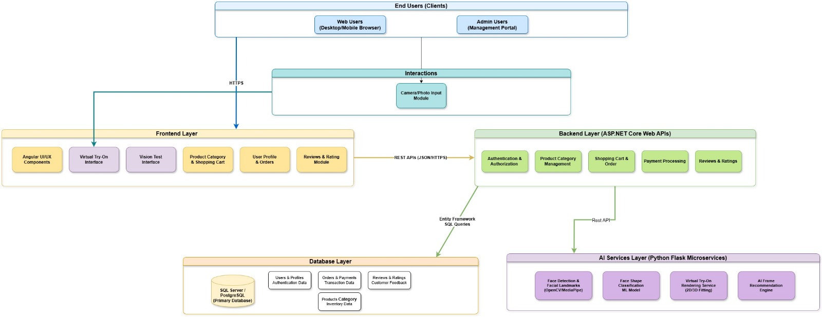

ERD Diagram


Class Diagram
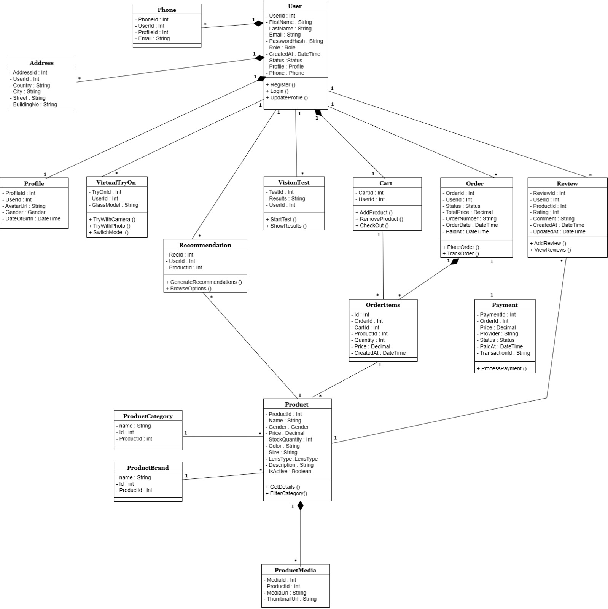

Sequence Diagrams
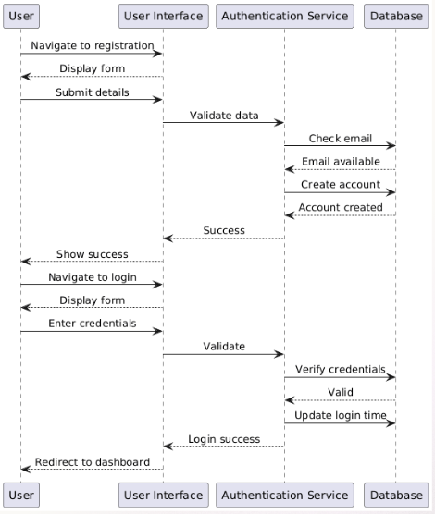
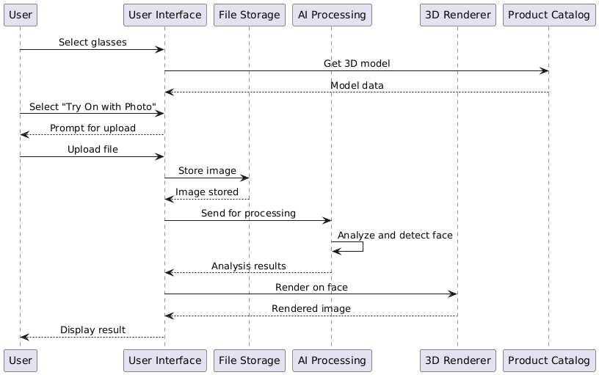
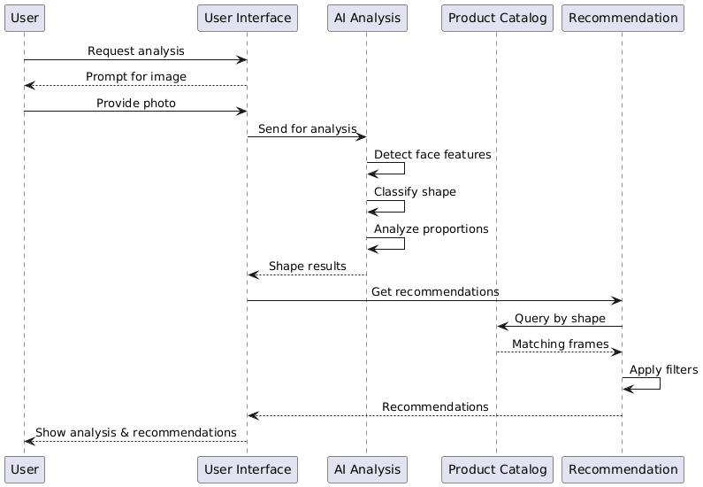
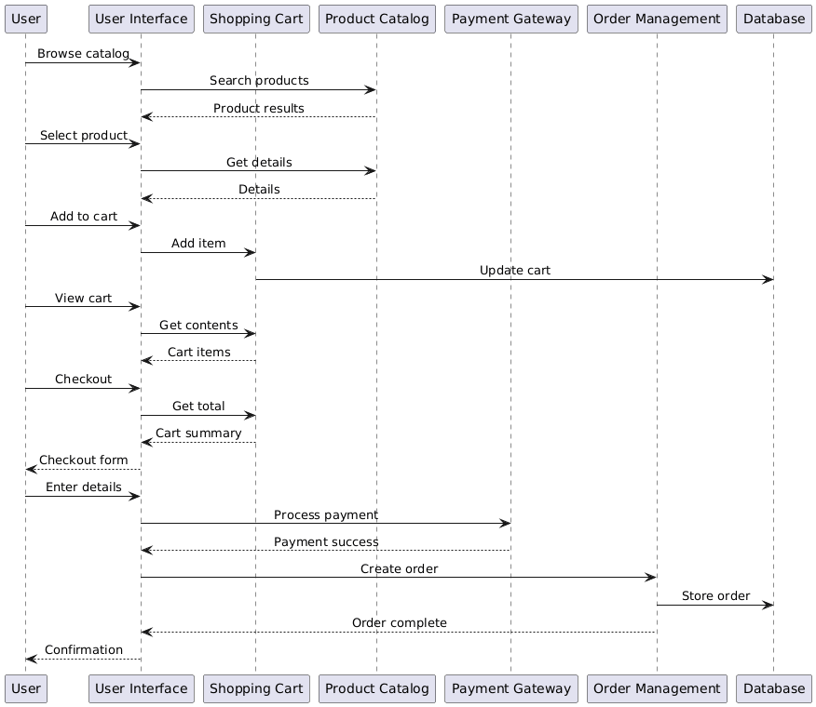
Use Case
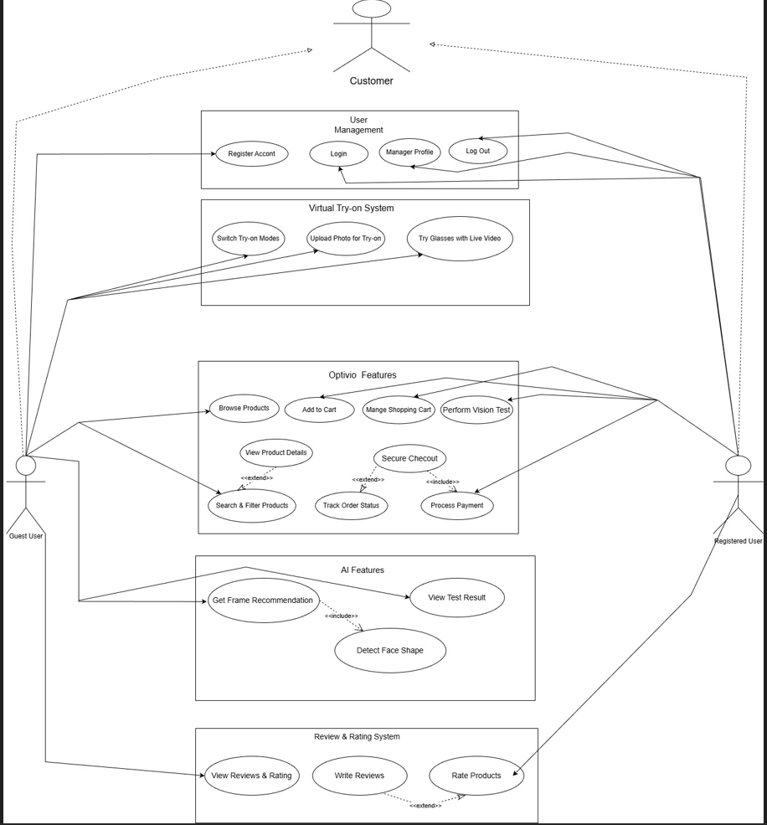
3.3 Algorithms or frameworks used.
The proposed system relies on a combination of computer vision algorithms, machine learning models, and web-based visualization frameworks to achieve accurate virtual try-on, face shape classification, and personalized eyewear recommendations. Each component is selected based on performance, accuracy, and real-time capabilities.
1. Face Detection and Facial Landmark Extraction
For face detection and landmark extraction, the system uses MediaPipe Face Mesh, a lightweight and highly optimized framework developed by Google.
MediaPipe Face Mesh provides 468 facial landmarks in real time, enabling precise identification of critical facial regions such as the eyes, nose bridge, cheeks, jawline, and forehead. This accuracy is essential for correct placement and scaling of virtual eyewear models.
In addition, OpenCV is used for image preprocessing tasks, including color space conversion, resizing, rotation, and frame manipulation. OpenCV also supports camera access and video stream handling, making it suitable for real-time applications.
2. Face Shape Classification Algorithm
The face shape classification module is implemented using a supervised machine learning approach. Facial measurements such as face length, cheek width, jaw width, and forehead width are extracted from the facial landmarks. These measurements are used as input features for the classification model.
The classification model may include:
- Support Vector Machine (SVM) for robust decision boundaries
- Random Forest Classifier for handling feature variability
- Convolutional Neural Networks (CNNs) for image-based classification in advanced versions
For the MVP, a rule-based geometric model is also used to validate classification results by comparing facial ratios. This hybrid approach improves reliability and interpretability.
3. Virtual Try-On Algorithm
The virtual try-on module uses geometric transformation algorithms to overlay eyewear models accurately onto the user’s face. These include:
- Scaling based on inter-ocular distance
- Translation using nose bridge or eye-center landmarks as anchor points
- Rotation derived from the angle between the eyes
For 2D virtual try-on, alpha blending techniques are used to merge transparent eyewear images with live video frames. For 3D try-on, Three.js and WebGL enable realistic rendering, depth alignment, and lighting adjustments.
4. Recommendation Algorithm
The eyewear recommendation system uses a rule-based filtering algorithm enhanced with AI logic. Eyewear products in the database are labeled according to frame shape, size, and style. The recommendation engine matches the user’s face shape classification with suitable frame categories and ranks results based on relevance.
Future extensions may incorporate collaborative filtering or content-based recommendation algorithms to improve personalization using user interaction data.
5. Online Vision Test Algorithm
The online vision test module follows standardized vision assessment patterns such as visual acuity and contrast sensitivity tests. The system dynamically presents symbols or letters at controlled sizes and distances on the screen, recording user responses to estimate visual performance. Simple statistical scoring algorithms are used to generate test results.
6. System Integration Frameworks
The proposed system follows a modular client–server architecture to ensure scalability, maintainability, and high performance. The integration between artificial intelligence modules, augmented reality components, and e-commerce services is achieved through well-defined interfaces and modern web frameworks.
Frontend Framework
The frontend of the system is developed using Angular, a robust and scalable web application framework. Angular is responsible for managing the user interface, handling user interactions, and ensuring smooth navigation across different platform features such as product browsing, virtual try-on, face shape analysis, and vision testing.
For the virtual try-on functionality, Three.js is integrated into the Angular application to enable 3D rendering of eyewear models. Three.js, built on top of WebGL, allows realistic visualization, lighting, and transformation of 3D glasses models in real time. Facial landmark data received from the backend is used to dynamically position, scale, and rotate the 3D eyewear models on the user’s face.
Backend Framework
The backend of the system is implemented using .NET, which provides a secure and high-performance environment for handling business logic and AI services. The backend is responsible for:
- Processing uploaded images and video frames
- Executing face detection and face shape classification algorithms
- Managing eyewear product data and user information
- Generating AI-based eyewear recommendations
- Handling authentication, authorization, and order management
Machine learning models developed in Python can be integrated into the .NET backend through RESTful APIs or microservices, ensuring flexibility and interoperability.
Communication and Integration
Communication between the frontend and backend is achieved using RESTful web services over HTTP. Data such as facial landmarks, classification results, and recommended eyewear lists are exchanged in JSON format, enabling seamless integration between Angular and .NET components.
This architecture ensures that the system can support real-time interactions, advanced AI processing, and high-quality 3D visualization within a unified and scalable platform.

Chapter 4
Implementation

4.1 Technologies, Tools, and Programming Languages Used

The development of Optivio required the integration of several modern technologies from the fields of web development, computer vision, machine learning, augmented reality, and e-commerce systems. These technologies were selected based on their performance, scalability, and compatibility with real-time applications.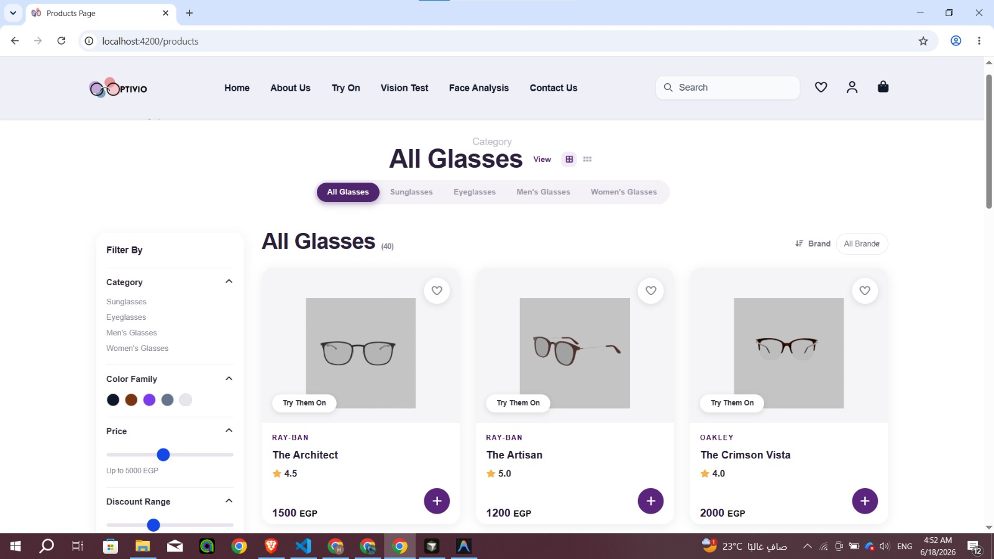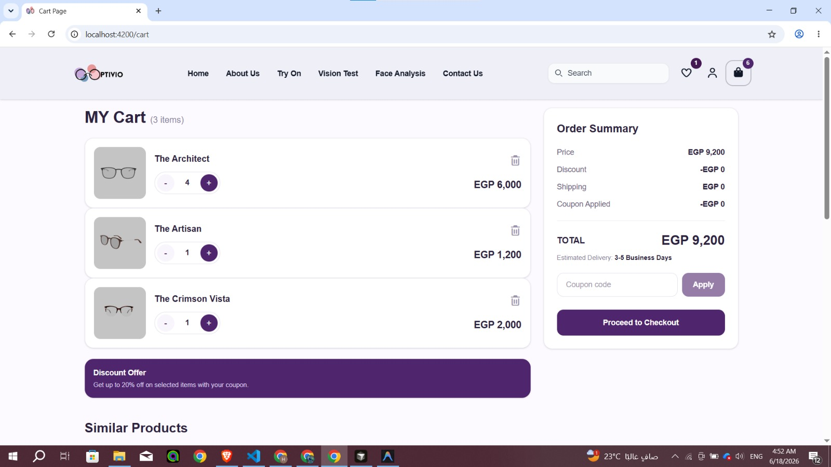

1-Frontend Technologies
Angular
Angular was selected as the frontend framework for developing the user interface. It provides a component-based architecture, efficient state management, responsive design capabilities, and seamless integration with backend APIs.
HTML, CSS, and TypeScript
HTML and CSS were used to structure and style the web application, while TypeScript was used to implement frontend logic and improve code maintainability.

2-Backend Technologies
.NET Framework
The backend system was developed using .NET to handle business logic, user authentication, product management, database communication, and API services. .NET provides high performance, security, and scalability for enterprise-level applications. 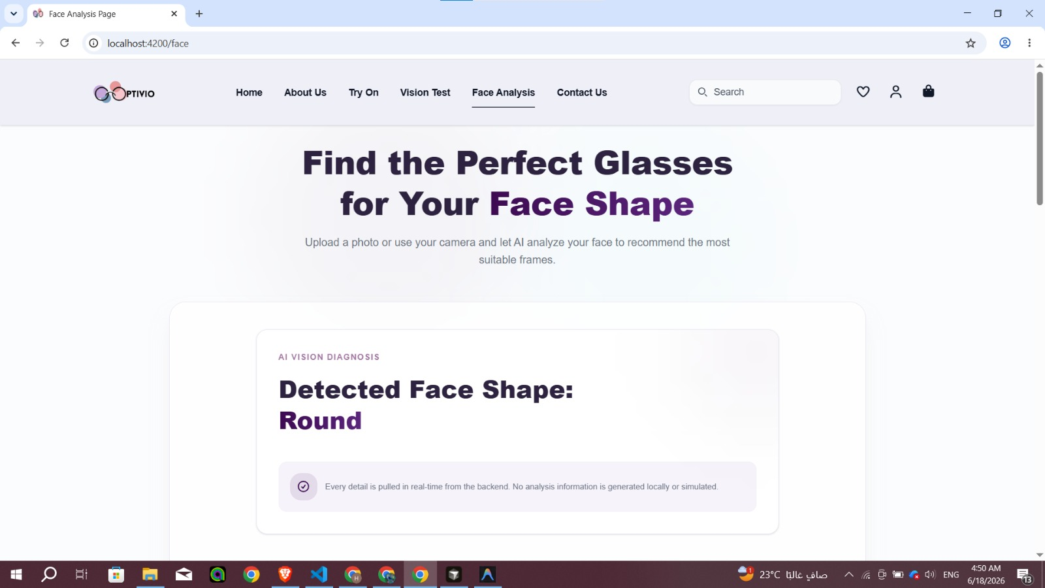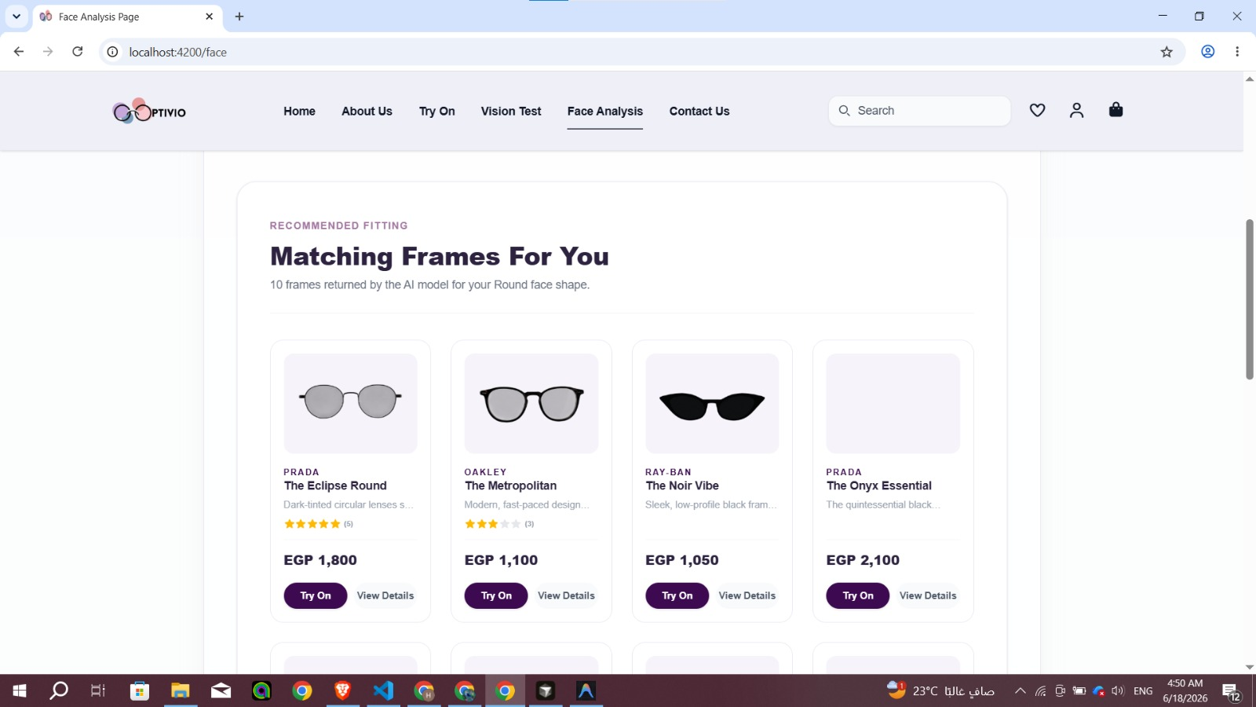 

3-Artificial Intelligence and Computer Vision
VGG16
A pre-trained VGG16 Convolutional Neural Network (CNN) was utilized through transfer learning to classify user face shapes into categories such as Oval, Round, Square, Heart, and Oblong. The classification results are later used to generate personalized eyewear recommendations.
MediaPipe Face Mesh
MediaPipe Face Mesh was used to detect and track facial landmarks. The framework provides 468 facial landmark points that accurately represent facial geometry and enable real-time face tracking.
TensorFlow
TensorFlow was used as the primary machine learning framework for developing and deploying the face shape classification model. It provided tools for building, training, and evaluating deep learning models, as well as supporting transfer learning with the VGG16 architecture to improve classification performance and efficiency.


4-3D Visualization and Augmented Reality
Three.js
Three.js was selected as the primary 3D rendering engine for displaying virtual eyewear models. It enables interactive rendering of 3D glasses and supports real-time transformations such as scaling, rotation, and positioning.

5-Database Technologies
SQL Server
SQL Server stores user accounts, product information, eyewear specifications, recommendation labels, and transaction data. It provides reliable data management and supports future scalability.

Development and Training Tools
- Google Colab for training deep learning models.
- Visual Studio for backend development.
- Visual Studio Code for frontend development.
- Git and GitHub for version control and collaboration.

4.2 Key Components and Modules of the System
The Optivio platform consists of several integrated modules that work together to provide a complete virtual eyewear shopping experience.

1-User Management Module
This module handles user registration, login, profile management, authentication, and account security.

2-Product Management Module
Responsible for managing eyewear products, categories, specifications, pricing, inventory, and product images.

3-Face Shape Classification Module
This AI-powered module analyzes uploaded facial images using the VGG16 model. The user's face shape is classified into predefined categories, which are used to personalize product recommendations.

4-Eyewear Recommendation Module
Based on the detected face shape, the system filters the eyewear database and recommends the most suitable frames for the user.

5-Virtual Try-On Module
This module enables users to virtually wear glasses using uploaded images or live camera input. Facial landmarks extracted by MediaPipe are used to position and align the eyewear accurately.

6-3D Rendering Module
The Three.js rendering engine loads and displays 3D eyewear models. Transformation matrices generated from facial landmark data are applied to ensure realistic alignment and movement.

7-Vision Test Module
A basic online vision screening tool allows users to perform preliminary eyesight assessments and determine whether they may need professional eye examination.

8-E-Commerce Module
Provides product browsing, search, filtering, shopping cart management, order processing, and checkout functionality.

9-Database Module
Stores all user information, products, recommendations, and transaction records while ensuring data consistency and integrity.

4.3 Challenges Faced and How They Were Resolved
During the implementation phase, several technical and practical challenges were encountered.

Challenge 1: Face Shape Dataset Limitations
The selected face shape dataset contained a significant imbalance in demographic representation, with a large portion of images belonging to female subjects.
Solution
Additional male facial images were collected and integrated into the dataset to improve diversity and reduce potential model bias. Data augmentation techniques were also applied to increase dataset variability.

Challenge 2: Accurate Face Shape Classification
Face shapes often share similar geometric characteristics, making classification difficult and potentially reducing model accuracy.
Solution
Transfer learning using the VGG16 architecture was adopted to leverage pre-trained visual features. Image preprocessing and augmentation techniques were implemented to improve model generalization.

Challenge 3: Precise Virtual Try-On Alignment
Accurately positioning virtual glasses on different faces requires precise landmark detection and pose estimation.
Solution
MediaPipe Face Mesh was integrated to extract 468 facial landmarks, while OpenCV was used to calculate geometric transformations and alignment parameters. This significantly improved positioning accuracy.

Challenge 4: Real-Time Performance
Real-time face tracking and 3D rendering can increase computational requirements, especially on low-end devices.
Solution
Efficient computer vision algorithms and optimized 3D models were used to reduce processing overhead and maintain smooth user interaction.

Challenge 5: Integration of Multiple Technologies
Combining machine learning, computer vision, augmented reality, 3D rendering, and e-commerce functionality into a single platform introduced integration complexity.
Solution
A modular architecture was designed, allowing each component to operate independently while communicating through well-defined APIs and services.

Challenge 6: Recommendation Accuracy
Generating useful recommendations requires linking AI predictions with product characteristics.
Solution
Each eyewear product was assigned metadata labels corresponding to suitable face shapes. Recommendation rules were then applied to match users with appropriate products automatically.

The implementation of Optivio demonstrates the successful integration of artificial intelligence, computer vision, augmented reality, and e-commerce technologies into a unified platform that enhances the eyewear shopping experience through personalization, realism, and accessibility.

Chapter 5
Testing & Evaluation

5.1 Testing Strategies
To ensure the reliability, accuracy, and usability of the Optivio platform, several testing strategies were employed throughout the development process. These strategies focused on verifying individual components, validating interactions between modules, and evaluating the overall user experience.

1-Unit Testing
Unit testing was performed on individual modules to verify that each component functions correctly and independently. Key modules tested include:
- User authentication and account management.
- Product search and filtering functions.
- Face shape classification module.
- Eyewear recommendation module.
- Vision test calculations.
- Database operations and API endpoints.
Testing individual modules helped detect errors early and improved system maintainability.

2-Integration Testing
Integration testing was conducted to ensure proper communication among different system components. The following integrations were verified:
- Angular frontend with .NET backend APIs.
- Database connectivity and data retrieval.
- Face shape classification module with the recommendation system.
- MediaPipe facial landmark detection with the virtual try-on module.
- Three.js rendering engine with facial tracking data.
This testing phase ensured that all modules work together as a unified system.

3-User Testing
User testing was carried out to evaluate usability and overall user satisfaction. Several users interacted with the platform and provided feedback regarding:
- Ease of navigation.
- Accuracy of virtual try-on.
- Quality of eyewear recommendations.
- Performance and responsiveness.
- User interface design.
Feedback obtained during this phase was used to improve the functionality and user experience of the platform.

5.2 Performance Metrics
The performance of Optivio was evaluated using several metrics related to artificial intelligence, system responsiveness, and scalability.

Classification Accuracy
Experimental results showed that the model achieved an overall validation accuracy of 92.47%, demonstrating its ability to effectively distinguish between different face shapes.

Precision, Recall, and F1-Score

The classification report obtained from the evaluation process is summarized below:
Face Shape | Precision | Recall | F1-Score
Heart | 0.93 | 0.92 | 0.92
Oblong | 0.95 | 0.93 | 0.94
Oval | 0.91 | 0.90 | 0.90
Round | 0.89 | 0.91 | 0.90
Square | 0.92 | 0.94 | 0.93
Macro Average | 0.92 | 0.92 | 0.92
Weighted Average | 0.92 | 0.92 | 0.92

Confusion Matrix
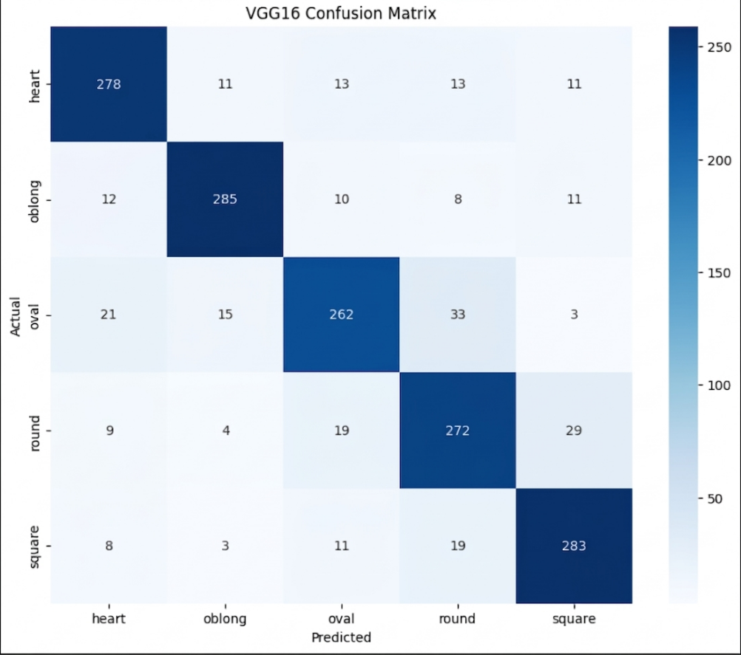

Processing Speed
Real-time performance is essential for virtual try-on applications. The system was evaluated based on:
- Face detection speed.
- Landmark extraction time.
- Model inference time.
- 3D rendering responsiveness.
Efficient processing ensures smooth interaction and minimizes user latency.

Scalability
The platform was designed using a modular architecture that supports future expansion. Scalability considerations include:
- Increasing the number of users.
- Expanding the eyewear catalog.
- Supporting additional AI models.
- Integrating advanced AR and 3D technologies.
The use of Angular and .NET contributes to system flexibility and maintainability.

Reliability
Reliability testing ensured that the system maintains stable performance under different operating conditions and continues functioning without significant failures.

5.3 Comparison with Existing Solutions
Several commercial eyewear platforms provide online shopping and virtual try-on features. However, most existing solutions focus on individual functionalities rather than providing a complete intelligent ecosystem.

1-Glasses.com
Glasses.com offers online shopping and virtual try-on capabilities. However, it does not provide AI-based face shape classification or integrated vision testing.

2-Magrabi
Magrabi provides e-commerce services and a large eyewear catalog but offers limited personalization and lacks advanced AI-driven recommendations.

3-Zenni Optical
Zenni Optical includes virtual try-on features and online purchasing services. Nevertheless, its recommendation capabilities are relatively limited and do not rely heavily on face shape analysis.

4-Warby Parker
Warby Parker provides virtual try-on and online shopping experiences. However, it does not integrate face shape classification, personalized recommendations, and vision testing into one unified platform.

Optivio
Optivio combines several technologies into a single platform, including:
- AI-based face shape classification using VGG16.
- Personalized eyewear recommendation system.
- Real-time facial landmark detection using MediaPipe.
- 3D virtual try-on using Three.js and WebGL.
- Online vision test functionality.
- Complete e-commerce services.
This integration provides a more personalized and intelligent user experience compared to existing solutions.

Summary
Testing and evaluation demonstrated that Optivio successfully integrates artificial intelligence, computer vision, augmented reality, and e-commerce technologies into a unified platform. The adopted testing strategies and performance metrics ensure system reliability, scalability, and usability, while comparison with existing solutions highlights the advantages and innovative capabilities offered by the proposed system.

Chapter 6

Results and Discussion

6.1 Introduction
This chapter presents the outcomes of the proposed Optivio platform and discusses the effectiveness of the implemented solution. The chapter summarizes the main findings obtained from the development and evaluation stages, analyzes whether the project objectives were achieved, and highlights the limitations encountered during the implementation process.

6.2 Summary of Findings
The developed system successfully integrates artificial intelligence, computer vision, 3D visualization, and e-commerce functionalities into a single platform. The project provides users with an intelligent and interactive eyewear shopping experience through several integrated components.
The major findings of this work can be summarized as follows:
- A face shape classification model based on the VGG16 architecture was successfully implemented and achieved an overall validation accuracy of approximately 92%.
- MediaPipe and OpenCV enabled reliable facial landmark extraction and face tracking, allowing accurate alignment of virtual glasses with the user's face.
- Three.js and WebGL provided realistic rendering of 3D eyewear models and supported smooth virtual try-on interactions.
- The AI-based recommendation system was able to suggest suitable frames according to the detected face shape.
- The platform combined virtual try-on, personalized recommendations, vision testing, and e-commerce functionality within a unified environment.
- The modular architecture based on Angular and .NET provided scalability and flexibility for future enhancements.
Overall, the proposed platform demonstrated the feasibility of integrating multiple advanced technologies into a single intelligent eyewear system.

6.3 Interpretation of Results
The experimental results indicate that the project successfully achieved its primary objectives.
The first objective was to provide a realistic virtual try-on experience. This objective was achieved through the integration of MediaPipe, OpenCV, Three.js, and WebGL, which enabled accurate face tracking and proper positioning of virtual eyewear models.

The second objective was to develop an AI-based face shape classification system capable of supporting personalized eyewear recommendations. The VGG16 model demonstrated strong classification performance and provided reliable predictions that improved recommendation quality.

Another objective was to combine several independent functionalities into one platform. Unlike existing solutions that focus mainly on virtual try-on or e-commerce separately, Optivio integrates:
- AI-based face shape classification.
- Personalized eyewear recommendation.
- Virtual try-on technology.
- Basic online vision testing.
- Complete e-commerce services.

Therefore, the proposed system successfully addresses many of the limitations observed in current eyewear platforms and provides a more comprehensive user experience.

6.4 Limitations of the Proposed Solution
Despite the promising results obtained, several limitations remain.

Dataset Limitations
The face shape dataset used in this work was relatively limited and initially contained an imbalance in demographic representation, with a large proportion of female images. Although additional male images and data augmentation techniques were introduced, further diversification of the dataset is still required.

Face Shape Similarity
Some face shape categories, particularly Oval and Round, exhibit similar geometric characteristics, which may lead to occasional misclassifications and affect recommendation accuracy.

Dependence on Lighting Conditions
The performance of face detection and landmark extraction may be influenced by poor lighting conditions, camera quality, and extreme head orientations.

Hardware and Performance Constraints
Real-time face tracking and 3D rendering require computational resources that may affect performance on low-end devices.

Simplified Vision Test
The current vision test module is intended only for preliminary screening and cannot replace professional eye examinations performed by ophthalmologists.

Limited Recommendation Strategy
The recommendation mechanism primarily relies on face shape information. Additional factors such as skin tone, personal preferences, fashion trends, and user behavior are not yet considered.

In summary, the results obtained demonstrate that Optivio successfully achieved its intended objectives and validated the feasibility of combining artificial intelligence, computer vision, 3D visualization, and e-commerce technologies into a unified platform. Nevertheless, several opportunities remain for improving accuracy, realism, and personalization in future versions of the system.

Chapter 7

Conclusion and Future Work

7.1 Summary of Contributions
This project presented Optivio, an AI-powered virtual eyewear platform that combines artificial intelligence, computer vision, 3D visualization, and e-commerce technologies into a unified system. The proposed platform aims to enhance the traditional eyewear shopping experience by providing intelligent, interactive, and personalized services.

The major contributions of this work can be summarized as follows:
- Development of a face shape classification system based on the VGG16 Convolutional Neural Network architecture.
- Implementation of an AI-based recommendation system capable of suggesting suitable eyewear according to the user's facial geometry.
- Integration of facial landmark detection and real-time face tracking using MediaPipe and OpenCV.
- Development of a virtual try-on module that enables realistic visualization of eyewear models through Three.js and WebGL.
- Incorporation of a basic online vision test to provide preliminary eyesight assessment.
- Construction of a complete e-commerce platform supporting product browsing, filtering, shopping cart management, and purchasing functionalities.
- Adoption of a modular architecture based on Angular and .NET, allowing scalability and maintainability.
- Successful integration of multiple advanced technologies into a single platform that provides a more comprehensive user experience compared to many existing solutions.

Overall, the proposed system demonstrates the feasibility of combining artificial intelligence and augmented reality technologies to improve accessibility, convenience, and personalization in eyewear e-commerce.

7.2 Future Work
Although the proposed system achieved promising results, several enhancements can further improve its accuracy, realism, and intelligence.

1-Enhanced Face Shape Classification
Future versions may employ more advanced deep learning architectures such as EfficientNet, ResNet, or Vision Transformers (ViT) to achieve higher classification accuracy and better generalization across diverse facial characteristics.

2-Expanded and More Diverse Dataset
A larger and more balanced dataset containing different genders, age groups, ethnicities, and lighting conditions can improve model robustness and reduce classification bias.

3-Advanced Recommendation System
The current recommendation mechanism is mainly based on face shape. Future systems may incorporate additional factors such as:
- Skin tone.
- Hairstyle.
- Personal preferences.
- Fashion trends.
- User behavior and purchase history.
Machine learning and collaborative filtering techniques can be utilized to provide highly personalized recommendations.

4-Full 3D Face Reconstruction
Instead of relying solely on facial landmarks, future implementations may generate complete 3D face models to achieve more realistic alignment and fitting of eyewear.

5-Markerless Augmented Reality
Future versions may integrate WebXR and advanced augmented reality frameworks to provide immersive and markerless AR experiences directly through web browsers.

6-Prescription and Vision Analysis
Artificial intelligence techniques may be employed to estimate visual impairments and provide intelligent guidance regarding possible prescription needs. However, such functionality should complement rather than replace professional medical examinations.

7-Generative AI Integration
Generative AI models could be used to:
- Generate customized frame designs.
- Recommend fashion styles.
- Provide intelligent conversational assistance.
- Produce personalized shopping experiences.

8-Mobile Application Support
Future development may include dedicated Android and iOS applications to provide improved accessibility and performance across mobile devices.

9-Multi-Accessory Virtual Try-On
The system may be extended to support additional accessories, including:
- Sunglasses.
- Contact lenses.
- Watches.
- Jewelry.
- Hats and fashion accessories.

Conclusion
In conclusion, Optivio provides an innovative approach to eyewear e-commerce by combining artificial intelligence, computer vision, and 3D technologies into one integrated platform. The proposed system successfully addresses several limitations of conventional eyewear websites and demonstrates the potential of intelligent virtual try-on systems to transform the online shopping experience. With further advancements in AI and augmented reality technologies, Optivio can evolve into a more intelligent, immersive, and highly personalized platform.

References

Datasets
[1] Niten19, "Face Shape Dataset," Kaggle, 2022.

Software Libraries and Frameworks
[2] TensorFlow Developers, "TensorFlow Documentation."
[3] MediaPipe Team, "MediaPipe Face Mesh."
[4] OpenCV Developers, "OpenCV Library."
[5] Mrdoob, "Three.js Documentation."
[6] Khronos Group, "WebGL Specification."
[7] Google, "Angular Framework."
[8] Microsoft, ".NET Documentation."

Research Papers
[9] Simonyan, K., and Zisserman, A., "Very Deep Convolutional Networks for Large-Scale Image Recognition," ICLR, 2015.
[10] Bazarevsky, V., et al., "MediaPipe Face Mesh: Real-Time Face Geometry Estimation Using Machine Learning," 2020.
[11] Bradski, G., "The OpenCV Library," Dr. Dobb's Journal of Software Tools, 2000.
Commercial Platforms
[12] Glasses.com. [13] Zenni Optical. [14] Warby Parker. [15] Magrabi Optical.

