Task 1

1. Find Datasets
2. Use an existing model

Report 1

I used mediapipe on a video I recorded

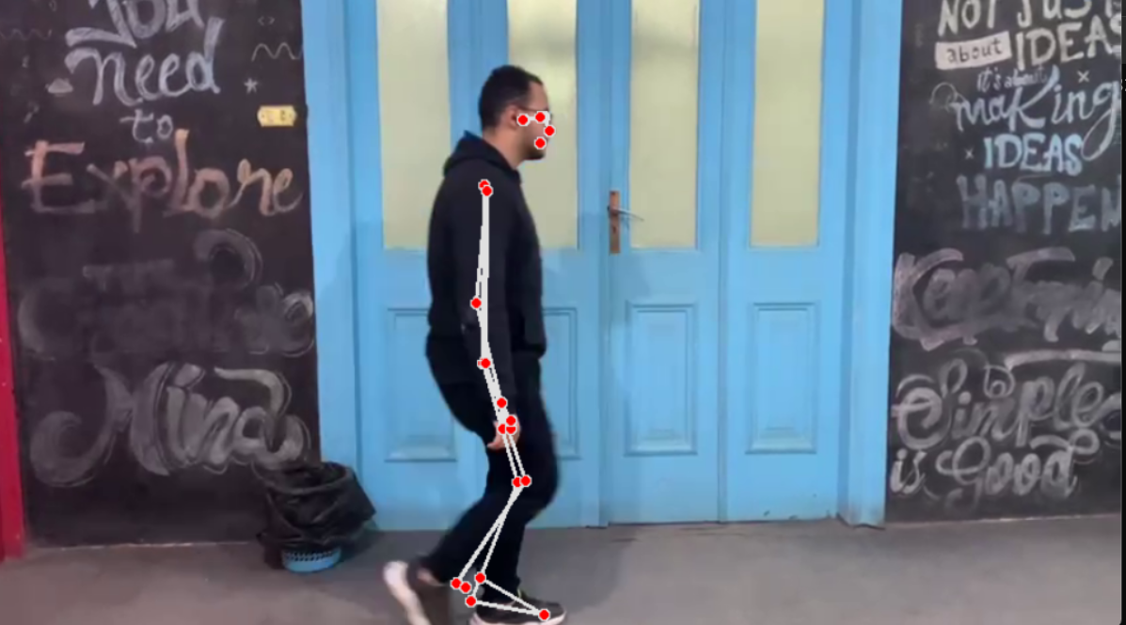

The data set part is a little tricky, As I found data sets for human detection, as in detecting humans with a bounding box, and I found data sets for pose detection, And both of them doesn’t really support my purpose, but human detection data sets could be used to isolate the human from the rest of the picture, further crowd detection should be explored.

I didn’t find any datasets that combines the pose with the surveillance camera angle.

Suggested model:

Activity detection

Pose detection

Human isolation

Human isolation and pose detection would be done using a pre-existing models, while activity detection would use a novel model that I will create

The activity detection part would use CNN-LSTM architecture