Report 2

Most common gait abnormalities:

* Parkinson’s gait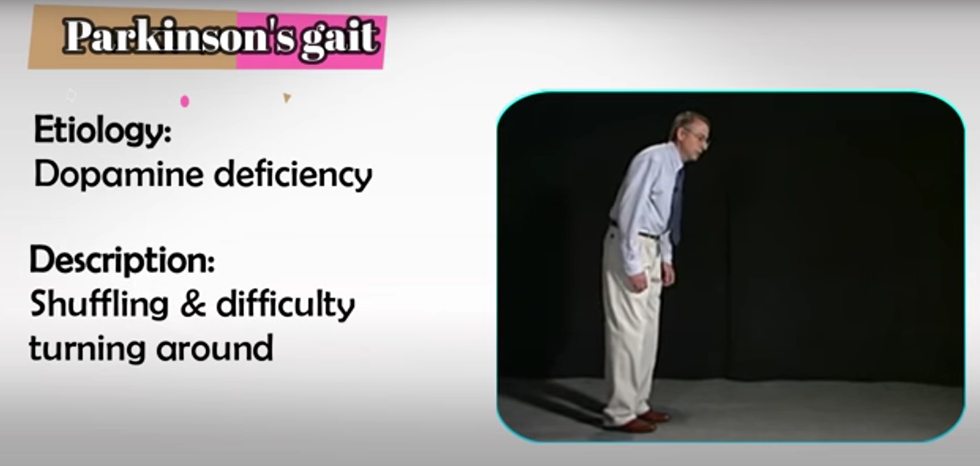
* Antalgic gait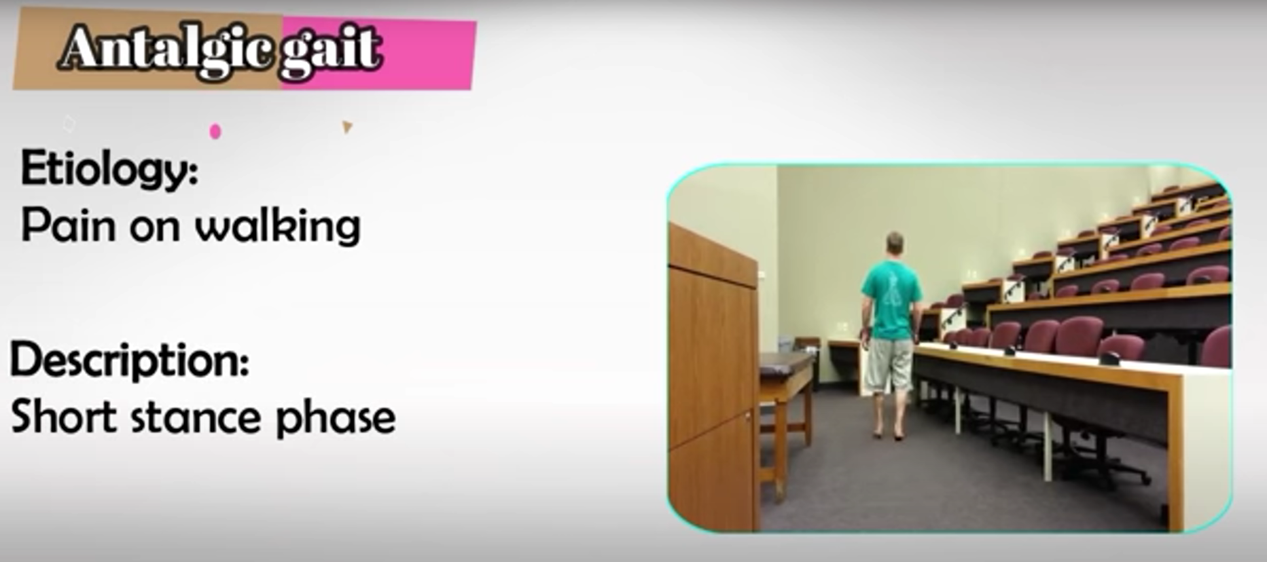
* Waddling gait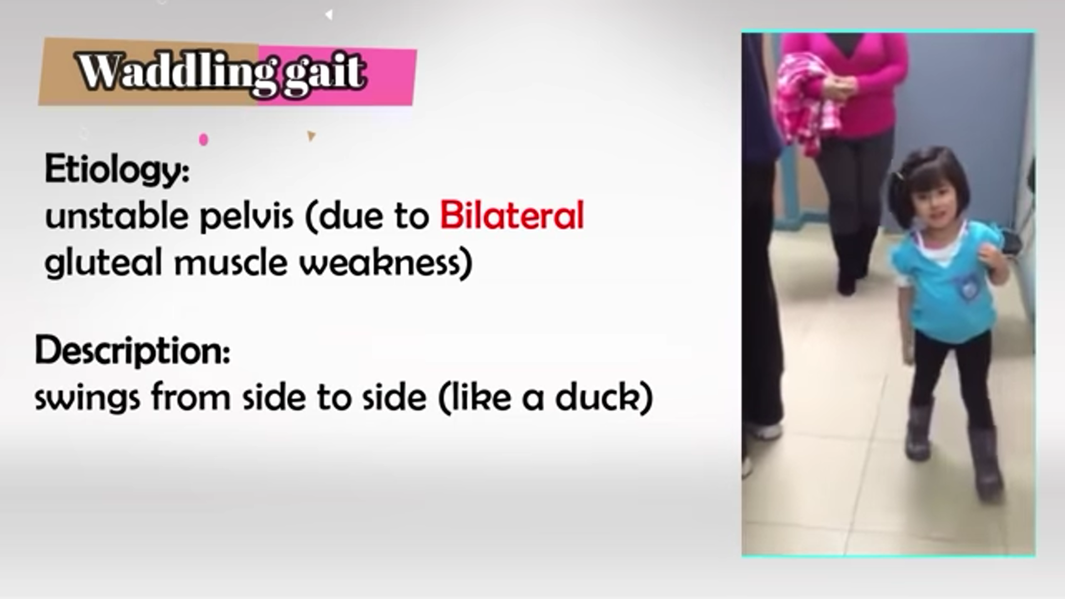
* Trendelenburg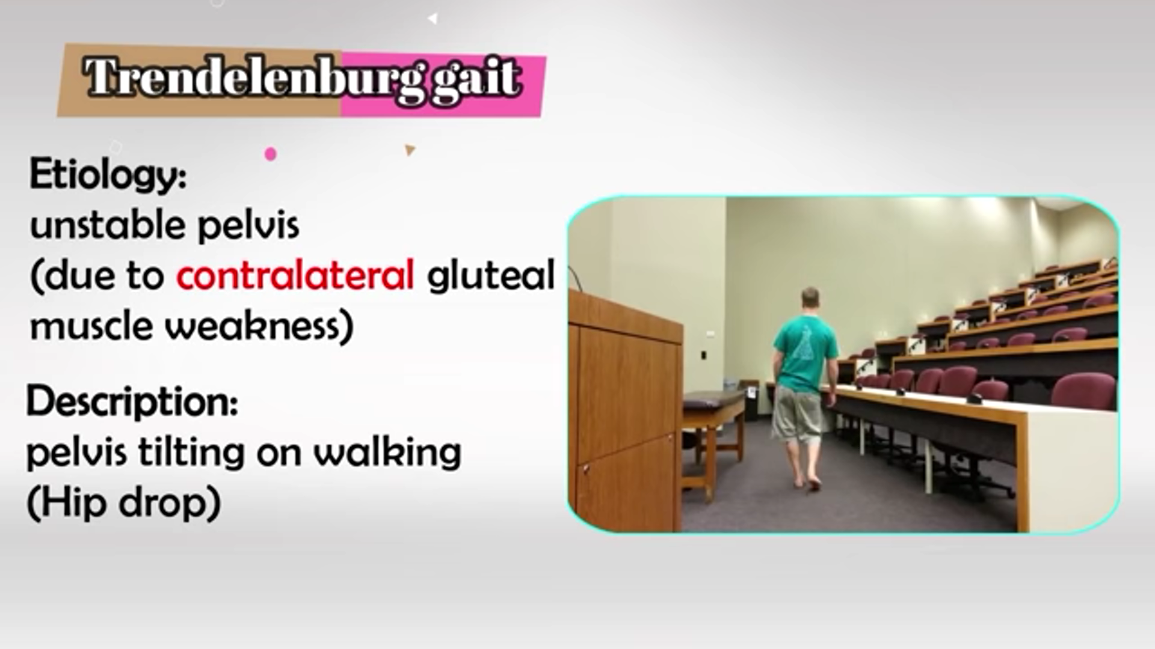

<https://www.youtube.com/watch?v=nmSEtrn_T5A>

-Circumduction gait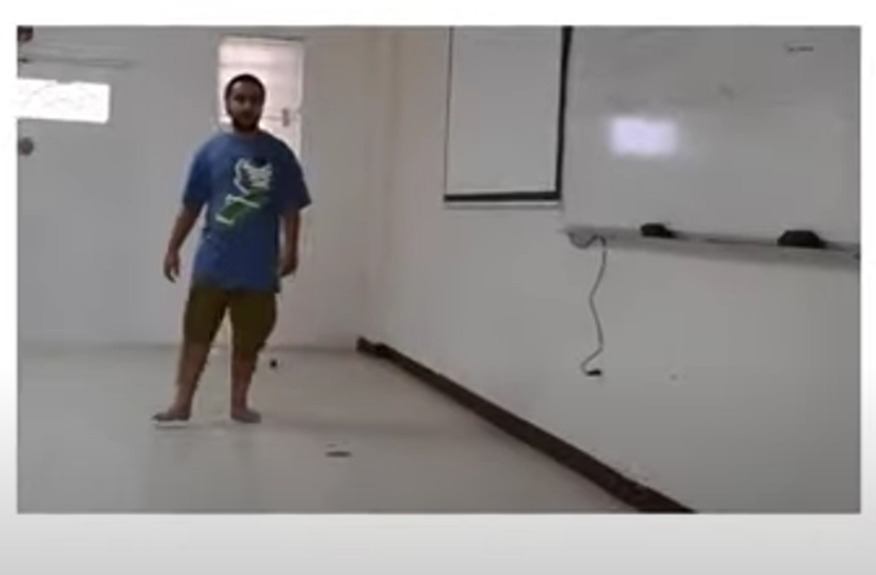

- Ataxic gait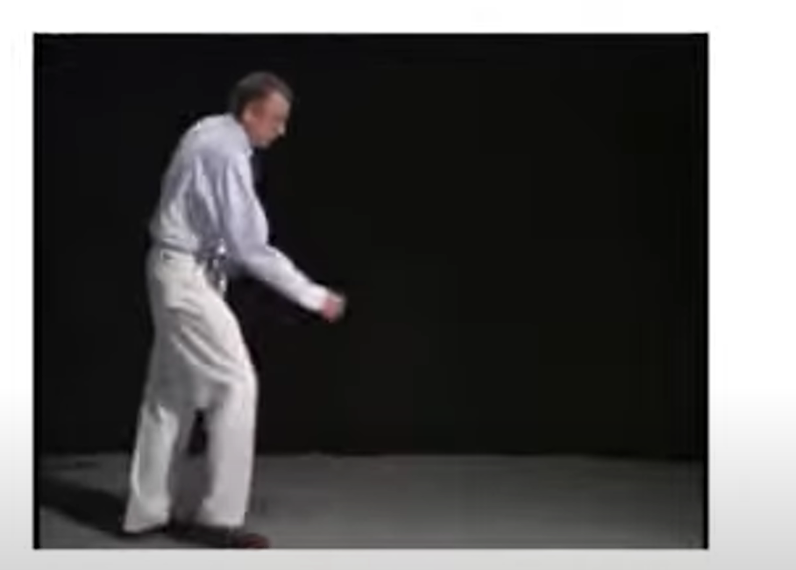

Datasets:

<https://www.kaggle.com/datasets/limi44/parkinsons-visionbased-pose-estimation-dataset>

<https://archive.ics.uci.edu/ml/datasets/Daphnet+Freezing+of+Gait>

<https://www.frontiersin.org/articles/10.3389/fnins.2022.832463/full>

<https://arxiv.org/pdf/2005.04185.pdf>

<https://github.com/AccSrd/multimodal-Parkinson-data-processing>

<https://data.world/uci/daphnet-freezing-of-gait>

IMU/computer vision data:

<https://www.researchgate.net/publication/348448121_Will_You_Be_My_Quarantine_A_Computer_Vision_and_Inertial_Sensor_Based_Home_Exercise_System>

<https://dl.acm.org/doi/pdf/10.1145/3421937.3421946>

<file:///D:/Downloads/Others/sensors-22-09690.pdf>

Stanford most common gait issues:

<https://stanfordmedicine25.stanford.edu/the25/gait.html>