**What is a Deployment Diagram?**

A Deployment Diagram is a type of Unified Modeling Language (UML) diagram that shows the physical deployment of software artifacts to hardware nodes. It visualizes the hardware infrastructure and the software components that run on it.

**Key Elements of a Deployment Diagram:**

* **Nodes (3D Cubes):** Represent hardware or software execution environments (e.g., servers, devices, databases).
* **Artifacts (Rectangles with Folded Corners):** Represent software components or data files (e.g., applications, libraries, databases).
* **Communication Paths (Lines):** Show the communication between nodes (e.g., network connections).
* **Stereotypes (Text in Guilements):** Provide additional information about the elements (e.g., <<cloud>>, <<device>>).

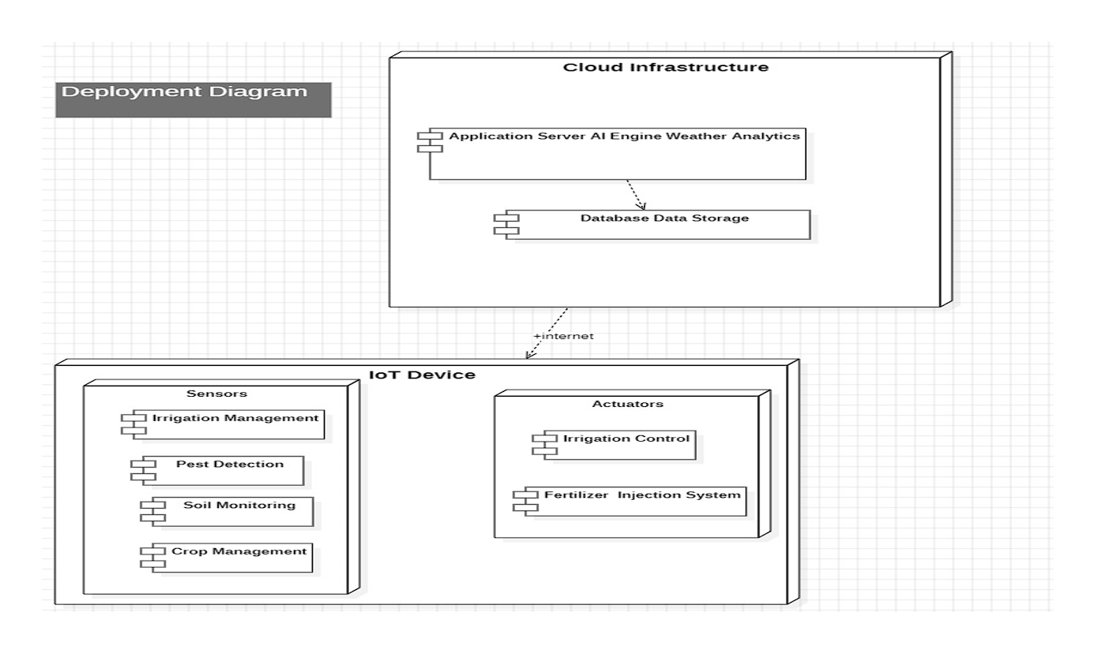

**Explanation of the Image (Deployment Diagram for Smart Agriculture System):**

The image presents a Deployment Diagram for a smart agriculture system, showing the deployment of software components across different hardware nodes.

**Nodes:**

1. **Cloud Infrastructure (Top Node):** Represents the cloud-based infrastructure hosting the system's core components.
2. **IoT Device (Bottom Node):** Represents an Internet of Things device deployed in the field.

**Artifacts:**

* **Cloud Infrastructure Node:**
  + **Application Server AI Engine Weather Analytics:** Represents the application server hosting the AI engine and weather analytics components.
  + **Database Data Storage:** Represents the database used for storing the system's data.
* **IoT Device Node:**
  + **Sensors:** Represents the sensor components (with sub-components: Irrigation Management, Pest Detection, Soil Monitoring, Crop Management).
  + **Actuators:** Represents the actuator components (with sub-components: Irrigation Control, Fertilizer Injection System).

**Communication Paths:**

* **+internet:** Represents the internet connection used for communication between the IoT Device and the Cloud Infrastructure.

**Interpretation:**

This Deployment Diagram effectively illustrates the physical deployment of the smart agriculture system. It shows that the system has two main hardware nodes: a cloud infrastructure and an IoT device.

* The **Cloud Infrastructure** node hosts the core application components, including the application server, AI engine, weather analytics, and database. This indicates that the system leverages cloud computing for processing and data storage.
* The **IoT Device** node is deployed in the field and is responsible for collecting sensor data and controlling actuators. It includes components for irrigation management, pest detection, soil monitoring, crop management, irrigation control, and fertilizer injection.
* The **+internet** communication path shows that the IoT Device communicates with the Cloud Infrastructure via the internet. This allows for data transfer and remote control.

**Key Takeaways:**

* It provides a clear overview of the system's hardware architecture.
* It shows the deployment of software components across different nodes.
* It highlights the use of cloud computing and IoT devices.
* It illustrates the communication between the IoT Device and the Cloud Infrastructure