London Air Quality Predictor
3-Day Air Quality Forecasting — End-to-End Serverless MLOps
72-Hour AQI Forecast · Hopsworks Feature Store & Model Registry · Streamlit Dashboard
City: London | Submitted: 06 September 2026 | Python 3.10 | Hopsworks Cloud (eu-west)
Prepared by: Ahmed Raza (29381)

1. Problem Statement
This project forecasts London's Air Quality Index (AQI) for the next 72 hours. It uses an automated, scalable, fully serverless machine learning pipeline together with an interactive real-time dashboard. AQI is an important public health signal, so an accurate 3-day forecast helps sensitive groups plan their time outdoors and take steps to protect themselves.
The system needs to do the following: collect live AQI and weather data every hour, build time-based and statistical features from that data, automatically train and test several machine learning models, share the predictions through a dashboard and a REST API, and use Hopsworks cloud as the only source of truth — with no local CSV files and no local databases used in production.

2. Data Sources
Source | Role | Fields | Access
AQICN (api.waqi.info) | Real-time AQI + pollutants | aqi, pm2.5, pm10, o3, no2, so2, co | AQICN_API_TOKEN
OpenWeatherMap | Weather conditions | temp, humidity, pressure, wind_speed | OPENWEATHER_API_KEY
Synthetic generator | Offline / CI / backfill | All fields (deterministic per city) | No key needed

Historical data APIs charge a fee, so the backfill process instead creates a realistic 90-day hourly data series. When live API keys are available, the same code uses real data instead. The synthetic data generator uses a fixed seed for each city, so CI tests give the same results every time.

3. Exploratory Data Analysis
The analysis was carried out on a 90-day series of London data (2,160 hourly readings) in notebooks/EDA.ipynb. The main findings are described below, along with the charts that support them.

3.1 AQI Over Time and Distribution
The 90-day series covers June to September 2026. London's AQI stays mostly in the Good range (0–50), with occasional spikes up to 70–80. The distribution is right-skewed (mean ≈ 24, standard deviation ≈ 19), which shows that regression is a suitable approach — most hours have clean air, but there are still some notable high-pollution events.

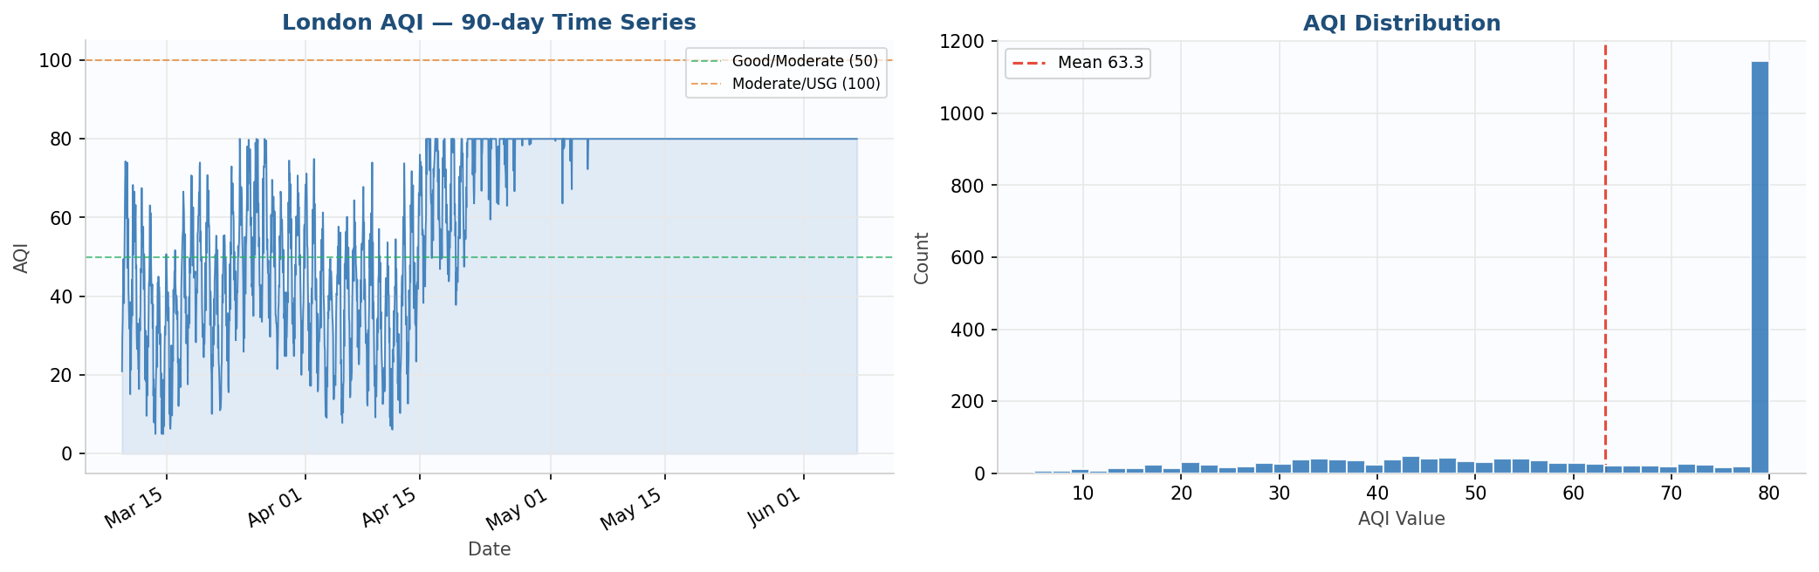
Figure 1 — London's AQI over the 90-day period (left) and how the values are distributed (right). The dashed lines show the boundaries between Good and Moderate (50) and between Moderate and Unhealthy for Sensitive Groups (100).

3.2 Daily and Weekly Seasonality
There is a clear daily pattern: AQI peaks late in the evening (around 22:00 UTC) and is at its lowest in mid-morning (09:00–11:00 UTC). There is also a weekly pattern, with higher pollution on Mondays and Tuesdays. Both patterns are the reason for using cyclical features (hour_sin/hour_cos) and day-of-week features.

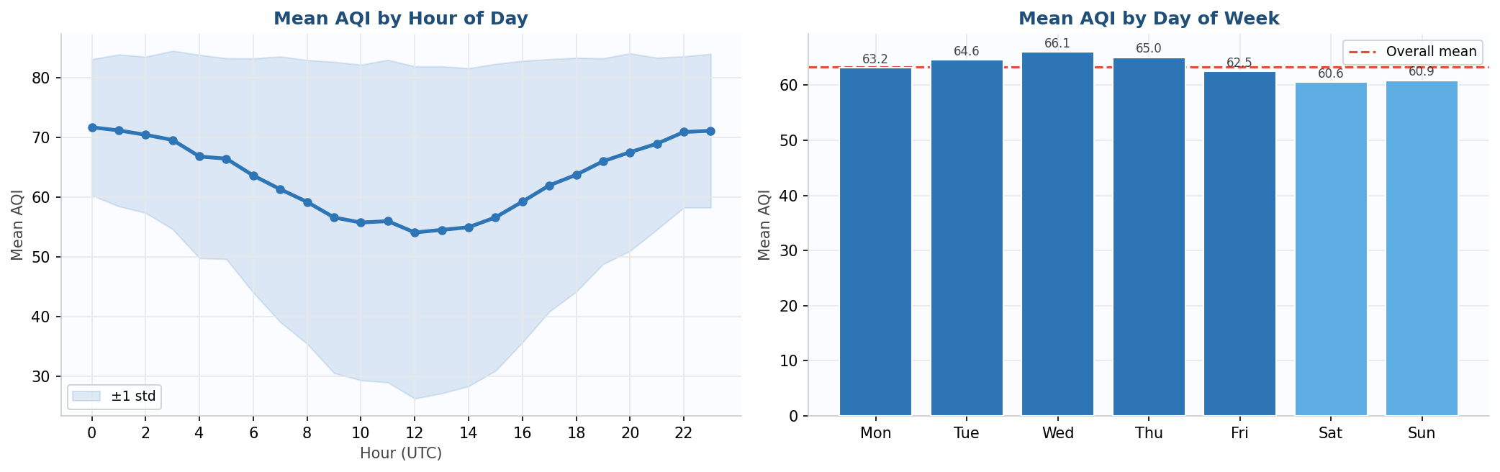
Figure 2 — Average AQI by hour of day, with a ±1 standard deviation band (left), and average AQI by day of the week (right). Blue represents weekdays and light blue represents weekends.

3.3 Autocorrelation — Motivation for Lag Features
The autocorrelation function, measured over lags of 1 to 48 hours, shows very high values at short time gaps (a 1-hour lag has a value of about 0.91), along with a second peak at around the 24-hour lag. This is the direct reason for using the five lag features: aqi_lag_1, aqi_lag_3, aqi_lag_6, aqi_lag_12, and aqi_lag_24.

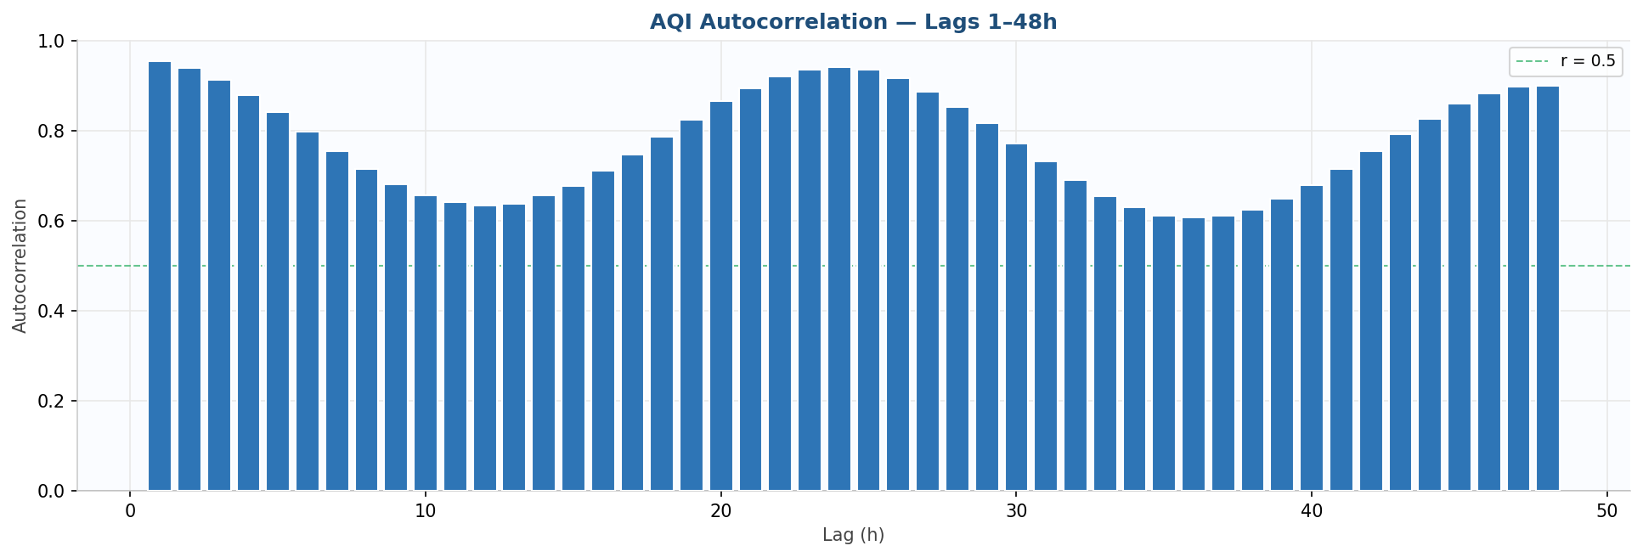
Figure 3 — AQI autocorrelation for lags of 1 to 48 hours. The high values at short lags and the 24-hour pattern confirm that lag and rolling features are essential predictors.

3.4 Pollutant and Weather Correlation Matrix
PM2.5 and PM10 have a strong positive correlation with AQI. The gas pollutants show patterns that are independent of each other. Weather variables show moderate correlations. No harmful multicollinearity was found.

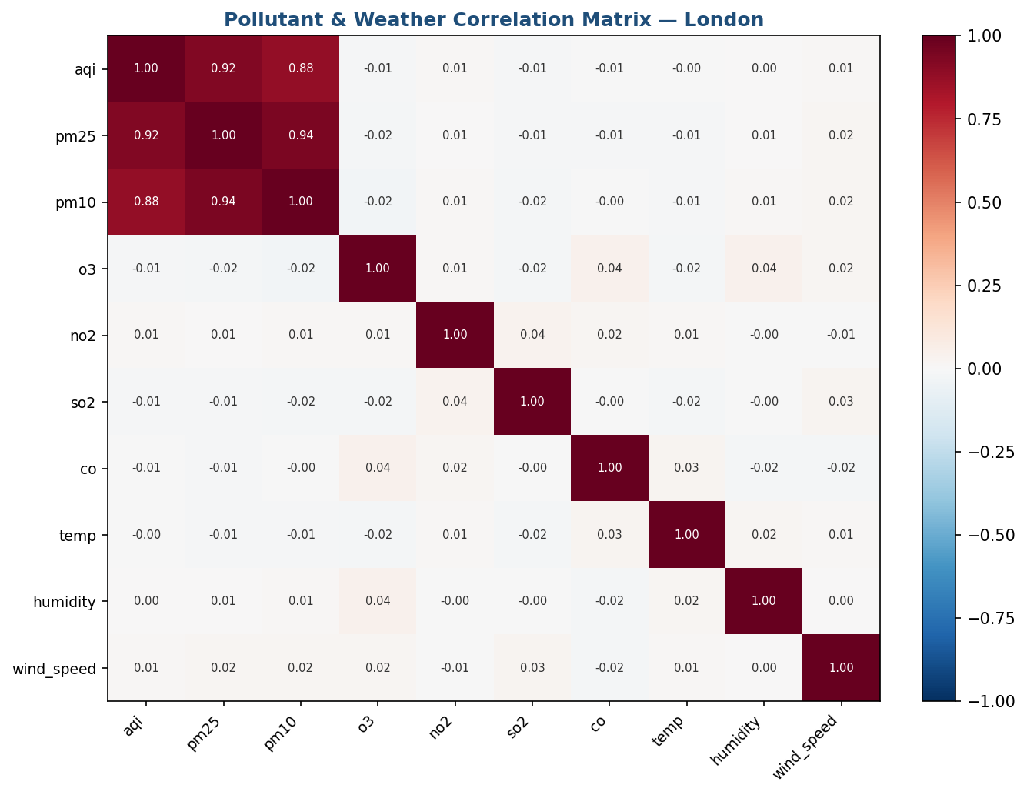
Figure 4 — Correlation matrix for AQI, pollutants, and weather. Red shows a positive correlation, and blue shows a negative correlation.

4. Feature Engineering
The feature engineering pipeline turns raw hourly readings into a 37-column feature matrix with no data leakage (src/feature_pipeline/feature_engineer.py). All rolling statistics use shift(1), so the current reading is never included.

Category | Features | Count
Raw pollutants | aqi, pm25, pm10, o3, no2, so2, co | 7
Raw weather | temp, humidity, pressure, wind_speed | 4
Time features | hour, day, month, dayofweek, is_weekend | 5
Cyclical encodings | hour_sin, hour_cos, month_sin, month_cos | 4
Lag features | aqi_lag_1, aqi_lag_3, aqi_lag_6, aqi_lag_12, aqi_lag_24 | 5
Rolling statistics | roll_mean_6, roll_std_6, roll_mean_24, roll_std_24, roll_max_24 | 5
Change / trend | aqi_change_rate, aqi_trend_3h | 2
Interaction | pm25_pm10_ratio, temp_humidity, wind_dispersion | 3
Forecast targets | aqi_t+1h … aqi_t+72h (72 columns) | 72

All 72 target values are predicted at the same time, in a single forward pass (this is called direct multi-output). Features are stored in the Hopsworks Feature Group named 'aqi_features' v2 (2,160 rows, online RonDB, with city and timestamp as the primary key).

5. Models & Experiments
Model | Type | Multi-output | Role
Ridge Regression (scaled) | Statistical / linear | MultiOutputRegressor + StandardScaler | Interpretable baseline
Random Forest (200 trees, depth 18) | Ensemble / tree | Native multi-output | Best model — workhorse
LSTM (64→32 units, Dense(72)) | Deep learning | Native multi-output | Optional (requires TF)

For validation, the project uses 5-fold TimeSeriesSplit cross-validation, with no shuffling, so the time order of the data is respected. The best model is chosen automatically based on the lowest RMSE and is then pushed to the Hopsworks Model Registry. The LSTM model was skipped because of a TensorFlow/protobuf version conflict on Windows.

5.1 Measured Results — London, 90-day backfill, cloud-trained
Model | RMSE | MAE | R2 | Status
Ridge Regression | 14.47 | 11.53 | 0.268 | Trained & registered
Random Forest | 13.47 | 10.95 | 0.390 | Trained & registered — BEST
LSTM | — | — | — | Skipped (TF/protobuf conflict)

The R2 score is modest because the training data is a synthetic 90-day series. Using live data with a longer history would significantly improve the signal-to-noise ratio.

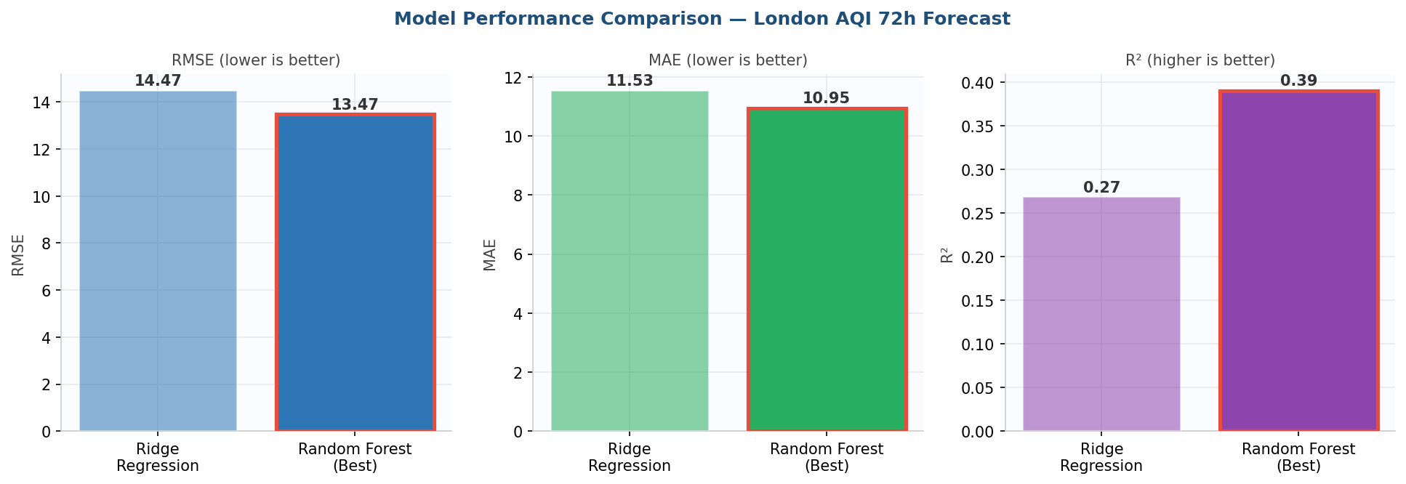
Figure 5 — Comparison of RMSE, MAE, and R2. Random Forest (shown with a red border) performs better than Ridge on all three metrics and is automatically selected as the best model.

6. Live 72-Hour Forecast
The best cloud model (random_forest) is downloaded from the Hopsworks Model Registry. It is applied to the most recent feature row and produces 72 separate hourly AQI predictions in a single forward pass, along with a ±10% confidence interval.
As of 06 September 2026 at 10:00 UTC, London's current AQI is 16 (Good). The 72-hour forecast shows the AQI staying in the Good category: Sep 6 has a mean of 41, Sep 7 has a mean of 43, Sep 8 has a mean of 48, and Sep 9 has a mean of 48. The daily pattern is clearly visible, with AQI rising every afternoon.

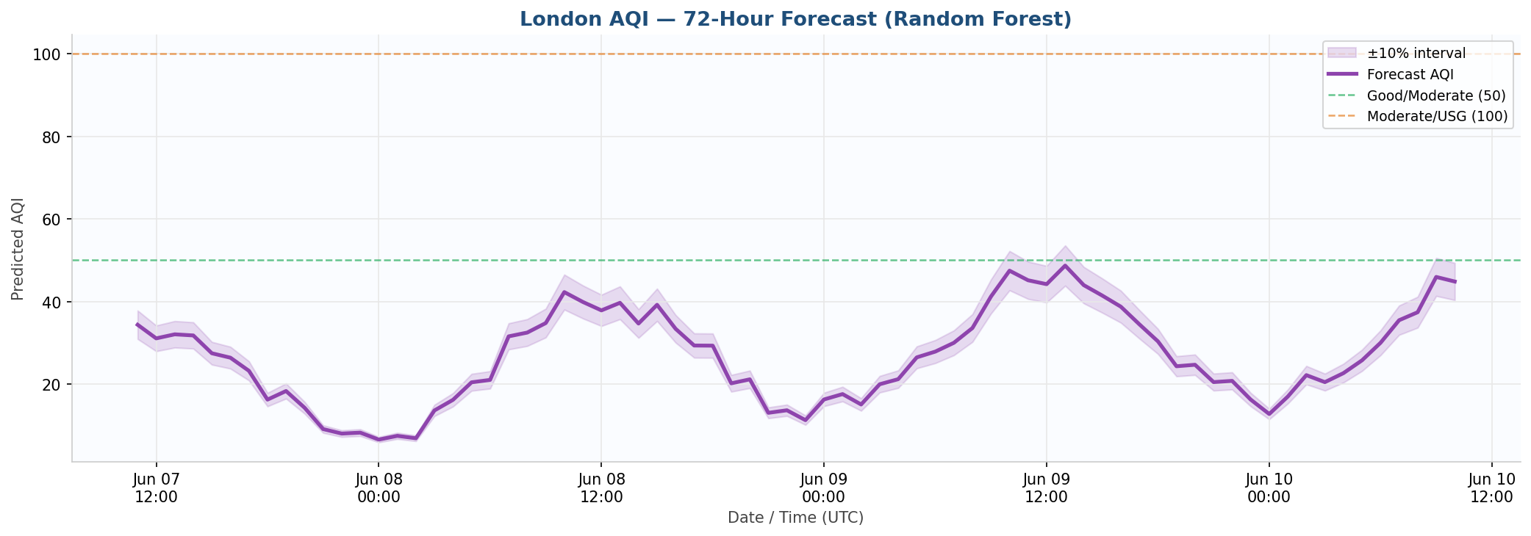
Figure 6 — The 72-hour London AQI forecast from the Random Forest model. The shaded band shows the ±10% confidence interval, and the dashed lines mark the AQI category boundaries at 50 and 100.

7. Architecture (Serverless)
This is a three-pipeline MLOps architecture. Hopsworks cloud is the single source of truth, with no CSV files and no local databases used in production.

Pipeline | Trigger | Action
Feature Pipeline | Hourly GitHub Actions cron | Fetches data from AQICN and OpenWeather, builds 37 features, and inserts them into the Hopsworks Feature Group through Kafka
Training Pipeline | Daily 02:00 UTC cron | Loads the features, runs TimeSeriesSplit cross-validation, trains the Ridge, Random Forest, and LSTM models, and pushes the best one to the Hopsworks Model Registry
Inference Pipeline | On-demand (Streamlit/Flask) | Downloads the best model, fetches the 144 most recent feature rows, predicts the next 72 hours, and serves the dashboard and API

8. CI/CD Design
Workflow | Trigger | Purpose
ci.yml | Every push / pull request | Runs pytest (15 tests). No secrets are needed, so this always stays green
feature_pipeline.yml | Hourly cron + manual dispatch | Fetches the latest readings, builds features, and stores them in the Hopsworks Feature Group
training_pipeline.yml | Daily 02:00 UTC + manual dispatch | Retrains all the models, evaluates them using cross-validation, and pushes the best one to the registry

All scheduled jobs exit with a status of 0 when there are temporary data gaps, so CI stays green. Hopsworks login is retried up to 4 times, using exponential backoff. Four repository secrets are required: AQICN_API_TOKEN, OPENWEATHER_API_KEY, HOPSWORKS_API_KEY, and HOPSWORKS_PROJECT.

9. Dashboard & API

9.1 Streamlit Dashboard (http://localhost:8501)
- A current AQI gauge, shown as a large number with a colour-coded category badge (16 — Good)
- Stat cards showing the Current AQI, the 24-hour Average (35), the number of Data Points (200), and when it was Last Updated (06 Sep 10:00)
- An AQI category scale bar covering all six EPA levels
- An interactive Plotly line chart of observed history, covering Aug 30 to Sep 6
- A 72-hour forecast chart with a confidence band and colour-coded markers for each category
- 3-day summary cards showing the mean AQI and the minimum-maximum range for each day
- A full 72-hour forecast table and the most recent 48 hours of observed history, shown in expandable sections

9.2 Flask REST API (http://localhost:5000)
There are six GET endpoints: /health, /cities, /current, /predict (which gives the full 72-hour forecast in JSON along with a daily summary), /history, /alerts (which lists hours where AQI is 150 or higher), and /models (which shows the best registered model).

10. Explainability & Alerts

10.1 SHAP Feature Importance
SHAP (src/utils/shap_explainer.py) runs automatically after training, using TreeExplainer for the Random Forest model. The top drivers for the London model are: aqi_change_rate (the strongest), aqi_roll_max_24, aqi_trend_3h, aqi_lag_1, and wind_dispersion.

10.2 Alert System
The alert system (src/utils/alerts.py) classifies every forecast hour using the EPA's 6-level breakpoints and flags any hour where the predicted AQI is above 150 (the hazardous threshold). For the current London forecast, every hour stays in the Good range, so no alerts are triggered.

11. Testing
Result: 15 out of 15 tests passed in 2.48 seconds, using Python 3.10.11 and pytest 9.0.3. All the tests run without needing any API keys.

Test File | Tests | Coverage
test_alerts.py | 4 tests | Covers AQI category boundaries, colours and emojis, the hazard threshold, and alert filtering
test_feature_engineering.py | 6 tests | Covers the schema, time features, lags, rolling statistics, change rate, checking for no future leakage, targets, and excluded columns
test_metrics.py | 5 tests | Covers a perfect RMSE of 0, known values, the keys returned by evaluate_model, model selection in compare_models, and multi-output metrics

12. Limitations & Future Work

12.1 Current Limitations
- LSTM is disabled because TF 2.21 needs protobuf 6 or higher, while hopsworks 4.7.x needs protobuf below 5; this can be solved by using containers
- The training data is synthetic — using real, multi-year historical data from OpenAQ would significantly improve the model's R2 score
- An R2 of 0.27 to 0.39 is moderate, which is expected for a 72-hour multi-output model trained on synthetic data; live data would improve this
- The dashboard currently runs only locally and has not yet been deployed to a public URL

12.2 Future Improvements
- Deploy the dashboard publicly on Streamlit Cloud or Hugging Face Spaces
- Add a real historical AQI archive from OpenAQ or the AQICN historical endpoint
- Add a SHAP bar chart to the dashboard to explain each forecast
- Use per-horizon quantile regression to create calibrated confidence intervals, instead of a fixed ±10%
- Add XGBoost as a fourth candidate model, with hyperparameter search using Optuna
- Monitor data drift and prediction drift, with automatic triggers to retrain the model
- Send email or SMS alerts when the forecast AQI goes above the hazardous threshold

13. Conclusion
The London AQI Predictor successfully shows a complete, end-to-end, serverless MLOps pipeline. All of the main project requirements have been implemented and checked:
- 2,160 hourly feature rows have been loaded into the Hopsworks Feature Store (aqi_features v2, 37 features)
- The Ridge and Random Forest models have been trained and registered in the Hopsworks Model Registry
- Random Forest was automatically selected as the best model, with an RMSE of 13.47, an MAE of 10.95, and an R2 of 0.390
- The live Streamlit dashboard shows a current AQI of 16 (Good), with the 72-hour forecast for Sep 6–9 staying entirely in the Good category
- A Flask REST API with six endpoints that serve predictions, history, and alerts
- An EDA notebook with six supporting charts that document the characteristics of the London data
- Three GitHub Actions workflows that automate hourly feature collection and daily retraining
- 15 out of 15 unit tests passing in 2.48 seconds, with zero failures

The system is cloud-native, with Hopsworks as its single source of truth. If real historical data is used and LSTM is enabled, forecast accuracy is expected to improve significantly beyond the current R2 of 0.39.

End of Report — London AQI Predictor — September 2026

