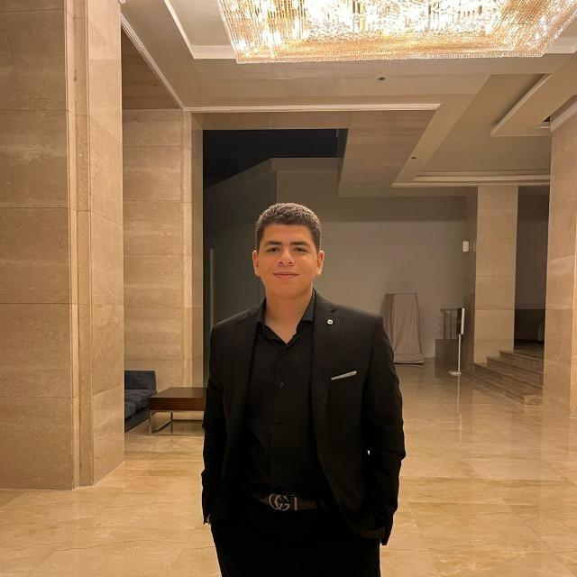  Ahmed Sameh  Abdel Gelil  Computer Science Student  CONTACT  ✉ ahmedsameh9034@gmail.com  🌐 My Portfolio  📍 Giza, Egypt  EDUCATION  AAST – Smart Village  B.Sc. Computer Science  Expected: 2028  Manor House School  Graduated: 2024  LANGUAGES  Arabic — Native  English — B2  INTERESTS  ⬡ Cyber Security  ⬡ Web Development  ⬡ Artificial Intelligence  ⬡ Robotics  ⬡ CTF Competitions | Ahmed Sameh AbdelGelil  Computer Science | Cyber Security | AI  PROFILE  Motivated 20-year-old CS student at AAST, passionate about AI, Robotics, Cyber Security and Web Development. 1st place winner in an IP Protocol Cyber Security competition. Experienced with real-world internships, backend API development in C#, and certified AI training, with a strong drive to leverage AI in modern solutions.  EXPERIENCE & CERTIFICATIONS  🏆 Cyber Security Competition — 1st Place  IP Protocol Track | Competition Winner  • Ranked 1st place in an IP Protocol Cyber Security challenge  • Demonstrated deep knowledge of network protocols and vulnerability analysis  Front-End Web Development Internship  Encrypt Core | Internship  • Worked on real-world front-end projects using HTML, CSS & JavaScript  • Built responsive UI components and collaborated with a development team  IT Internship — Project Management System  Corelease | Smart Village | Summer Internship  • Interned as an IT trainee and developed a project management system  • Built the backend REST API in C# and integrated it with the frontend  AI Courses — Anthropic  Anthropic | Certifications  • Claude 101, AI Fluency Framework & Foundations, and Claude Code in Action  Operations Team — Student Bridge Club  College Admission Club | 2 Summers  • Served 2 summers on the operations team, strengthening team collaboration  Cyber Security Courses  Encrypte Core & Quantum AI | Certifications  • Completed structured Cyber Security programs covering network security, ethical hacking & encryption  • Trained on AI-assisted security tools through Quantum AI  PROJECTS  QR Code Generator Website  HTML | CSS | JavaScript  • Built a fully functional QR code generator web application  • Link: ahmeds34.github.io/Scanme-QR-code-generator  Personal Portfolio Website  • Designed and deployed a portfolio to showcase projects and skills  • Link: ahmeds34.github.io/Ahmedportfolio  TECHNICAL SKILLS  Programming Languages  Python • JavaScript • Java • C • C++ • C# • SQL  Web Development  HTML • CSS • type script • Responsive Design • GitHub Pages  Cyber Security & Tools  Cyber Security • IP Protocols • Network Security • Microsoft Excel • AI Tools  Soft Skills  Team Work • Problem Solving • AI-Driven Workflow • Fast Learner

