**Important Disclaimer before taking the test !**

This test is made by students taking their information from WHO(World Health Organization), which through their own words is a list made for informational purposes only. So kindly, always consult your local medical authority for advice, don’t base your health status entirely on this test. The more proper way to find out if you have covid is through PCR [ (Polymerase chain reaction), which is a commonly used molecular test where samples are collected from the nose and/or throat, and the molecular test detects the virus in the sample by amplifying viral genetic material to detectable levels. ]

NOTES:  
*If you have any of the serious symptoms, seek immediate medical attention and always call before visiting your doctor or health facility.*

*People with mild symptoms who are otherwise healthy and young should manage their symptoms at home.*

Questions:  
  
(COMMON SYMPTOMPS)   
1- Do you have a fever? Y/slightly/N   
2- Do you have a cough? Y/slightly/N   
3- Are you feeling tired? Y/slightly/N   
4- Do you have a loss of taste or smell? Y/Slightly/N  
  
(LESS COMMON)

1- Do you have sore throat? Y/N

2- Do you have a headache? Y/N

3- Are you feeling any aches or pain? Y/N

4- Do you have diarrhea? Y/N

(Serious symptoms)

1- Are you suffering from difficulty breathing or shortness of breath? Y/N   
2- Are you suffering from loss of speech or mobility? Y/N   
3- Are you suffering from chest pain? Y/N  
  
  
  
  
  
  
  
  
  
  
  
Extra information:   
1- There is no evidence that people can catch COVID-19 from food. The virus that causes covid-19 can be killed at temperatures similar to that of other known viruses and bacteria found in food.   
2- The best household disinfectant for surfaces can be regular household cleaning and disinfection products. Products mostly based on ethanol are most helpful.   
3- On average it takes 5-6 days from when someone is infected with the virus for symptoms to show, however it can take up to 14 days.   
4- It is safe to have groceries delivered if the provider follows good personal and food hygiene practices, and after accepting the delivery, hands must be properly washed.

5- Older people and those with underlying medical problems like cardiovascular disease, diabetes, chronic respiratory disease, and cancer are more likely to develop serious illness.  
6- Quarantine is used for anyone who had contact with someone who has tested positive for corona where you remain separated from others because you have been exposed to it and may be infected, Isolation is used for people who have tested positive for the virus where you are completely separated from others.

7- Antibiotics do not work against viruses but on bacterial infections only.

8- 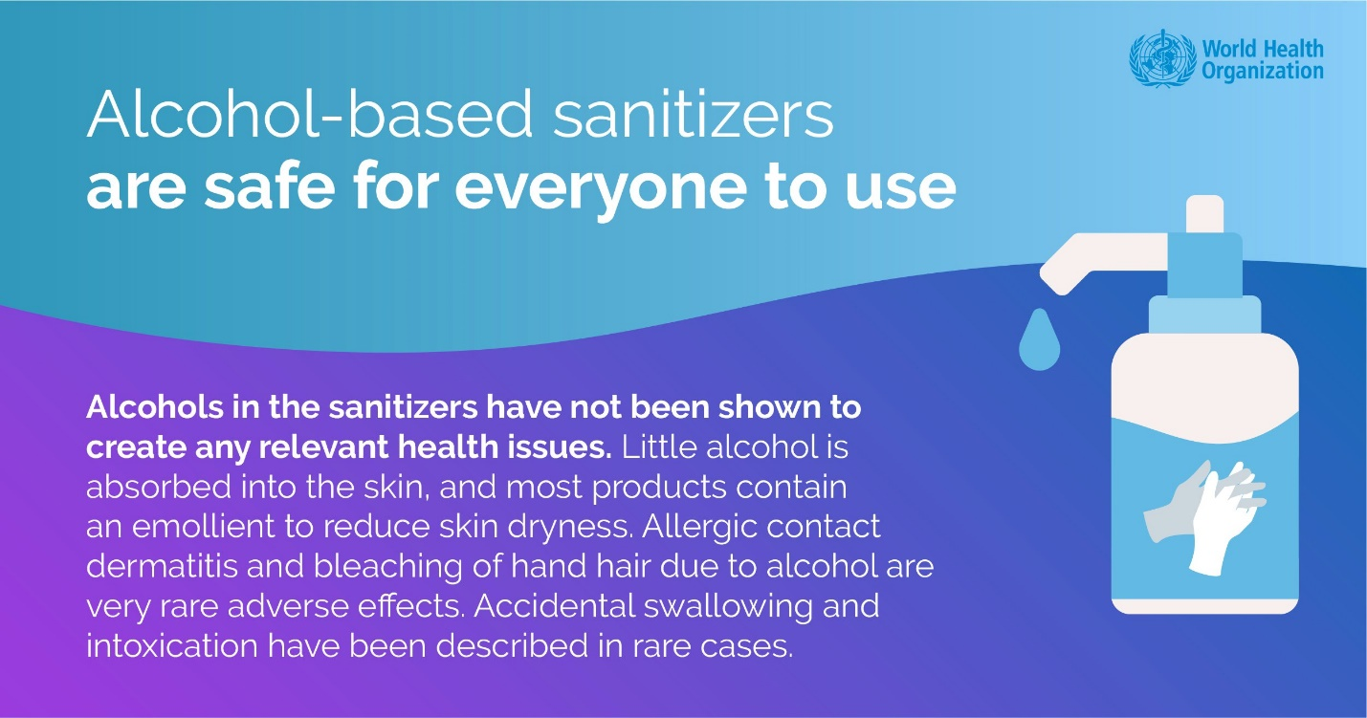

9- 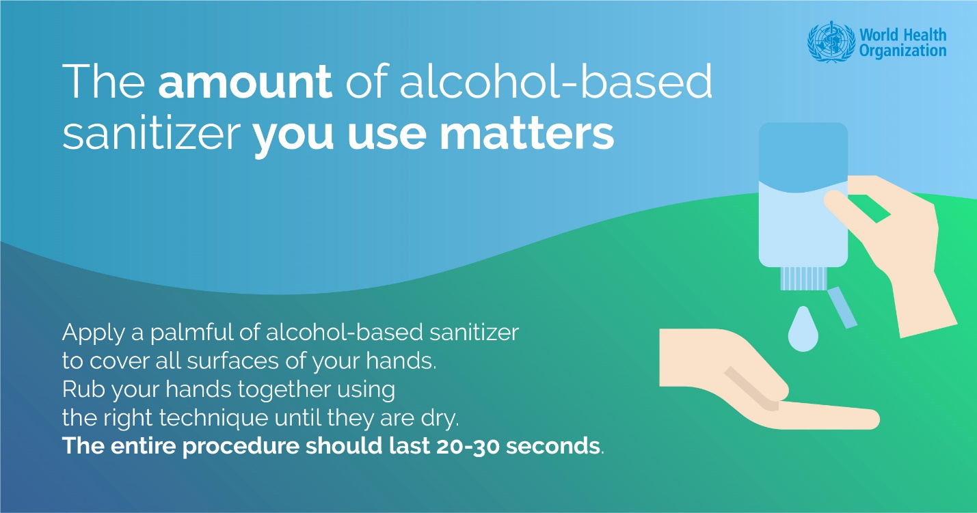

10- 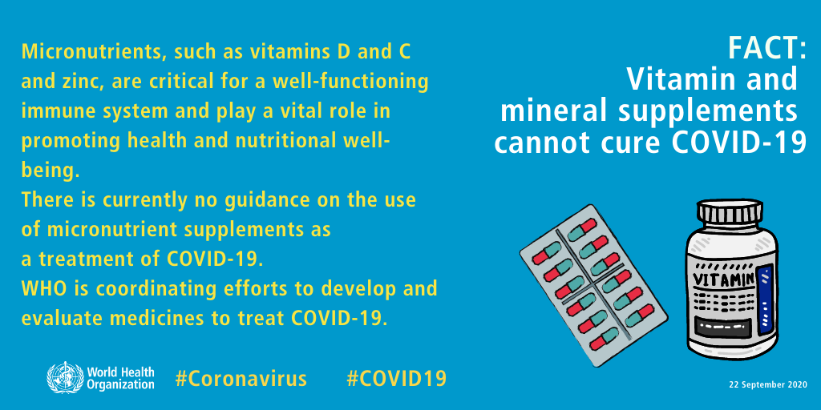  
  
  
  
  
  
  
  
  
11- 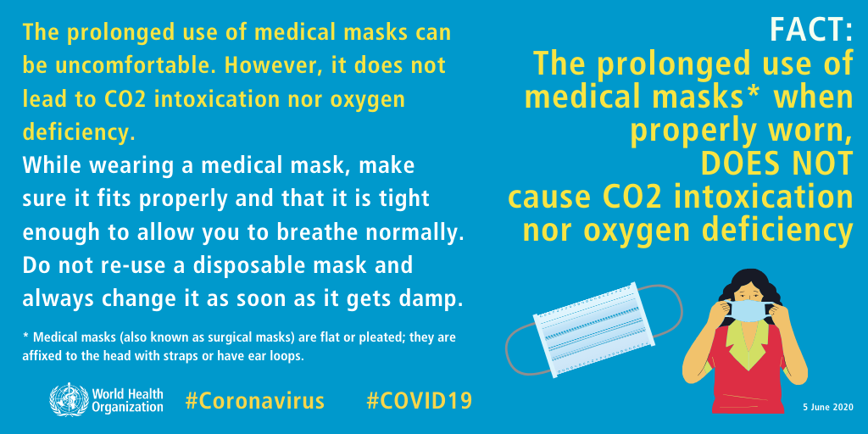

12- 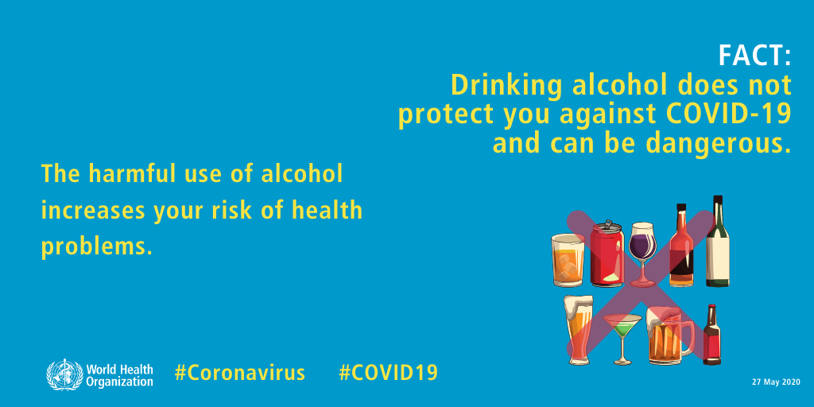

## 13- Exposing yourself to the sun or temperatures higher than 25°C DOES NOT protect you from COVID-19.

## 14- Covid-19 can spread in hot and humid climates. 15- Cold weather and snow cannot kill COVID-19.

## 16- People of all ages can be affected by COVID-19 virus.

## 17- Current evidence suggests that virus spreads between mainly between people who are in close contact with each other whether from his mouth or nose when they cough, sneeze, speak, sing or breathe.

## 18- You can avoid covid by following the local guidance, keeping distance, wearing a mask, avoiding crowded places, frequently clean your hands and get vaccinated. *INFORMATION FOR OMICRON* : (TO BE UPDATED..)

Sources:  
<https://www.who.int/>   
<https://www.who.int/news-room/questions-and-answers/item/coronavirus-disease-covid-19>  
  
  
Please, if you can, help people who fight Covid-19 by donating to https://covid19responsefund.org/en/  
to support WHO and its partners’ efforts against COVID-19, to help decrease the cases of infections among our beloveds.