Team name: Aug

Team members:

1-Ahmed Hassan Ali

2-Ahmed Salah Emam

3-Anas Alaa Mohamed

4- Mostafa AbdelMawgood Ismail

5-Mohamed Hesham Abdelghaffar

6-Rawan Mohamed ElSayed

**Introduction**

Experimental studies focusing on elucidating the underlying mechanisms of tumor proliferation cross all physiological scales—from the classification of genes that lead to enhanced proliferation and survival, to the quantification of physical stresses such as pressure that spatially constrain the direction and quantity of tumor expansion .While a wealth of knowledge has been acquired for understanding tumor initiation, development, progression, and response to therapy, robust methods do not exist to reliably predict tumor growth and response to specific therapeutic regimens for the individual patient. Largely independent of the developments in cancer biology, investigators have developed a wealth of mathematical models and techniques to predict cancer development and response to therapy. These models can potentially be used to optimize therapy by exploring dosing regimens with cytotoxicity models that describe the effect on proliferation, cell signaling models that identify cellular transition rates for drug targeting, and tissue scale models that predict tumor response to therapy using patient-specific imaging data

Having accurate and biologically relevant predictive models of tumor proliferation would provide a rigorous framework to systematically test different cancer therapies—and do so more quickly and cheaply in the pre-clinical or (even) clinical setting. The availability of a validated mathematical model that can predict the spatiotemporal evolution of tumor growth would allow oncologists to intervene in an optimal way for the individual patient. A crucial facet of this modeling challenge is understanding and faithfully modeling proliferation itself. The capability to proliferate at elevated rates, and in often nutrient poor and toxic microenvironments, well beyond the capacity of normal cells, is the primary distinguishing characteristic of cancer cells. In many regards, to study cancer is to study cellular replication, in general, and the regulators of cellular reproduction, in particular. The manner by which proliferation is characterized and implemented in a mathematical model for tumor growth is central to its ability to predict growth and treatment response for cancer (i.e., deviation from expected growth following treatment).

The term “proliferation” can be defined broadly as the net change in the number of cells per unit time, the mechanisms of which have been tabulated and classified into as many as 10 different categories. Here, we will discuss tumor cell proliferation models organized by scale: from individual cellular mechanisms to the tissue and cellular populations as a whole. Towards this end, we focus on the mathematical descriptions and associated results related to avascular growth and treatment, mechanical effects on growth, nutrient availability and consumption, the ability to evade the immune response, and tumor signaling pathways. In particular, many specific biological topics that can be intricately related to proliferation will not be discussed, such as genomics and therapeutic resistance and persistence. Thus, the goals of this review are to: 1) present a brief background on basic mathematical strategies for modeling and understanding proliferation in cancer with an emphasis on strategies that have been compared to experimental data, 2) discuss biological topics related to cancer cell proliferation (ranging from cell signaling to mechanical properties at the tissue scale), and 3) identify areas that could enable clinical translation through better integration of experiment and theory.

**Mathematical model**

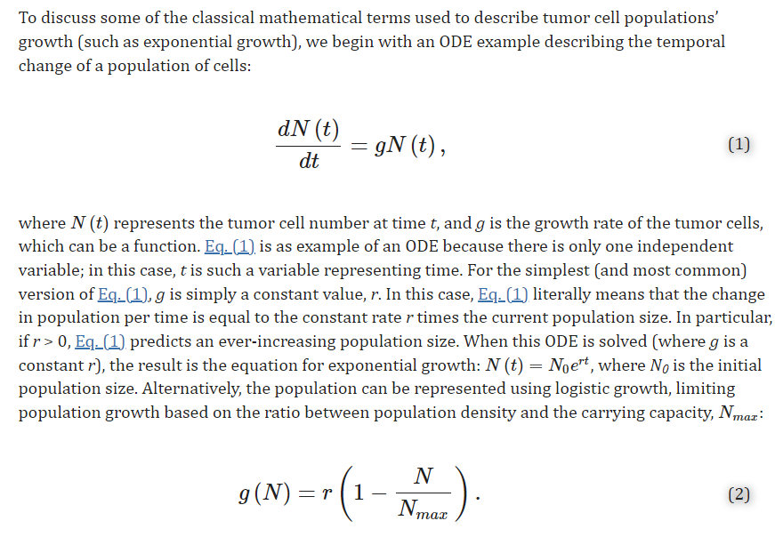

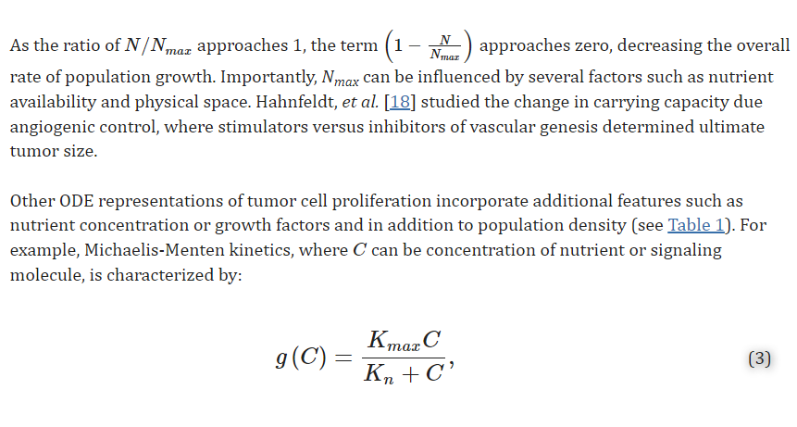

where Kmax is the maximal rate of proliferation, and Kn is the Michaelis-Menten constant, which is the concentration of the nutrient or signaling molecule when the growth rate is half its maximum.

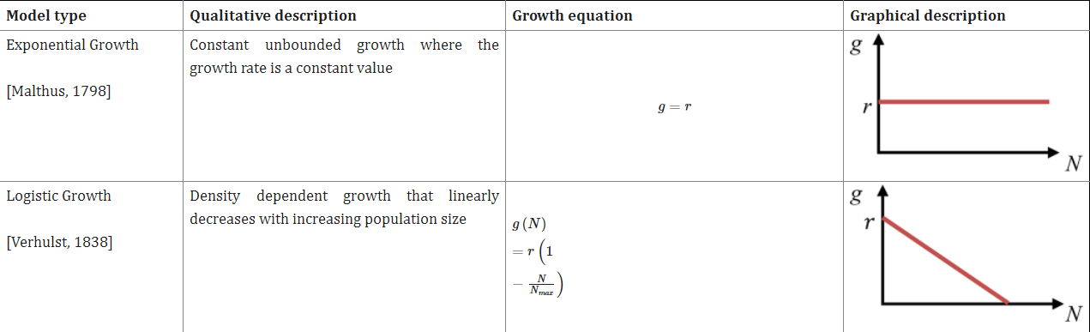

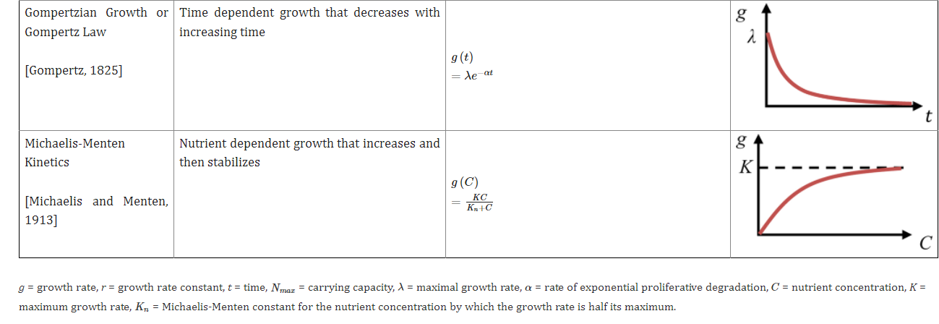

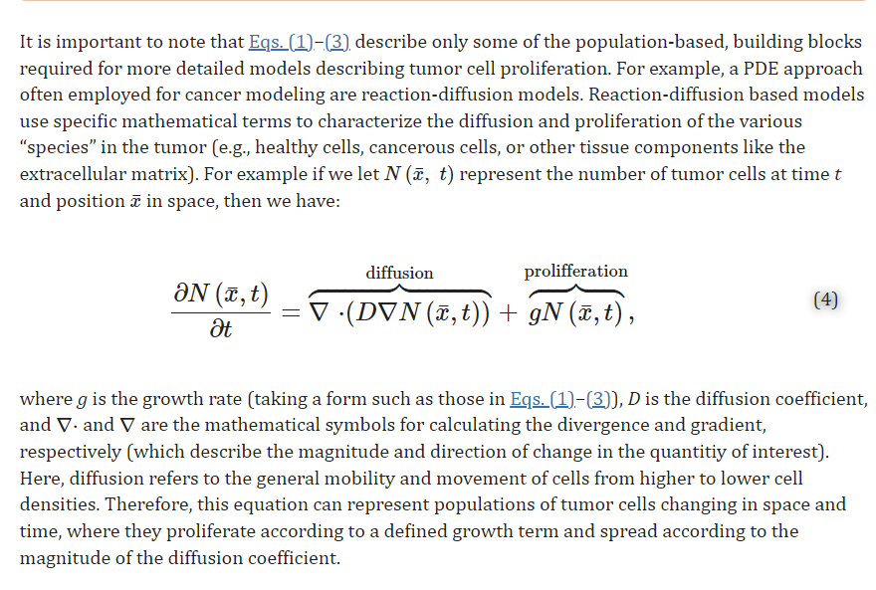

While continuum models describe an average of the interactions between tumor cells or with other cells in the body (e.g., connections/networks that may trigger changes in proliferation due to overcrowding and/or changes in signaling), discrete models are able to reproduce distinct cellular heterogeneity (and not mixed populations) inside the tumor mass and individual cellular dynamics for proliferation .Discrete models have the advantage of capturing individual cell behavior and interactions among cells by defining distinct or individual components for each cell or chemical signal. Discrete models are often used in multi-scale models that combine the effects of more than one layer of tumor cell proliferation dynamics, such as intra- and inter-cellular signaling. This does, of course, come at an increase in computational cost due to the large number of equations required to govern all the interactions within the system.

In an attempt to achieve better spatial agreement with experimental results at the cell scale, discrete approaches such as cellular automata or agent-based models have been developed. Cellular automata are mathematical models that simulate complex systems by well-defined rules. It is defined by distributing identical cells within a regular spatial lattice. Each cell has a value, or “state”, which is updated at each time-step based on a set of pre-defined rules explicitly describing how the nth cell changes based on its state and the states of its neighbors. For example, the probability that a tumor cell will proliferate or become necrotic can be based on nutrient availability, concentration of an inter-cellular signal, and therapy. Agent-based models can be thought of as generalizations of cellular automata models; they are designed to overcome the requirement that cells be constrained to a grid by instead representing cells as agents that interact with each other. This is particularly useful to model tumor growth as, due to the uncontrolled tumor proliferation, cellular division does not require a free empty place in the neighborhood of the cell to divide (this arrangement is typically required in the cellular automata model structure).