Write a Note WEBSITE

With :
HTML ,
CSS ,
& JavaScript

From :
Eng / Ahmed Mostafa

Introduction
In the world of technology which all in
race to make amazing things like
Web , Game and Apps with thing called
Programming
Which all rushing to learn this skill
This skill when you see from out
You often feels this complexity thing
But,
You have a journey in programming’s world

Welcome to programming’s world
Eng / Ahmed Mostafa
Frist:
What is HTML
HTML stands for Hyper Text Markup Language
?
Mean the language which browser understands it
What is uses of HTML
Uses :
Make a structure of website
?
Seriously ? ok

Like the skeleton of human body
More Examples :
HTML like the building materials of home
Second :
What is CSS
CSS is Cascading Style Sheets
Before you ask again this is sister of HTML
?
What is uses
?
okay CSS uses is :
Styling the page of HTML
Example :
The paint and culture of home that build with HTML
After this 50 percent (50%) of home is completed
You : what 2 languages is 50% ?!?!
Because you ignored the most important one between them
? what ?
JavaScript
Third :
JavaScript
Is the brain of website
The place that is :
Make solve mathematical problems
Make a web game
, Get info from servers
, etc
Example :
This is like the vital organs of human like :
Heart , brain , etc
Now let’s go to component of my project :
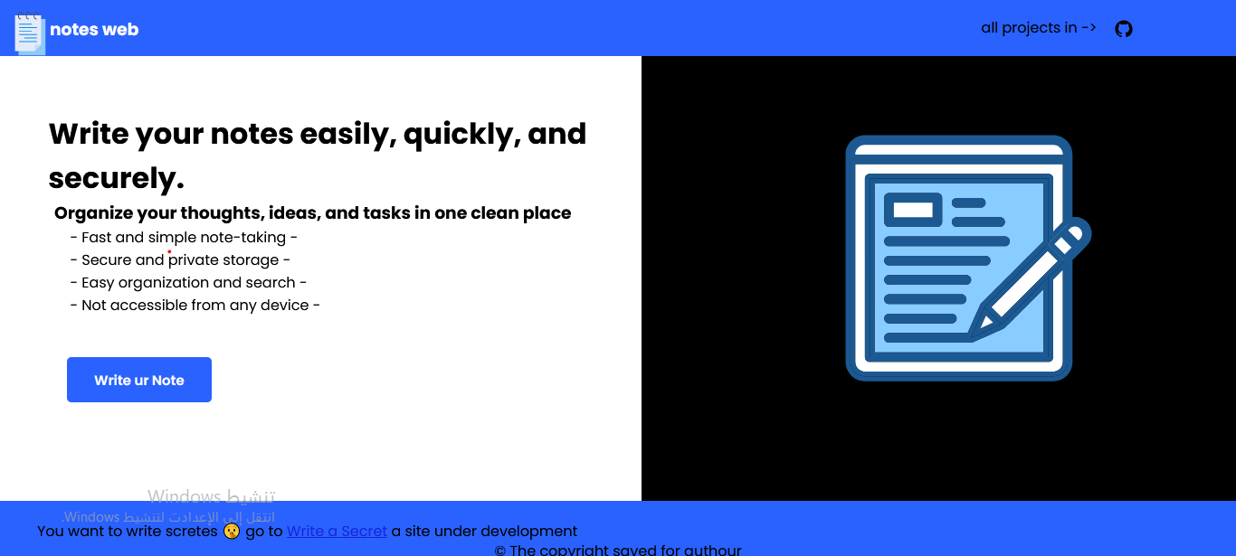

This is my home page of my website
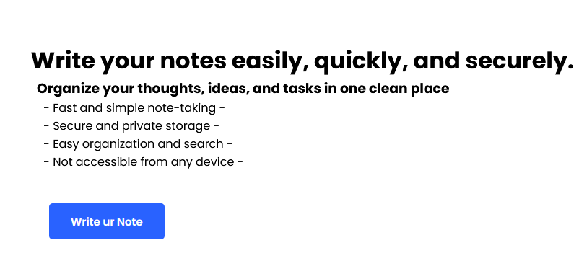
To make the boldest sentence I use <h1>*content*</h1>

<pre>*content*</pre>
<h3>*content*</h3>

