Enterprise Network Infrastructure

Project Overview
This project presents the design and implementation of a small enterprise network infrastructure using Cisco Packet Tracer.
The network consists of a Headquarters (HQ) and a Branch Office connected through a routed WAN link. The design includes VLAN segmentation, inter-VLAN routing, centralized DHCP, OSPF dynamic routing, network management through SSH, Access Control Lists (ACLs), and switch port security.
The main objective of the project is to build a structured, secure, and scalable network environment while applying practical enterprise networking concepts.

Network Architecture
The infrastructure is divided into two main locations:
- Headquarters (HQ)
- Branch Office
The Headquarters contains multiple departments and a server network, while the Branch Office contains Sales and Support departments.
The two locations communicate through a routed WAN connection using OSPF as the dynamic routing protocol.

VLAN & IP Addressing Plan
The network uses VLAN segmentation to separate departments and management traffic into dedicated broadcast domains.

Headquarters VLANs
VLAN | Department / Purpose | Network | Default Gateway
10 | HR | 10.10.10.0/24 | 10.10.10.1
20 | Finance | 10.10.20.0/24 | 10.10.20.1
30 | IT | 10.10.30.0/24 | 10.10.30.1
40 | Servers | 10.10.40.0/24 | 10.10.40.1
99 | Management | 10.10.99.0/24 | 10.10.99.1

Branch VLANs
VLAN | Department / Purpose | Network | Default Gateway
50 | Sales | 10.20.50.0/24 | 10.20.50.1
60 | Support | 10.20.60.0/24 | 10.20.60.1
99 | Management | 10.20.99.0/24 | 10.20.99.1

WAN Transit Networks
Connection | Network | Device Addresses
HQ Core ↔ HQ Edge | 10.255.254.0/30 | Core: 10.255.254.1 / Edge: 10.255.254.2
HQ Edge ↔ Branch Router | 10.255.255.0/30 | Edge: 10.255.255.1 / Branch: 10.255.255.2
The addressing scheme uses separate private IPv4 subnets for each VLAN and point-to-point WAN connection, providing clear network segmentation and simplified routing.

Routing and DHCP

Inter-VLAN Routing
Inter-VLAN routing is implemented to allow communication between different VLANs while maintaining logical network segmentation.
At the Headquarters, a Layer 3 core switch provides the default gateways for the HQ VLANs and performs inter-VLAN routing using Switch Virtual Interfaces (SVIs).
At the Branch Office, Router-on-a-Stick is used on the branch router to provide routing between VLAN 50 (Sales), VLAN 60 (Support), and VLAN 99 (Management).

OSPF Dynamic Routing
OSPF (Open Shortest Path First) is configured as the dynamic routing protocol between the Headquarters and Branch Office.
The routing topology uses three routers/devices participating in OSPF:
- HQ Core — Router ID: 1.1.1.1
- HQ Edge Router — Router ID: 2.2.2.2
- Branch Router — Router ID: 3.3.3.3
All OSPF routers operate in Area 0.
OSPF provides dynamic route exchange between the HQ and Branch networks, allowing remote VLAN networks to be learned automatically.

Centralized DHCP
DHCP is provided centrally by the HQ server.
DHCP scopes are configured for:
- HR
- Finance
- IT
- Sales
- Support
DHCP relay (ip helper-address) is configured on the appropriate Layer 3 interfaces so that clients in different VLANs can obtain their IP configuration from the centralized DHCP server. This approach centralizes IP address management and reduces the need for separate DHCP services at each VLAN or location.

Network Security & Management
Several security and management mechanisms were implemented to improve the security and administrative control of the network.

SSH Management
SSH version 2 is configured on the network infrastructure devices to provide secure remote management.
Local user authentication is used for administrative access, and Telnet access is disabled on the configured devices.

Access Control Lists (ACLs)
Extended ACLs are configured on the Branch Router to control communication between selected departments and HQ networks.
The implemented policies include:
- Sales VLAN is restricted from accessing the HR network.
- Support VLAN is restricted from accessing the Finance network.
- Other permitted traffic is allowed according to the configured ACL rules.
The ACL policies were tested to verify that restricted traffic is blocked while permitted traffic remains accessible.

Port Security
Port Security is configured on end-device access ports on the access switches.
The configuration includes:
- Maximum of one secure MAC address per access port.
- Sticky MAC address learning.
- Violation mode set to restrict.
This provides basic Layer 2 protection against unauthorized devices being connected to protected access ports.

Management VLAN
VLAN 99 is dedicated to network management.
Management IP addresses are assigned to the switch management interfaces, allowing network devices to be managed separately from normal user traffic.
These security and management features provide a stronger foundation for controlling administrative access and limiting unauthorized network communication.

Testing & Verification
The network configuration was tested using Cisco IOS verification commands and end-to-end connectivity tests.

OSPF Verification
OSPF neighbor relationships were verified using:
show ip ospf neighbor
The routers successfully established OSPF neighbor relationships with a FULL state.

Routing Verification
Learned OSPF routes were verified using:
show ip route ospf
The Branch Router successfully learned the HQ networks through the OSPF routing process.

DHCP Verification
DHCP connectivity was tested on both the HQ and Branch client networks.
Clients successfully received IP addresses, default gateways, and DNS configuration from the centralized DHCP server.

ACL Verification
The configured ACL policies were tested using end-to-end connectivity tests.
The following results were verified:
- Sales → HR: Blocked
- Sales → Server: Allowed
- Support → Finance: Blocked
- Support → Server: Allowed
ACL counters were also verified using:
show access-lists

SSH Verification
SSH configuration was verified using:
show ip ssh
SSH Version 2 was successfully enabled, and remote administrative access was tested from a network client.

Port Security Verification
Port Security was verified using:
show port-security
The configured access ports showed the expected security settings, including a maximum of one secure MAC address and restrict violation mode.

Overall Result
The implemented network was successfully tested across routing, DHCP, VLAN communication, remote management, access control, and Layer 2 security functions.

## Project Evidence
1-Topology.png
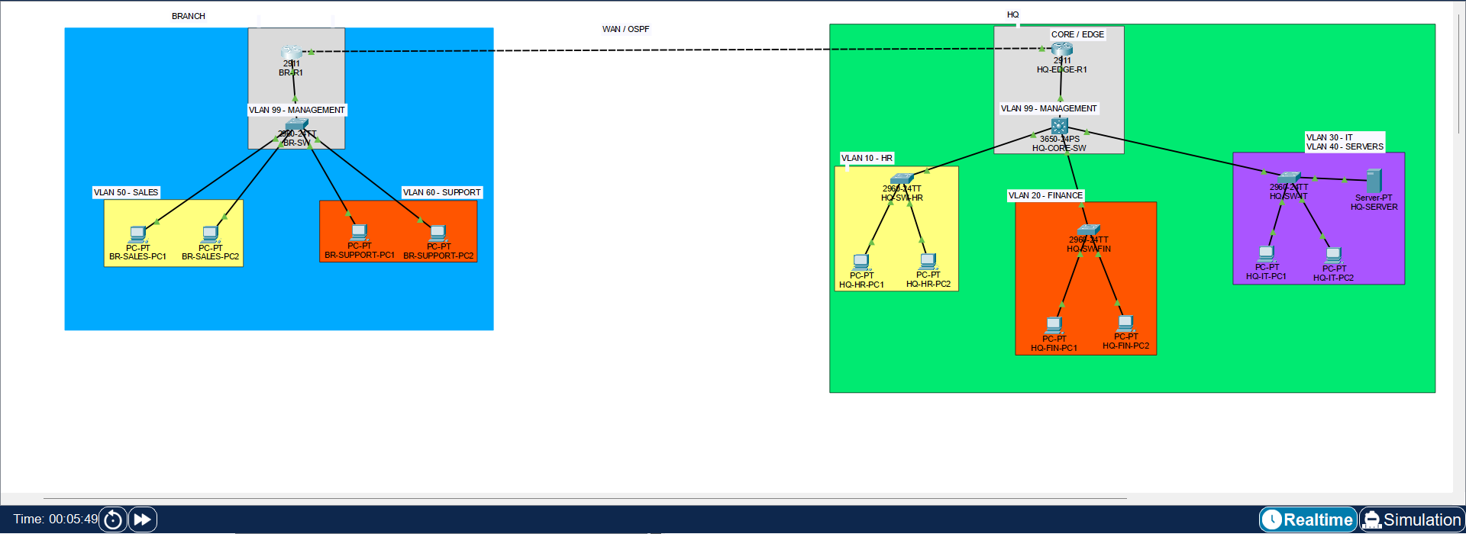
2-OSPF-Neighbor.png
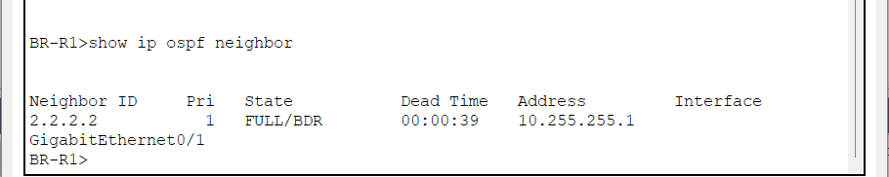
3-OSPF-Routes.png
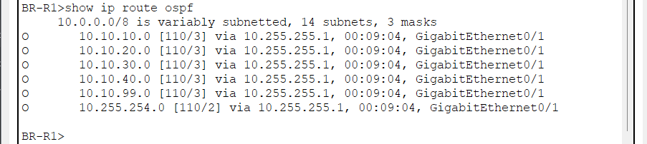
4-ACL-Verification.png
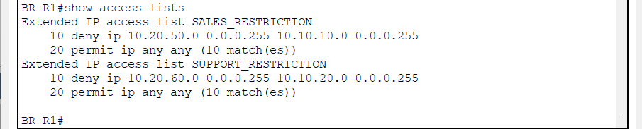
5-SSH-Verification.png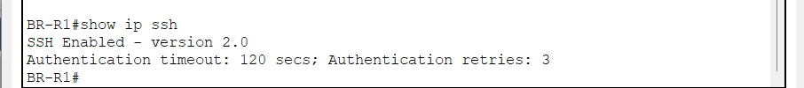

6-Port-Security-Verification.png
