LAB3

Name: Ahmed Alaa Eldin Tawfik

ID: 6842

Dijkstra’s Algorithm pseudocode
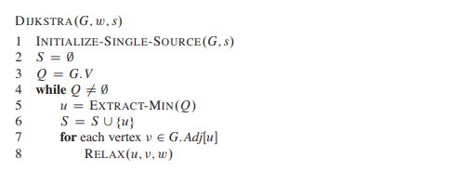

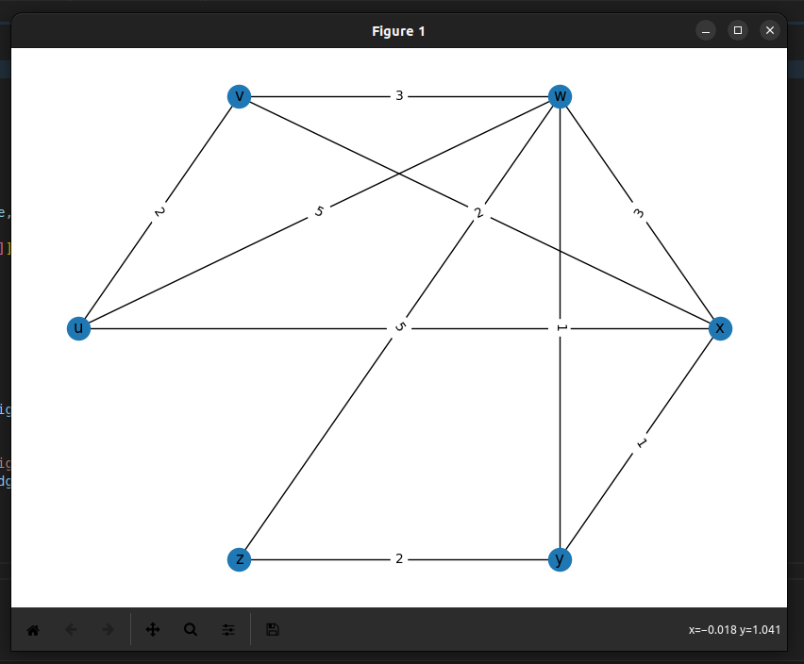
Results of visualizing the input graph
Output of using networkx
Forwarding Table
{
'v': ['u', 'v'],
'w': ['u', 'x'],
'x': ['u', 'x'],
'y': ['u', 'x'],
'z': ['u', 'x']
}

Output of using dijkstra’s algorithm
Forwarding Table
{
'v': ['u', 'v'],
'w': ['u', 'x'],
'x': ['u', 'x'],
'y': ['u', 'x'],
'z': ['u', 'x']
}

