Complete-Thesis Front End

1. As soon as the customer Logs in, he comes to the below Dashboard.

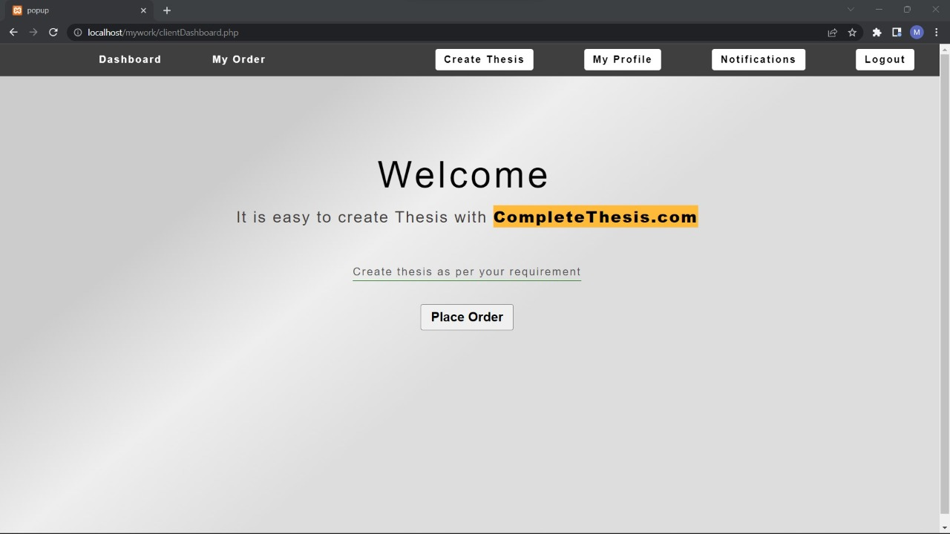

As soon as customer will click on place order he will be redirected to the below form. Where he will put the details of the project get the quote after submitting and making the payment all these details will be submitted to the admin panel. And this order will start appearing in his order history.

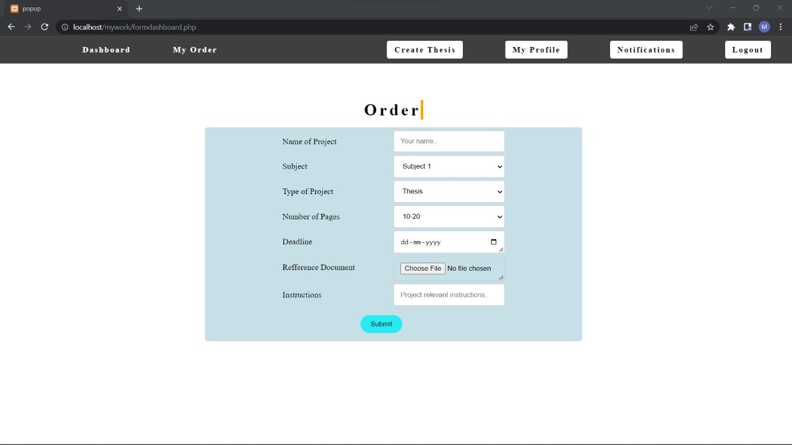

My order will redirect to the below page. Here customers will be able to see their order history.

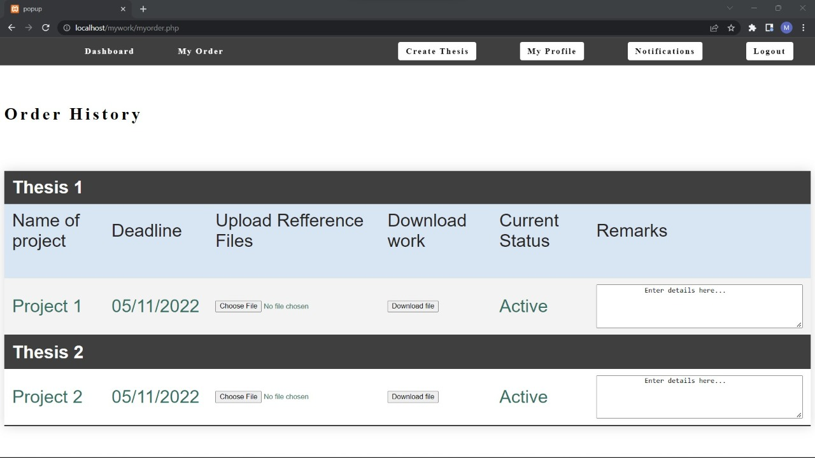

In each specific project, they will be able to see the name of the project, deadline, will be able upload reference files which will come to the admin in admin panel. Download the work as uploaded by the admin from the admin panel. We will be able to set the status of the work Active, Complete. This status should be able to set from the admin panel. And in the remarks panel, the customer should be able to put his remarks, these remarks will go to admin to the admin panel and admin will be able to answer those remarks. This will be like a chat bot in which all the chat history will also be there in this column.

In the My profile page, the email address of the customer will come. Whenever something is updated from the admin panel, it should appear in the notification and this notification should also reach to his email. If he clicks on create thesis then he will be redirected to the order page. If he clicks on logout then he should be logout from his account.