Analog Final Project

Rahma Sabry Mohamed AbdRabo 9033
Rawan Saleh galal 9186
Mohammed El Hofy 8790
Ahmed Tamer 8842
Mostafa Mohamed El Kassar 8580
Ahmed Mostafa Kamel 8623

EXPERIMENT 1
- Original Spectrum
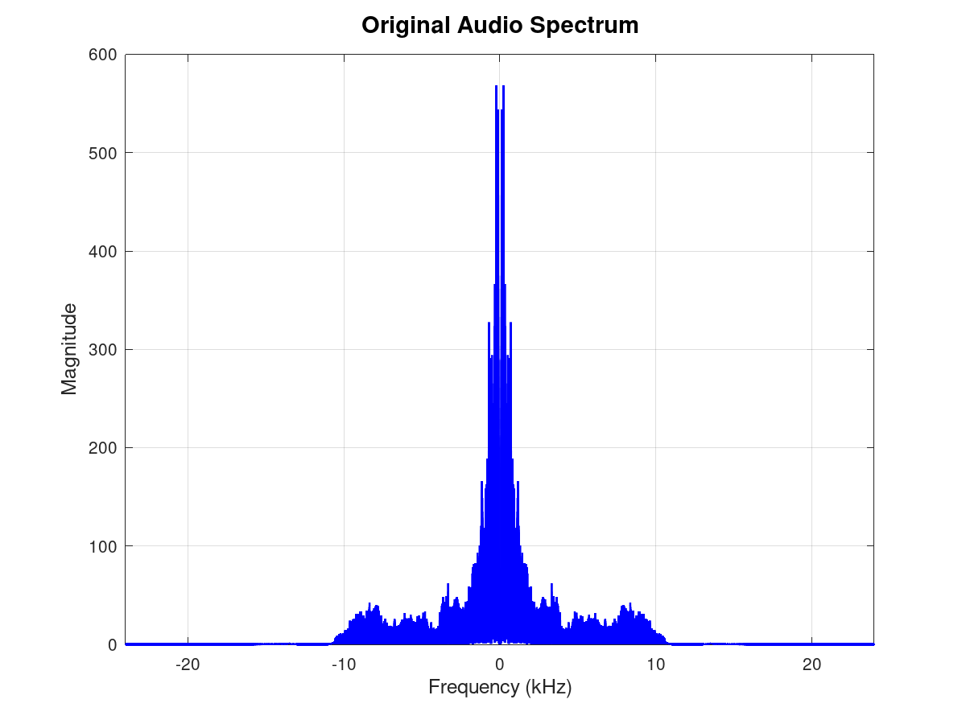

- FIltered spectrum after low pass filter

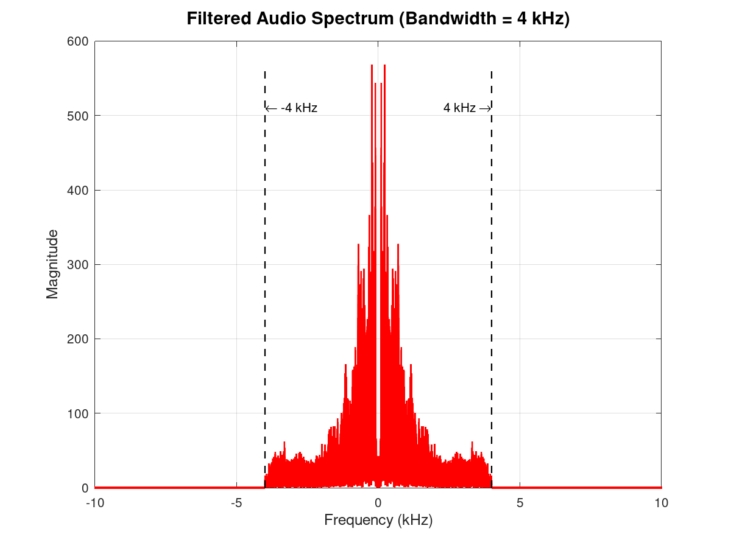
- Time comparison
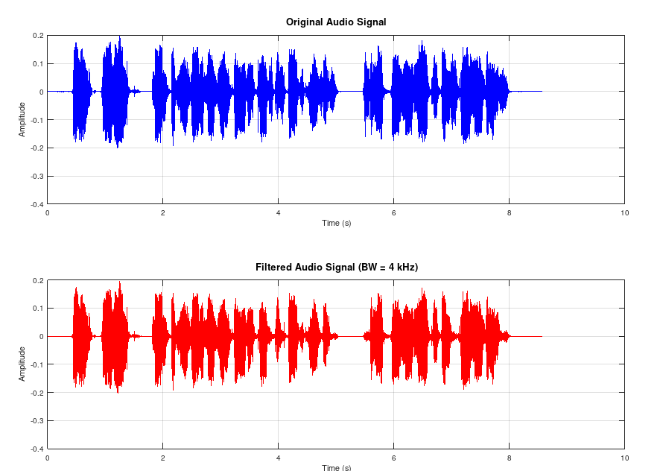
- DSB-TC spectrum frequency domain
Zoomed in
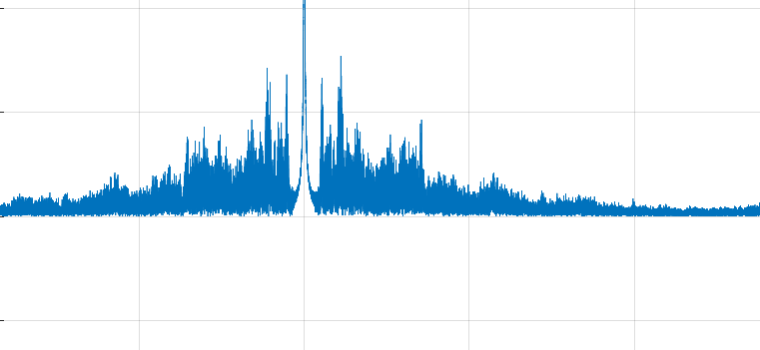
Zoomed out
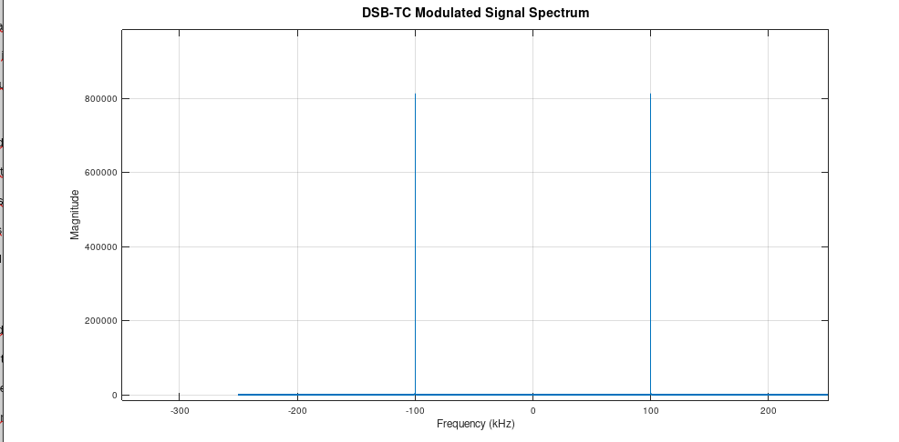
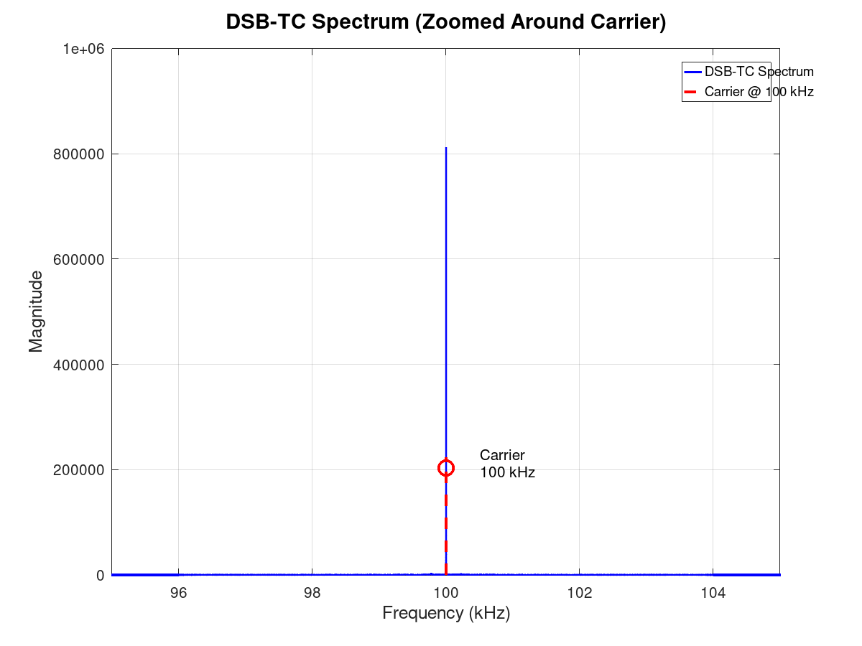

DSB-TC with detector

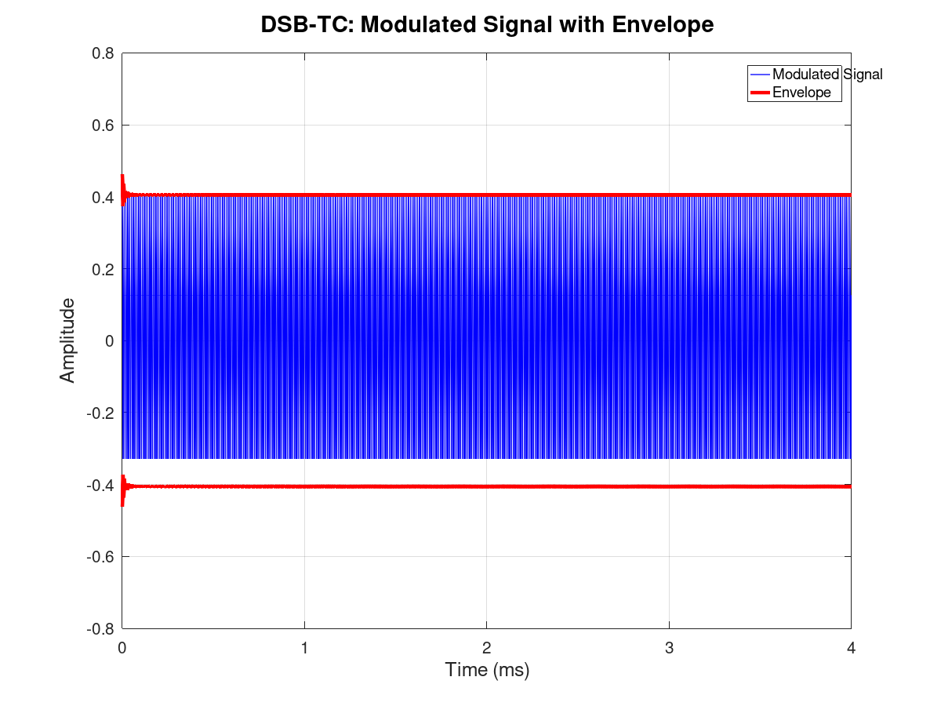
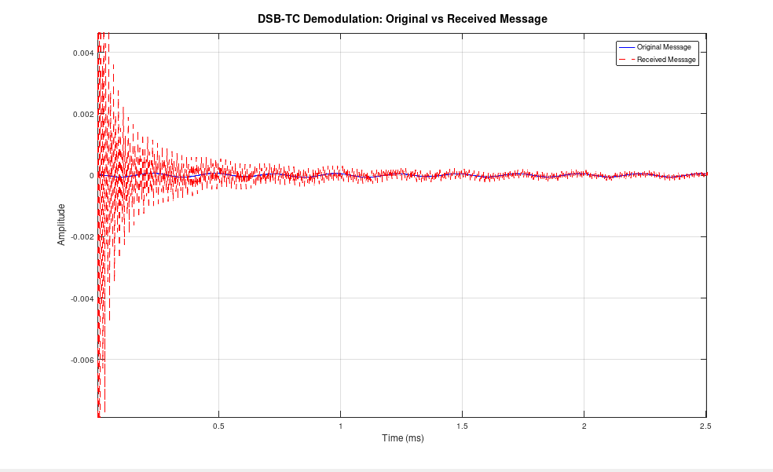

DSB-SC

Frequency domain
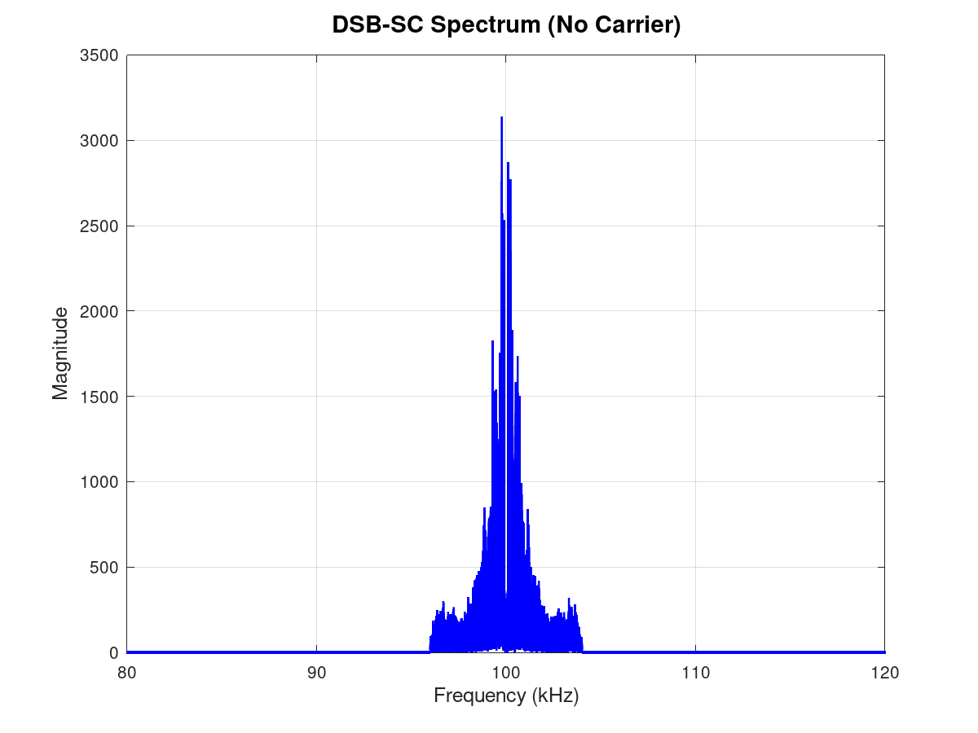
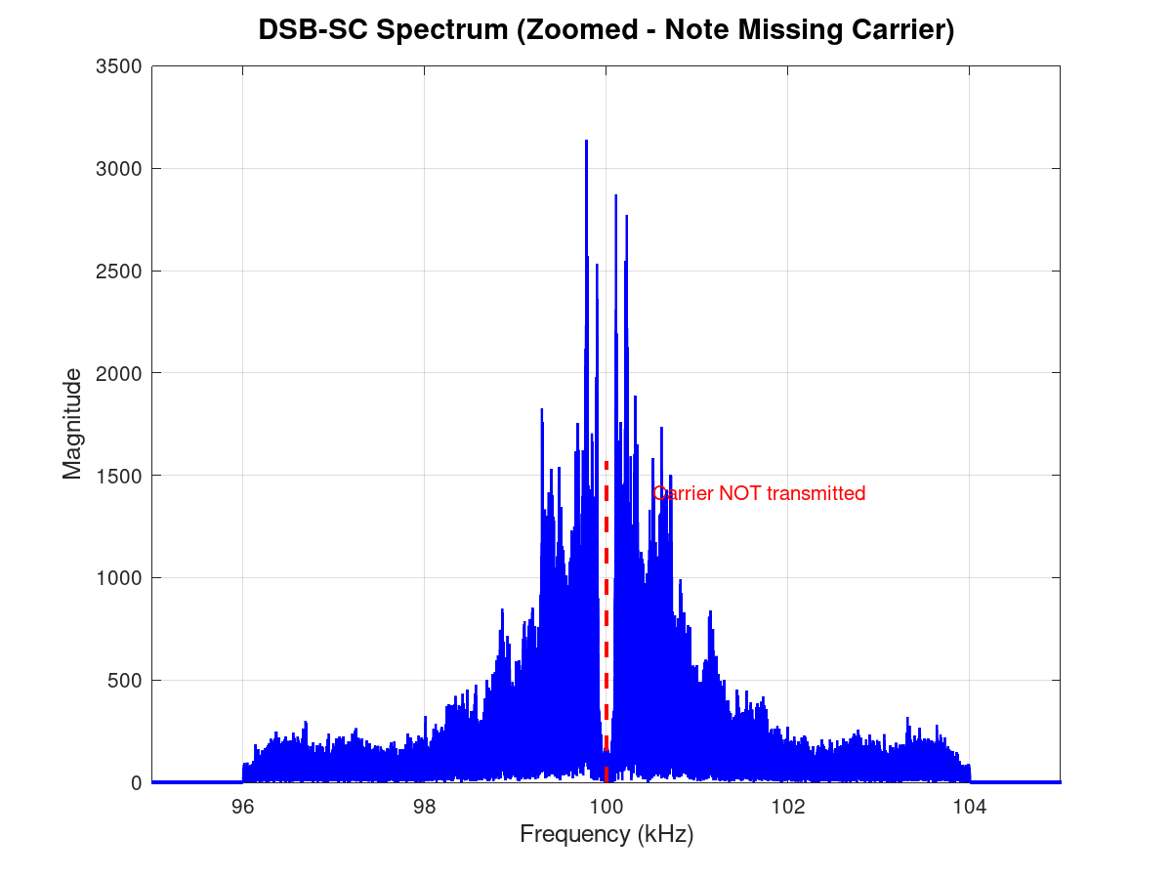

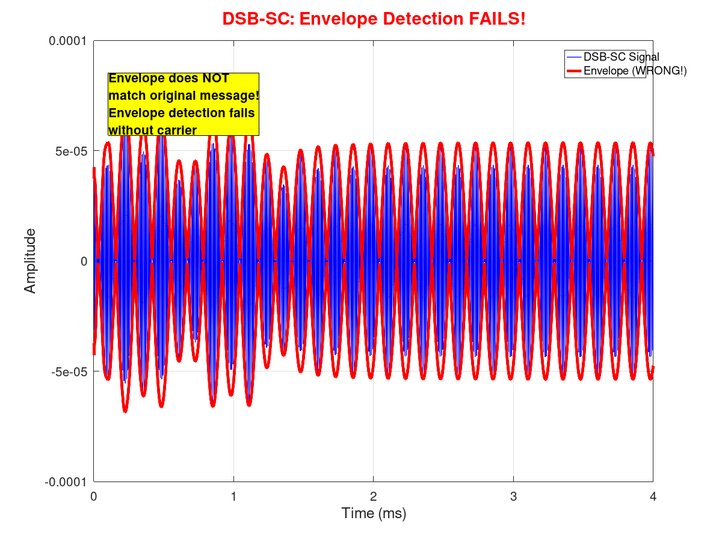
DSB-SC Envelope
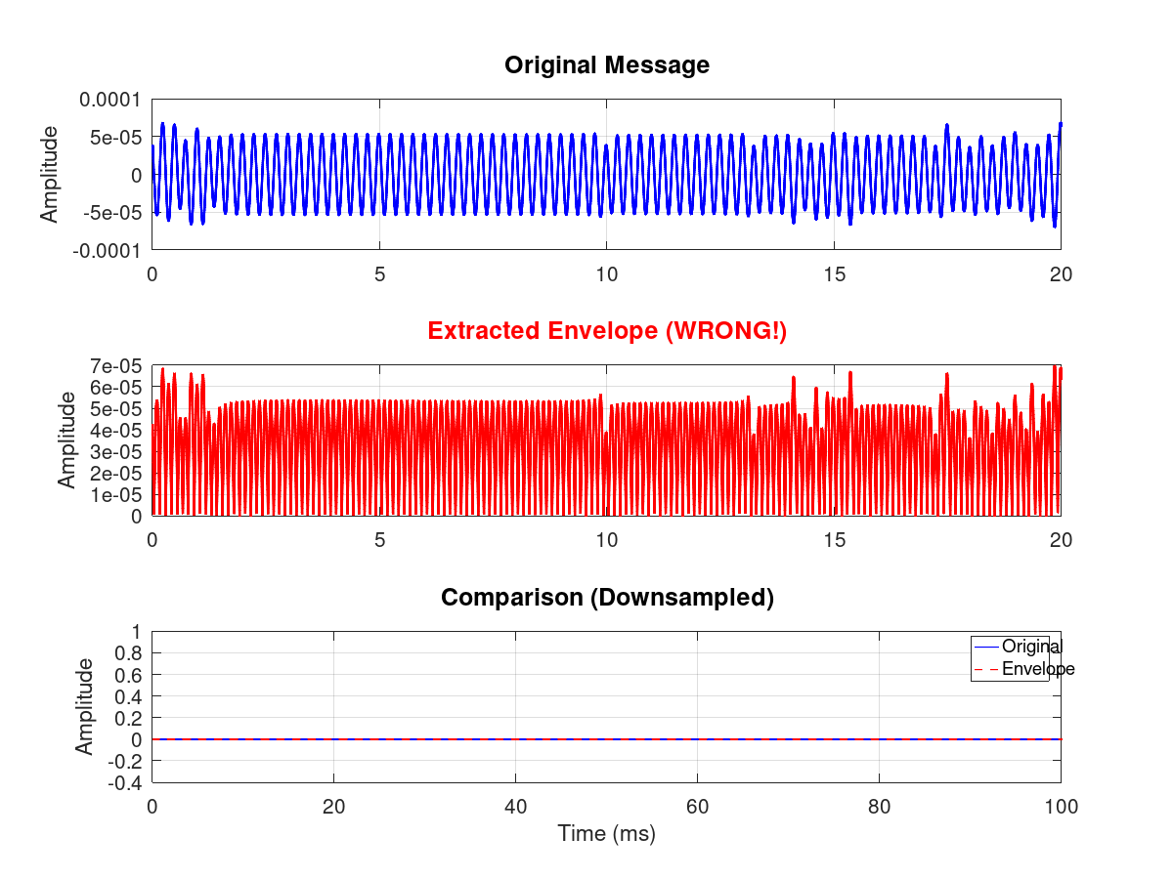
- For DSB TC: The demodulated signal is slightly attenuated or/and distorted
- While for DSB – SC: the demodulated signal is distorted and unintelligible

Coherent detection
SNR = 0

SNR = 10

SNR = 30

Frequency Error

Frequency error causes a beating effect with a beating frequency of 100 hz, beating effect is when a signal amplitude oscillates periodically

Phase Error

Phase error causes reduction in amplitude, but the audio is still clear

EXPERIMENt 2

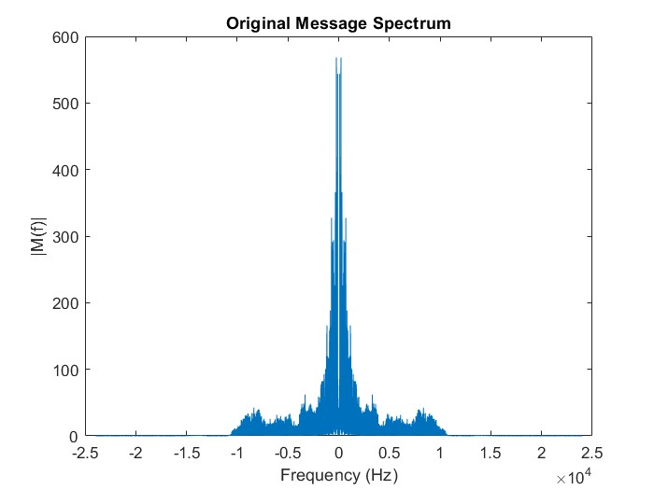

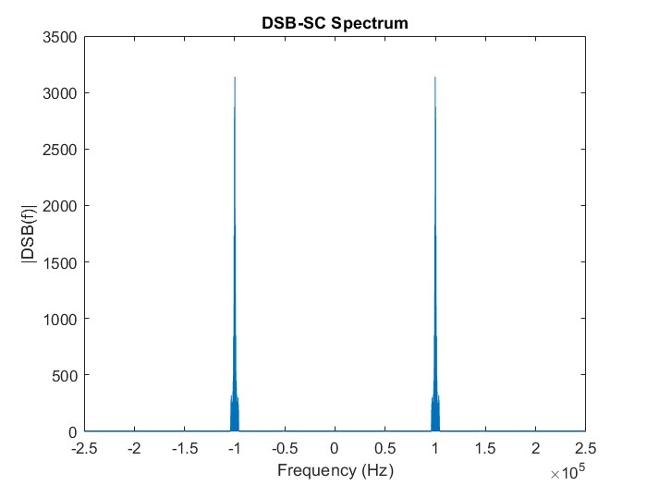

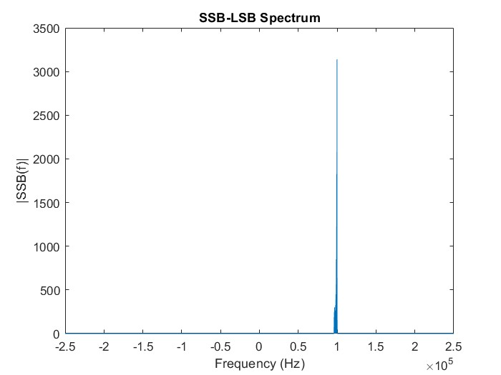

Disadvantages of SSB:

- Generating SSB requires sharp filtering (to remove exactly one sideband without hurting the other) or complex phase-shifting networks.
- SSB-SC requires precise Coherent Detection (synchronization of frequency and phase). A slight frequency error results in the "Donald Duck" effect (pitch shift), unlike DSB where it might just result in fading.
- Practical SSB filters struggle to separate sidebands if the message has significant low-frequency content near DC, as the gap between the LSB and USB vanishes at $f_{C}$​.

EXPERIMENt 3

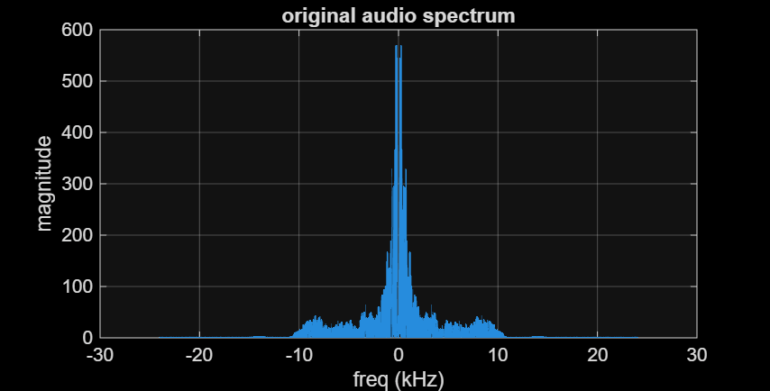

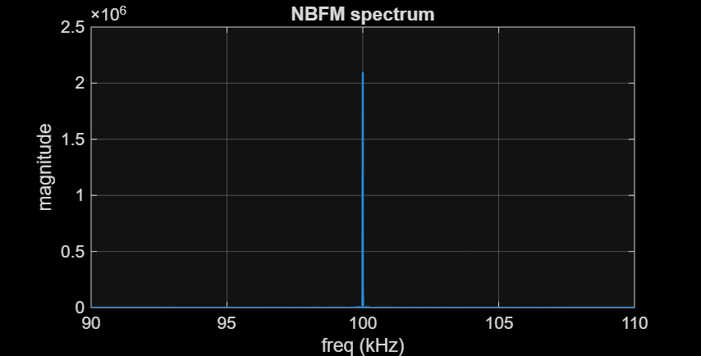

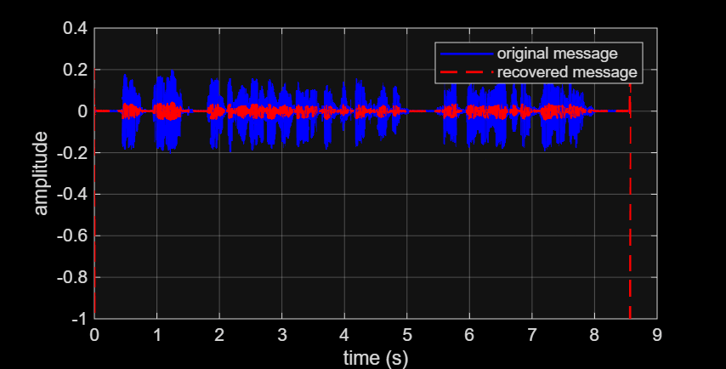

Observation:

- The envelope of the recovered signal matches the timing and shape of the original message.
- The recovered signal has a significantly lower amplitude than the original signal. Since this is Narrowband FM, the modulation index β and frequency deviation are intentionally kept small, so the resulting amplitude variations after differentiation are also very small. To match the original signal, the recovered message would need to be amplified.
Similarities and Differences AM vs. NBFM:

- Similarities:
• They both occupy the same bandwidth (2×BW).
• Both signals consist of a discrete carrier component and two sidebands (Lower Sideband and Upper Sideband) located at fc​±fm​.

- Differences:
• AM has variable amplitude while NBFM has variable frequency.
• In AM, total power fluctuates with the message. In FM, the total transmitted power is constant regardless of modulation

