GENTEK GUEST NETWORK USER INSTRUCTIONS

**How to connect to the Wireless Network**

1. Select the wireless network “**Gentek_Misafir**” from your devices and enter the password

**Welcome2019!** and click on connect.

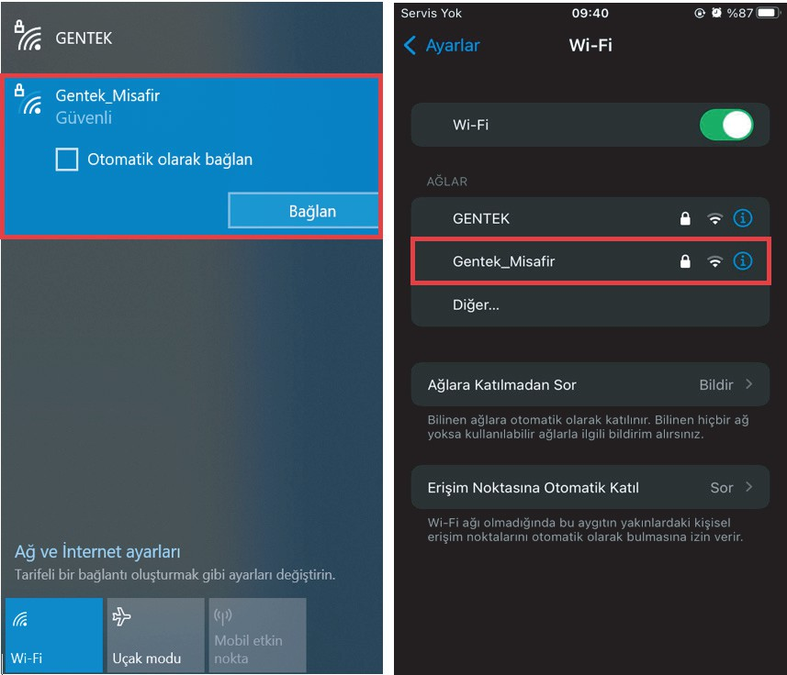

1. After selecting the “**EN**” language on the screen that opens, continuing with the “**Login**” button, by entering the personalized username and password given to you, you can access the internet by clicking the “**Sign In**” button.

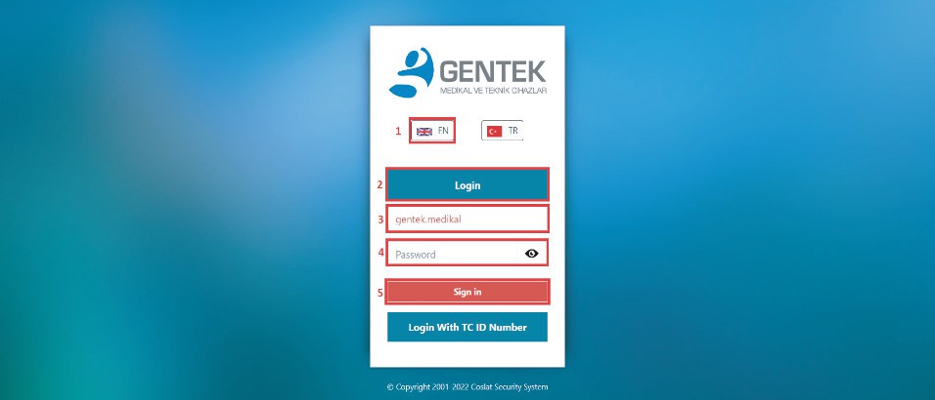

1. After successful login, you will be automatically redirected to [www.gentek.com.tr](http://www.gentek.com.tr/) web address. Otherwise, the system will ask for the login information to be re-entered.

User Name : **zeina.mneimneh**

Password : **Gentek.6753**