﻿# YAP 470 / BIL 570 - Proje Ilerleme Raporu 2
Tablo ve basliklar ders sablonuna gore doldurulmustur.

Erisim Bilgileri
Ogrenci: Ahmet Babagil - 211101067
Orijinal Veri Seti Adi: CREMA-D ve MELD
Orijinal Veri Seti Baglantisi:
- CREMA-D: https://github.com/CheyneyComputerScience/CREMA-D
- CREMA-D ses aynasi: https://huggingface.co/datasets/AbstractTTS/CREMA-D
- MELD: https://github.com/declare-lab/MELD
- MELD raw veri: http://web.eecs.umich.edu/~mihalcea/downloads/MELD.Raw.tar.gz
Proje Calismasinin Yuklendigi Google Drive Baglantisi:
- https://drive.google.com/drive/folders/1Hbp4WtCGFZjpvQCDxFmqtOmeqq-SMPvW?usp=sharing
Kod / GitHub Deposu:
- https://github.com/AhmetBabagil/speech-emotion-recognition/tree/feat/speech-emotion-recognition
Ilk asamada kullanilan veri setleri degistirilmedi. Drive teslim klasorune proje dosyalariyla birlikte veri_seti_ses.zip veri seti arsivi de konuldu; ayrica orijinal veri seti baglantilari ve indirme/manifest olusturma kodlari yukarida verildi. Proje kodu, deney ciktilari, rapor dosyalari, validation gridleri, test sonuclari ve karmasiklik matrisleri odev2 klasorunde hazirlandi.
Calistirilacak Dosyalar ve Ne Yaptiklari:
Dosya | Gorev
odev1/extract.py | Ses dosyalarindan donmus Wav2Vec2 ozniteliklerini cikarir ve cache'e kaydeder. Bu adim pahali oldugu icin 1. asamadaki cache tekrar kullanildi.
odev2/run_experiment.py | CREMA-D ve MELD icin Decision Tree, Random Forest ve Gradient Boosting validasyon gridlerini calistirir; en iyi modeli train+validation ile yeniden egitip test setinde olcer.
odev2/model_pipeline.py | Veri bolme, StandardScaler, PCA, model kurma, class weight/sample weight, validation secimi, test metrikleri ve karmasiklik matrisi uretimini icerir.
odev2/build_report.py | Deney ciktilarindan rapor tablolari, test karsilastirmalari ve otomatik bulgulari uretir.
odev2/SONUCLAR.ipynb | Test karsilastirmalarini, validation kapsamini ve karmasiklik matrislerini Jupyter formatinda gosterir.

Calistirma komutlari:
python odev2/run_experiment.py --manifest odev1/manifest_subset.csv --grid-mode report
python odev2/build_report.py

Veri Seti ve Degerlendirme Metrikleri
Projede konusmadan duygu tanima problemi ele alindi. Iki veri seti kullanildi:
Veri seti | Kisa aciklama | Ortak siniflar
CREMA-D | Kontrollu/studyo ortaminda kaydedilmis oyuncu konusmalari | angry, disgust, fear, happy, neutral, sad
MELD | TV diyaloglarindan gelen daha dogal ve gurultulu konusmalar | angry, disgust, fear, happy, neutral, sad

MELD veri setindeki surprise sinifi CREMA-D ile ortak olmadigi icin cikarildi. Iki veri seti de ayni 6 duygu sinifi uzerinde degerlendirildi.
Egitim, gecerleme ve test bolmeleri konusmaci bagimsiz yapildi. Ayni konusmaci train, validation ve test bolumlerinde birlikte bulunmadi. Bu tercih, modelin ayni konusmacinin ses ozelliklerini ezberlemesini engellemek icin kullanildi.
Degerlendirme metrikleri:
- Accuracy
- Balanced accuracy
- Macro-F1
- Weighted-F1
- Sinif bazli precision/recall/F1
- Karmasiklik matrisi
Ana model secim metrigi validation macro-F1 olarak belirlendi. Veri setlerinde sinif dagilimi ve siniflarin zorluklari farkli oldugu icin accuracy tek basina yeterli gorulmedi; macro-F1 ve balanced accuracy ozellikle raporlandi.

Yontem
Ses kayitlari once Wav2Vec2 tabanli donmus oznitelik cikarici ile vektorlere donusturuldu. Bu asamada Wav2Vec2 modeli egitilmedi; yalnizca her ses girdisi icin sabit uzunluklu oznitelik vektoru elde edildi.
Oznitelik vektoru icin uc farkli havuzlama/boyut secenegi hiperparametre olarak denendi:
F | Anlami
768 | Wav2Vec2 zaman ekseni mean havuzlama
1536 | mean + std havuzlama
2304 | mean + std + max havuzlama

PCA oncesinde StandardScaler uygulandi. StandardScaler ve PCA yalnizca egitim verisine fit edildi; validation ve test setlerine sadece transform uygulandi. Bu sekilde validation/test bilgisi egitim asamasina sizdirilmadi.
PCA boyutu da hiperparametre olarak ele alindi. Decision Tree ve Random Forest icin none, 64, 128, 256; Gradient Boosting icin calisma suresi nedeniyle none ve 64 secenekleri denendi. PCA uygulanmayan durumda model dogrudan normalize edilmis Wav2Vec2 vektorleri uzerinde egitildi.
Sinif dengesizligi icin Decision Tree ve Random Forest modellerinde class_weight="balanced" kullanildi. Gradient Boosting modelinde ayni amacla sample_weight kullanildi.

Model Gecerleme
F: Oznitelik vektoru boyutu
P: PCA cikti vektoru boyutu (none PCA uygulanmadigini gosterir)
X: Modelin ana hiperparametresi 1
Y: Modelin ana hiperparametresi 2
Z: Modelin ana hiperparametresi 3; Gradient Boosting icin iki ana hiperparametre oldugundan Z yoktur.
Model bazinda X/Y/Z karsiliklari:
Model | X | Y | Z
Decision Tree | criterion | max_depth | min_samples_split
Random Forest | n_estimators | max_depth | max_features
Gradient Boosting | learning_rate | max_depth | -

Hiperparametre secimi test setine bakmadan yapildi. Her veri seti ve model icin validation grid calistirildi. En iyi kombinasyon once validation macro-F1'a gore, esitlik durumunda balanced accuracy ve accuracy degerlerine gore secildi. Secilen kombinasyon daha sonra train + validation verisi uzerinde yeniden egitildi ve test seti yalnizca final degerlendirme icin kullanildi.
Deney kapsami:
Veri seti | Model | Denenen kombinasyon sayisi
CREMA-D | Decision Tree | 216
CREMA-D | Random Forest | 72
CREMA-D | Gradient Boosting | 24
MELD | Decision Tree | 216
MELD | Random Forest | 72
MELD | Gradient Boosting | 24

Asagidaki tablolar, her veri seti-model ikilisi icin validation macro-F1'a gore en iyi kombinasyonlari gostermektedir. Tam grid dosyalari odev2/outputs/<veri_seti>/*_validation_grid.csv altinda saklandi.

CREMA-D - Karar Agaci validasyon
Sira | F | PCA | Hiperparametreler | Val dogr. | Val dengeli dogr. | Val makro-F1
1 | 1536 | none | criterion=entropy, max_depth=8, min_samples_split=10 | 0.4049 | 0.4056 | 0.4031
2 | 1536 | none | criterion=log_loss, max_depth=8, min_samples_split=10 | 0.4049 | 0.4056 | 0.4031
3 | 1536 | none | criterion=entropy, max_depth=16, min_samples_split=2 | 0.3902 | 0.3881 | 0.3859
4 | 1536 | none | criterion=log_loss, max_depth=16, min_samples_split=2 | 0.3902 | 0.3881 | 0.3859
5 | 1536 | none | criterion=entropy, max_depth=8, min_samples_split=2 | 0.3902 | 0.3917 | 0.3851
6 | 1536 | none | criterion=log_loss, max_depth=8, min_samples_split=2 | 0.3902 | 0.3917 | 0.3851
7 | 1536 | none | criterion=entropy, max_depth=None, min_samples_split=10 | 0.3829 | 0.3806 | 0.3804
8 | 1536 | none | criterion=entropy, max_depth=16, min_samples_split=10 | 0.3829 | 0.3806 | 0.3804
9 | 1536 | none | criterion=log_loss, max_depth=None, min_samples_split=10 | 0.3829 | 0.3806 | 0.3804
10 | 1536 | none | criterion=log_loss, max_depth=16, min_samples_split=10 | 0.3829 | 0.3806 | 0.3804
11 | 2304 | none | criterion=entropy, max_depth=8, min_samples_split=10 | 0.3829 | 0.3849 | 0.378
12 | 2304 | none | criterion=log_loss, max_depth=8, min_samples_split=10 | 0.3829 | 0.3849 | 0.378

CREMA-D - Gradient Boosting validasyon
Sira | F | PCA | Hiperparametreler | Val dogr. | Val dengeli dogr. | Val makro-F1
1 | 1536 | none | learning_rate=0.1, max_depth=3 | 0.5244 | 0.5226 | 0.5238
2 | 1536 | none | learning_rate=0.05, max_depth=3 | 0.522 | 0.5206 | 0.5151
3 | 768 | none | learning_rate=0.1, max_depth=3 | 0.5073 | 0.5052 | 0.5043
4 | 2304 | none | learning_rate=0.1, max_depth=3 | 0.5098 | 0.5056 | 0.5016
5 | 768 | none | learning_rate=0.05, max_depth=3 | 0.5024 | 0.5016 | 0.4966
6 | 2304 | none | learning_rate=0.05, max_depth=3 | 0.5024 | 0.5008 | 0.4949
7 | 2304 | none | learning_rate=0.1, max_depth=1 | 0.4976 | 0.496 | 0.4858
8 | 1536 | none | learning_rate=0.1, max_depth=1 | 0.4927 | 0.4913 | 0.4808
9 | 768 | none | learning_rate=0.1, max_depth=1 | 0.4854 | 0.4825 | 0.478
10 | 768 | 64 | learning_rate=0.05, max_depth=3 | 0.478 | 0.4786 | 0.4683
11 | 768 | 64 | learning_rate=0.1, max_depth=3 | 0.4756 | 0.475 | 0.4664
12 | 2304 | 64 | learning_rate=0.1, max_depth=3 | 0.4732 | 0.475 | 0.4629

CREMA-D - Rastgele Orman validasyon
Sira | F | PCA | Hiperparametreler | Val dogr. | Val dengeli dogr. | Val makro-F1
1 | 1536 | none | max_depth=16, max_features=log2, n_estimators=100 | 0.5049 | 0.5048 | 0.4964
2 | 2304 | none | max_depth=24, max_features=sqrt, n_estimators=100 | 0.5049 | 0.5028 | 0.4941
3 | 768 | none | max_depth=None, max_features=log2, n_estimators=100 | 0.5 | 0.4984 | 0.4924
4 | 768 | none | max_depth=24, max_features=log2, n_estimators=100 | 0.5 | 0.498 | 0.4923
5 | 2304 | none | max_depth=None, max_features=sqrt, n_estimators=100 | 0.5024 | 0.5004 | 0.4904
6 | 2304 | 128 | max_depth=16, max_features=log2, n_estimators=100 | 0.5 | 0.5004 | 0.487
7 | 1536 | none | max_depth=24, max_features=log2, n_estimators=100 | 0.5 | 0.4972 | 0.4863
8 | 1536 | none | max_depth=None, max_features=log2, n_estimators=100 | 0.5 | 0.4976 | 0.4859
9 | 768 | none | max_depth=16, max_features=log2, n_estimators=100 | 0.4951 | 0.494 | 0.4841
10 | 2304 | 64 | max_depth=24, max_features=log2, n_estimators=100 | 0.4927 | 0.4909 | 0.4821
11 | 2304 | none | max_depth=16, max_features=log2, n_estimators=100 | 0.4927 | 0.4909 | 0.4807
12 | 1536 | none | max_depth=None, max_features=sqrt, n_estimators=100 | 0.4927 | 0.4913 | 0.4804

MELD - Karar Agaci validasyon
Sira | F | PCA | Hiperparametreler | Val dogr. | Val dengeli dogr. | Val makro-F1
1 | 768 | 128 | criterion=gini, max_depth=8, min_samples_split=10 | 0.2512 | 0.2579 | 0.2492
2 | 768 | 128 | criterion=gini, max_depth=8, min_samples_split=2 | 0.2488 | 0.2549 | 0.2461
3 | 768 | 64 | criterion=gini, max_depth=None, min_samples_split=2 | 0.2365 | 0.2313 | 0.2299
4 | 768 | 64 | criterion=gini, max_depth=8, min_samples_split=2 | 0.2291 | 0.2349 | 0.2285
5 | 768 | 64 | criterion=gini, max_depth=8, min_samples_split=10 | 0.2291 | 0.2348 | 0.2283
6 | 768 | 64 | criterion=entropy, max_depth=16, min_samples_split=2 | 0.2266 | 0.2221 | 0.2223
7 | 768 | 64 | criterion=log_loss, max_depth=16, min_samples_split=2 | 0.2266 | 0.2221 | 0.2223
8 | 768 | 64 | criterion=gini, max_depth=16, min_samples_split=2 | 0.2266 | 0.2218 | 0.2203
9 | 768 | 64 | criterion=entropy, max_depth=None, min_samples_split=10 | 0.2266 | 0.2177 | 0.217
10 | 768 | 64 | criterion=entropy, max_depth=16, min_samples_split=10 | 0.2266 | 0.2177 | 0.217
11 | 768 | 64 | criterion=log_loss, max_depth=None, min_samples_split=10 | 0.2266 | 0.2177 | 0.217
12 | 768 | 64 | criterion=log_loss, max_depth=16, min_samples_split=10 | 0.2266 | 0.2177 | 0.217

MELD - Gradient Boosting validasyon
Sira | F | PCA | Hiperparametreler | Val dogr. | Val dengeli dogr. | Val makro-F1
1 | 1536 | 64 | learning_rate=0.1, max_depth=3 | 0.2365 | 0.2312 | 0.2268
2 | 2304 | none | learning_rate=0.05, max_depth=3 | 0.234 | 0.2251 | 0.2234
3 | 768 | none | learning_rate=0.1, max_depth=3 | 0.2291 | 0.2193 | 0.2204
4 | 1536 | none | learning_rate=0.1, max_depth=3 | 0.2241 | 0.2172 | 0.2185
5 | 768 | 64 | learning_rate=0.1, max_depth=1 | 0.2365 | 0.2232 | 0.215
6 | 1536 | 64 | learning_rate=0.05, max_depth=3 | 0.2192 | 0.2172 | 0.2138
7 | 768 | 64 | learning_rate=0.05, max_depth=3 | 0.2241 | 0.2157 | 0.212
8 | 2304 | none | learning_rate=0.1, max_depth=1 | 0.2291 | 0.2216 | 0.2112
9 | 1536 | none | learning_rate=0.05, max_depth=3 | 0.234 | 0.2157 | 0.2082
10 | 2304 | 64 | learning_rate=0.1, max_depth=1 | 0.2241 | 0.2135 | 0.2046
11 | 2304 | 64 | learning_rate=0.05, max_depth=3 | 0.2143 | 0.2061 | 0.202
12 | 768 | 64 | learning_rate=0.05, max_depth=1 | 0.2241 | 0.2109 | 0.201

MELD - Rastgele Orman validasyon
Sira | F | PCA | Hiperparametreler | Val dogr. | Val dengeli dogr. | Val makro-F1
1 | 2304 | 64 | max_depth=16, max_features=sqrt, n_estimators=100 | 0.2586 | 0.2379 | 0.2349
2 | 768 | 128 | max_depth=None, max_features=log2, n_estimators=100 | 0.2389 | 0.2323 | 0.234
3 | 1536 | 64 | max_depth=None, max_features=log2, n_estimators=100 | 0.2537 | 0.2355 | 0.2333
4 | 768 | 64 | max_depth=24, max_features=sqrt, n_estimators=100 | 0.2537 | 0.2342 | 0.2295
5 | 2304 | 256 | max_depth=None, max_features=log2, n_estimators=100 | 0.2414 | 0.2277 | 0.2274
6 | 2304 | 128 | max_depth=None, max_features=sqrt, n_estimators=100 | 0.2611 | 0.2341 | 0.2246
7 | 1536 | 128 | max_depth=24, max_features=sqrt, n_estimators=100 | 0.2365 | 0.2211 | 0.2228
8 | 1536 | 128 | max_depth=None, max_features=sqrt, n_estimators=100 | 0.2488 | 0.2264 | 0.2224
9 | 2304 | 128 | max_depth=16, max_features=log2, n_estimators=100 | 0.2389 | 0.2213 | 0.2202
10 | 1536 | 64 | max_depth=16, max_features=sqrt, n_estimators=100 | 0.234 | 0.2213 | 0.2198
11 | 768 | 128 | max_depth=None, max_features=sqrt, n_estimators=100 | 0.234 | 0.22 | 0.2186
12 | 1536 | 128 | max_depth=16, max_features=log2, n_estimators=100 | 0.234 | 0.2187 | 0.2185

2. asama modelleri test karsilastirmasi
Veri seti | Model | F | PCA | Hiperparametreler | Test dogr. | Test dengeli dogr. | Test makro-F1 | Test agirlikli-F1
CREMA-D | Gradient Boosting | 1536 | none | learning_rate=0.1, max_depth=3 | 0.5202 | 0.5179 | 0.5144 | 0.5153
CREMA-D | Rastgele Orman | 1536 | none | max_depth=16, max_features=log2, n_estimators=100 | 0.486 | 0.484 | 0.4721 | 0.4717
CREMA-D | Karar Agaci | 1536 | none | criterion=entropy, max_depth=8, min_samples_split=10 | 0.3614 | 0.361 | 0.3496 | 0.3494
MELD | Gradient Boosting | 1536 | 64 | learning_rate=0.1, max_depth=3 | 0.2093 | 0.2072 | 0.2027 | 0.2068
MELD | Rastgele Orman | 2304 | 64 | max_depth=16, max_features=sqrt, n_estimators=100 | 0.2116 | 0.2146 | 0.2006 | 0.2004
MELD | Karar Agaci | 768 | 128 | criterion=gini, max_depth=8, min_samples_split=10 | 0.1465 | 0.1475 | 0.143 | 0.1463

KNN dahil genel test karsilastirmasi
Veri seti | Model | F | PCA | Hiperparametreler | Test dogr. | Test dengeli dogr. | Test makro-F1 | Test agirlikli-F1
CREMA-D | Gradient Boosting | 1536 | none | learning_rate=0.1, max_depth=3 | 0.5202 | 0.5179 | 0.5144 | 0.5153
CREMA-D | Rastgele Orman | 1536 | none | max_depth=16, max_features=log2, n_estimators=100 | 0.486 | 0.484 | 0.4721 | 0.4717
CREMA-D | KNN (Odev 1) | 2304 | 256 | K=15 | 0.4798 | 0.4803 | 0.4657 | 0.4641
CREMA-D | Karar Agaci | 1536 | none | criterion=entropy, max_depth=8, min_samples_split=10 | 0.3614 | 0.361 | 0.3496 | 0.3494
MELD | Gradient Boosting | 1536 | 64 | learning_rate=0.1, max_depth=3 | 0.2093 | 0.2072 | 0.2027 | 0.2068
MELD | Rastgele Orman | 2304 | 64 | max_depth=16, max_features=sqrt, n_estimators=100 | 0.2116 | 0.2146 | 0.2006 | 0.2004
MELD | KNN (Odev 1) | 768 | 128 | K=5 | 0.2047 | 0.2063 | 0.1941 | 0.1938
MELD | Karar Agaci | 768 | 128 | criterion=gini, max_depth=8, min_samples_split=10 | 0.1465 | 0.1475 | 0.143 | 0.1463

Otomatik bulgular
- CREMA-D icin en iyi model Gradient Boosting (test makro-F1=0.5144).
- MELD icin en iyi model Gradient Boosting (test makro-F1=0.2027).
- Genel en iyi sonuc CREMA-D veri setinde Gradient Boosting ile elde edildi (test makro-F1=0.5144).

Deney Sonuclari ve Degerlendirme
Test sonuclari incelendiginde CREMA-D veri setinde en iyi performans Gradient Boosting ile elde edildi. Bu model test macro-F1 = 0.5144 degerine ulasti. Random Forest ikinci sirada kalirken, tek Decision Tree modeli daha dusuk performans verdi. Bu sonuc, tek agac modelinin yuksek boyutlu ses ozniteliklerinde yeterince genelleyemedigini; ensemble tabanli yontemlerin daha kararli oldugunu gostermektedir.
MELD veri setinde genel performans CREMA-D'ye gore belirgin sekilde dusuktur. Bunun temel nedeni MELD'in TV diyaloglarindan gelmesi, kayit kosullarinin daha dogal/gurultulu olmasi ve duygu siniflarinin daha zor ayrilmasidir. MELD uzerinde de en yuksek test macro-F1 degeri Gradient Boosting ile elde edildi: 0.2027. Random Forest cok yakin bir sonuc verdi; KNN ise bu iki modele yakin fakat biraz daha dusuk kaldi.
KNN dahil genel karsilastirmada CREMA-D icin Gradient Boosting, 1. asamadaki KNN sonucunu gecti. MELD icin de Gradient Boosting en yuksek macro-F1'i verdi. Bu nedenle genel en iyi model Gradient Boosting olarak degerlendirildi. Ancak MELD sonuclarinin dusuk olmasi, sonraki asamada daha guclu oznitelik cikarimi, veri artirma veya veri seti ozelinde daha uygun modeller denenmesi gerektigini gostermektedir.
Karmasiklik matrisleri asagida ve odev2/outputs/<veri_seti>/*_confusion_matrix.png dosyalarinda verildi. CREMA-D matrislerinde siniflarin MELD'e gore daha iyi ayrildigi gorulmektedir. MELD'de siniflar arasi karisma daha yuksektir; bu da macro-F1 degerinin dusuk kalmasina neden olmustur.

CREMA-D Karmasiklik Matrisleri
Decision Tree:
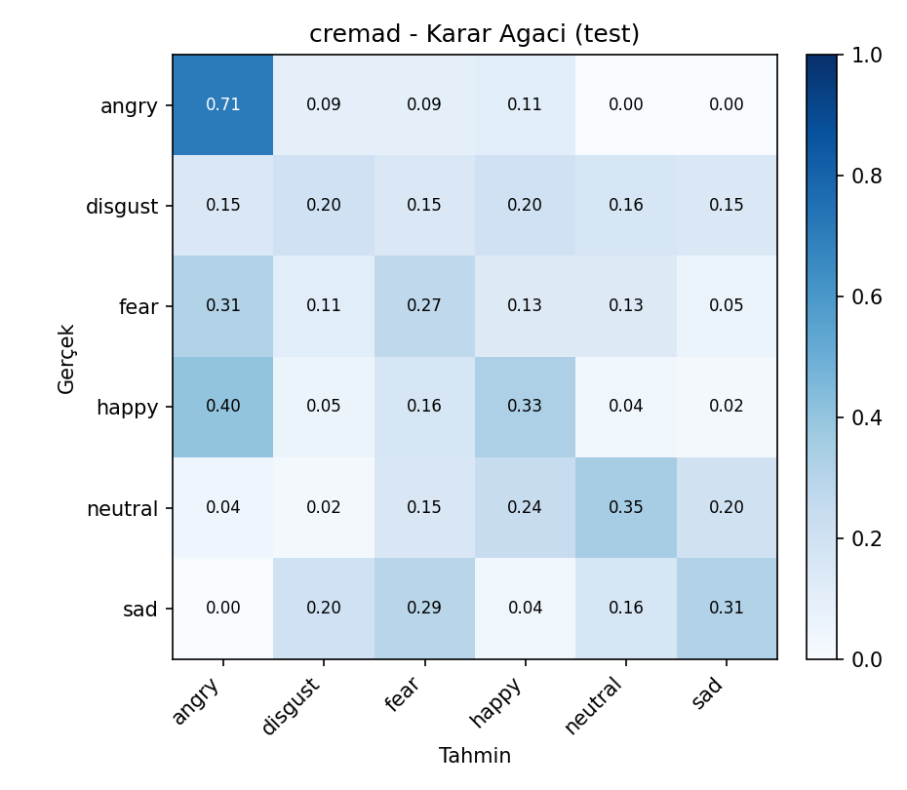
Random Forest:
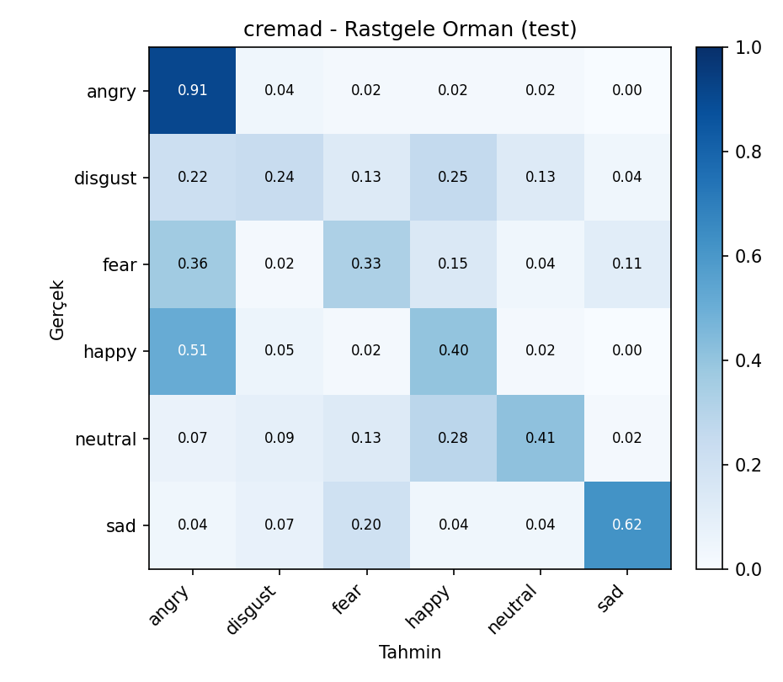
Gradient Boosting:
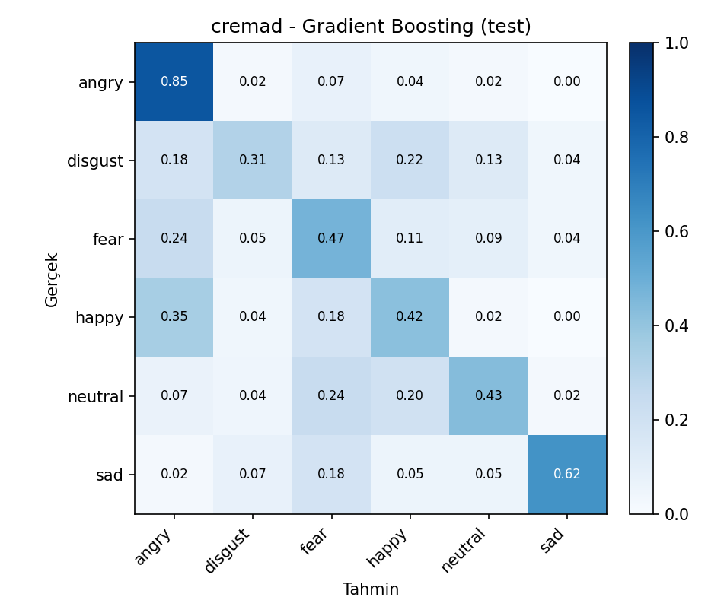

MELD Karmasiklik Matrisleri
Decision Tree:
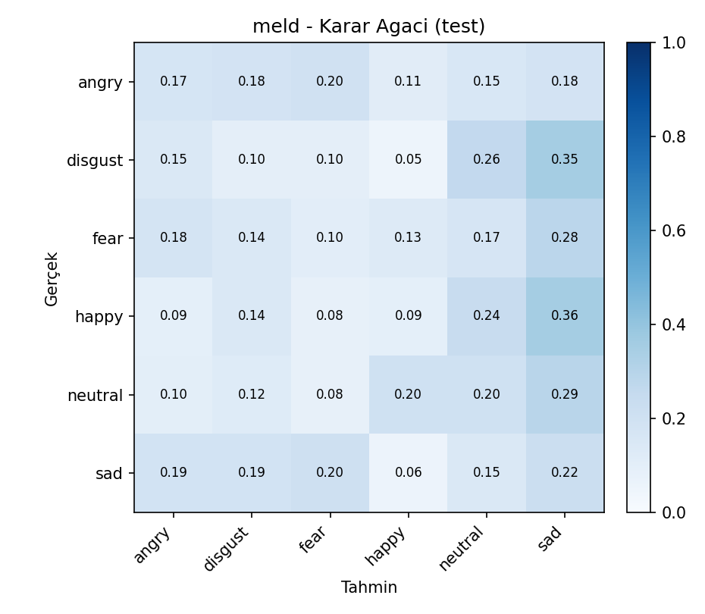
Random Forest:
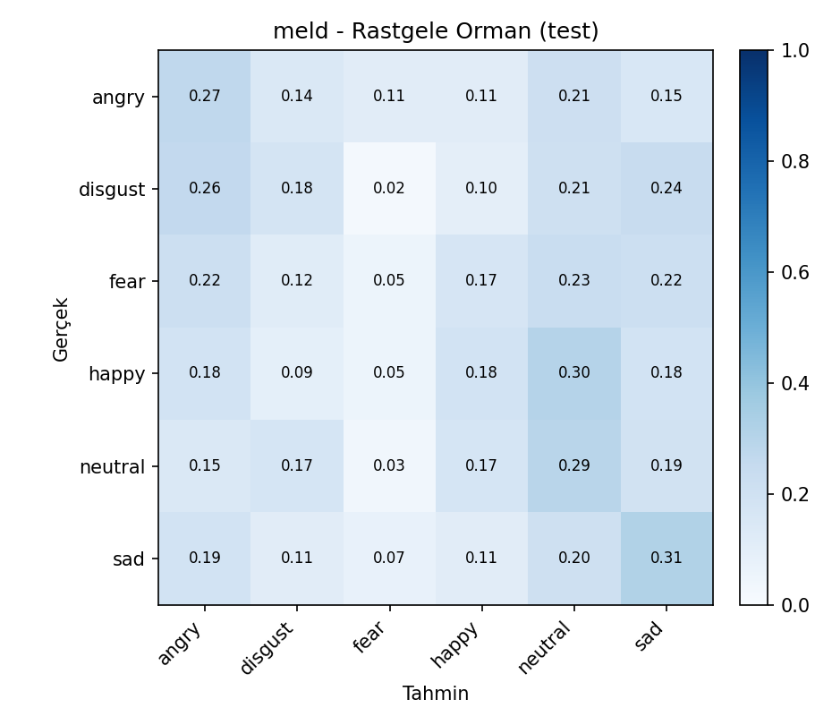
Gradient Boosting:
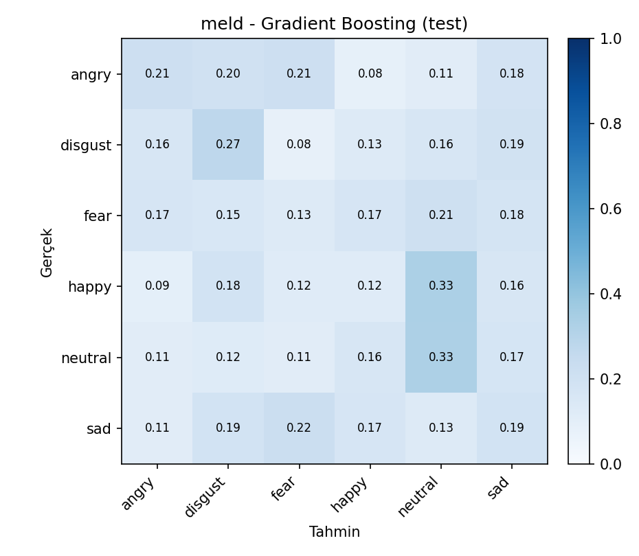

Sonuc ve Ileride Yapilacaklar
Bu asamada iki veri seti icin uc farkli makine ogrenimi modeli gelistirildi ve karsilastirildi: Decision Tree, Random Forest ve Gradient Boosting. Her model icin oznitelik boyutu, PCA boyutu ve model hiperparametreleri validation seti uzerinde sistematik olarak arandi. Test seti yalnizca final degerlendirme icin kullanildi.
Sonuclar, ensemble tabanli modellerin tek karar agacina gore daha basarili oldugunu gosterdi. CREMA-D uzerinde en iyi sonuc Gradient Boosting ile elde edildi. MELD veri setinde performans daha dusuk kaldi; bu durum veri setinin dogal/gurultulu yapisindan ve duygu siniflarinin daha zor ayrilmasindan kaynaklanmaktadir.
Sonraki asamada yapilabilecekler:
- MELD icin daha guclu veya veri setine daha uygun oznitelik cikarimi denemek.
- Wav2Vec2 vektorleri disinda farkli ses temsilleriyle karsilastirma yapmak.
- Sinif bazli hata analizini karmasiklik matrisleri uzerinden detaylandirmak.
- Daha genis hiperparametre aramasi veya daha verimli arama stratejileri denemek.
- CREMA-D ve MELD arasindaki domain farkini azaltacak yontemler uzerinde calismak.

