log_softmax Function

The benefit of Log_softmax for us is that after tensor multiplications, very very large values ​​or very very small values ​​are arranged because the computer cannot read them.

Mathematical representation of log_Softmax :

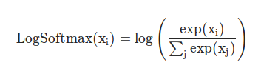

Written with Python codes :

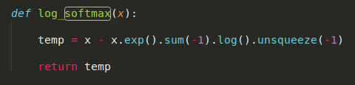

logsumexp Function

The **LogSumExp** (LSE) (also called **RealSoftMax** or multivariable [**softplus**](https://en.wikipedia.org/wiki/Softplus)) function is a [smooth maximum](https://en.wikipedia.org/wiki/Smooth_maximum) – a [smooth](https://en.wikipedia.org/wiki/Smooth_function) [approximation](https://en.wikipedia.org/wiki/Approximation) to the [maximum](https://en.wikipedia.org/wiki/Maximum) function, mainly used by machine learning algorithms.

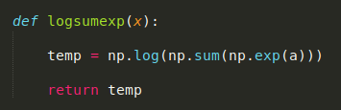

Why do we manipulate step spacing on CNN layers?

If we use the stride value with values ​​of 2,3,4 ... instead of 1, we will reduce the size of the output layer after the CNN layer. If we want to reduce the size of the output layer, we can use it. So when the output layer gets smaller, we also reduce the number of parameters, so the model gets better updates and becomes a plus in the computer, in short, the pool layer can function.