|  |  |  |  |
| --- | --- | --- | --- |
| **CS102** | **Spring 2018/19** | Project Group | 1B |
| Instructor: | **David Davenport** |  |  |
| Assistant: | Mehmet Başaran |  |  |

|  |  |  |
| --- | --- | --- |
| **Criteria** | **TA/Grader** | **Instructor** |
| Presentation |  |  |
|  |  |  |
|  |  |  |
|  |  |  |
| Overall |  |  |

~ CITIZEN OF THE WORLD ~

KERATTA KERATTALAR

Burak Öçalan - Ahmet Işık - Batuhan Gelgi

Emin Adem Buran - Ahmet Kağan Uğuralp - Yusuf Ziya Özgül

|  |
| --- |
| Detailed Design Report  ( Version 1.0 )  12 May 2019 |

# Introduction

The game we designed is a serious game aiming to make children learn general knowledge about countries all around the world. It is a mixture of game elements and knowledge of the world. By implementing educational elements to a game, we designed both educational and enjoyable game especially for students. The game is turn based and it is played on the world map.

# System Overview

We are going to use Java for making the program. The program, which is going to be a game, will work on computers and have a desktop application. There is a database which contains the questions about countries, flags of countries, various images for countries and player information. The game will be played on full screen to keep players concentrated. Also, the game can be saved to continue later. Therefore, there will be kept another data to keep the saved games. We explained overview of our game in a basic diagram below:

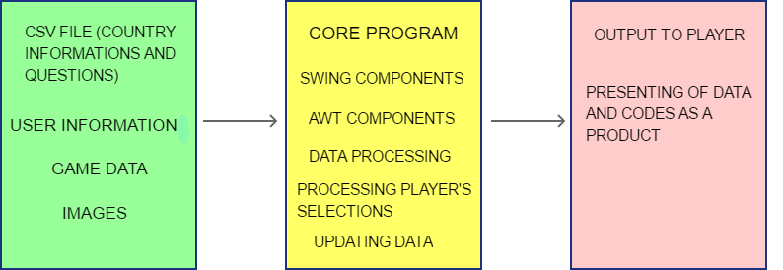

**Figure 1:** Basic Organization Diagram [1]

# Core Design Details

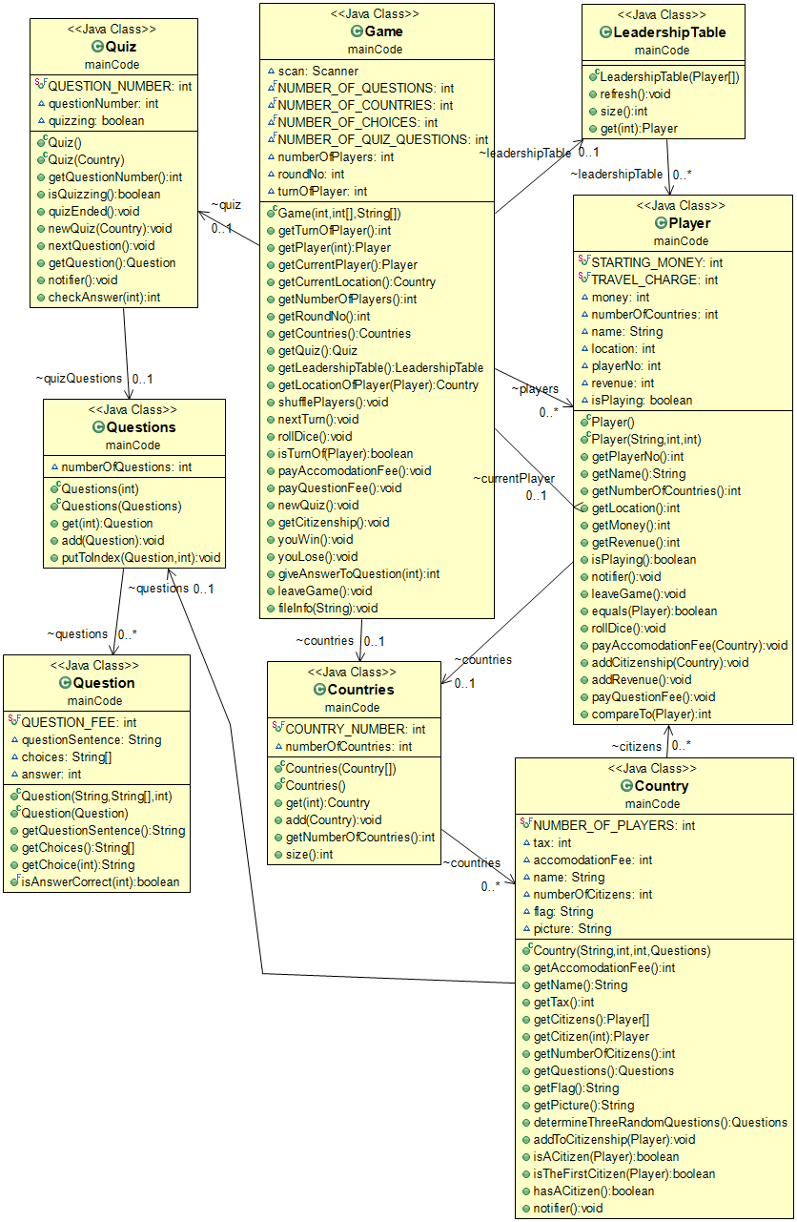

**Figure 2:** UML Diagram of the Core Program [2]

These classes build the hierarchy of the main codes of the game:

“Questions” class is made of Question array. And similarly, “Countries” class is made of Country array.

Game class includes main methods to play game. This class gets data from other classes with methods and creates main game screen.

Quiz class choose 3 different questions about the specific country by getting them from Questions class, provides these to the Game class, and also checks the answers later on.

Player class keeps the information about the players which are taken at the beginning. Also assigns new information obtained throughout the game to the specific players’ information storage.

Leadership table class shows the information of players in an order consisted of citizenship numbers and money.

Pawn class directs the movement of pins in the game.

HowToPlay and Credits classes show informations about how to play game and credits.

SaveGame class is designed for saving game and keeps data, LoadGame is designed for load game.

YouWinPage, YouLosePage, AccomodationFeePage classes are composed of game dynamics which depend on acts in the game.

Application class gets together the part of main menu elements and extends JFrame class.

MainMenu class creates “New Game”, “Load Game” and other elements by using swing and awt.

MusicPlayer class provides background music during game.

Avatar, CountryFlag, CountryPicture classes get the pictures of avataras, country flags and pictures from folders and use them in game.

GameFileReader class gets the data of countries with questions which are in txt format.

ResizablePicture class helps to resize pictures used in the game to fit panels.

OpenCloseJButton class changes the color of buttons or disables buttons according to acts in the game.

# Task Assignment

|  |  |  |  |  |  |  |  |  |  |  |  |  |  |  |
| --- | --- | --- | --- | --- | --- | --- | --- | --- | --- | --- | --- | --- | --- | --- |
| |  |  | | --- | --- | | **Group Members** | **Classes** | | Burak Öçalan | Game, Pawn, Route, GameGUI, OpenCloseJButton | | Ahmet Işık | Player, GameOver, PlayerInfo, LeadershipTable, Questions | | Batuhan Gelgi | Country, HowToPlay, Credits, MainMenu, MusicPlayer | | Emin Adem Buran | LT, Countries, SaveGame, LoadGame, Application | | Ahmet Kaan Uğuralp | ResizablePicture, YouWinPage, YouLosePage, AccomodationFeePage, Question, Questions, Quiz | | Yusuf Ziya Özgül | GameFileReader, CSVReader, Question, CountryInfo, Avatar, CountryFlag, CountryPicture | |

References

1. “Pencil Project.” *Home - Pencil Project*, pencil.evolus.vn/.
2. ObjectAid program implemented into Eclipse.