**CSE 5031 Operating Systems Prj1–Report**

**Student-Id and Name:1900005528 Ahmet Kaan Memioğlu**

1. **Answer following questions after attaching C8 Prj in Bridged Networking Mode**

| **Question** | **Answer** |
| --- | --- |
| **C8 Prj** Network Adapter **CIDR IPv.4 @** | 192.168.1.20 |
| **C8 Prj** Network Adapter **MAC @** | 08:00:27:88:6F:6B |
| **C8 Prj** Default Gateway **CIDR IPv.4 @** | 192.168.1.1 |
| **Host** Network Adapter  **CIDR IPv.4 @** | 192.168.56.1 |
| **Host** Network Adapter  **MAC @** | 0A-00-27-00-00-0E |

1. **Answer following questions after attaching C8 Prj in NAT Mode**

| **Question** | **Answer** |
| --- | --- |
| **C8 Prj** Network Adapter **CIDR IPv.4 @** | 10.0.2.15 |
| **C8 Prj** Network Adapter **MAC @** | 08:00:27:88:6F:6B |
| **C8 Prj** Default Gateway **CIDR IPv.4 @** | 10.0.2.2 |

1. **Run the command “which passwd” and “ls –al /etc/passwd” to answer the question**

**Are these two files different? If your answer is YES explain the difference; if NO try to explain why the same file is stored under two different folders**.

C) They are different because one of them is a file that contains user’s information regarding the OS and the other is an application that changes passwords.

**Try to explain briefly why the “which passwd” command lists of them and not both (Hint. You may display the DESCRIPTION of the this command with “man passwd”**.

1)Our “which” command does a search in the form of the executable files which in this case is a passwd command. The command “passwd” changes passwords for the user. so essentially this line searches for the passwd executable.

1. **Define briefly the function of the “/boot” with the help of the FSH document; does Windows provide its users access to such data?**

/boot function is a file that contains the booting operations logs and you can access it by the linux commands it also allows you to alter the files but in windows you cannot change the booting operation it also doesn't provide full access to the files although you can look for the boot files.

1. **Analyze the “slin.c” program and explain briefly why records are sorted in ascending order of the studentid field without using string comparison functions?**

With the use of the linked list and the pointers we don’t need to compare strings in order to sort the list by ascending order we are setting a pointer to the linked list then in the while loop we are checking if the pointer is not null and after that we compare it to the given id then we sort it out this will allow us to search the given information assigned to the pointer.After all we are inserting new given information if its lower than the previous one.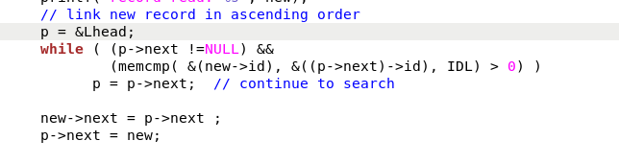

1. **Connect C8 Prj to the external network (Home/Laboratory Network) in Bridged Networking mode; start it; and Paste here after the output of the “ifconfig “ command.**

