1. **Introduction**

**1.1 Purpose**

The purpose of this document is to present a detailed description of the monitoring for DevOps portal project. It will explain the purpose and features of the open-source monitoring tool Zabbix and adapters, the user interface of the monitoring part of the software and what the adapters are used for. This document is intended for the users of the DevOps portal.

**1.2 Document Conventions**

This Document was created based on the IEEE template for System Requirement Specification Documents.

**1.3 Intended Audience and Reading Suggestions**

* Typical Users, such as students, who want to use the DevOps Portal Project that is developed by GTU CSE343 students.
* Advanced/Professional Users, such as engineers or researchers, who want to study the DevOps portal Project by GTU CSE343 students.

**1.4 Product Scope**

This product is developed to implement the monitoring part of the GTU CSE343 DevOps Portal Project. Users can use this product to monitor the clients that are connected to the server. They can see what DevOps portal developed programs are installed by the clients and they can monitor how much resource these programs are using. All these actions can be done by remotely accessing the computers of the clients and monitoring them in real time.

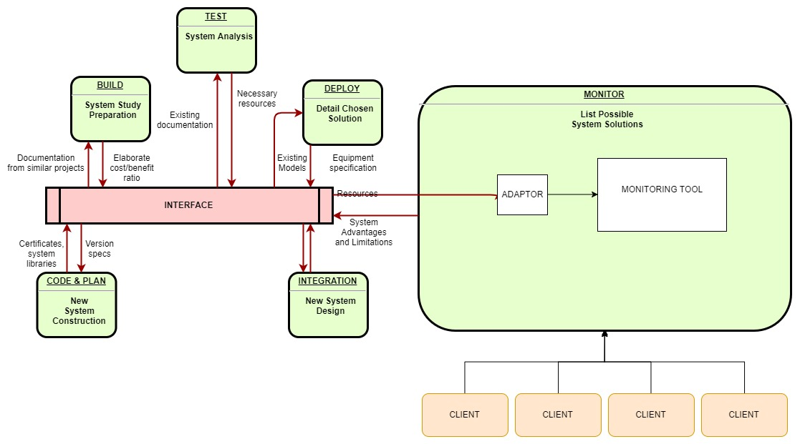

**1.5 References**

Zabbix’s website:

<https://www.zabbix.com>

Zabbix’s github:

<https://github.com/zabbix>

IEEE Template for System Requirement Specification Documents:

<https://goo.gl/nsUFwy>

Zabbix’s requirements:

<https://www.zabbix.com/documentation/3.0/manual/installation/requirements>

**2.** **Overall Description**

**2.1 Product Perspective**

This project is developed for everyone who is interested in developing applications in DevOps logic and wants to monitor them so that he can enhance their performance or just experiment with the feature so that he can understand it and use it as a means of analyzing performance of his/her project.

**2.2 Product Functions**

GTU CSE343 DevOps Portal Project has a main page which includes six buttons of the parts of DevOps. The last button represents monitoring. When clicked it redirects to the main page of monitoring that shows the programs that are developed in the portal where you can access the following features by clicking the buttons representing each program.

Monitor:

* *Application_Name* : Shows each client that installed the specific application with a representing button.
  + ->Client_Name: Redirects to a new page that has the corresponding information about the client.

**2.3 User Classes and Characteristics**

* Developers, who wants to monitor the efficiency of the programs they developed.
* Operational users, such as CEO, POs, Scrum Masters, Support Desk, etc. who wants to monitor the clients.

**2.4 Operating Environment**

* On web
* Zabbix Cloud
* Linux
* Windows 7
* Windows 8
* Windows 10

**2.5 Design and Implementation Constraints**

The communication between Interface and Monitoring needs an adapter which is developed in Java. The DevOps Portal Project monitoring module uses Zabbix Monitoring Tool.

**2.6 User Documentation**

This part will be updated according to the progression of the project.

**2.7 Assumptions and Dependencies**

Since the project uses Zabbix to monitor, it requires every requirement that Zabbix needs such as Apache and PHP which can be accessed from the following link to Zabbix requirements page:

<https://www.zabbix.com/documentation/3.0/manual/installation/requirements>

Adapters that are used to perform communication between the Interface and the monitor modules are developed in Java therefore Java version 7 or higher has to be installed on the computer that will monitor the clients.

To access the monitoring module as well as the other modules of the DevOps Portal, a web browser with cookies and JavaScript enabled is required as well.

**3.** **External Interface Requirements**

**3.1 User Interfaces**

This part will be updated according to progress of the project.

**3.2 Hardware Interfaces**

##### Memory:

Zabbix requires both physical and disk memory. 128 MB of physical memory and 256 MB of free disk space could be a good starting point. However, the amount of required disk memory obviously depends on the number of hosts and parameters that are being monitored.

##### 

##### CPU:

Zabbix and especially Zabbix database may require significant CPU resources depending on number of monitored parameters and chosen database engine.

**3.3 Software Interfaces**

The project requires Java to be installed on the computer that will monitor. A web browser with cookies and Java script enabled is required. The system also needs to provide the requirements for Zabbix. Additional information can be found on section 2.7 of this document.

**3.4 Communications Interfaces**

DevOps Portal Monitoring requires an internet connection and a connection between the clients and the server.

**4. System Features**

This part will be updated according to progress of the project.

//BURADAN

(This section demonstrates monitoring module of GTU CSE343 DevOps Portal Project most prominent features and explains how they can be used.)

**4.1 Application Discovery**

Scan nodes and automatically discover appllications.

**4.2 Alerts**

**4.3 Tracking Clients Informations**

**4.4 Viewing Application Data**

//BURAYA

**5. Other Nonfunctional Requirements**

**5.1 Performance Requirements**

##### 

##### Memory:

Zabbix requires both physical and disk memory. 128 MB of physical memory and 256 MB of free disk space could be a good starting point. However, the amount of required disk memory obviously depends on the number of hosts and parameters that are being monitored.

##### CPU:

Zabbix and especially Zabbix database may require significant CPU resources depending on number of monitored parameters and chosen database engine.

**5.3 Security Requirements**

Zabbix does not have any security requirements and thus any type of user can use it without any additional privileges.

**6.Glosary**

* Adapter: In computing, adapter is a hardware or software device that converts transmitted data from one presentation form to another.
* Client: A client is a piece of computer hardware or software that accesses a service made available by a server.
* Cookies: Small files which are stored on a user's computer. They are designed to hold a modest amount of data specific to a particular client and website, and can be accessed either by the web server or the client computer.
* DevOps: It is a project development philosophy which aims at increasing software

productivity by combining development and Operational part of project together.

* GTU: An accronym for Gebze Technical University.
* Server: In computing, a server is a computer program or a device that provides functionality for other programs or devices, called “clients”.
* Web Browser: A web browser is a software application for retrieving, presenting and traversing information resources on the Word Wide Web.
* Zabbix: An open source application monitoring tool.