|  |
| --- |
| cd app  md modules  cd modules  ng g module shared  ng g module public --routing  ng g module admin --routing  cd admin  ng g component cities  cd cities  ng g component cities-edit  └───app  ├───auth-guards  ├───endpoints  │ ├───auth-endpoints  │ ├───city-endpoints  │ └───country-endpoints  ├───helper  ├───modules  │ ├───admin  │ │ ├───admin-error-page  │ │ ├───admin-layout  │ │ ├───cities  │ │ │ └───cities-edit  │ │ ├───dashboard  │ │ ├───destination  │ │ └───reservation  │ ├───auth  │ │ ├───auth-layout  │ │ ├───forget-password  │ │ ├───login  │ │ ├───logout  │ │ ├───register  │ │ └───two-factor  │ ├───public  │ │ ├───about  │ │ ├───blog  │ │ ├───contact-us  │ │ ├───home  │ │ ├───public-layout  │ │ └───travels  │ └───shared  │ └───unauthorized  └───services  └───auth-services  └───dto |

# Angular moduli, komponente, lazy loading

# Endpoint interface

# Auth service i http interceptor

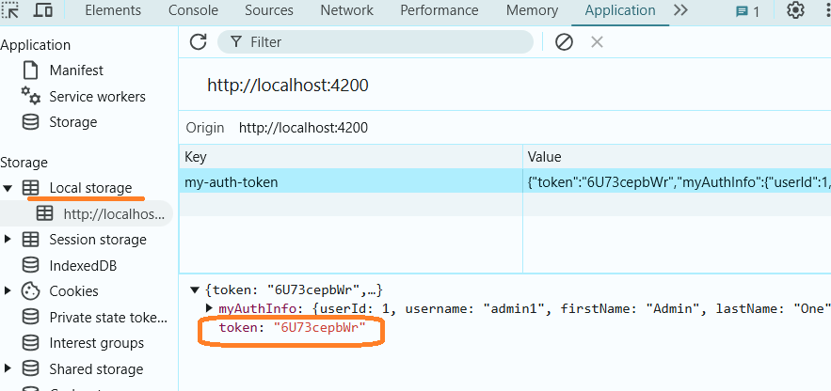

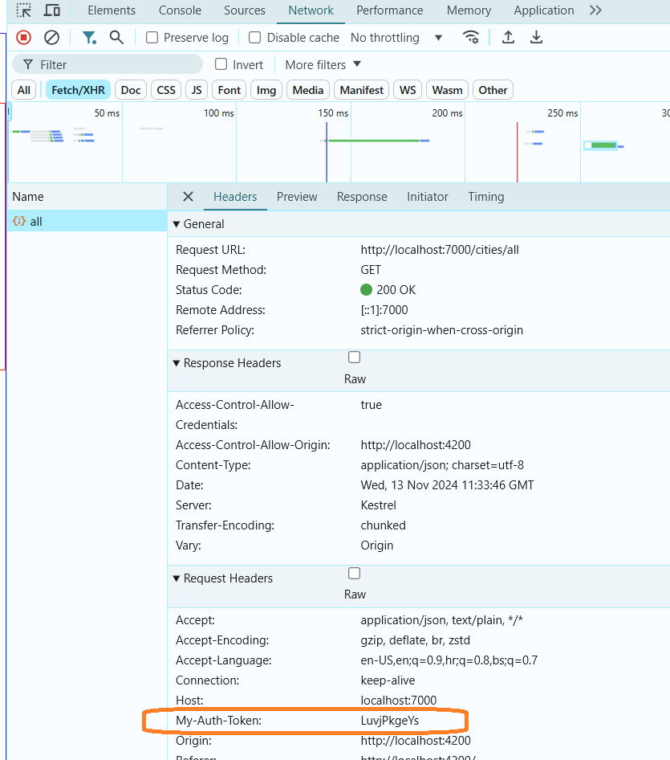

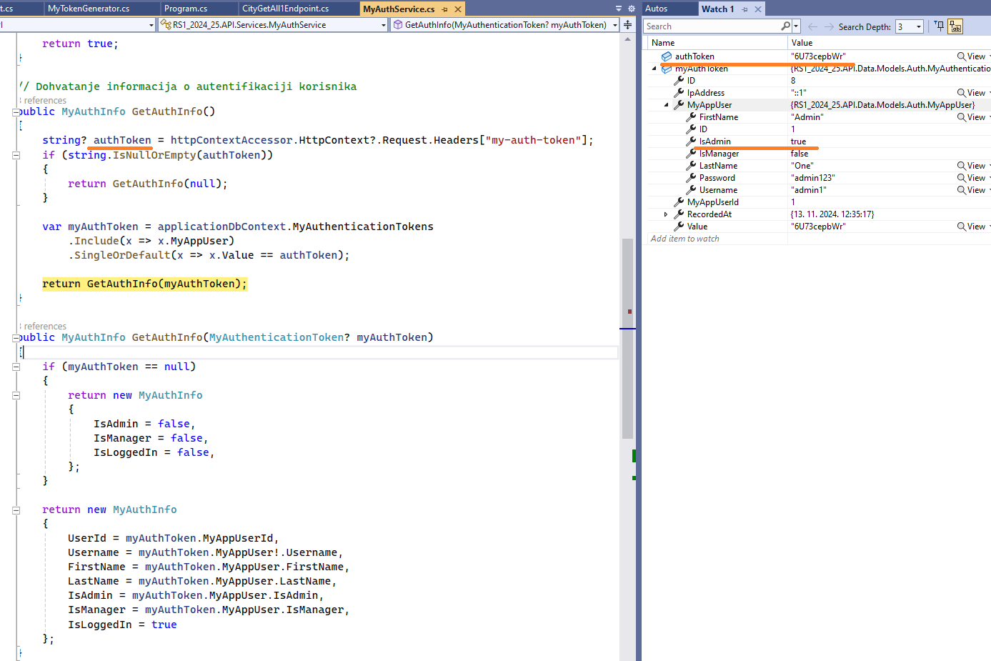

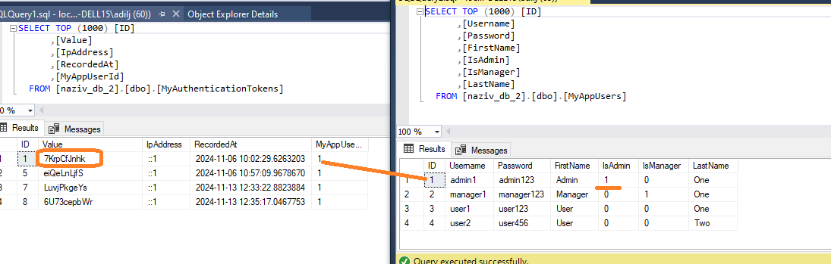

# AuthGuard

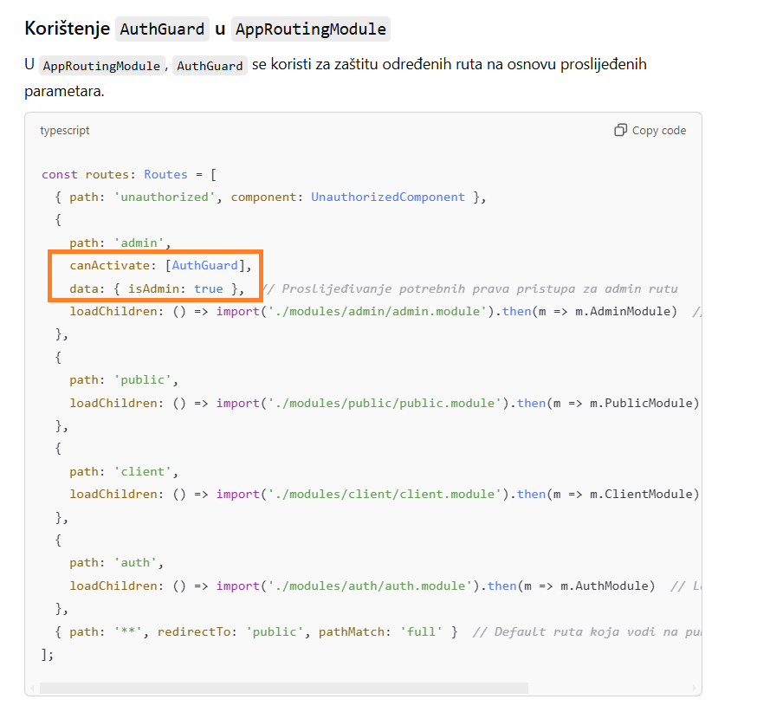

# Angular Reactive Forms

