

Yaşar University
Department of Computer Engineering
2010 – 2011 Spring Semesters

SENG 310 – Software Engineering

Project Topic

Auction Website

Team # 6
E-Gaye

Ezgi Kaysı 06070001022
Gülnar Kadiroğlu 07070001038
Ahmet Tavlı 07070001060
Yusuf Yasin Kumbul 07070001046
Eda Dolu 08070001022

Table of Contents

- Executive Summary
- Introduction
- Corporate Overview
- System Request
- Requirements Specification
- Functional Model
- Use Case Diagram of the Whole System
- Use Case Descriptions of a Selected Major Part of the System
- Activity Diagram of Selected Use Cases
- System Sequence Diagram
- Analysis Class Diagram
- System Operations
- Design Class Diagram
- Interaction Diagrams
- Appendix

- Executive Summary

This report provides an analysis and methods of the current prospective of auction based website. Methods of analysis include use case diagrams, use case descriptions, activity diagrams, and systems sequence diagrams. Results of diagrams analyzed show that, user want to see item, get the item or sell item in a quicker way. In particular, user wants to trust the site, in order to do some actions inside the site. We just classify user into two groups; visitors and members. Visitors can only see pictures with the item, whereas member can buy, sell, bid for the item.
This report provides some methods for a reliable, flexible, occupied auction website.
- Search inside site: Any user should able to see item list, with pictures and descriptions.
- Become a Member: User should give us name, surname, and valid email address as an input. Then user will become a member, can buy, and sell item.
- Buy item: Member should give us PayPal number as an input, enter for bidding, and then wait till announcement of the results.
- Sell item: Member should give us PayPal number as an input, then put item for bidding. Buyer of the item should feedback for seller.

- Introduction

Purpose of the Document

This report will show you how our auction website is better than the other auction websites. First of all why did we create a new system? Answer is simple because there is a need for our system. When you type www.ebay.com or www.gittigidiyor.com you will see probably a whole web page containing a lot of offers, special purchase types, bidding, certification, etc.. In particular what you see is a lot of numbers, and pictures. Is this why the user enter those sites? In order to see the thousands of percentages? And average sized pictures? The answer is absolutely and positively no. User enters those sites in order to see the item he or she interested in or may find an interesting item. So what we created an elegant website, with a two optional section; search and category. You can either specifically enter the item name or choose it from category. That’s it, that’s what a visitor or member should do, not to track all the numbers and pictures throughout page.
We also provided some menus, so user may look at it. Such as Home, Categories, hot buys, Search. It is simple to use, the complexity is nearly zero. Any average user can use it without having difficulty. We provided a small square for visitors and members. Such as user login label, user mail field, password field, register and login button. If you have already member, you just need to fill the fields in a correct way, then you are inside the site. Or you may become a new member. When you search item inside our system, result will appear with a picture and a simple description. As a result our website provides the same functionality as other web sites does, what’s more our site is much clearer, elegant, flexible compared to the others.

Intended Audience
This report will read by marketing people , business people , curio dealers , auction buyers. At least we suppose they may interested in this kind of article. The reason is our scope always at bidding, auction, making new members. Our system mostly depend on selling, or enable members tell via online. It is quite a business system depends on members. Therefore people whose interest area is trading, may spend time reading on this article.
Organization of the Document
Rest of the documents depends on the diagrams. We have auction use case diagram. In these diagrams we divided actors into the 4 main part, user, helpdesk, controller, and accountant. User is generalization of the visitor and member. Visitor can become a new member, or just see the pictures related to item. Member can buy product, add product to sale, and make bidding. Accountant create invoice for the related item. Controller job is to control the product by conforming product and sending it to the buyer. Helpdesk job is to managing tickets. We can say that the user part is our customer and the accountant, helpdesk and controller are the people whom we can hire. Our system is depending on make bidding, search product by type, make new member, add new product, login, and details of the product. Those are crucial for the system. For instance if our system cannot do make bidding, there is a fatal error throughout the system. If our members cannot login to the site, this is also fatal error. Make bidding enable member to bid for the system. Search product by type enable member to search for the system. Add new product is designed for the seller in our system. They can sell their product with this system. Login enables member to bid, sell, or buy the product. Details of the product enlighten users about the product.

- Corporate Overview

ASD Company which ordered us to develop an online auction, system established in 2001. They have a purchase system with 50 workers. Their average income was $30 million last year. They have been growing about %4 per year compared to previous years. They want to expand in their business, so they call us to cooperate with them. They believe that they have tremendous internet potential. So we suggested them to starting auction web site. We told them if they start an online auction, their growth will increase %10 compared to previous years. What’s more company aim is to become famous in the field of commercial.

- System Request

  - Project Sponsor: Alican Öztürk, Manager of the ASD Marketing

  - Business Need:

This project has thought to design for a web site which is more reliable, convenient, secure online auction and to serve for existing and new customers by providing the highest quality auction via Internet.

  - Business Requirements:

Upon examining the system the following requirements were assessed:

- Visitors and members can see all the pictures related to auction material and can read the detailed explanation related to auction material.
- Only members can buy and sell items.
- The customer's address is not overtly seen by the seller. Our company directs the product to the buyer.
- If member prefers to put item on auction, set time, initial money to begin, set accrual.
- If member bid for the auction, feedback user whenever the accrual increased.
- The system has an online help desk valid for a certain period of time

  - Business Value

We expect that auction will benefit us in a good way by enabling a various material from different sections. If customers see variety of products, in our website, this might be end up with a lot of participants. The more customers and visitors the better the salary is expected. We also expect the improved online communication system with customers will increase the reliability. We expect this ‘cause 60% unhappiness may be caused by not finding the material in the search catalog. So the users simply hesitate to join our website. Our estimated tangible values will be like

  - $20.000 (%40 of $50.000) in sales from new customers in a year.
  - $54.000 (%60 of $90.000) in sales from existing customer in a year.

  - Special Issues and Constraints

  - If we bring special items related to holiday, just before a day or two, we increase our sales in a wiser way. For example: Christmas Tree designed by famous person. If we enable bidding for this item we will increase our salary.
  - In order to reach more population we make our advertisement into a strategic website, this way we can get more potential customers.

- Requirements Specification

  - Non-functional Requirements

    - Operational Requirements
      - The system will operate in Windows, Macintosh and Linux environment.
      - The system will able to import bmp, jpg, gif, tiff and png graphic files
      - The system will able to write and support all kind of documents and theme fonts and colors. (e.g. MS Office files, Open Office files, Times New Roman font etc...)

    - Performance Requirements
      - The system will respond all the members at the same time while bidding.
      - The system countdown timer should work flawless.
      - The system will check the amount in bidding text box whether the value is integer or not.

    - Security Requirements
      - The system should handle all kind of unauthorized attacks and invalid credit card numbers
      - The system should be verified by eTrust, Paypal, McAfee secured and CyberTrust.

    - Cultural and Political Requirements
      - The system should be able to distinguish members as Turkish and European.
      - The system will support universal insurance standards.
  - Functional Requirements

    - Bidding
      - User can type any value they want for bidding.
      - User can view the other bidding other values.
      - User can shop with any kind of credit card.

    - Searching
      - User can search auction material by selecting from drop down list
      - User can see all the picture related to auction material
      - User can learn more about item sellers eventually rate the seller or make comment about the seller.

    - Uploading
      - User can upload picture of the product
      - User can change any additional information about the product or himself.
      - User can set up countdown for the item.

    - Printing
      - User can select which page to print
      - User can preview the selected page
      - User can change margins, paper size etc. of the paper.

    - Spell Checking
      - User can check for spelling mistakes , the spell checker software will underline the misspelled word
      - User can add new words to the spell checking software
      - User can cancel spell checking software while writing.

- Functional model
- Use case diagram of the whole system
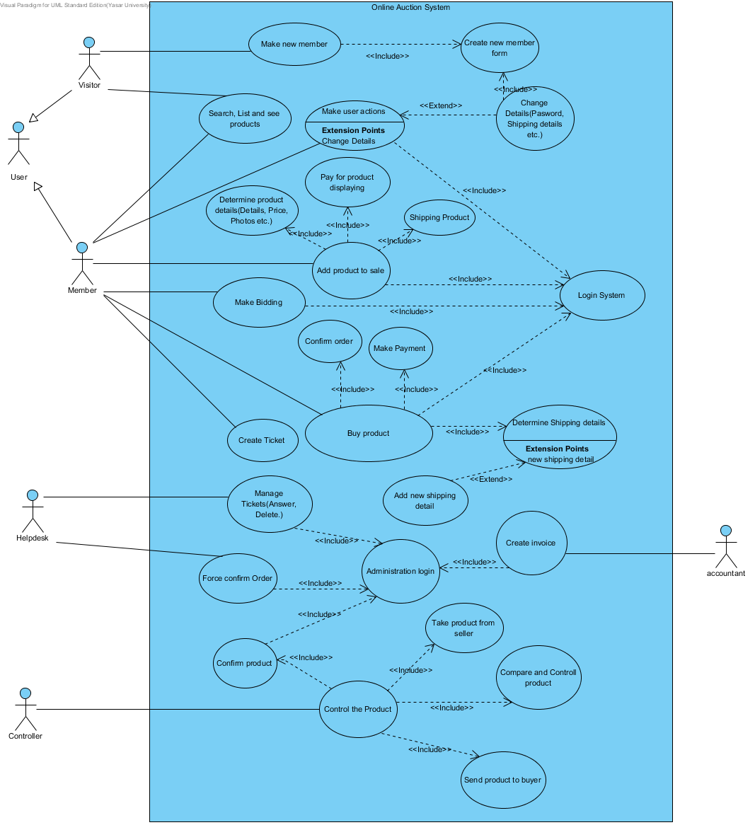

- Use case descriptions of a selected major part of the system
AddProduct

Use case name: Add product | ID: 4 | Importance Level: High
Primary actor: Member  Secondary actor: None | Use case type: Detail, essential
Brief description: This use case describes how make bidding.
Preconditions:
1. The member must be entered the website.
Main Flow:
1. include (Login System)
2. include (Determine product details(Details, Price, Photos etc.))
3. include (Pay for product displaying)
4. include (Shipping Product)
5. The member logout from website.

Postconditions:
1. The product and details such as shipping price etc.. are saved.

Alternative Flows: None.

SearchProductbyTitle

Use case name: Search and List Products | ID: 2 | Importance Level: High
Primary actor: Visitor  Secondary actor: Member | Use case type: Detail, essential
Brief description: This use case describes how visitor search, list and see products.
Preconditions:
- The visitor or member must be entered the website.
Main Flow:
- The visitor or member enter product type
- System returns list of available product maching the search criteria.
Postconditions:
1. The visitor or member can see a list of items which they searched.
Alternative flows:
1.1. The searched item could not found .
1.2. The visitor or member logout from website.

Make Bidding
Use case name: Make bidding | ID: 5 | Importance Level: High
Primary actor: Member  Secondary actor: None | Use case type: Detail, essential
Brief description: This use case describes how member offer a price for product.
Preconditions:
- User must be log in the system
Main Flow:
- Include(searchproduct)
- System returns a list available product and members choice the product which they want to buy
- System returns details of selected product
4. The members offer price according to accrual
5. System checks time if time is not up, bidding continue
6. The member increases his/her offer.
7. The member quit from the system.
Post conditions:
1. After bidding process, member had chance to buy product.

Alternative Flows:
5.1. Time is up and bidding finishes
6.1. The member doesn’t increase his/her offer.
6.2. The member quit from the system.

L Use case name: Make member | ID: 1 | Importance Level: High
Primary actor: Visitor  Secondary actor: None | Use case type: Detail, essential
Brief description: This use case describes how make a new member.
Preconditions:
- The visitor must be entered the website.
Main Flow:
1. The visitor enter become member page.
2. include (CreateNewMemberForm)
3. The visitor became a member successfully.
Postconditions:
- The visitor become a member of auction website.

Alternative Flows: None.

- Activity diagrams of the selected use cases

Add Product Activity Diagram

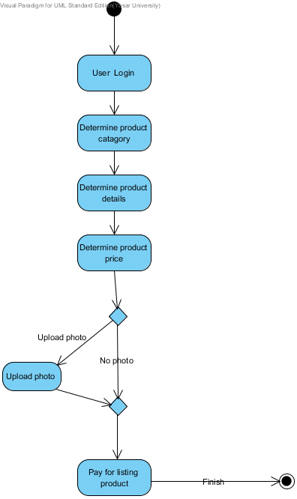

Buy Product Activity Diagram
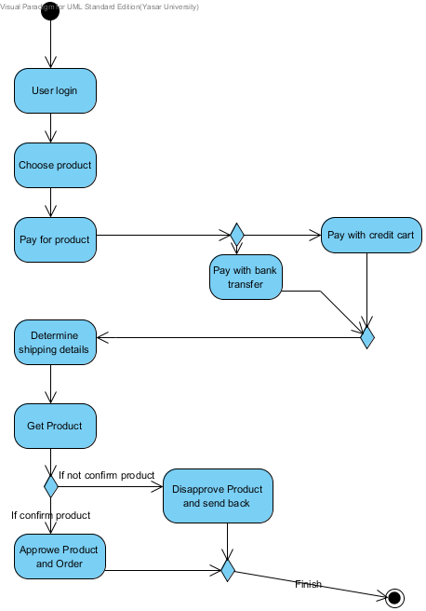

Make New Memeber Activity Diagram
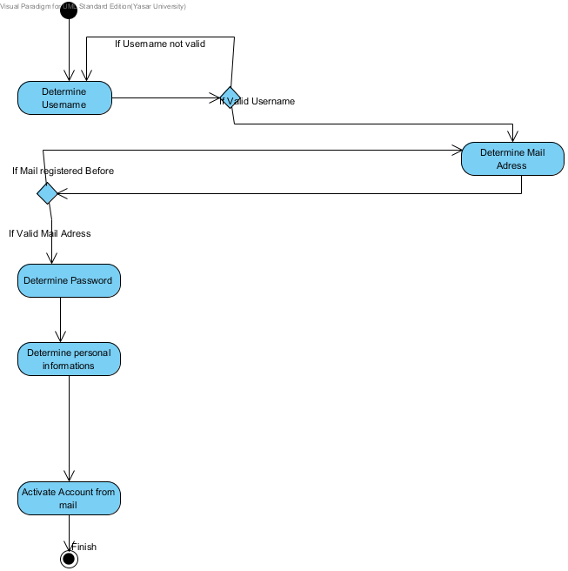

- Login System Activity Diagram
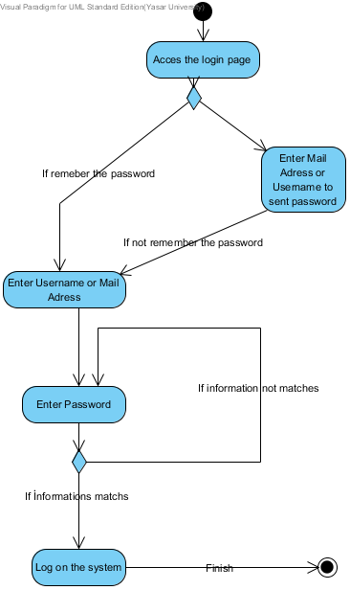

- Create Ticket
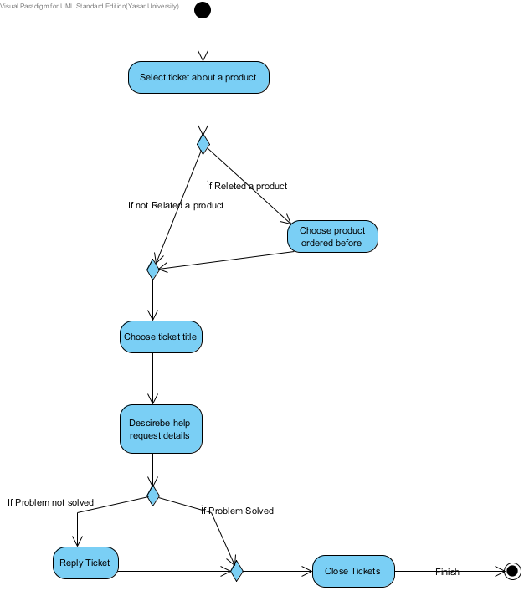

- System sequence diagrams
AddProduct

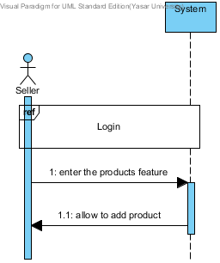

SearchProductbyType
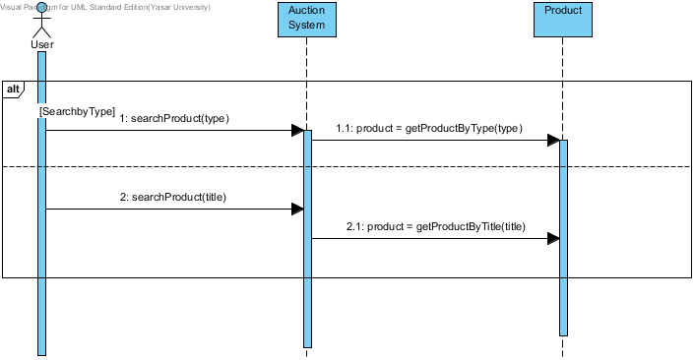

MakeBidding
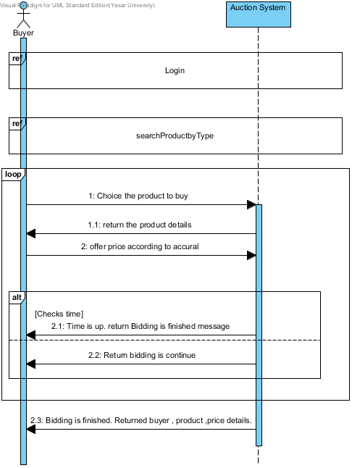

- Analysis Class Diagram

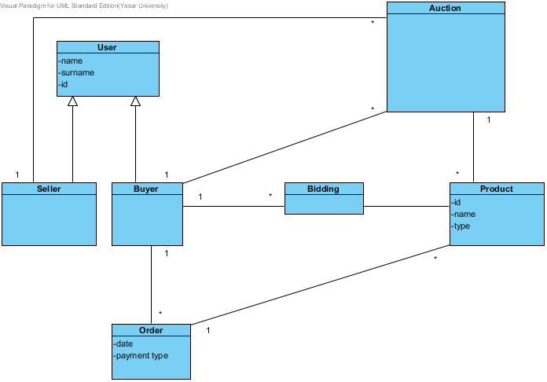

- System Operations

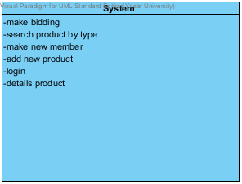

- Design Class Diagram

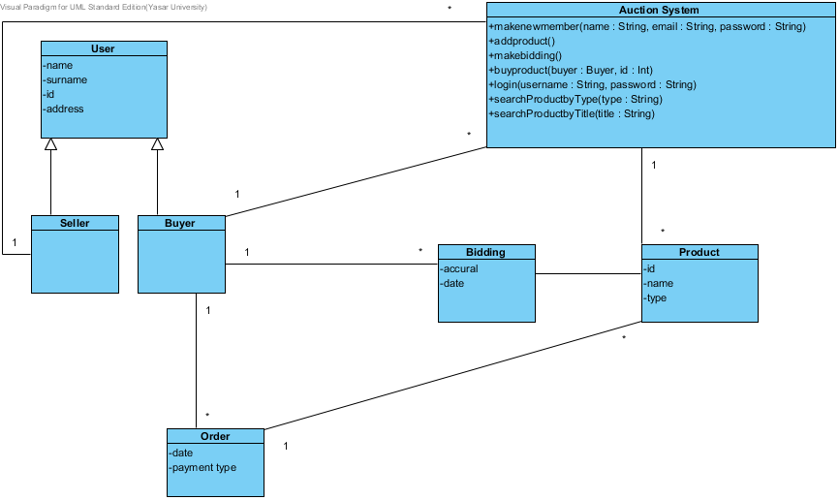

- Interaction Diagrams

Sequence Diagram - AddProduct

Sequence Diagram - Login
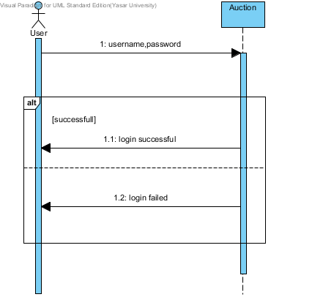

Sequence Diagram – searchProductbyType

Sequence Diagram – MakeNewMember

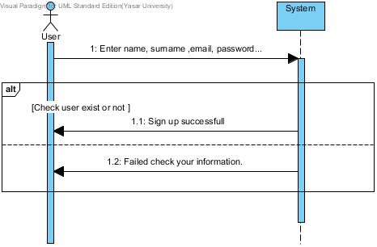

Sequence Diagram- BuyProduct

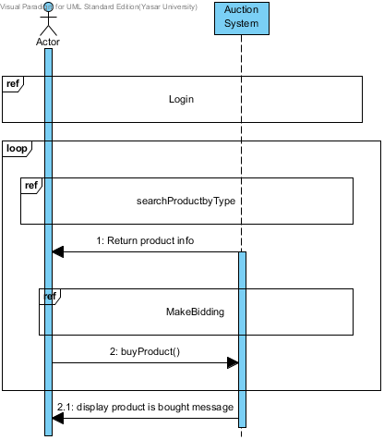

Sequence Diagram – MakeBidding
Sequence Diagram - Show product Details

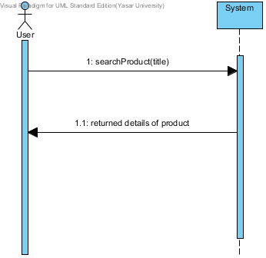
Communication Diagram – MakeBidding

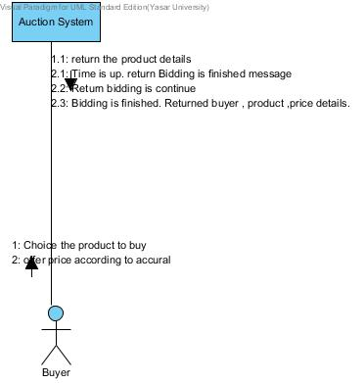

Communication Diagram – Login

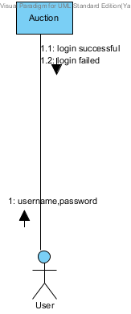

Communication Diagram – SearchProductbyType
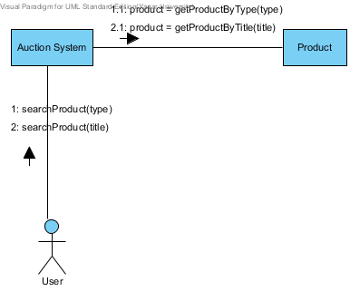
Initilization

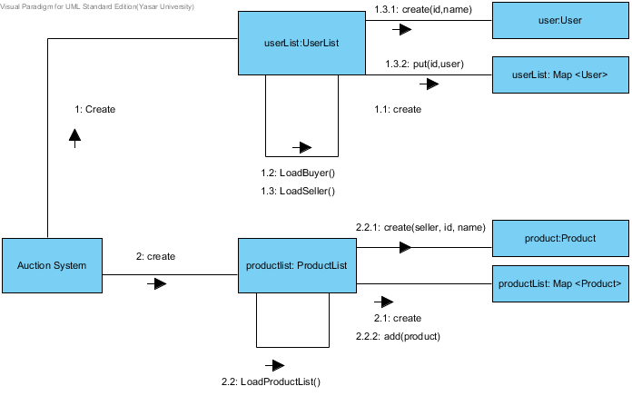

- Appendix

