**Implemantation:**

In the software development phase of the project, the system components were coded step by step. An infrastructure that processes data from microcontrollers was developed using Python programming language. The software was written and edited using Thonny IDE.

First, a data processing module was developed to detect the error codes of the devices. Thanks to this module, the data coming from microcontrollers were interpreted and classified. Then, an error-code matching algorithm was created to make sense of this data.

Information from the system was configured to be transferred to the Firebase database. Both real-time data updates and historical records were kept on Firebase. To enable connection to the mobile application, data was processed in JSON (this format is used to store and transmit data between a server and a web application or between different systems). format.

Another important part of the application was the calculation of maintenance times. An algorithm was developed that dynamically estimates the maintenance time for each device based on its usage time, error history and model. Thanks to this algorithm, the maintenance time of the device could be notified to the user on the mobile application.

Below are the python codes of the algorithms in a simplified form.

**NOTE:** **These codes are sketches and do not reflect the actual implementation.**

**Scripts**

* **Getting error code:**

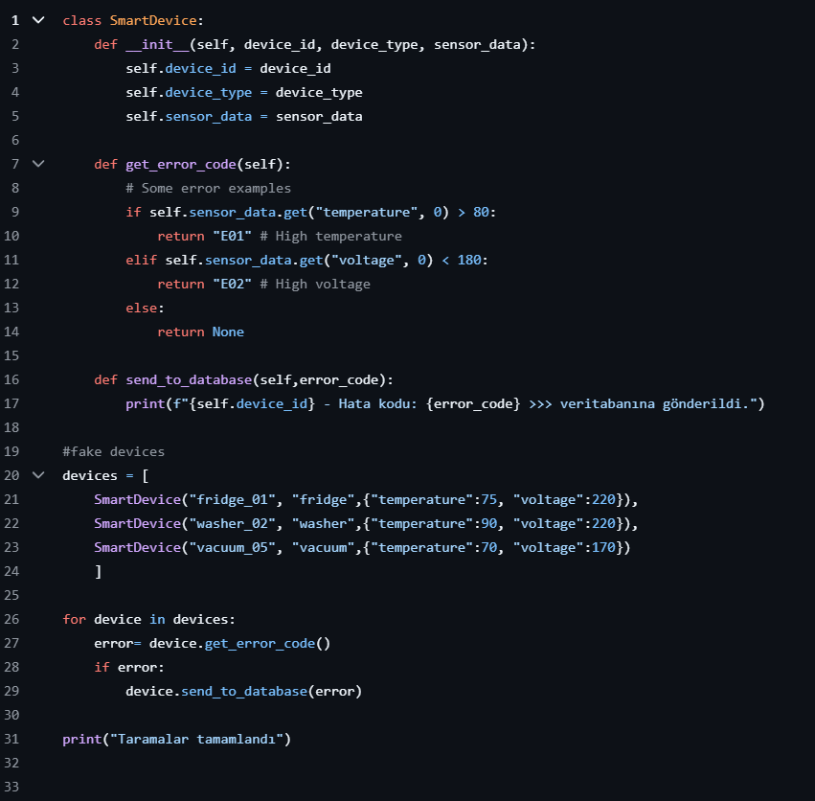

* **Showing Status Devices:**

**1)**

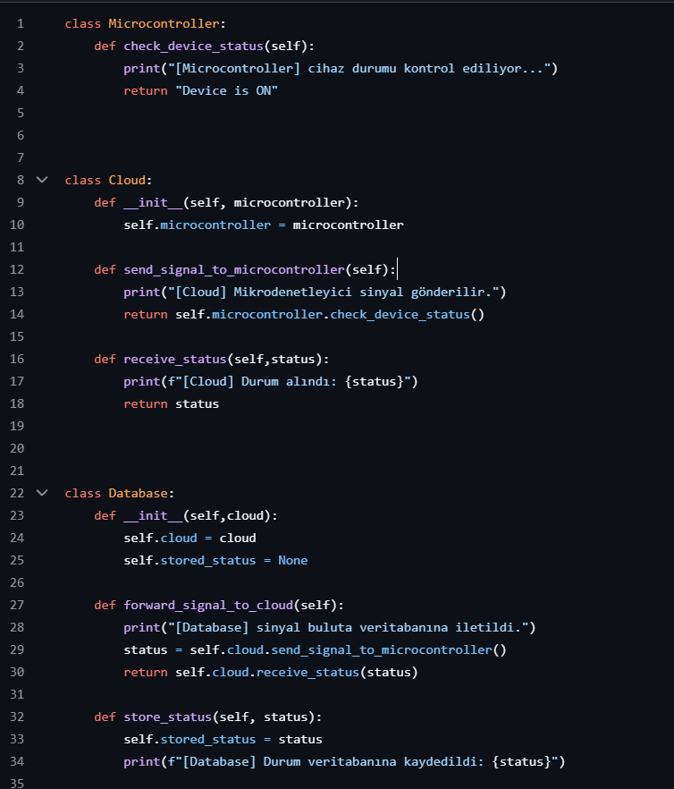

**2)**

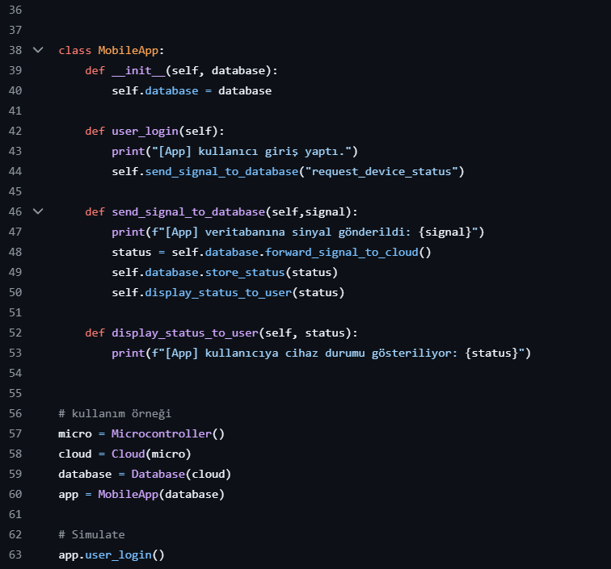

* **Check maintance:**

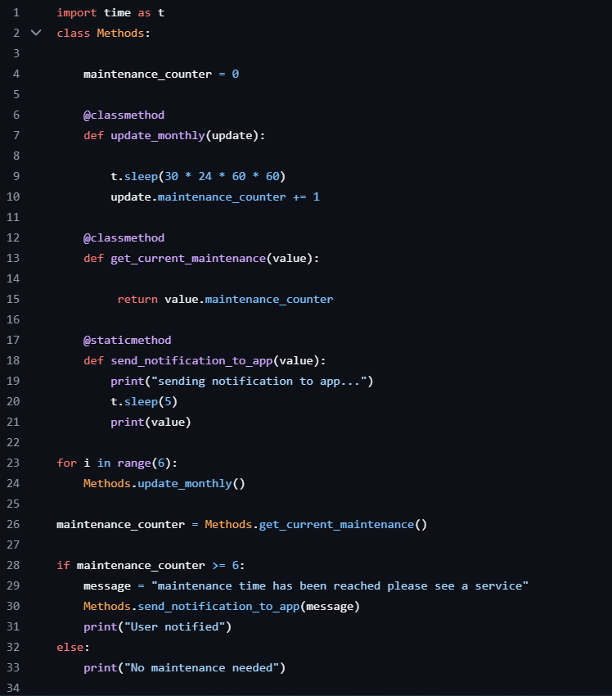

* **Sending Error Code:**

