|  |  |
| --- | --- |
|  | **DOKUZ EYLÜL UNIVERSITY**  **ENGINEERING FACULTY**  **DEPARTMENT OF COMPUTER ENGINEERING** |

**PuckBall**

1. **CME 4407 COMPUTER GAME DESIGN AND PROGRAMMING**
2. **Game Report**

|  |  |
| --- | --- |
| 2017510030 | Ahmet Efendioğlu |
| 2017510078 | İhsan Batuhan Uz |
| 2017510100 | Mesut Selim Serbes |
| 2017510019 | Ahmet Bulur |

Outline

* World/Level design
* Gameplay
  + Objective(s)
  + Rules
* Characters
  + Move style
  + Ball Handling
  + Special attributes
  + AI
* User Interface, Game Controls
* Graphics, Sound and Music

# World design

The overall appearance of the football game that we are aiming to develop will be designed in a horizontal-looking way that resembles a football field theme. In camera view, it can be played from a bird's-eye angle.

There are five players on the field, including four players and a goalkeeper. It will have a central area for players to start the match and a penalty area that can protect the goalkeeper's area.

# Gameplay

* **Objectives**

Puck ball is a classic football game played with disks. The purpose is to make a goal by advancing a ball over the goal line into the goal net. At the same time defending a goal and keeping the opponents from scoring.

* **Rules**
* Players\Teams:

Football is a sport played with two teams. In this game, each team consists of 5 players. These are made up of one goalkeeper and four outfield players.

* Ball:

The ball loses its speed over time.

* Time:

A standard football match is 90 minutes made up of two 45-minute halves. In this game, this time duration can only be set as 5 minutes.

* Winning the game:

To win, teams have to score more goals than opponents.

# Characters

The characters (players) in our game will be in the form of a disc.

* **Move Style**

Players will be able to move left, right, up, down and cross directions (8 directions). Goalkeepers will only be able to move left and right in front of the goal.

* **Ball Handling**

There will be 2 different ways to hit the ball; one strong (for throwing the ball far), one weak (for passing the ball to nearby players). The speed of the ball is reset after a certain distance after these two different strokes.

If a player is in contact with the ball, the player moves together, transferring his speed to the ball. However, it will be easier for the opponent player to catch up. Since the shape of the player and the ball is round, the point where the player touches the ball as the direction of the shot will be the direction of the shot. In this way, it allows you to hit in all directions.

* **Special Attributes**

There are no special attributes.

* **Artificial Intelligence**

The user will play their matches against the computer, other players will be controlled by AI except the player that the user controls.

There are designated positions for all discs on the field. Two discs attacking and two-disc defenders. Defenders always meet the ball a certain distance back.

While the opposing team is attacking, the players that are not under our control return to their predetermined positions and defend the area. We interfere with the ball ourselves with the player under our control. This also applies to the opposing team, but the player who is always closest to the ball on the opponent moves towards the ball, and the rest of the players return their positions.

While attacking, the other players move forward within certain limits together with the player under our control. The defenders are only a little bit in front of the midfield, they do not go further unless they are passed. The opposing team also attacks in the same way. If the player with the ball is in the role of defender, he passes the ball to the players ahead. Players in the offensive role dribble forward. There are also random moves towards the middle of the field in the dribbling process. The AI ​​will pass if there is a player from the opposing team nearby. If he is within a certain distance of the goal, it shoots.

# User Interface, Game Control

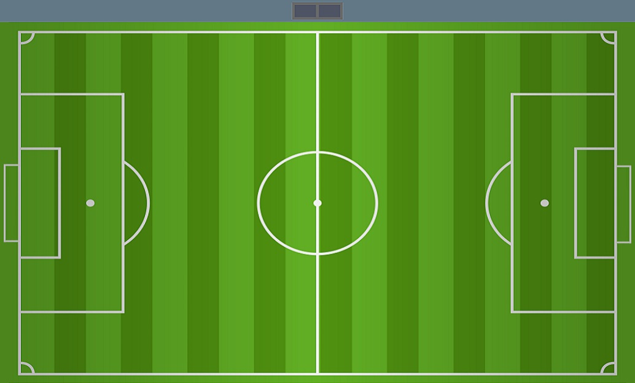

This is how the game looks like. The score will be displayed in the upper middle part of the screen, and the time will be displayed in the upper left part of the screen.

Our characters have two types of jersey designs, blue and red.



Black and white tones were used in the in-game image of the ball.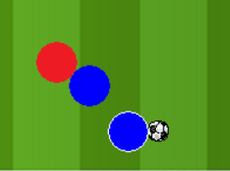

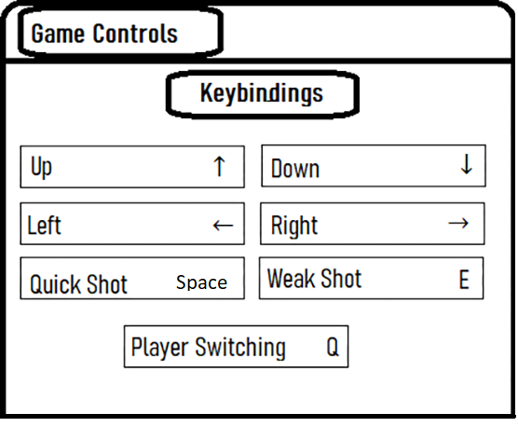

In the basic control settings that allow the game to be played, the directional keys on the keyboard are used to move the characters, while the space and e keys are used to perform the character's strokes. During the match, the Q key is pressed to change the player.

# Graphics, Sound and Music

The game is in 2D and bird's eye view.

There are several different sound effects in our game, these are cheer sounds, net sound, whistle sound, ball hitting sound.

