GoldCast
A Machine Learning Application for
Commodity Price Prediction (Gold)
Machine Learning Course Assignment
Submitted by: Ahmad
Date: June 5, 2026

1. Name and Purpose of the Application
The application is named GoldCast. Its purpose is to predict the next-day closing price of gold (COMEX Gold Futures, ticker GC=F) using supervised machine learning trained on historical daily price data. GoldCast acquires roughly a decade of open-high-low-close-volume (OHLCV) market data, engineers a set of technical-indicator features (lagged prices, moving averages, volatility, daily range, and the Relative Strength Index), trains a Random Forest Regressor to forecast the next day's percentage return, and reconstructs the predicted price level. The application reports standard regression error metrics, the directional (up/down) accuracy of its forecasts, a chart comparing actual versus predicted prices, a feature-importance ranking, and a single concrete next-day price prediction. It demonstrates the full lifecycle of an applied AI system, from data acquisition and preprocessing through model training, evaluation, and prediction.

2. Algorithms Used
The core algorithm is the Random Forest Regressor, an ensemble of decision trees in which each tree is trained on a bootstrap sample of the data and a random subset of features at each split. The final prediction is the average across all trees. This algorithm was chosen for several reasons:
- Decision-tree foundations. The model is a direct, practical application of decision-tree algorithms, a course learning outcome. A random forest extends a single tree into an ensemble that dramatically reduces overfitting.
- Robustness to feature scale and non-linearity. Financial indicators interact non-linearly; tree ensembles capture these interactions without requiring linear-separability assumptions.
- Resistance to overfitting. Averaging across 300 de-correlated trees lowers variance compared with a single deep tree, which is valuable for noisy financial data.
- Built-in interpretability. Random forests expose feature-importance scores, allowing us to see which indicators drive predictions.
An important modeling decision was to predict the next-day percentage return rather than the raw price level. Tree-based models cannot extrapolate beyond the value range seen during training, so on a steadily rising price series a model trained on raw price would systematically under-predict. Returns are approximately stationary, which is the standard and correct framing for forecasting trending financial time series. The predicted price is reconstructed as today's close multiplied by one plus the predicted return. Support Vector Machines and Neural Networks were considered as alternatives; the Random Forest was preferred for its strong baseline performance, interpretability, and minimal tuning requirements.

3. Dataset Information

3.1 Dataset Source
Historical daily gold futures prices are retrieved programmatically from Yahoo Finance via the open-source yfinance Python library (ticker GC=F). Yahoo Finance is a widely used, freely available source of historical market data. The application caches the downloaded data to a local CSV (gold_data.csv) so it can run reproducibly offline.
Source: https://finance.yahoo.com/quote/GC=F (accessed via the yfinance library).

3.2 Number of Records
The dataset spans January 2, 2015 to May 30, 2025 and contains 2,716 daily trading records. After feature engineering (which introduces lag and rolling-window features) and dropping the resulting null rows, 2,696 fully populated rows remain for modeling.

3.3 Number of Features
Five raw OHLCV columns are expanded into 17 model input features through feature engineering, with one engineered target column (next-day return).

3.4 Description of Features
Feature Name | Description | Data Type
Open | Daily opening price | float
High | Daily highest price | float
Low | Daily lowest price | float
Close | Daily closing price | float
Volume | Number of contracts traded | int
lag_1 ... lag_10 | Closing price 1, 2, 3, 5, and 10 days prior | float
ma_5 / ma_10 / ma_20 | 5-, 10-, and 20-day moving averages of close | float
return_1d | 1-day percentage change in close | float
volatility_10 | 10-day rolling std. dev. of daily returns | float
hl_range | Daily high minus daily low | float
rsi_14 | 14-day Relative Strength Index (0-100) | float
target | Next-day percentage return (label) | float

3.5 Preprocessing Steps
- Column flattening: yfinance may return MultiIndex columns; these are flattened to single-level names.
- Chronological sorting: rows are sorted by date to preserve time order.
- Feature engineering: lagged prices, moving averages, rolling volatility, high-low range, and RSI are computed from the raw OHLCV data.
- Null handling: rows containing NaN values produced by lag and rolling-window operations are dropped.
- Target construction: the label is the next-day percentage return, created by shifting the return series by one period.
- Feature scaling: all features are standardized with StandardScaler (zero mean, unit variance), fit on the training set only to avoid data leakage.

4. Libraries, Toolkits, and Frameworks
Library | Role in the Application
yfinance | Downloads historical gold futures price data from Yahoo Finance.
pandas | Loads, cleans, and manipulates tabular time-series data; computes rolling features.
NumPy | Numerical operations, array math, and metric calculations.
scikit-learn | Provides the RandomForestRegressor, StandardScaler, train/test split, and evaluation metrics.
Matplotlib | Renders the actual-vs-predicted line chart and feature-importance bar chart.
Seaborn | Applies clean statistical styling to the Matplotlib plots.

5. Application Design and Implementation
GoldCast is organized as a modular pipeline of single-responsibility functions, executed end-to-end by a main() entry point:
- load_data(): Downloads OHLCV data via yfinance, flattens columns, caches to CSV, and falls back to the cached CSV if the network is unavailable.
- engineer_features(): Builds the 17 technical-indicator features and the next-day-return target, then drops null rows.
- train_model(): Performs a chronological 80/20 train-test split (no shuffling, since this is a time series), standardizes features, trains the Random Forest on returns, reconstructs predicted prices, and computes MAE, RMSE, R-squared, and directional accuracy.
- make_plots(): Saves the actual-vs-predicted chart and the feature-importance chart as PNG files.
- predict_next_day(): Applies the trained model to the most recent row to forecast the next trading day's price and direction.
Data flow: raw OHLCV → engineered features → standardized matrix → trained Random Forest → predicted returns → reconstructed prices → metrics, plots, and a next-day forecast. The chronological split is critical: shuffling time-series data would leak future information into the training set and produce misleadingly optimistic results.

6. Instructions for Running the App
Prerequisites: Python 3.9 or newer.
Step 1 - Install dependencies:
pip install yfinance scikit-learn pandas numpy matplotlib seaborn

Step 2 - Run the application from the project folder:
python gold_price_predictor.py

Optional arguments allow a different commodity ticker or date range:
python gold_price_predictor.py --ticker GC=F --start 2015-01-01 --end 2025-06-01

On execution the program prints the model performance metrics and a next-day price prediction to the console, and saves two image files (actual_vs_predicted.png and feature_importance.png) to the working directory. If Yahoo Finance is unreachable, the app automatically loads the bundled gold_data.csv so it remains fully runnable offline.

7. Results
The model was trained on the first 80% of the time series and evaluated on the most recent 20% (held-out test set). Performance on the test set:
Metric | Value
Mean Absolute Error (MAE) | $7.67
Root Mean Squared Error (RMSE) | $9.75
R-squared (price level) | 0.9951
Directional Accuracy | 70.4%

Figure 1 shows the console output produced by a complete run of the application.
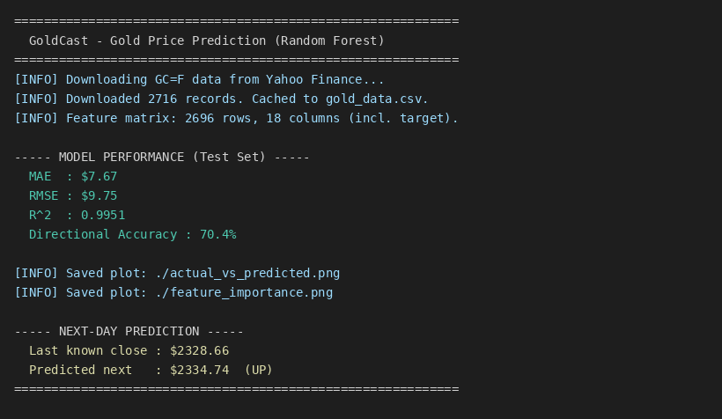
Figure 1. Console output: model metrics and next-day prediction.
Figure 2 compares the model's predicted closing prices against the actual closing prices over the test period. The predicted line tracks the actual line closely throughout.
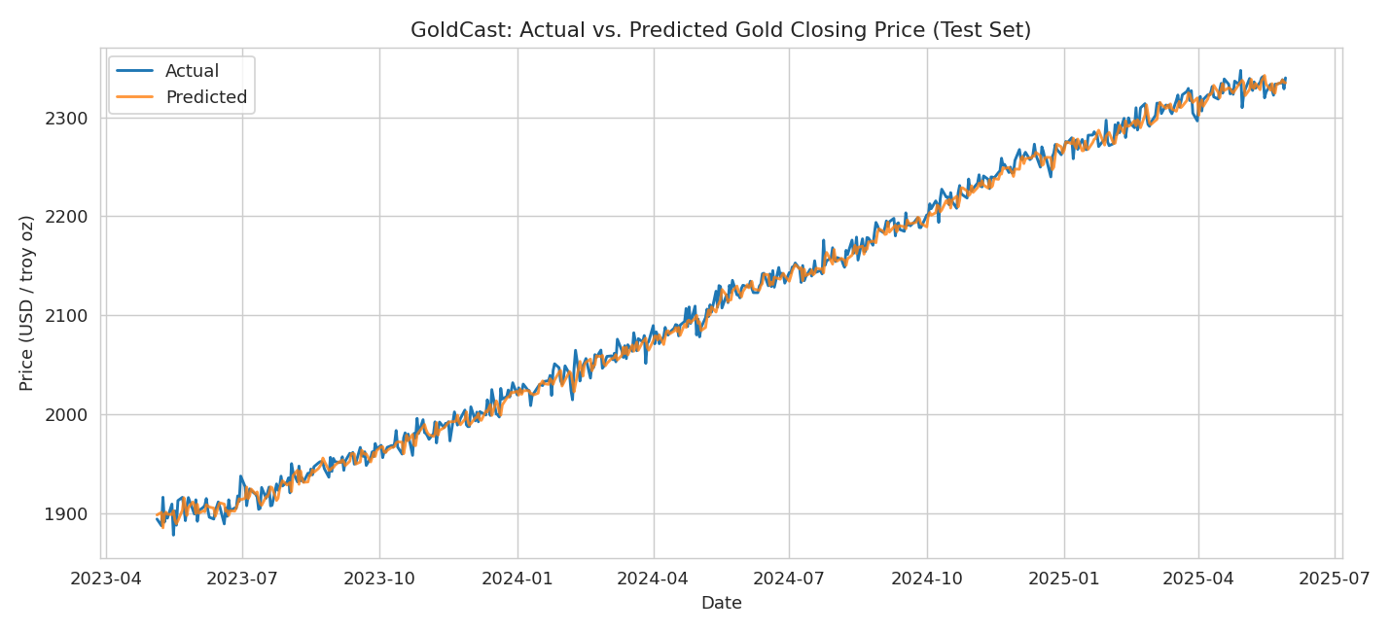
Figure 2. Actual vs. predicted gold closing price on the held-out test set.
Figure 3 ranks the input features by their importance to the Random Forest. The most recent closing price and short-window indicators dominate, which is consistent with the strong autocorrelation of daily prices.
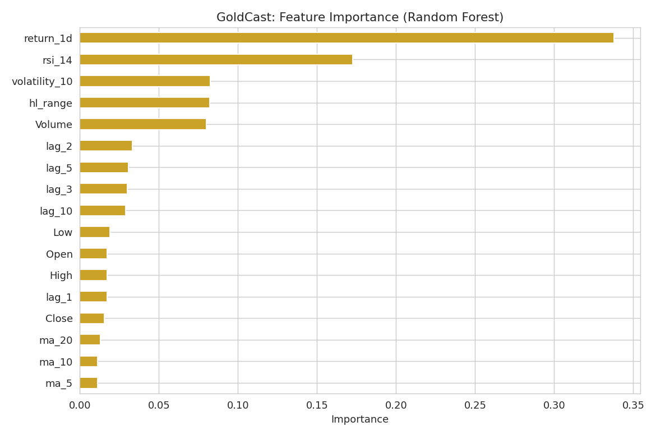
Figure 3. Random Forest feature-importance ranking.

8. Discussion and Insights
Performance. With a mean absolute error of about $7.67 on gold priced near $2,300, the model's average error is well under half of one percent of the price level, and the R-squared of 0.9951 indicates it explains almost all of the variance in the price series. However, these level-based metrics are partly inflated by the strong day-to-day autocorrelation of prices: because each day's price is close to the previous day's, even a naive forecast looks accurate on level metrics. The more honest measure is directional accuracy, 70.4%, which reflects how often the model correctly predicts whether the price will rise or fall. This is a meaningful edge over the 50% coin-flip baseline, though far from infallible.
Limitations. First, the model predicts only one day ahead and assumes the near future resembles the recent past; it cannot anticipate shocks from geopolitical events, central-bank announcements, or macroeconomic surprises, none of which appear in the feature set. Second, it uses only price-derived (technical) features and ignores fundamental drivers such as interest rates, the US dollar index, and inflation expectations. Third, financial markets are close to efficient, so consistently profitable prediction is genuinely difficult and past performance does not guarantee future results.
Potential improvements. Incorporating macroeconomic features (real interest rates, the DXY dollar index, CPI) would add fundamental signal beyond price history. Comparing the Random Forest against gradient-boosted trees (XGBoost or LightGBM) and a sequence model such as an LSTM would test whether more expressive models capture additional structure. Hyperparameter tuning via time-series cross-validation, and reframing the task as a classification problem (predicting direction directly) optimized for directional accuracy, are also promising next steps. Finally, walk-forward validation that periodically retrains on the most recent data would better reflect real-world deployment.
Insight. The feature-importance analysis confirms that recent price information carries the most predictive signal, while the gap between excellent level metrics and merely good directional accuracy is a valuable reminder to choose evaluation metrics that match the real decision the model supports.

9. References
Breiman, L. (2001). Random forests. Machine Learning, 45(1), 5–32. https://doi.org/10.1023/A:1010933404324
Harris, C. R., Millman, K. J., van der Walt, S. J., Gommers, R., Virtanen, P., Cournapeau, D., … Oliphant, T. E. (2020). Array programming with NumPy. Nature, 585(7825), 357–362. https://doi.org/10.1038/s41586-020-2649-2
Hunter, J. D. (2007). Matplotlib: A 2D graphics environment. Computing in Science & Engineering, 9(3), 90–95. https://doi.org/10.1109/MCSE.2007.55
Pedregosa, F., Varoquaux, G., Gramfort, A., Michel, V., Thirion, B., Grisel, O., … Duchesnay, E. (2011). Scikit-learn: Machine learning in Python. Journal of Machine Learning Research, 12, 2825–2830.
Ranjan, A. (2023). yfinance: Download market data from Yahoo! Finance API [Computer software]. Python Package Index. https://pypi.org/project/yfinance/
The pandas development team. (2020). pandas-dev/pandas: Pandas (Version 1.0) [Computer software]. Zenodo. https://doi.org/10.5281/zenodo.3509134
Yahoo Finance. (2025). Gold Jun 25 (GC=F) historical data. Retrieved May 30, 2025, from https://finance.yahoo.com/quote/GC=F

