Instructions for the code

# Importing the libraries

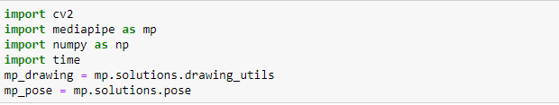

We start off by importing all the important libraries and mediapipe’s drawing utils and pose solutions.

# Make Detections

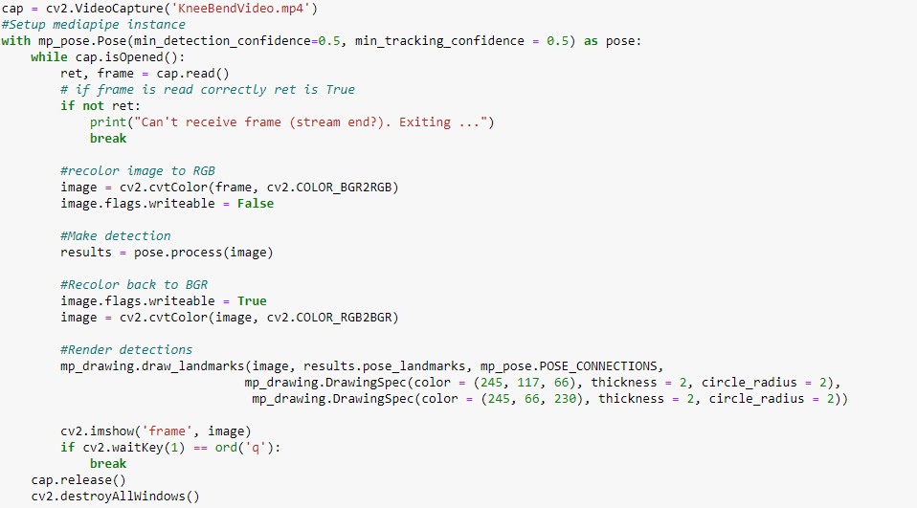

This will be our baseline code and we will build open this code as we move forward. Basically, we are capturing our Knee Bend Video and using mediapipe’s pose solutions. Minimum detection confidence will set the threshold value of the confidence level. Minimum tracking confidence is the confidence value from the landmark-tracking model for the pose landmarks to be considered tracked successfully, or otherwise person detection will be invoked automatically on the next input image. We will convert the video colour from BGR to RGB make the detection and then recolour it to BGR for OpenCv. Now using the drawing utils we will draw the pose connections using the landmarks.

# Extracting Joints

Building upon the previous code, we will now use landmark coordinates to extract joints which will be further useful to us in the code. As you can see below, there are in total 33 pose landmarks.

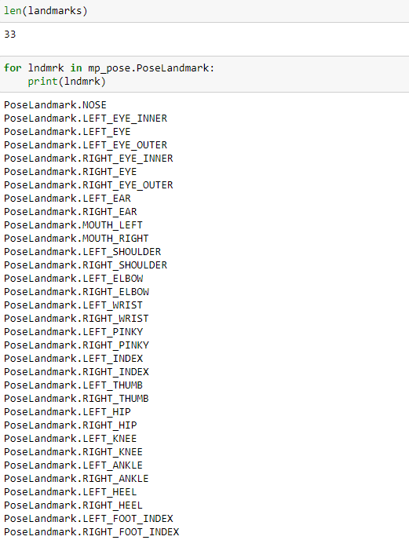

In the video, we can see that the leg closer to the camera is the left one. Hence, we will need the x, y coordinates of the left hip, left knee and left ankle pose landmarks so that we can calculate the angle between these three joints to make our rep counter.

# Calculating Angles

Let’s define a function to calculate the angle between any three joints.

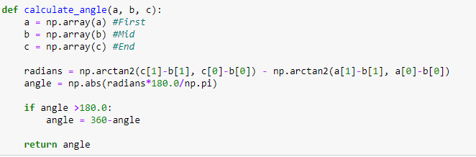

This function will take the three pose landmarks and extract the x, y coordinates and calculate the angle between them. Using the previous code and this function let’s display the angle between the three joints.

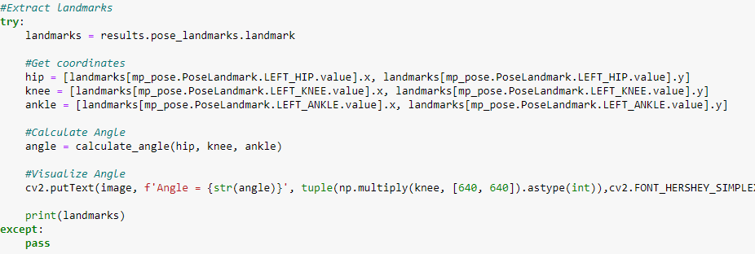

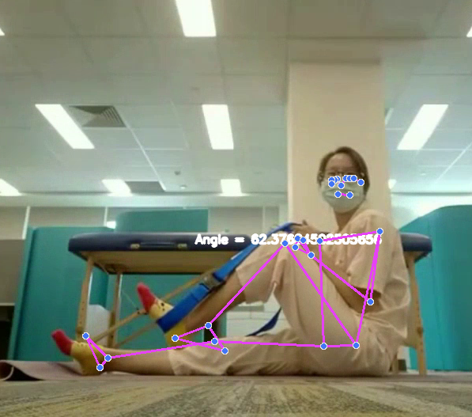

# Knee Bend Counter

All we have to do now is make a rep counter with a conditional logic and save the video as the final part of our assignment.

The conditional logic says that for a rep to be counted the angle should be less than 140 degrees and when the angle is less than 140 degrees a timer should start and for that rep to be counted the time should be at least 8 seconds. If the knee is straightened before completing the 8 seconds marks, the rep should not be counted and a message should appear saying that “keep your knee bent”.

We will initialize the following variables to implement our logic

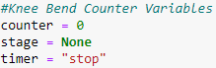

And the logic code will be:

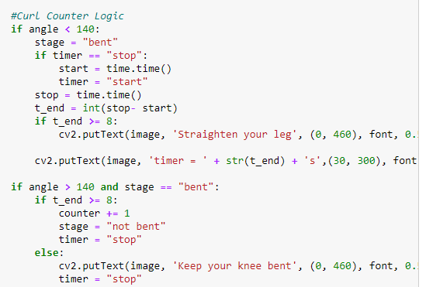

# Final Output

To display the rep counter and the knee bent status, we will use opencv to display the stats.

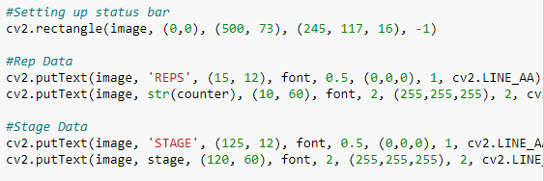

Our final output will look like:

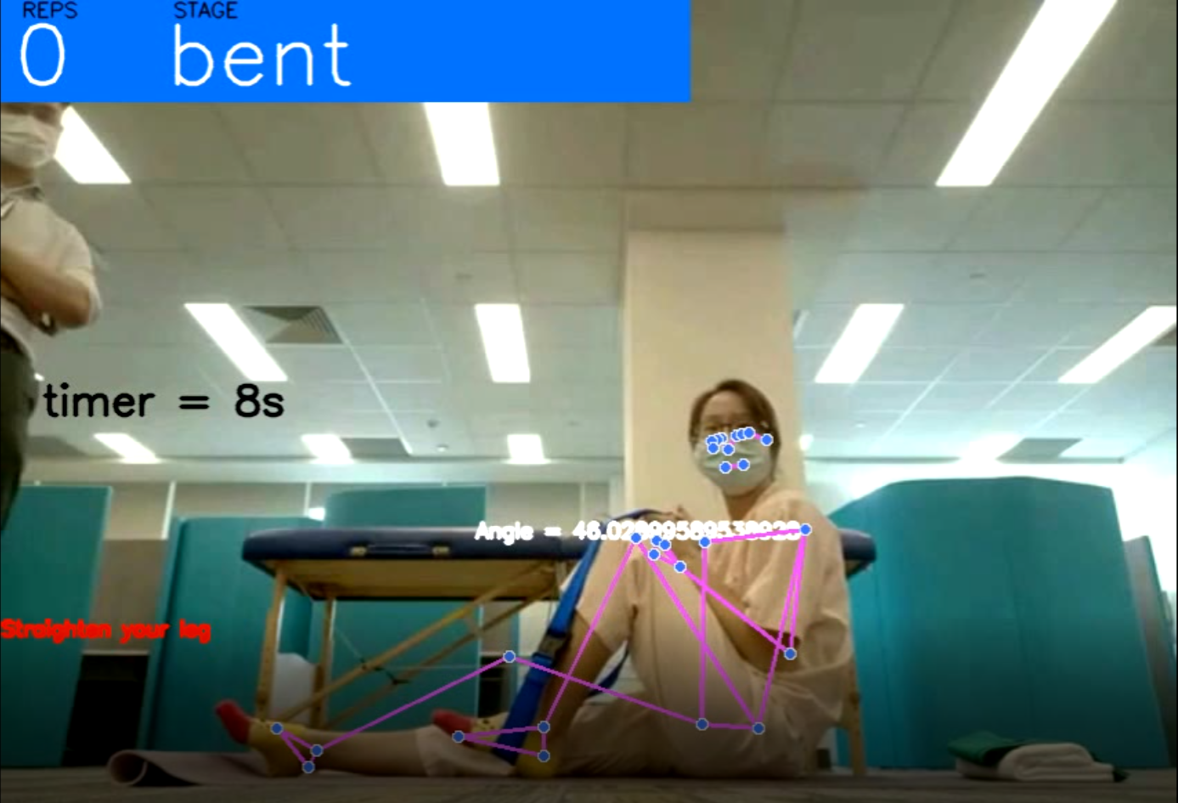

# Working on Fluctuating Frames

The fluctuating frames can be removed from the video by extracting those specific frames from the video and deleting them. This will maintain the smoothness of the algorithm. There are in total 4 redundant frames in the video. I was in a hurry to finish the assignment hence, finishing the task at hand with maximum performance was my primary goal. Hope ya’ll like then work.