**University of Asia Pacific**

Department of Computer Science and Engineering

**Proposal of Thesis**

**Subject : Emotion Monitoring Based on Face Recognition.**

**Submitted By:**

|  |  |  |  |
| --- | --- | --- | --- |
| **Name :** | Shahin Alam | Md. Nime Molla | Al khaled Rayhan |
| **ID :** | 17201023 | 17201029 | 17201045 |
|  |  |  |  |

**Supervised By: Submitted To:**

Fahad Ahmed Jahir Ibna Rafiq

Lecturer Assistant professor

Dept. of CSE Dept. of CSE

University of Asia Pacific University of Asia Pacific

# **Project Name**

**Emotion Monitoring Based on Face Recognition.**

**(provide project link)**

# **Thesis Group Members**

1.Shahin Alam -17201023

<https://github.com/AhnabShahin/Emotion-monitoring/tree/17201023>

3.Md. Nime molla -17201029

<https://github.com/AhnabShahin/Emotion-monitoring/tree/17201029>

4.Al Khaled Rayhan -17201045

<https://github.com/AhnabShahin/Emotion-monitoring/tree/17201045>

**Try to make it the CEP mapping format.**

# **Motivation**

In previous times, for psychologists, analyzing facial expression was an essential part. Nowadays image processing has motivated significantly on research work of automatic face mood detection. However, this COVID-19 pandemic still remains some challenges about emotional solicitude for infants and young children, elderly and mentally ill persons during pandemic.There are lots of depressed people living in our society. Also lots of busy people who do not know their present mental condition. So we try to develop such an application and by this application they will be able to see their present mental condition.

# **Objective**

The objective of Face Emotion Detection (FED) is to identify the emotion of a human face. That is given a face of a human the system has to automatically identify the type of emotion of the face as happy, anger, disgust, fear, happiness, sadness, and surprise. Several studies have been conducted in this area as there are a large number of applications which directly or indirectly use FED. FED can be used as a part of many interesting and useful applications like Monitoring security, treating patients in the medical field, marketing research, E-learning etc.

**Why is Face Detection Important?**

* First step for any fully automatic face recognition system
* First step in many surveillance systems
* Face is a highly non-rigid object
* Lots of applications
* A step towards Automatic Target Recognition (ATR) or generic object detection/recognition

**Why Is Face Detection Difficult?**

* Pose (Out-of-Plane Rotation): frontal, 45 degree, profile, upside down
* Presence or absence of structural components: beards, mustaches, and glasses
* Facial expression: face appearance is directly affected by a person's facial expression
* Occlusion: faces may be partially occluded by other objects
* Orientation (In-Plane Rotation): face appearance directly vary for different rotations about the camera's optical axis
* Imaging conditions: lighting (spectra, source distribution and intensity) and camera characteristics (sensor response, gain control, lenses), resolution.

# **Methods to Detection**

* **Knowledge-based methods:**

Encode human knowledge of what constitutes a typical face (usually, the relationships between facial features)

* **Feature invariant approaches:**

Aim to find structural features of a face that exist even when the pose, viewpoint, or lighting conditions vary

* **Template matching methods:**

Several standard patterns stored to describe the face as a whole or the facial features separately

* **Appearance-based methods:**

The models (or templates) are learned from a set of training images which capture the representative variability of facial appearance

# **Flow chart of learner emotion recognition model**

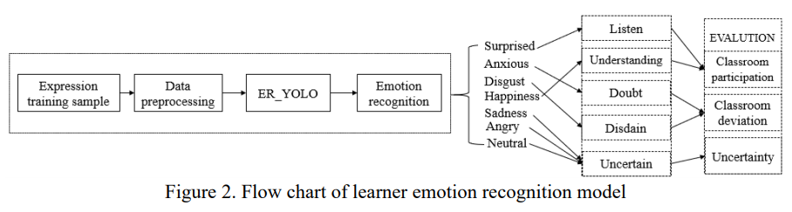

# **Rationale of the Study**

# 

# **Project problem definition in details**

# **Benefits of the project**

Detecting emotions with technology is quite a challenging task, yet one where machine learning algorithms have shown great promise. By using Facial Emotion Recognition, businesses can process images, and videos in real-time for monitoring video feeds or automating video analytics, thus saving costs and making life better for their users.

We have combined the science of psychology, human expressions and artificial intelligence to recognize different emotions on an individual’s face automatically. Our face analysis algorithm can identify nine different types of emotional states: happiness, sadness, disgust, surprise, anger, fear.natural,doubt and contempt.

# **Risk Analysis**

Facial recognition can be a useful tool for governments, companies and consumers, but it also comes with risks, especially to individuals. The latter includes:

* **The lack of permission**

Facial recognition data can easily be collected in public places – all

the software would need is a clear image of the subject’s face.

* **Predatory marketing**

Software which analyses facial expressions could potentially be put to use by some companies to prey on vulnerable customers. This could be done by segmenting extreme emotions – such as distress – and tailoring their products and services to these individuals.

* **Disadvantage when applying for jobs**

Job applicants who don’t want to give potential employers access to details of their personal lives can keep these private, such as by selecting the related privacy settings on social media. However, facial recognition could potentially allow recruiters to find out more about you than you’d realise.

* **Stalking**

Tools like reverse image searches can provide stalkers with more data about their victims.

* **Identity fraud**

Criminals who have collected enough personal information on you could commit **identity fraud**. This could have a significant effect on your personal life, including on your finances.