OUTPUT

1. 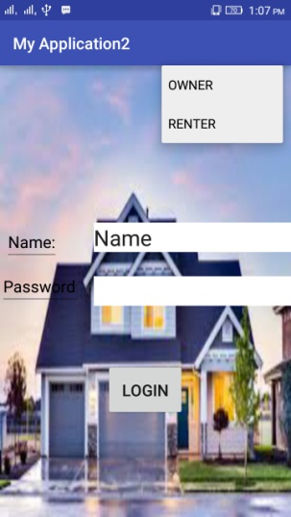

This is the first page of our project.You have to select the owner or renter to login in the application.we use spinner to select the owner or renter.

Then you have to give your name and password for login.

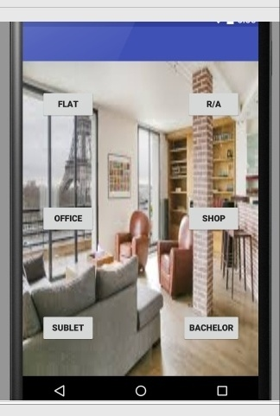2.This is the second page of our application.IN this page a owner and Renter select a option for her own need. We use flat, residential area,office,shop, sublet, bechalor .if we select R/A then you can have the option for owner or renter. We only work with R/A in this output.

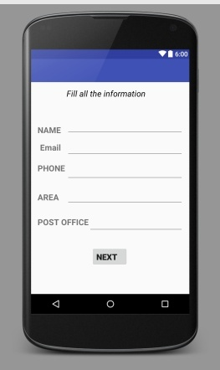3. This is the third page of our app. In this page you all the information of you need.you need to select all the the information to go to next page. 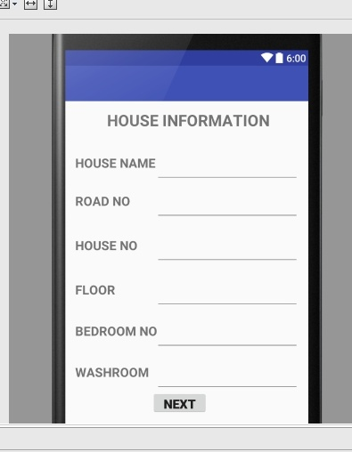

4.In this page you have to fill the all information of your house of owner.

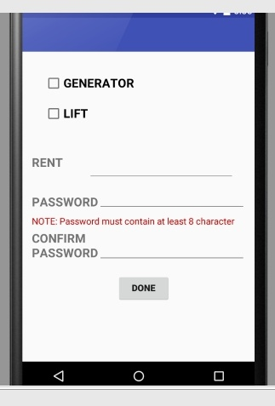 5. In this page you have to select all the facilities of your house.then you have to set the rent of your house. Now to submit the form ,you will give the password and press the done button.

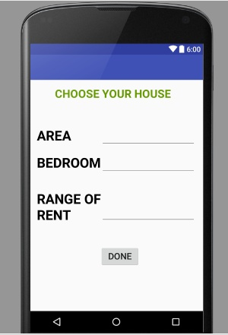6. this page is for renter only. In this page a renter can select all his need for a house and press done button.  
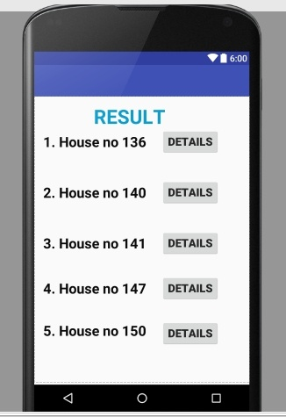

7. This page is for the main result of the needed house. Then a renter can see the details of the house.