**Chittagong University of Engineering**

**& Technology**



DEPARTMENT OF COMPUTER SCIENCE & ENGINEERING

**Name of The Project**

**An efficient solution to rental house searching problem using 0/1 knapsack and merge sort considering owner and renter constraints.**

**Submitted By: Team Leader**

Md. Ahanf Alam (1604029)

**Team member**

Suresh Paul Pranta (1604007)

**Submitted To: COURSE TEACHER**

Md. Sabir Hossain, Lecturer,

Department of Computer Science & Engineering,

Chittagong University of Engineering & Technology, Bangladesh

**Course Title:** Algorithm design and analysis

**Course No:** CSE-243

**Date of Submission:** 19.01.2019

**Level:** 2 **Term:** II **Section:** A **Group:** A1

**01. ABSTRACT**

The power of technology is increasing day by day. We can use this power in many sectors we want. Housing sector remains wary to face the task of change by employing a new technique simplify easy management of houses for rent. So, there is a need to develop a rental house management system.

The relation between the person or family who rented house and the house owner is complicated sometime because some renters have good or bad behavior. It is a tough thing to find a suitable and affordable house for him going different places and finding a house which is ready to rent and he can afford to have this home for rent. If he can't find then both his time and money to travel from one place to another will spent without any profit.

Considering those facts, we decided to develop a system by which we will solve some major issue which we face at the time of house renting with the current manual system. Here we used knapsack and merge sort to find the best houses fill up the requirements of the user. The solution helps both the renters and the house owners.

**02. INTRODUCTION**

Rental house management system has become important factor in modern society. House is needs for all kinds of people those who have not any home to live in. So, they may live by paying rent to the house owner.

There are different types of person or family in our country who needs a bachelor house or a better house to live with their family. But there are limitations to live in a house because a person prefers a house within his range of income he can afford. So this is a tough thing to find a suitable and affordable house for him going different places and finding a house which is ready to rent and he can afford to have this home for rent. If he can't find then both his time and money to travel from one place to another will spent without any profit.

So, there is an importance to solve those facts. We propose a better solution of this problem which is related to house renting. So, for reducing this problem we decide to build a system which is helpful for all people to find a house for rent in an easy and efficient way which may save their time and money previously which was spent for finding a house going different places. In this system a person can deal with more than one house easily.

The general technique to solve this problem by other researchers is finding affordable house within the financial means of those in the lower income ranges. Considering the income of all people they find the houses. Our approach to solve the problem is to using the 0/1 knapsack and merge sort algorithm considering the rating and income also user can easily find the affordable house. The expected outcome of this project is any user can easily find house using this app and owner also submit their house information for rent.

**02.01. THE OBJECTIVES OF THIS PROJECT**

Objectives of our proposed system can be summarized as:

1. Our objective is to build a system which is helpful for all people to find a house for rent in an easy and efficient way.

2. It may save their time and money previously which was spent for finding a house going different places.

3. In this system a person can deal with more than one house easily. We want to design our project into different modules.

4. We try to use the algorithm knapsack & merge sort to find the best house.

5. There will always be an attempt to modify the above system by adding payment system by bank account for making it enriched and more effective.

**03. RELATED WORK**

[1]- This paper contains the importance of house renting system. In this paper, we can know the scope of house finding rules. Developing this idea there is many details about the customers and the house which is ready for finding. From this paper we can know the process of system designing, system maintain and others thing. We can know the difficulties of developing the apps and how to overcome this problem.

[2]-Knapsack is related to dynamic programming. This paper contains the idea of dynamic programming and how to built a system using knapsack. in the project we will use 0-1 knapsack which is based on dynamic programming. The general purpose of knapsack problem is told in this paper. There are many problems about knapsack so we can easily understand this method.

[3]-In this paper we can see that there is a problem between two friends about bicycle tour which was solved by using knapsack. There is also the general structure of a knapsack problem is given. Then two friends give two solution. In the solution there are some situations it can be considered as approximate solution.

[4]-Here we see the whole concept of Knapsack by an example given. Also know that it is an optimization problem. There is a solution to solve the problem. Partition the problem into subproblems, solving the problems and then combining it which means divide & conquer concept. But the best solution is to solve it by DP (Dynamic Programming). Here is also clear description how to construct a DP algorithm for knapsack & the bottom up computation.

[5]- In this paper they proposed that their system works with spatial data. They also used notification panel which is automatically sent to all those clients. The system takes minimum time to search and have a friendly user interface.

[6]-The main formation of a house is concluded in this paper. The fundamental properties of a house is being described. The conceptual frame work and critical issue of a rental house is described. The main reason of finding a good house is described.

[7]-This paper is considered about the house rent, property rent, land buying in overseas. renting system is practice of our daily life where we can face many problems to find a perfect house. In this paper this issues is briefly described. Property finding and land buying is also good problem we face. This paper is discussed about this problem and give a good solution.

[8]-in this paper, how to find a good house in an easy way is discussed. The main reason of not getting a good house is that, moving here from there. As result people get disturbed and lose his energy. So, this processes of finding a good house is important.

[9]- most important thing in this paper is that to built a project about house renting system. The main process is that make a diagram and flow the system.

[10]- in this paper, the processes of buying a house is described. The main method of buying a perfect house for the buyer and maintain the house.

**04. PRELIMINARIES**

**Knapsack –** Knapsack is a part of dynamic programming. Suppose you are given a bag which can afford 10 kg weight. Now you are given some things with their weight and price. Now you are told to take those items which cost is max. This type of problem is solved by using knapsack.

In our project we will use this method for finding the perfect house for you. we will follow this procedure. First the house owner post the house details with price .now the admin panel will rate this house according the place and price and other facilities.

The customer who will want to find house, set a price and location in the apps. Now the apps will automatically rate his information. Now the algorithm will work. The apps will find those houses for the which is profitable for him/her following the rating. In this process we will build our system.

**Pseudo code of 0-1 knapsack:**

1. For i from 0 to weight
2. Do
3. A[0,i] -> 0
4. End for
5. For j from 1 to n
6. Do
7. For k from 0 to weight
8. If w[i]<=i then
9. A[i,k] -> max(A[i-1,j],A[i-1,k-w[i]+v[i])
10. Else
11. A[i,k] -> A[i-1,k]
12. End if
13. End for

**Merge sort –** It’s a sorting process which is important part of our project. Merge sort works like divide and conquer process. First the array will divide into two part. Then, two parts of this array will divide into another two part. This process will continue until one element will left. Then merge sort function will compare two element of the array and sort these two elements. Then these two elements will merge. This process will continue until we get the full array. This process merge sort will work. In our project we will sort the house price according our information so that we can easily get our output.

**Pseudo code of Merge Sort:**

Merge-Sort (A, p, r)

1. If p < r
2. q = [ (p + q) /2]
3. Merge-Sort (A, p, q)
4. Merge-Sort (A, q+1, r)
5. Merge (A, p, q, r)

Merge(A, p, q, r)

1. n1 = q – p +1
2. n2 = r – q
3. let L[1..n1+ 1] and L [1.. n2+ 1] be new arrays
4. For i=1 to n1
5. L[i] = A [ p + i -1]
6. For j=1 to n2
7. R[j]= A[ q + j ]
8. L[n1+ 1] = ∞
9. R[n2+ 1] = ∞
10. i = 1
11. j = 1
12. For k = p to r
13. if L[i] < R[j]
14. A[k] = L[i]
15. i = i + 1
16. else A[k] = R[j]
17. j = j + 1

**05. OUTCOMES OF THIS PROJECT**

• This project will help to find the house easily

• This project will remove difficulty of finding a house.

• A renter can give all the information to find his desired house.

• Renter will not need to move one place to another to find house for rent.

**06. PROPOSED METHODOLOGY**

∎ Admin

∎ House Owner

∎ Renter

∎ All houses should be sorted by their cost. So that it is easy to every user finding home within a suitable range.

∎ Information about houses.

∎ Registration

This is a demo feature of our proposed system for renting houses in a better way.

**CONTEXT DIAGRAM**

The context diagram of our project is given below which show the relationship between all panel to main system. The renters are choosing a house which is suggested by the admin by their requirements. The house owner gives all the information about his/her house to rent. After the registration process has been completed then house management panel manage house for renters.

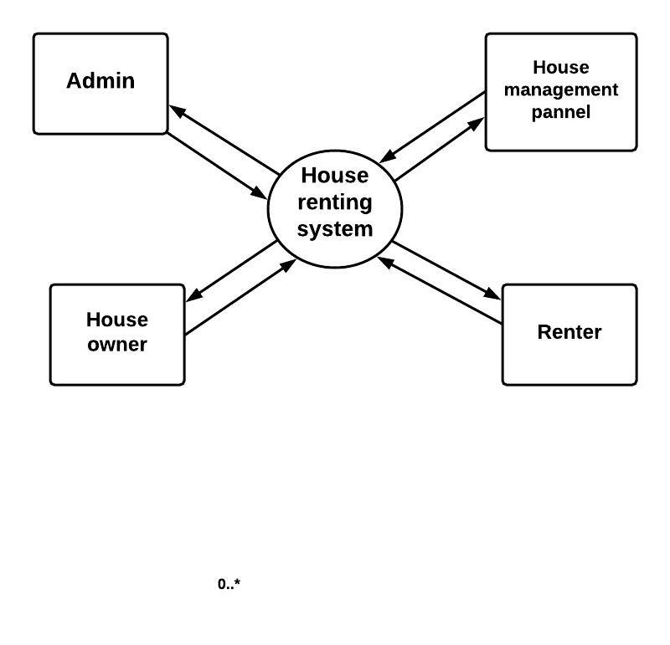

Fig 1: Context Diagram

**PROPOSED SYSTEM ARCHITECTURE**

In the dataflow diagram we can see the how the whole system works. At first an owner login in the system process and give his information. This information will sent in the registration process system. Then admin panel will check all the information of the owner and approve his account. Now the renter will follow the same process. All the information of owner and renter will store in data store section. When a renter find a house he will give the required information to the finding house section. It will process the whole data and gives a result to the renter.

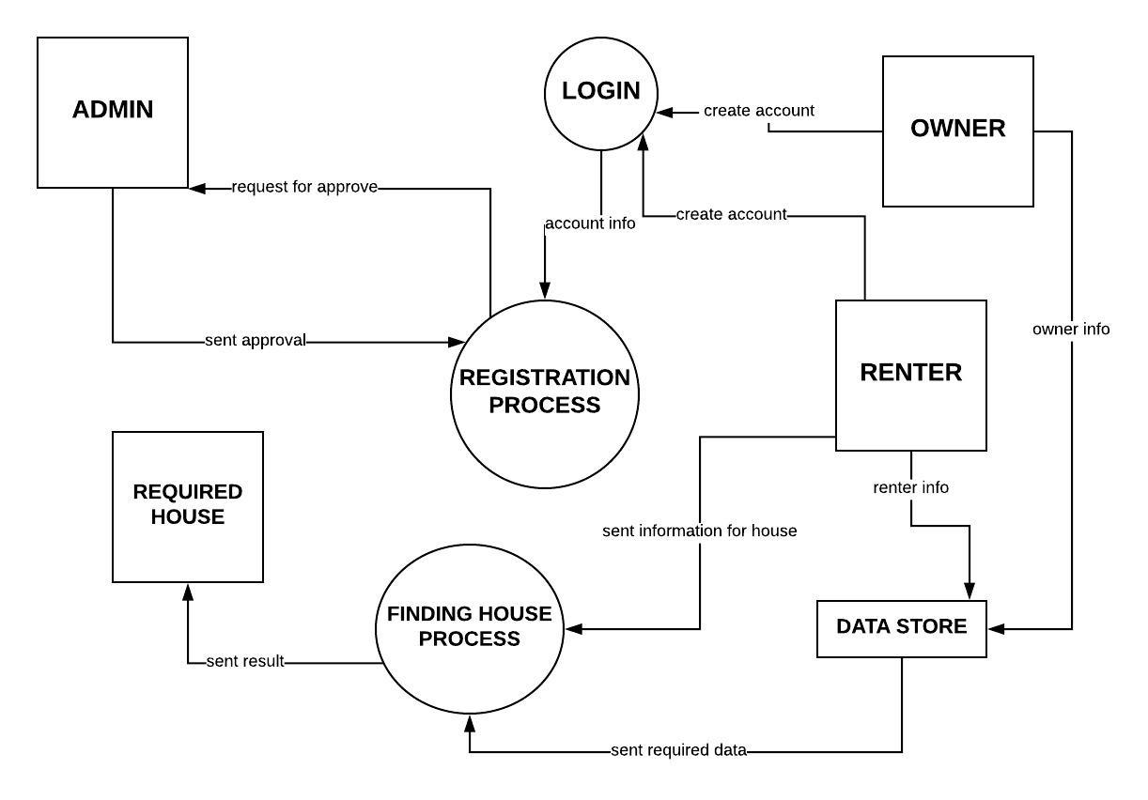

**Sent Results Using 0/1 Knapsack & Merge Sort**

Fig 2. Proposed Methodology

**07. IMPLEMENTATION DETAILS**

**07.01. WORKING PROCEDURE**

Knapsack algorithm: Knapsack algorithm is a greedy algorithm. In this algorithm, you are given some weight and value of something. And you have a limit capacity of bag. You have to fill the bag as you value is max. so this type of problem is solved by knapsack algorithm.

This algorithm is work like, you will take one item and don’t take the item and calculate the value of the taken item. This algorithm will give you the max price or value of an item.

In our project we use this algorithm to find the best house for a user. We rate every house in the apps and we will use knapsack using this rating.

First, we take rating as price in knapsack and rent as weight. So that we can maximize the price and minimize the rent. For capacity we calculate a number using rent. So, knapsack will select those houses which rating is good for the user. By default, we will select only five best houses in our app as user will not be disturbed of finding house.

Merge sort: We will also use sorting for finding the all house in user capacity. Merge sort is working divide and conquer procedure.

First the unsorted array will divide into two parts using recursion. This procedure will apply until there is one element in the sub-array. Then it will compare the two sub-array and swap them. Then it will merge together. This merging will continue until whole array will get.

In our project we use this sorting algorithm for sort the rent of the house. The rent will sort according the range of the rent which will give by the user. Then he will find the all house in his/her selected area.

**07.02. EXPERIMENTAL RESULT:**

The output of our project is given below-

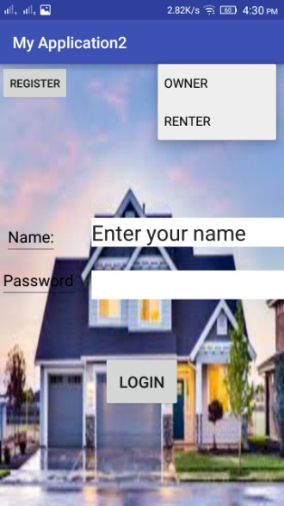1.this is the first page of the apps. You can find many things here. A user can register here for a new account. If he selects register button, next register page will appear.

If a user has already an account, he will select owner or renter for login. Then he will give her name and password and press the login button. If he has no account then a toast will appear and say User doesn’t exists”. If user has an account then say “Welcome X”.

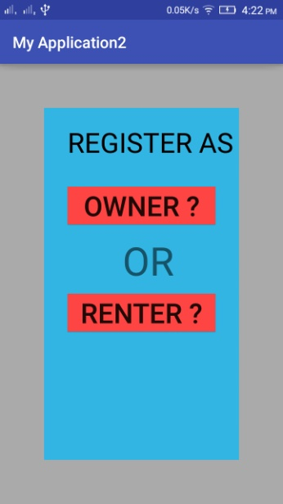2. if a user has no account in the app then he will select the register button. Then this page will appear. Here he can see two buttons. One is for owner and another is for renter. User will select one button for his need.

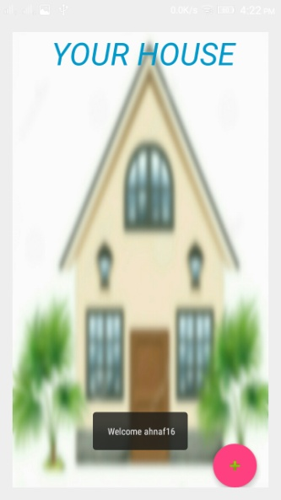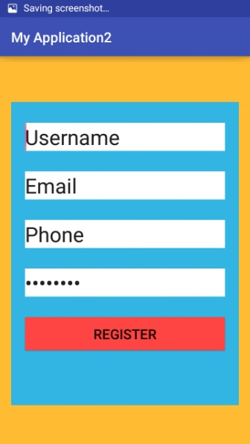3. If user will select owner button for registration, this page will appear. In this page he has to fill all the information login. Then click register button for completing his registration.

4. If an owner register or login in the apps this page will appear. In the page the post of his /her house will displayed. If user want to add more house then he will select “+” floating button under the page. Then next page will appear.

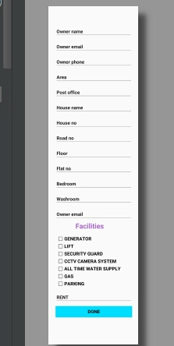5. If an owner selects add button to add more house for rent then this page will appear. In this page there are many information of an owner and about his house. He must fill all the information and set the rent of her house. Then he will select done button. Then the information of the house will show in the step 4.

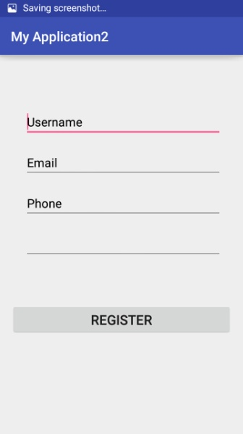6. when a user selects the register button and select the renter then this page will appear. Then he has to fill the information and press the register button.

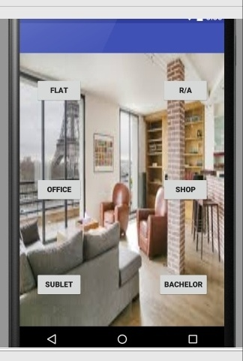7. this page will appear when a renter logged in or register. Here he can find many options. He/she will select his/her desired button for going to next page.

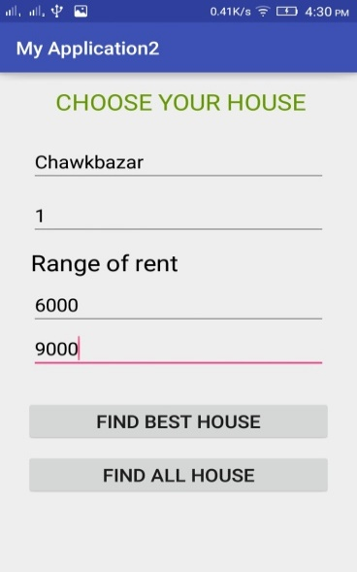8. if a renter selects the R/A in step 7 then he will appear this page. Then he/she has to fill the information and select what kind of process he like. If he/she find the best house then select first button or select he second button.

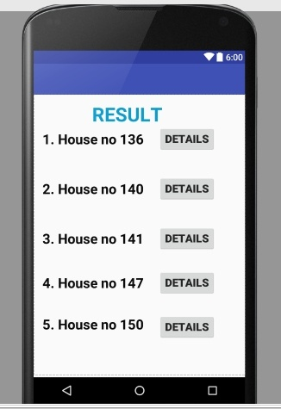9. it’s the main key of our project. Here a renter can find the best house considering his need. He can see the details of the house using details button.

**08. EXPERIMENTAL RESULTS AND ANALYSIS**

**8.01. EXPERIMENTAL RESULTS**

From different users we get different opinion about our app. Considering all the answers we found an experimental result. Here we see the percentage of agree disagree all category with a table below.

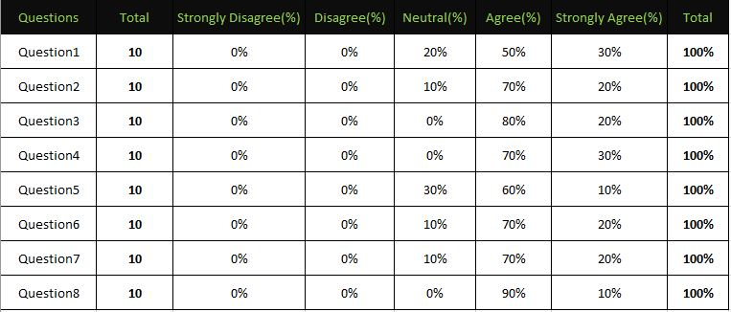

**08.02. USER SURVEY AND ANALYSIS**

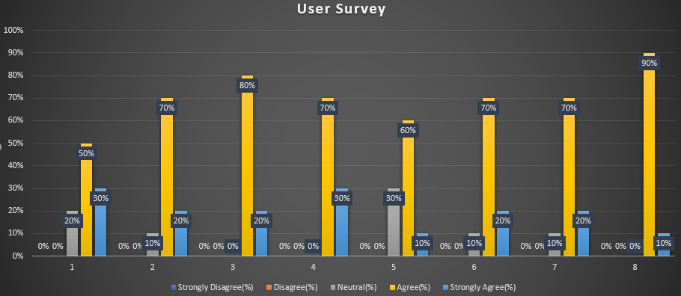

From this survey we can see that for each of our survey question maximum user agree with us and it is on an average 80%. Some user Strongly Agree with us and it is 15% approximately and other 5% are became neutral.

**08.03. COMPARISON WITH EXISTING WORK**

|  |  |
| --- | --- |
| **Our work** | **Related work** |
| Our work will find the best house for the user. | To-let will show the all house in the apps. |
| User can search his area according his need. | User can’t search his area. |
| User can select a range of rent. | User can’t select range of rent. |
| User can select number of bedrooms. | User can’t select number of bedrooms. |
| Processing of maintenance is easy. | Processing of maintenance is difficult. |

**09. CONCLUSION**

Today’s finding house for a renter is so difficult. This app will remove this problem of finding a house. This process a user can easily find a house for his own requirement. This app will also help the owner for give to to-let of his house. As to days world is technology depended, so this apps will remove the problem of a renter of finding a house. This apps will also useful for those who want to sell flat, shop and most importantly this will helpful for sublet and bachelor section.

**10. FUTURE RECOMMENDATIONS**

The new features we can add:

1. We can design this system more beautifully.
2. We can use google map in future.
3. Improvement of the algorithm.
4. Use image of house for rent.
5. Using online payment system.

**11. REFERENCES**

*[1] S. Public and K. Thapa, “Rental Housing : Myths and Reality,” no. October 2004, 2005.*

*[2] “Lecture 13: The Knapsack Problem.”*

*[3] “DYNKNAP.”*

*[4] H. Peter Gommans, G. Mwenda Njiru, A. Nguka Owange, S. Proffessional, and T. Kenya Limited, “Rental House Management System,” Int. J. Sci. Res. Publ., vol. 4, no. 11, 2014.*

*[5] “house_rental_management_system_project_documentation.” .*

*[6] S. Mcnelis and T. Burke, “Rental s ystems in Australia and o verseas authored by,” no. 74, 2004.*

*[7] N. Momtahana and N. Tabassum, “Home Rental System Implementing Constraint Satisfaction Problem,” no. 13101075.*

*[8] W. Bohm, “cs475 Knapsack Problem and Dynamic Programming.”*

*[9] Building Intuition. 2008.*

*[10] J. A. Kirmani, A. Yousuf, and S. M. Bhat, “International Journal of Computer Science and Mobile Computing Rental Housing Management System,” 2017.*