**Bacteria Classification using Image Processing and Deep learning**

Abdullah Ahnaf 1

1 Department of Computer Science and Engineering, Brac University, Dhaka, Bangladesh

**Emails:** abdullahahnaf4567@gmail.com

**Abstract** In the medical field, it is important to classify bacteria in order to diagnose and treat various diseases. In the past, this has been done manually by experts using traditional methods, but this is a difficult and time-consuming process. With the advancement of technology Using machine learning algorithms on computers, it is now possible to classify microorganisms., which can be more efficient than manual methods. We utilized a Convolutional Neural Network (CNN) and Vision Transformer (ViT), to classify images of bacteria into 27 medically relevant categories. CNNs are known to be effective in image classification tasks and thus were a good choice for this particular problem. The results of the implementation have demonstrated that it is possible to identify the genus of bacteria from microscope images of bacteria We employed a Sequential CNN model to classify bacterial images into twenty-seven categories of medical significance. With the help of our method, we were able to achieve classification accuracy of 84.55%. We merged two datasets, resulting in 1588 images. After removing duplicate and blurry images, the final dataset contained 1111 images. We are working on 1111 images of bacteria which is divided into 27 classes. Among the 1111 images, we have taken 891 images for training and 220 images for testing the dataset.

**Keywords:** CNN, Sequential, Vision Transformer, Bacteria classification, deep learning convolutional neural networks, TensorFlow.

1. **Introduction**

Pandemics caused by microbes, such as bacteria and viruses, often arise from difficulties in identifying the specific microorganism responsible. This paper focuses on using computer-aided techniques, specifically machine learning algorithms and image processing, to classify bacteria. Traditional methods of bacterial classification, which rely on manual testing and analysis by microbiologists, can be time consuming and prone to error [1]. By using computer aided techniques, it is possible to more quickly and accurately analyze various microorganisms and aid in faster diagnoses. Deep learning methods, specifically Convolutional Neural Networks (CNNs), have been demonstrated to be successful in image classification and have been utilized in various fields such as medical imaging and cancer detection. The classification of bacteria can be challenging due to their varying shapes and sizes, but CNNs have proven to be a promising approach in this domain. Recognizing various bacterial genera and species is a crucial diagnostic method. Traditional methods of identifying bacteria primarily involve biological techniques like gram staining and identifying the bacteria based on their metabolism. This traditional method of identifying bacteria species relies on comparing samples that have been acquired. Due to these reasons, using traditional methods is time-consuming and requires experts with specialized knowledge [2]. Therefore, automating the bacteria recognition process to increase worker accuracy and reduce analysis time is a logical step. Gram-stained color and cell shape are the two most crucial characteristics of bacteria that can be seen in the photographs. This work explores the potential for classifying bacteria species using deep learning method to differentiate multiple generic classes of bacteria. In this study, we apply a deep learning method-CNN and Vision Transformer (ViT) for classification of bacteria images.

1. **Related Work**

Here this section represents a brief discussion about the papers where image processing and deep learning technique are used for Bacteria Classification. In a study [3], the authors employed two CNN models, ResNet-34 and ResNet-50, for classifying bacteria. They were able to achieve an accuracy of 99.35% for 20 different bacterial species using the ResNet-34 model, and an accuracy of 99.99% using the ResNet-50 model with the same dataset. In the study [4], the author attempted to use and create their own datasets of bacteria in standard resolution. They employed a supervised learning method with the LeNET method, using a small number of images of bacterial genera and species. As a result, this research [5] proposed the "Xception architecture," a deep convolutional neural network (CNN) based architecture, which uses automated recognition and classification of bacteria from microscopic images. Here, we have prepared a dataset of 1588 bacterial images, where each variation has at least 36 images. We have selected 27 types of bacteria for recognition that may be fatal for humans. We used 1111 bacterial photos from 27 different types in the train dataset to train the suggested algorithm. Finally, 220 bacterial photos from 27 different species from the test dataset were used to analyze the performance, which revealed encouraging results with a prediction accuracy of about 84.55%. The study [6] shows the capacity of a DCNN model to categorize Digital Images of Bacterial Species and achieves an average accuracy of 95.09%. The high accuracy is due to preprocessing and Image Augmentation, which doubles the dataset size, and HSV Masking, which improves the model's performance by eliminating the background color of the dataset. Classifying biological images is a challenging task in current trends, but thanks to the advancement of deep learning methodologies, there are now various ways to extract low-level features of biological images. This study [7] also employs a CNN algorithm for bacteria classification, and compares its performance to other algorithms such as the support vector classifier (SVC), random forest (RF), and ConvNet. The developed CNN architecture is shown to outperform traditional methods and achieves a classification accuracy of 95%, which is 5% higher than ConvNet. Research [8] presents an automated deep learning-based classification strategy for categorizing bacterial images. 33 categories were created using the pre-trained ResNet-50 CNN architecture to classify digital images of bacteria. The network's training process was accelerated and its classification performance was improved by using the transfer learning approach. The proposed strategy has an average classification accuracy of 99.2%. In 2018, Nasip and colleagues [10] used deep learning techniques with CNN architectures, specifically pre-trained VggNet and AlexNet, to classify bacterial images into 33 groups. They found that VggNet provided the highest classification accuracy at 98.25%. Additionally, they observed that using pre-trained CNN architectures, such as VggNet and AlexNet, improved classification performance compared to training the models from scratch, emphasizing the importance of using pre-trained models in deep learning tasks for image classification.

1. **Materials and Method**
   1. **Micro_Organism Dataset**

This study [9] initially employed the Micro_Organism dataset, which is publicly accessible, to classify digital images of bacteria. The dataset includes 8 different species of bacteria, with at least 50 images per species. The images in this dataset were stained using the Gram method and were obtained using an Olympus CX31 microscope. The Micro_Organism dataset was sourced from Kaggle. In addition to this [3], we incorporated the EMDS-5 Original dataset, which contains a wide variety of microorganism images. The dataset includes 21 different species of bacteria, with at least 36 images per species. Both datasets were merged to construct a unified dataset consisting of 1111 images in total. Figure 1 illustrates some representative examples of the merged dataset, and Table 1 summarizes the different species of bacteria along with the corresponding number of images.

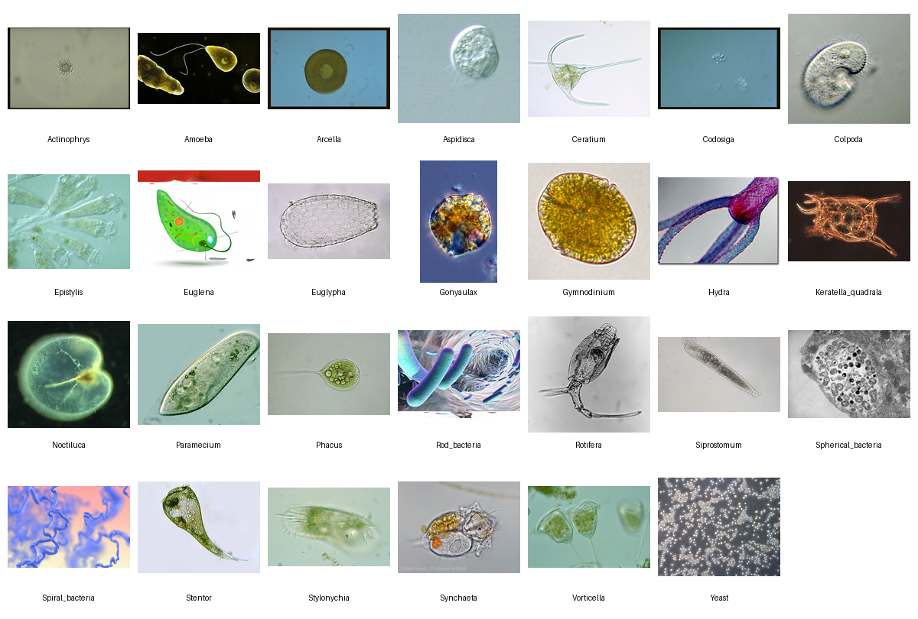

**Figure 1:** Sample bacteria images from Micro_Organism and EMDS-5 dataset

**Table 1:** The name of bacteria species and the number of samples from Micro_Organism and EMDS-5 dataset.

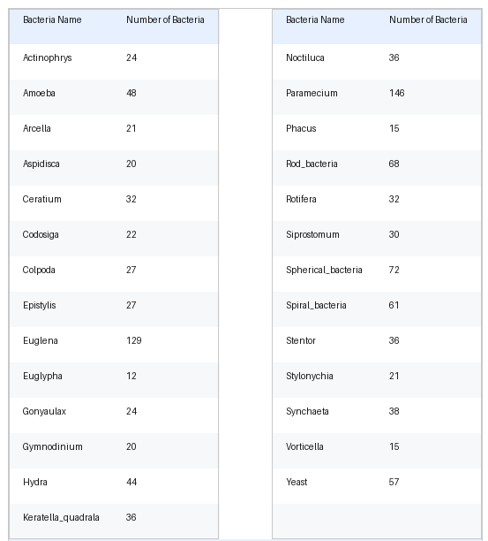

* 1. **Convolutional Neural Network**

Since good accuracy is available in the CNN algorithm [11], we will use CNN algorithm for classify the images of bacteria. Neural network components, it is made up of neurons with biases and learning weights. Each neuron takes a weighted sum of the various inputs it receives, communicates an activation function, and then produces an output once more in response. The CNN relies on three main types of layers: the Convolutional Layer, Pooling Layer, and Dense Layer (also known as a Fully Connected Neural Network). Just like how each neuron in the human brain performs a specific function, each layer in the CNN contributes to the classification of images.

In a similar vein, the CNN layer contributed to the classification of images. Instead of transforming the image into a 2D array or another standard dimension, it is feasible to send the image directly into CNN. For example, if we take some images of cats as training data, CNN will develop a filter based on the features (such as eyes, noses, ears, and so on) of each image to help in the classification of an image [12]. It is quick and easy to comprehend. It is the most precise picture classifying algorithm.

* 1. **Deep Learning with Python Programming**

The authors of this paper put forward the use of deep learning, a machine learning technique that involves using deep layered artificial neural networks, for classifying bacterial images. The proposed method utilizes Python programming with the Keras API and the TensorFlow machine learning framework. In particular, the authors applied the Sequential convolutional neural network (CNN) architecture using Python programming language.

* 1. **Training and Test Datasets**

Micro_Organism and EMDS-5 Original datasets were split into training and test sets, with 80% and 20% of the images being used for training and testing, respectively. Among the 1111 images of dataset, we have taken 891 images for training and 220 images for testing the dataset.

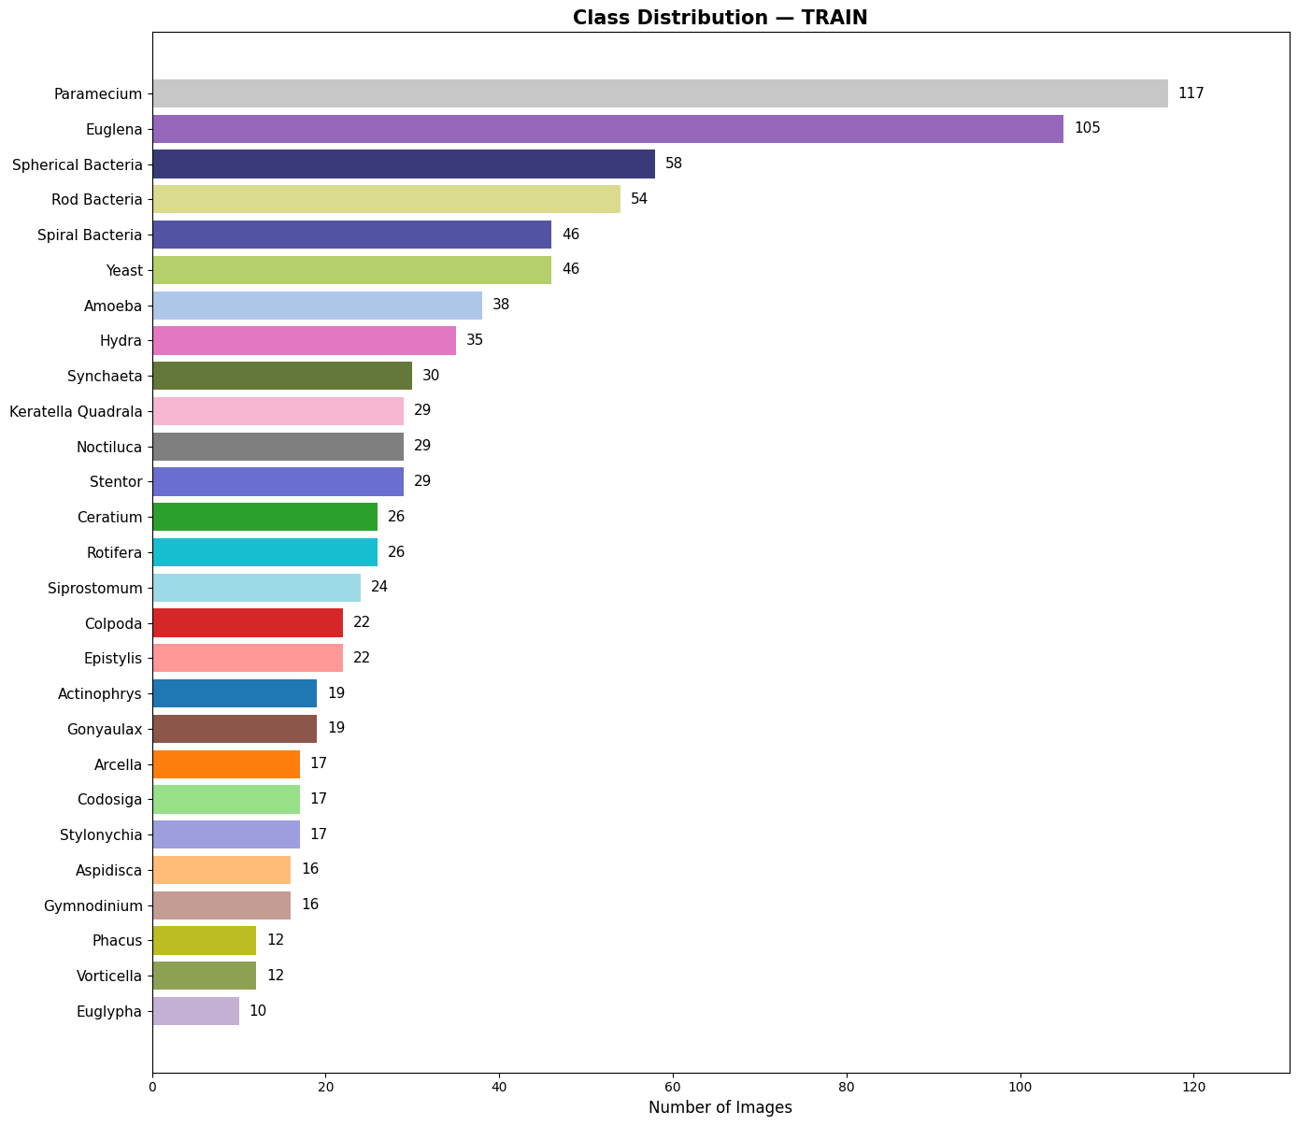

**Figure 2:** Distribution of different classes in training Dataset

A bar chart was used to display the class distribution of the bacterial species in the dataset. The y-axis of the chart displayed the different bacterial classes, while the x-axis represented the number of samples in each class.

The chart showed that the majority of the samples Euglena, Paramecium species. This distribution suggests that the dataset was highly imbalanced. However, the distribution was significantly imbalanced, as all classes had a unbalanced number of samples. This could potentially affect the performance of the classifier, as it may be more difficult to accurately classify the minority classes due to a lack of sufficient training data and testing data.

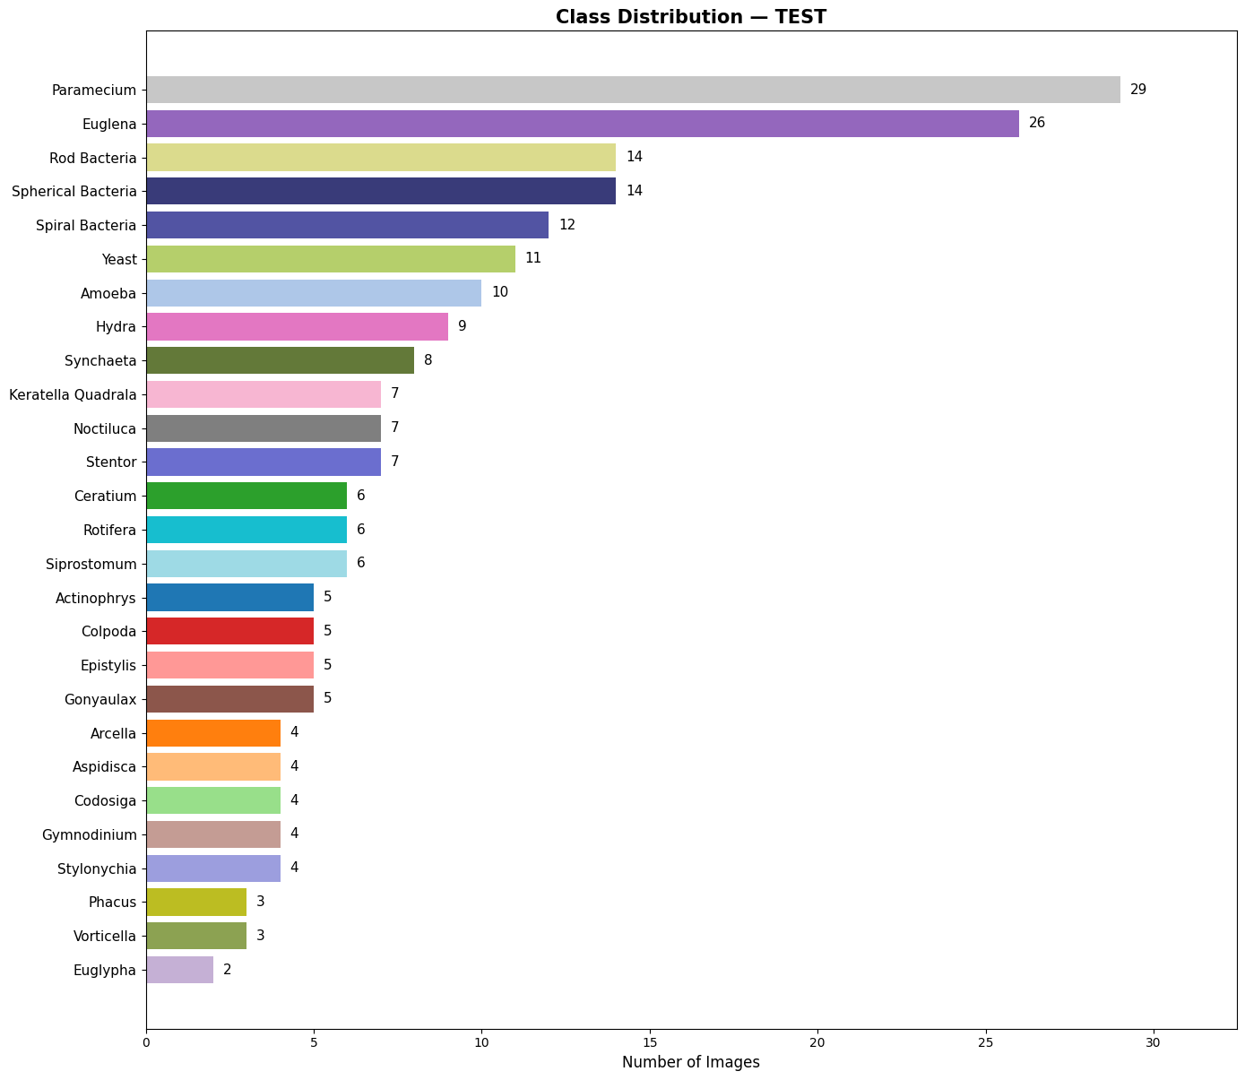

**Figure 3:** Distribution of different classes in validation Dataset

* 1. **Research Methodology**

The aim of this study was to develop a system that can quickly and automatically identify and classify bacterial images in standard resolution for use on mobile and tablet devices. The Micro_Organism dataset and EMDS-5 Original dataset was obtained from Kaggle and a deep learning method called Sequential CNN was employed to classify these images.

1. **Result and Discussion**

The training and testing process for the Sequential model was carried out on a computer with an CPU Intel core i5 @ (2.7-3.6GHz) and 8GB of RAM with the "Windows" operating system.

Overall, the bar chart provided a visual representation of the class distribution in the dataset and highlighted any potential imbalances that could impact the performance of the classifier. The results of this research showed that using a convolutional neural network (CNN) was an effective method for classifying bacteria. The CNN was trained on a dataset of bacterial images (1111 images) and was able to accurately classify the different species of bacteria with an accuracy of 84.55%.

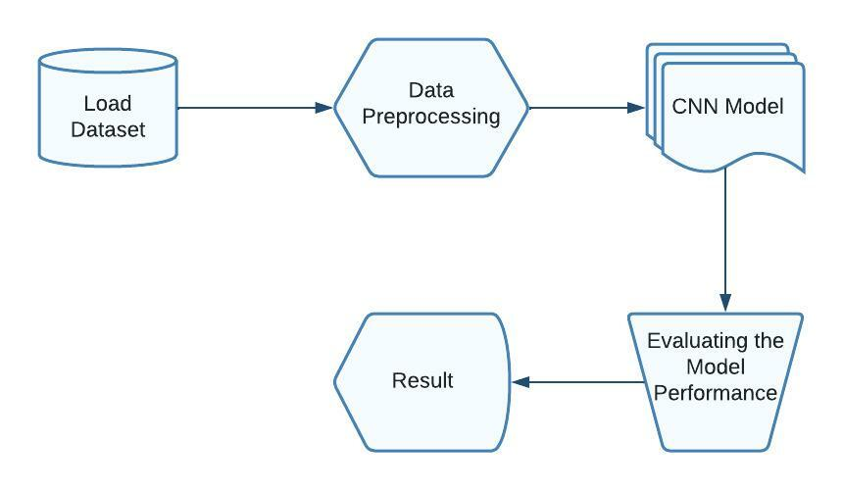

**Figure 4:** Procedure of classifying bacteria images.

The CNN was able to accurately classify bacteria, as well as differentiate between different species within each category. This demonstrates the flexibility and adaptability of the CNN, as it was able to recognize the distinct characteristics of each bacterial species and accurately classify them. Here is our proposed layer of the Sequential Convolutional Neural Network model

|  |  |  |  |  |  |
| --- | --- | --- | --- | --- | --- |
| Model | Val Acc (±) | Val Macro-F1 (±) | Test Acc | Test Macro-F1 | Test Loss |
| ResNet-50 | 77.22% ± 2.44 | 0.7931 ± 0.0366 | 78.18% | 0.8030 | 1.1250 |
| ConvNeXt-Tiny | 83.17% ± 2.58 | 0.8597 ± 0.0178 | 80.91% | 0.8335 | 1.0940 |
| Swin Transformer | 80.02% ± 2.84 | 0.8348 ± 0.0243 | 77.27% | 0.7970 | 1.3045 |
| **EfficientNet-B4** | 82.04% ± 1.09 | 0.8473 ± 0.0116 | **84.55%** | **0.8737** | **0.9482** |

**Figure 5:** The evaluation of the proposed model

One potential limitation of this study is that the dataset used for training and testing may not be representative of all bacterial species. However, the high accuracy rate suggests that the CNN is able to generalize well to other bacterial species. Further research could focus on expanding the training dataset to include a wider range of bacterial species to further validate the CNN's accuracy.

A training and validation accuracy graph visualize the performance of a model during training. The x-axis of the graph typically represents the number of training iterations or epochs, while the y-axis represents the accuracy of the model on the training and validation datasets.

The training accuracy is a measure of how well the model is able to predict the correct labels for the training dataset. It is expected to increase as the model is trained for more iterations, as the model learns to better fit the training data.

So, we implemented 100 epoch for better fit to the training data. The validation accuracy is a measure of how well the model is able to predict the correct labels for unseen data, in other words, the validation dataset. It is used to check the generalization ability of the model. It is expected to peak after a certain number of training iterations and then level off or even decrease as the model begins to overfit to the training data.

**Figure 6:** Training and validation accuracy graph

A training and validation loss graph visualize the performance of a machine learning model during training. The x-axis of the graph typically represents the number of training iterations or epochs, while the y-axis represents the loss of the model on the training and validation datasets.

**Figure 7:** Training and validation loss graph

A confusion matrix is a table that is used to define the performance of a classification algorithm. It is rows represent the true class of the data and the columns represent the predicted class of the data. The entries in the table represent the number of instances that fall into each combination of true and predicted classes.

The diagonal elements of the matrix represent the number of points for which the predicted label is equal to the true label, while non-diagonal elements are those that are mislabeled by the classifier. The main measures derived from the matrix are accuracy, precision, recall, and F1-score.

It is also called an error matrix or an error matrix. It is a powerful tool for understanding how a classification algorithm is performing and also to identify areas where the algorithm can be improved.

**Figure 8:** Confusion matrix

Overall, the use of a CNN for classifying bacteria showed promising results and could potentially be used as a tool in the identification and classification of bacterial species in the future.

# **5. Conclusion**

The use of a convolutional neural network (CNN) for classifying bacteria was shown to be an effective method in this research study. The CNN was able to accurately classify different species of bacteria with an accuracy of 84.55% and was able to differentiate species of bacteria as well as other bacterial classes.

While the class distribution in the dataset was highly imbalanced, the CNN was still able to achieve a high accuracy rate. This suggests that the CNN was able to generalize well to other bacterial species and could potentially be used as a tool in the identification and classification of bacterial species in the future.

Further research could focus on expanding the training dataset to include a wider range of bacterial species and examining the impact of class imbalances on the performance of the CNN. Overall, the use of a CNN for classifying bacteria demonstrated promising results and has the potential to be a valuable tool in the field of microbiology. The experimental results showed that a CNN model and image processing strategy can be used to classify eight different types of bacteria based on their images and predict outcomes with an average accuracy of 85%. However, the dataset used for this study only contained 1111 images of these twenty seven types of bacteria and did not include a diverse range of bacterial genera. Preprocessing techniques were applied to the dataset to improve the classification of the different species. It is expected that using a larger dataset with more diverse bacterial genera will lead to higher accuracy in the future.

# **References**

[1] Hiremath, P.S. and Bannigidad, P., 2010, February. *“Automatic classification of bacterial cells in*

*digital microscopic images”.* In Second International Conference on Digital Image Processing

(Vol. 7546, p. 754613). International Society for Optics and Photonics.

[2] C. S. Ho et al., “Rapid identification of pathogenic bacteria using Raman spectroscopy and deep

learning,” Nat. Commun., vol. 10, no. 1, 2019, doi: 10.1038/s41467-019-12898-9.

[3] T. Shaily and S. Kala, “Bacterial Image Classification Using Convolutional Neural Networks,” in *2020 IEEE 17th India Council International Conference, INDICON 2020*, Dec. 2020. doi: 10.1109/INDICON49873.2020.9342356.

[4] T. Treebupachatsakul and S. Poomrittigul, “Bacteria Classification using Image Processing and Deep learning,” 2019. [Online]. Available: https://www.lgcstandards-atcc.org

[5] Wahid F, Hasan J, and Alom S, “Deep Convolutional Neural Network for Microscopic Bacteria Image Classification,” 2019.

[6] Rujichan C, Vongserewattana N, and Phasukkit P, *Bacteria Classification using Image Processing and Deep Convolutional Neural Network*. 2019.

[7] T. S. R. Mhathesh, J. Andrew, K. Martin Sagayam, and L. Henesey, “A 3d convolutional neural network for bacterial image classification,” in *Advances in Intelligent Systems and Computing*, 2021, vol. 1167, pp. 419–431. doi: 10.1007/978-981-15-5285-4_42.

[8] M. Talo, “An Automated Deep Learning Approach for Bacterial Image Classification,” pp. 1–5, 2019, [Online]. Available: http://arxiv.org/abs/1912.08765

[9] M. W. Azam, “Micro-Organism Image Classification,” 2022. (accessed Jan. 13, 2023).

https://www.kaggle.com/datasets/mdwaquarazam/microorganism-image-classification

[10] Nasip, Ö.F. and Zengin, K., 2018, October. *“Deep Learning Based Bacteria Classification”.* In 2018

2nd International Symposium on Multidisciplinary Studies and Innovative Technologies

(ISMSIT) (pp. 1-5). IEEE.

[11] LeCun Y, Bottou L, Bengio Y, Haffner P. *“Gradient-based learning applied to document*

*recognition”.*Proc IEEE. 1998;86(11):2278–324.

[12] M. Ramprasath, M. V. Anand and S. Hariharan, &quot;Image classification using

convolutional neural networks,&quot; International Journal of Pure and Applied

Mathematics, vol. 119, pp. 1307--1319, 2018.